

U.S. Department DOT-VNTSC-FA27-PM-07-06
Of Transportation

Federal Aviation
Administration

Comparison of the Wake Vortices of Heavy and non-Heavy B757

June 2007

Prepared for: Prepared by:
U.S. Department of Transportation U.S. Department of Transportation
Federal Aviation Administration Research and Special Programs
Wake Turbulence Program Administration
Washington, DC 20591 Volpe National Transportation
Systems Center
Advanced Communication,
Navigation, and Surveillance (CNS)
Technologies Division
Cambridge, MA 02142
Technical Report Documentation Page
REPORT DOCUMENTATION PAGE |  |  |  |  |  |  |  |  | Form Approved  OMB No. 0704-0188
The public reporting burden for this collection of information is estimated to average 1 hour per response, including the time for reviewing instructions, searching existing data sources, gathering and maintaining the data needed, and completing and reviewing the collection of information. Send comments regarding this burden estimate or any other aspect of this collection of information, including suggestions for reducing the burden, to the Department of Defense. Executive Services and Communications Directorate (0704-0188). Respondents should be aware that notwithstanding any other provision of law, no person shall be subject to any penalty for failing to comply with a collection of information if it does not display a currently valid OMP control number.
PLEASE DO NOT RETURN YOUR FORM TO THE ABOVE ORGANIZATION.
1. REPORT DATE (DD-MM-YYYY)  June 2007 |  |  | 2. REPORT TYPE  Technical Report |  |  |  |  | 3. DATES COVERED (FROM - TO)  September 2001 to May 2007
4. TITLE AND SUBTITLE  Comparison of the Wake Vortices of Heavy and non-Heavy B757 |  |  |  |  | 5A. CONTRACT NUMBER
 |  |  |  |  | 5B. GRANT NUMBER
 |  |  |  |  | 5C. PROGRAM ELEMENT NUMBER
6. AUTHOR(S)  James N. Hallock and Melanie A. Soares |  |  |  |  | 5D. PROJECT NUMBER  FA27
 |  |  |  |  | 5E. TASK NUMBER
 |  |  |  |  | 5F. WORK UNIT NUMBER
7. PERFORMING ORGANIZATION NAME(S) AND ADDRESS(ES)  U.S. Department of Transportation, Research and Innovative Technology Administration, Volpe National Transportation Systems Center, Advanced CNS Technologies Division, Cambridge, MA 02142 |  |  |  |  |  | 8. PERFORMING ORGANIZATION REPORT NUMBER  DOT/VNTSC-FAA-07-06
9. SPONSORING/MONITORING AGENCY NAME(S) AND ADDRESS(ES)  U.S. Department of Transportation  Federal Aviation Administration  System Operations Service Unit  Washington, DC 20591 |  |  |  |  |  |  |  | 10. SPONSOR/MONITOR'S ACRONYM(S)
 |  |  |  |  |  |  |  | 11. SPONSOR/MONITOR'S REPORT NUMBER(S)
12. DISTRIBUTION/AVAILABILITY STATEMENT

13. SUPPLEMENTARY NOTES

14. ABSTRACT
In July 1996, a new wake vortex category was created for the B757-200 which placed it between revised Large and Heavy categories. Shortly thereafter, the B757-300, stretched version of the B757-200, was placed in service and soon treated by Air Traffic Control as a Heavy aircraft due to its maximum certificated takeoff weight. This study examines the behavior of vortices from both aircraft during landing operations, and shows little difference between the vortices of the two B757 series. In fact, both measurements and theory indicate that B757-300 vortices decay somewhat faster than B757-200 vortices. Therefore, the B757-300 is being penalized by an unneeded increased wake vortex spacing during landing operations.
15. SUBJECT TERMS
B757, wake turbulence, wake vortices, Windline, SFO
16. SECURITY CLASSIFICATION OF: |  |  |  | 17. LIMITATION OF ABSTRACT  None |  |  | 18. NUMBER OF PAGES  35 |  |  | 19A. NAME OF RESPONSIBLE PERSON  James N. Hallock
A. REPORT  Unclassified | B. ABSTRACT  Unclassified | C. THIS PAGE  Unclassified |  |  |  |  |  |  |  | 19A. NAME OF RESPONSIBLE PERSON  James N. Hallock
19B. TELEPHONE NUMBER (INCLUDE AREA CODE)
617-494-2199

ABSTRACT

In July 1996, a new wake vortex category was created for the B757-200 which placed it between revised Large and Heavy categories. Shortly thereafter, the B757-300, stretched version of the B757-200, was placed in service and soon was treated by Air Traffic Control as a Heavy aircraft due to its maximum certificated takeoff weight. This study examines the behavior of vortices from both aircraft during landing operations, and shows little difference between the vortices of the two B757 series. Both measurements and theory indicate that the B757-300 vortices decay somewhat faster than B757-200 vortices. Therefore, the B757-300 is being penalized by an unneeded increased wake vortex spacing during landing operations.
This page intentionally left blank
TABLE OF CONTENTS

Section Page

- INTRODUCTION 1

2. EFFECT OF WEIGHT ON VORTEX DECAY 3

3. VORTEX AND METEOROLOGICAL DATA 5
3.1 INTRODUCTION 5
3.2 SFO TEST SITE 5
3.3 WINDLINE OPERATION 8

4. ANALYSES 9
4.1 MET AND VORTEX DATA 9
4.2 INITIAL COMPARISON 11
4.3 NORMALIZE TO SAME WINDS 14
4.4 NORMALIZE TO SAME TIME OF DAY 19
4.5 COMPARE BEHAVIOR TO HEAVY AND LARGE AIRCRAFT 22
4.6 STATISTICAL ISSUES 25

5. RESULTS AND RECOMMENDATIONS 27
5.1 RESULTS 27
5.2 SEPARATION STANDARDS IMPLICATIONS OF MOVING THE B753 TO THE B757 CATEGORY 27
5.3 RECOMMENDATIONS 28

6. REFERENCES 29
LIST OF FIGURES

Figure Page

Figure 1. SFO Airport Diagram 6
Figure 2. SFO Test Site 2000 – 2002 7
Figure 3. Windline Layout 7
Figure 4. B777 Aircraft over SFO Windline 1 8
Figure 5. B753 Tracks on Windline 1 9
Figure 6. B752 Tracks on Windline 1 10
Figure 7. Winds for B753 and B752 Tracks 10
Figure 8. B753 Winds and B752 Winds for Long-Lasting Wakes 11
Figure 9. B753 and B752 Tracks Ending on Windline 1 12
Figure 10. B753 and B752 Maximum Age and Corresponding Crosswind 13
Figure 11. B753 and B752 Maximum Age and Corresponding Lateral Transport 14
Figure 12. Winds for Subset 1 15
Figure 13. B752 and B753 Tracks – Similar Winds 15
Figure 14. B752 and B753 Maximum Wake Age and Corresponding
Crosswind – Similar Winds 16
Figure 15. B752 and B753 Maximum Wake Age and Lateral Transport –
Similar Winds 16
Figure 16. Winds for Subset 2 17
Figure 17. B752 and B753 Tracks with Similar Winds: Subset 2 17
Figure 18. Maximum Wake Age vs. Crosswind – Similar Winds: Subset 2 18
Figure 19. Maximum Wake Age vs. Lateral Transport – Similar Winds: Subset 2 19
Figure 20. B752 and B753 Crosswind and Headwind Values – Similar Time
of Day 20
Figure 21. B752 and B753 Tracks – Similar Time of Day 20
Figure 22. B752 and B753 Maximum Wake Age and Crosswind –
Similar Time of Day 21
Figure 23. B752 and B753 Maximum Wake Age and Lateral Transport –
Similar Time of Day 21
Figure 24. Cumulative Probability – All Tracks 22
Figure 25. Cumulative Probability – Similar Winds 23
Figure 26. Cumulative Probability – Similar Time of Day 23
Figure 27. Cumulative Probability – Downwind Vortex 24
Figure 28. Cumulative Probability – Upwind Vortex 25
LIST OF TABLES

Table Page

Table 1. Current Landing Separation Standards 1
Table 2. Aircraft Characteristics 2
Table 3. Tracks That Went Off the Far End of Windline 1 11
Table 4. Summary – Similar Winds Datasets 19
Table 5. Summary – Similar Time of Day Dataset 22
LIST OF ACRONYMS

ASOS Automated Surface Observation System
B752 B757-200
B753 B757-300
CLT Central Limit Theorem
CW Crosswind
DFW Dallas/Ft. Worth International Airport
DIA Denver International Airport
FAA Federal Aviation Administration
ft foot or feet
IAH George Bush Intercontinental/Houston Airport
JFK John F. Kennedy International Airport
kts knots
lb pound(s)
Met Meteorological
nmi nautical mile(s)
ORD O’Hare International Airport
Rwy Runway
s second(s)
SFO San Francisco International Airport
SOIA Simultaneous Offset Instrument Approach
sqft square feet
STL St. Louis International Airport
US United States
NOMENCLATURE

b wingspan
b₀ initial vortex spacing, Kb
C_{L} lift coefficient
g acceleration of gravity
K wing loading factor
k 1/½SC_{L}
L lift
M mass
M₂₀₀ mass of B757-200
M₃₀₀ mass of B757-300
q dynamic pressure, ½ ρV²
r distance from vortex center
S wing planform area
T non-dimensional time, 2πb₀²/Г
T₂₀₀ non-dimensional age of B757-200 vortices
T₃₀₀ non-dimensional age of B757-300 vortices
v(r) vortex velocity profile
V airspeed
w initial descent speed, Г/2πb₀
Γ circulation, Mg/KρVb
ρ air density
This page intentionally left blank

1. INTRODUCTION

Wake vortex separation standards define the minimum distance between lead and following aircraft to ensure the following aircraft will operate safely without experiencing a hazardous wake vortex encounter. Smaller aircraft following a larger aircraft are more susceptible to the circulation (strength) of the wake of the larger aircraft, and so the longitudinal or inter-aircraft distance is increased for the smaller aircraft. Separation standards are based on the maximum certificated gross takeoff weight of the lead and following aircraft.

The Boeing B757 aircraft is a twin-engine short-to-medium range jetliner designed to be versatile in decreasing airport congestion by accommodating both short- and long-range routes [Ref. 1]. There are two series currently used in passenger air traffic, the 200 and the 300 series; the 300 is a stretch version of the 200. A freighter version of the B757-200 is also in use.

The B757-200 was certified by the FAA in December 1982 and placed in service on January 1, 1983, by Eastern Airlines. Initially, the B757 was categorized as a Large aircraft according to the separation standards defined in November 1975 [Ref. 2] where the minimum weight cutoff for Heavy aircraft was 300,000 lb. Following a series of incidents and accidents [Refs. 3, 4] involving the B757 as the leading aircraft, the landing separation standards were modified in July 1996 by creating a new category just for the B757. At the same time, a new minimum weight cutoff for Heavy aircraft was set at 255,001+ lb (see Table 1; the times in seconds, s, are for a 135-kt approach speed).

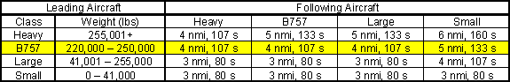

Table 1. Current Landing Separation Standards

Boeing introduced the B757-300 in September of 1996. This stretch version of the 200 series has a maximum certificated gross takeoff weight of 270,000 lb. As the wingspan and wing area are the same, one would expect the B-757-300 wake vortices to behave similarly to the wake vortices of the B757-200. But, because of its maximum certificated gross takeoff weight, the B757-300 is currently classified as a Heavy aircraft. As seen in Table 1, this classification requires an additional mile separation for B757, Large and Small aircraft following a Heavy B757-300. The maximum landing weight of the B757-300 is 224,000 lb, well below the Heavy cutoff weight. A summary of the characteristics for both the 200 and 300 series is presented in Table 2. The only physical difference between both series lies in the stretched fuselage.

 | B757-300 | B757-200
Wing Span | 124.8 ft | 124.8 ft
Wing Area | 1951 sqft | 1951 sqft
Length | 178.6 ft | 155.3 ft
Max Takeoff Weight | 270,000 lb | 255,000 lb
Max Landing Weight | 224,000 lb | 210,000 lb

Table 2. Aircraft Characteristics

The issue at hand is whether the somewhat heavier B757-300 needs to be in the Heavy category for landing. Section 2 of this report presents a simple model showing the effect of weight on wake vortex decay. Section 3 briefly describes the San Francisco International Airport (SFO) test site and the vortex and meteorological data. Section 4 contains the analyses of the Windline data comparing the vortex behavior of the B757-200 with the vortex behavior of the B757-300 as well other Heavy and Large aircraft. Section 5 reviews the results of the study and presents a recommendation for the treatment of the B757-300 during landing. Section 6 lists the references referred to within the report.
2. EFFECT OF WEIGHT ON VORTEX DECAY

A simple model is presented here to examine the effect of aircraft weight on vortex decay. The intent is to determine theoretically how the expected lifetimes of B757-300 vortices compare with the expected lifetimes of B757-200 vortices. In Section 4 the data on the lifetimes of B757-200 and B757-300 vortices will be compared to the theoretical results.

After the wake rollup process is complete, an aircraft wake can be described as two counter rotating, axially symmetric line vortices. Each vortex can be characterized by its tangential velocity profile v(r), where r is the distance from the vortex center. The circulation or strength profile, Γ(r), can be calculated from the velocity profile:

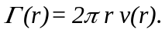 (1)

As the vortex radius r increases, the circulation approaches an asymptotic value:

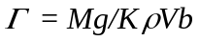 (2)

where M is the aircraft mass, g is the acceleration of gravity, K is the wing loading factor (K=1 for uniform loading and K = π/4 for elliptic loading), ρ is the air density, V is the airspeed, and b is the wingspan. Mg is the weight of the aircraft. The lift coefficient, C_{L,} is given by:

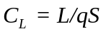 (3)

where L is the lift, q is the dynamic pressure equal to ½ρV² and S is the wing planform area. Thus, setting the lift equal to the weight of the aircraft,

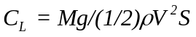 (4)

or, rearranging the terms,

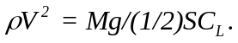 (5)

On approach, aircraft are operated typically with a constant lift coefficient so that

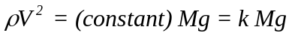 (6)

and Eq. (2) becomes

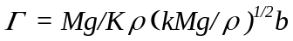 (7)

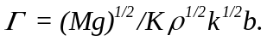 (8)

The timescale for wake vortices is expressed in normalized form, T, based on the time for the vortex pair to descend one initial vortex spacing, b₀, at an initial descent speed of w:

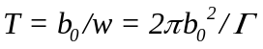 (9)

Using Eq. 8 for Γ,

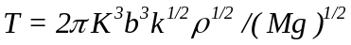 (10)

or

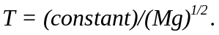 (11)

This simple model shows that the time for complete vortex decay (typically 5 to 8 T units) is inversely proportional to the square root of the weight Mg of the aircraft. Therefore, for the same wingspan b, on approach the wake vortices of the heavier aircraft are expected to decay somewhat faster than the wake vortices of the lighter aircraft; the B757-300 vortices are expected to decay faster than the B757-200 vortices.

Compare the decay times (Eq. 11) for the B757-200 and B757-300. The maximum landing weights in Table 2 are used:

T₃₀₀/T₂₀₀ = [(M₂₀₀ g)/(M₃₀₀ g)]^{1/2} = (210,000/224,000)^{1/2} = 0.97. (12)

Thus, the simple model indicates that the lifetime of B757-300 vortices is expected to be 97% of the lifetime of B757-200 vortices – essentially no difference. The next sections of the report will see what the data collected at SFO indicates.
3. VORTEX AND METEOROLOGICAL DATA

3.1 INTRODUCTION

Over the past 30+ years, the US Wake Turbulence Program has collected Windline, Sodar and Lidar wake vortex data from various sites including SFO, STL, DIA, ORD, DFW, and JFK. The Windline is a series of propeller anemometers aligned to measure the crosswind component with respect to the arrival runway. Using the crosswind component, it is possible to determine the presence of vortices along the length of the Windline. The Sodar uses reflected sound waves to determine the wind speed at various altitudes in the crosswind, headwind and vertical wind direction and can determine the location of vortices that pass overhead. The Lidar uses pulsed-laser reflections off aerosols in the atmosphere to measure wind speed along its beam. It is then able to determine the vortex height, lateral position and strength. From all the test site locations, a variety of wake vortex data is available as aircraft traffic, meteorological conditions and geographic (i.e., land/water interface, orographic) effects differ from airport to airport.

The largest data set with both the 200 and 300 series of B757s is the Windline data collected at the San Francisco International Airport during 2001-2002. The purpose of this extensive wake vortex measurement program was to provide data to support the safety assessment of the Simultaneous Offset Instrument Approach (SOIA) procedure that permits continued use of the closely-spaced parallel runways at SFO in deteriorating weather [Ref. 5].

Currently, there are 595 B757-200s operated by the major airline carriers and 37 B757-300s [Ref. 1]. To compare B757-200 wake vortex tracks to B757-300 vortex tracks, only the second SFO Windline data collection period contained enough B757-300 wake tracks to make this comparison meaningful [Ref. 6].

3.2 SFO TEST SITE

San Francisco International Airport has two pairs of parallel runways, 28/10 left and right and 1/19 left and right [Fig. 1]. The Volpe Center test site was located on the 28’s end of the airport with San Francisco Bay to the North and East as shown in Figure 2. The runway separation is 750 ft centerline to centerline.

Three Windlines were deployed to collect arrival wake data on the closely-spaced parallel runways 28L and 28R. Windline 1 was 1275 ft in length and was located perpendicular to the ends of the runways, 280 ft East of the runway thresholds. Windline 2, 500 ft West of the 28 thresholds, and Windline 3, 750 ft West of Windline 2, were located between both runways to track wake transport in ground effect farther down the runway. The Windline configuration is shown in Figure 3. The Windlines consisted of propeller anemometers mounted on 3-ft poles spaced 25 ft apart. The anemometers were oriented to measure crosswind. There was also a 20-ft Meteorological (Met) pole outside each end of Windline 1. Both Met poles were equipped with three propeller anemometers to measure crosswind, headwind and vertical wind components.

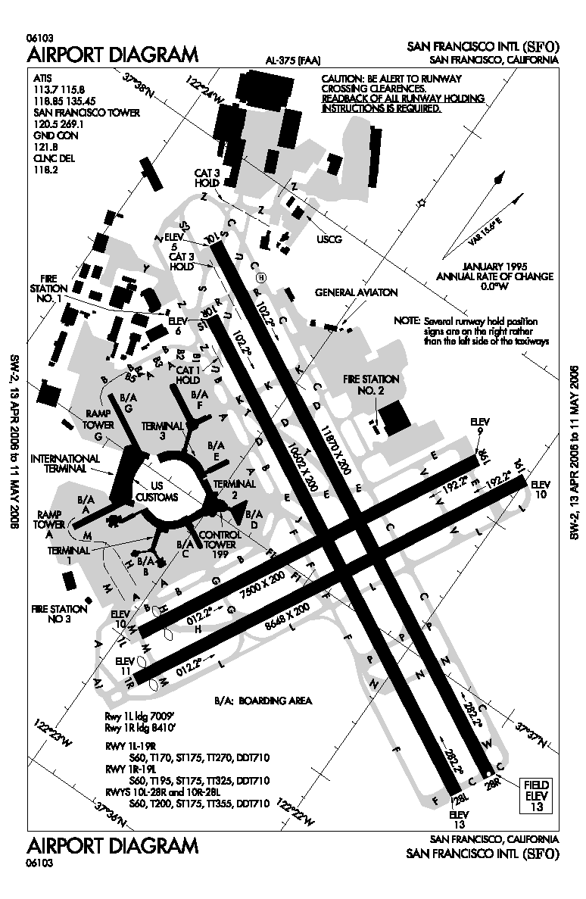
Figure 1. SFO Airport Diagram

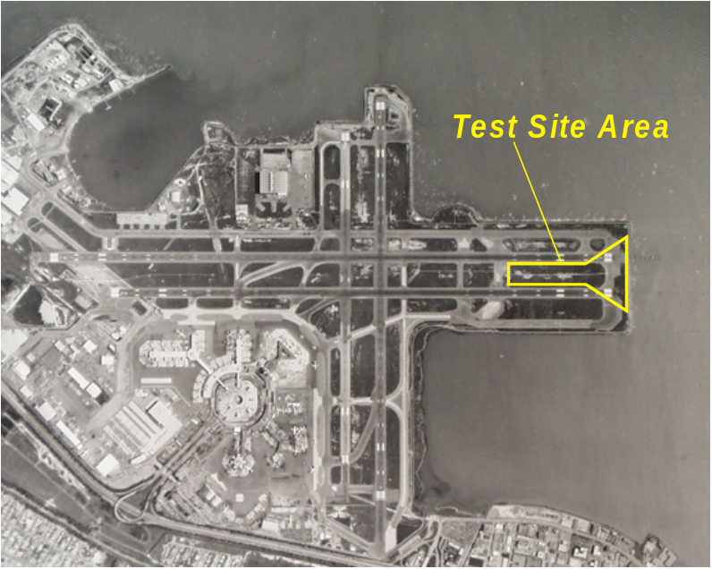
Figure 2. SFO Test Site 2000 - 2002

The test site was operational from February 2000 to May 2001 when data collection stopped because of construction (the runways were extended), and then from September 2001 until October 2002. The second data collection period is the focus of this report. Only wake vortex tracks measured on Windline 1 are being shown throughout this report. Between September 2001 and October 2002, there were 11,629 B757-200 arrivals recorded which produced 23,220 vortices detected on Windline 1 (for 38 arrivals, only one vortex was detected; these cases occurred under high wind conditions). In the same time period, a total of 194 B757-300 arrivals was recorded and 388 vortices were detected on Windline 1.

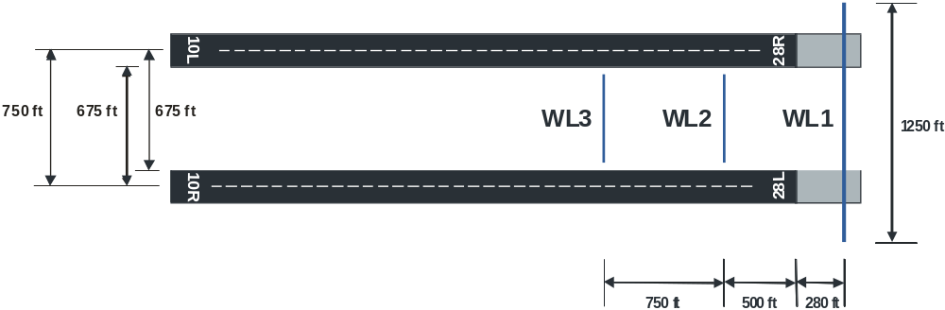
Figure 3. Windline Layout
3.3 WINDLINE OPERATION

Figure 4 shows a B777 passing over Windline 1, the array of propeller anemometers spaced 25 ft apart. The aircraft were typically at an altitude of about 65 ft as they passed over the Windline.

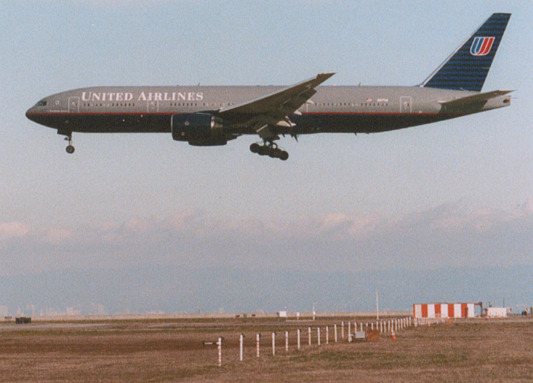
Figure 4. B777 Aircraft over SFO Windline 1

The windline anemometers located on top of each 3-ft pole measured the cross-runway wind component at 10 Hz. These data were stored as 2-s averages. These 2-s data were processed using a windline vortex algorithm to estimate the lateral transport distance of each vortex with time, that is, the distance of travel of each wake vortex from one runway toward the adjacent runway. These lateral transport distances and the age of the vortices when they were no longer detected are the primary measurements analyzed in this report.

It is important to note the limitations of the windline system and algorithm. Like all measurement systems, the accuracy of the wake vortex measurements and algorithm estimates increase with signal strength. That is, strong vortices close to the ground are more easily and more accurately detected than weaker vortices farther from the ground. In the case of the windline algorithm, a weak, nearly decayed vortex close to the ground may look similar to a stronger vortex farther from the ground. Thus, a vortex that “bounces” off the ground may be difficult to detect.

4. ANALYSES

4.1 MET AND VORTEX DATA

The anemometers produced a voltage which is then translated to wind speed in the data acquisition system and averaged every 2 s. A least-square fit is applied to the peaks in the wind speed values along the Windline to generate vortex tracks. For reference, the origin for data analysis was located at the threshold of runway 28L. The runway centerlines are located at 0 ft for 28L and 750 ft for 28 R. A positive crosswind refers to a wind blowing from 28L to 28R and a negative crosswind indicates winds coming from the bay (28R to 28L). For simplicity, the B757-300 will be denoted B753 and the B757-200 will be denoted B752.

For both the B753 and B752 cases, the entire set of tracks was plotted as shown in Figure 5 and Figure 6, respectively. The plots show the position of the wake every 2 s in its lifetime. The B753 tracks fall within the limits of the B752 tracks (Figure 6). Throughout the report, upwind vortices are represented by blue circles and downwind vortices by red triangles.

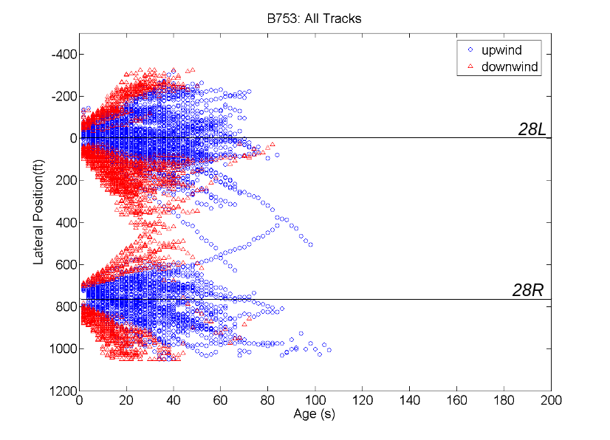
Figure 5. B753 Tracks on Windline 1

Some of the data appear to be cut off near the ends of the Windline. Under certain wind conditions, it was possible for the wake to be transported beyond the edge of the Windline. These cases will be removed to avoid a bias in the data. This will also be done to similar cases in the B752 data set. Examining the B752 tracks, another cutoff is visible at an age of 184 s. This is due to the Windline program processing algorithm which terminates all tracks at 184 s for easier data storage. Vortices at this age are generally very weak and in these cases there is little ambient wind.
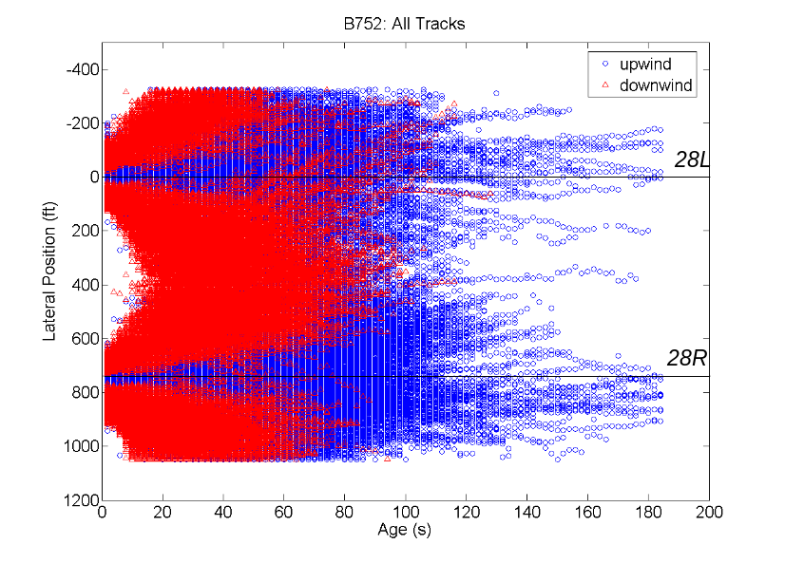
Figure 6. B752 Tracks on Windline 1

The ASOS-measured crosswind and headwind components are shown for all B753 and B752 tracks in Figure 7. Occasionally, there was no ASOS data available and so the average headwind and crosswind values of the two Met poles during that track were used. In Figure 7, each data point represents the crosswind and headwind for one arrival.

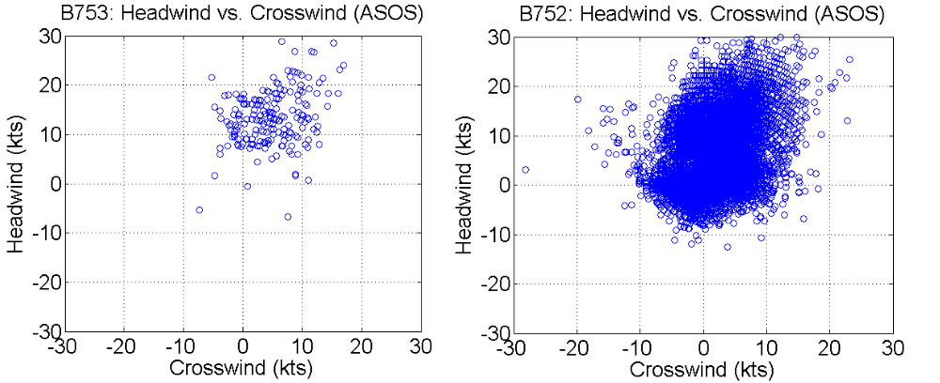
Figure 7. Winds for B753 and B752 Tracks

As the maximum wake age for the B753 data was 98 s, the B752 tracks that last longer than 95 s were studied to determine the difference between this dataset and the B753 data available. Looking only at crosswind and headwind components, a difference in the crosswind speed is obvious. Figure 8 shows the crosswind and headwind components for all the B753 cases and only the long-lasting (more than 95 s) B752 cases. There is a concentration of low-magnitude and negative crosswinds and headwinds for the longer lasting wakes in the B752 dataset. These wind values are not present in the B753 dataset and the lack thereof can account for the shorter B753 wake ages.

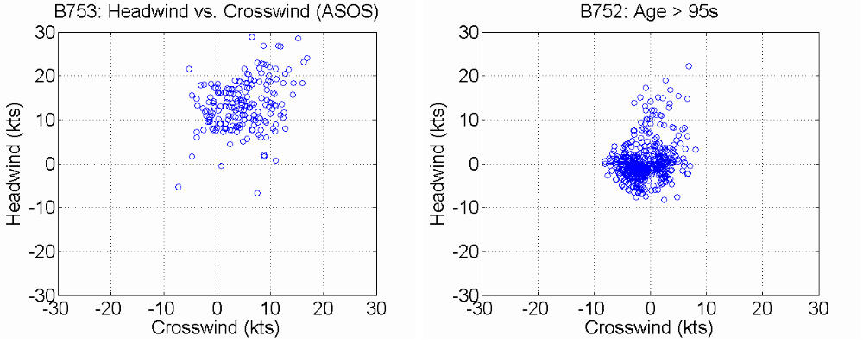
Figure 8. B753 Winds and B752 Winds for Long-Lasting Wakes

4.2 INITIAL COMPARISON

As stated in Section 4.1, wake vortex tracks that were transported to the ends of Windline 1 were removed from the dataset. Tracks that terminated prematurely would pose a bias in the comparison of the average wake age between the B752 and B753 tracks. Vortices that were transported off the near end of the Windline were subject to moderate crosswinds and lack of coverage in that direction was expected, as the Windlines were designed to cover the area between the runways. Those tracks that went past the other runway and off the far end of Windline 1 were studied in more depth. All tracks that went past the far end of Windline 1 are summarized in Table 3.

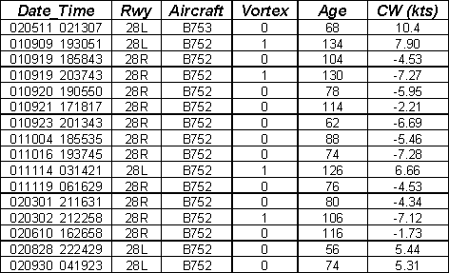

Table 3. Tracks That Went Off the Far End of Windline 1

Of the 86 B753 vortices that went off the end of the Windline, only one went past the other runway to the far end of the Windline. This was a downwind vortex (denoted vortex 0 in Table 3) from 28L and exited after 68 s; the crosswind was 10.4 kts. For the B752 arrivals, 5,734 vortices went off the end of the Windline; only 15 went past the other runway and reached the far end. The wake vortices that were transported past the other runway lasted over 100 s and/or were subjected to stronger crosswinds.

Once these anomalous tracks were removed, there remained 302 B753 vortices and 17,486 B752 vortices. The data was once again plotted, now with only tracks that ended on Windline 1. The result is shown in Figure 9. The B752 cases are presented in lighter outlined data points while the B753 cases are overlaid in darker, filled symbols. All B753 vortex tracks remained within the bounds of the B752 tracks.

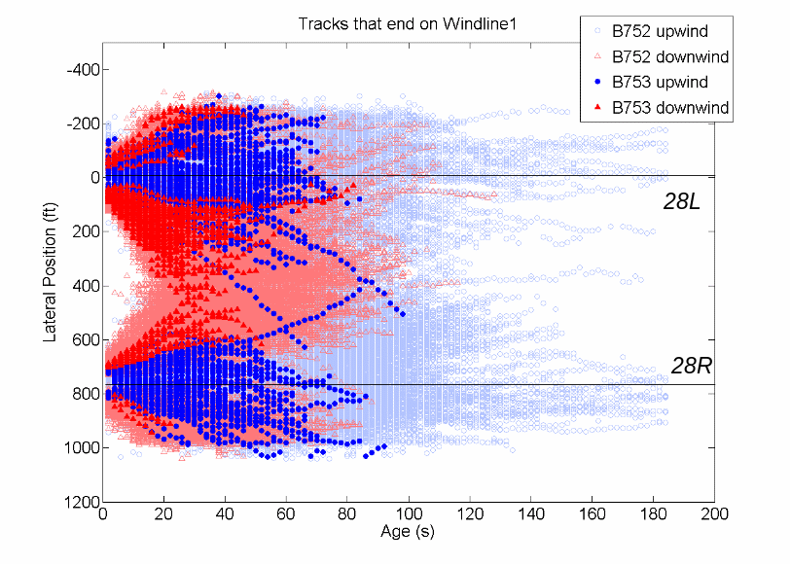
Figure 9. B753 and B752 Tracks Ending on Windline 1

Both the B752 and B753 tracks displayed similar characteristics. The median lateral transport for both datasets was 128 ft while the median age for the B753 was 42 s and the median age for the B752 was 46 s. The maximum lateral transport was 625 ft for the B753 and 916 ft for the B752 cases. The maximum wake age for B753 tracks was 98 s while there were cases, as noted before, in the B752 data that were terminated at the maximum 184 s by the Windline algorithm.

The maximum wake age was plotted versus the crosswind for each track. As seen earlier in the B752 wind plots, wake vortices last longer under weaker crosswinds. In Figure 10, the B753 tracks behaved in the same manner. The longer lasting wakes had a lower crosswind value associated with them. Also, the upwind vortex tends to last longer than the downwind vortex.

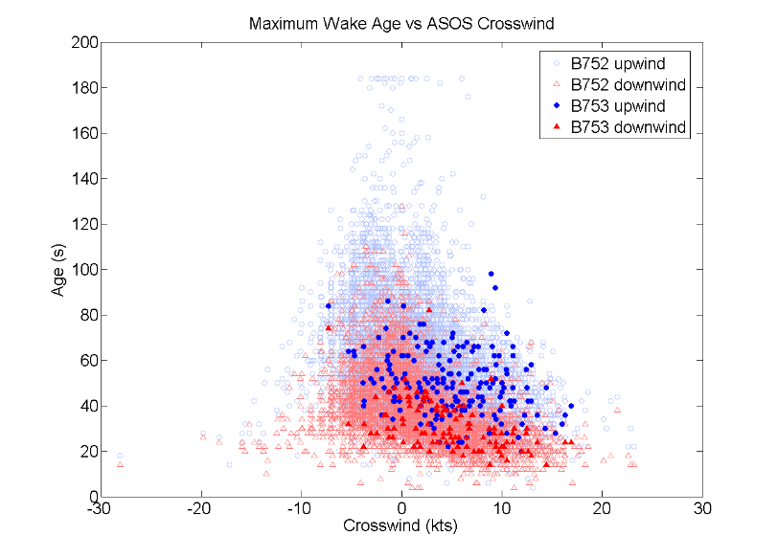
Figure 10. B753 and B752 Maximum Age and Corresponding Crosswind

Figure 11 shows the maximum wake age plotted against the wake lateral transport. To determine lateral transport, the position of the first point detected on Windline 1 was subtracted from the final point of the track. As before, the B752 cases are presented by lighter, outlined symbols and the B753 symbols darker and filled. The downwind vortices tend to transport farther than the upwind and also not last as long as the upwind cases.

Because of the great difference in number of runs for the B753 in comparison to the B752, the larger B752 dataset was further divided into subsets based on similar wind values and time of day. The results of these comparisons are discussed in the following sections.

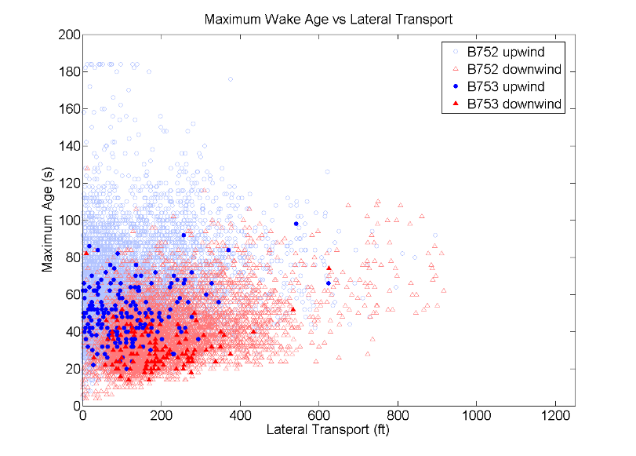
Figure 11. B753 and B752 Maximum Age and Corresponding Lateral Transport

4.3 NORMALIZE TO SAME WINDS

In order to make a more accurate comparison between the B753 data available from the second SFO data collection period and the B752 vortex track data available, the B752 dataset was reduced to the same number of tracks, a total of 302, under similar wind conditions as the B753 dataset. Thus, for each B753 case, the B752 dataset was searched to find a B752 case with nearly identical wind conditions. Once a B752 case was selected, it could not be selected a second time. Two subsets of the B752 dataset will be compared to the B753 dataset and shown in detail in this report. Note that additional subsets of the B752 dataset were selected that yielded similar results, but only two subsets are discussed herein.

4.3.1 B752 Similar Winds - Subset 1

The winds for the B753 cases as well as B752 Subset 1 winds are shown in Figure 12. If the exact crosswind and headwind combination was not available in the B752 dataset, the closest values available to both the B753 crosswind and headwind components were used to select a track. The majority of vortex tracks were under positive crosswind and positive headwind. Because of the orientation of the Windline coverage (in between the runways), these will be mostly 28L arrivals experiencing crosswinds from the land direction.

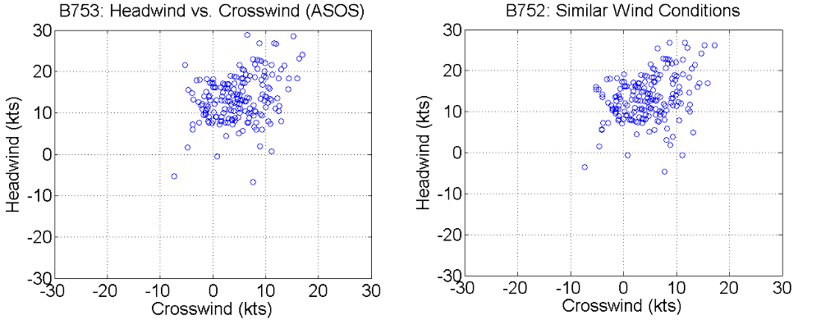
Figure 12. Winds for Subset 1

The B752 Subset 1 tracks were plotted in conjunction with the B753 tracks. The results are shown in Figure 13. Again, the B752 wakes are shown in lighter symbols while the B753 are represented by darker, filled symbols. Note that the B753 tracks fall within the bounds of the B752 tracks in Subset 1. The B752 and B753 tracks have similar duration times under these wind conditions, generally less than 80 s. The tracks also show similar movement along the Windline.

The median lateral transport under these wind conditions for the B752 was 122 ft. Recall the value was 128 ft for the B753 cases. The maximum lateral transport was 730 ft for B752 compared to 625 ft for the B753 cases. The median wake age was 41 s for the B752 and 42 s for the B753. The maximum age values were 132 s and 98 s, respectively.

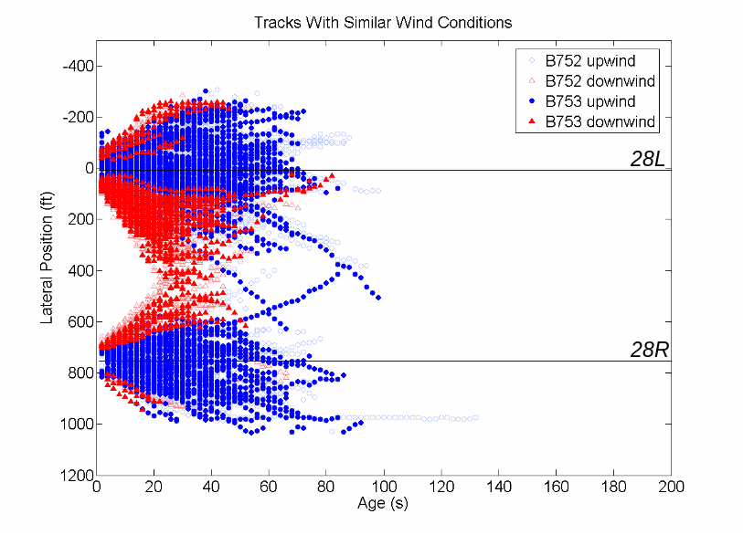
Figure 13. B752 and B753 Tracks -- Similar Winds

To further compare these two datasets, the maximum wake age versus crosswind and lateral position and maximum age of each track were plotted as in Section 4.2.

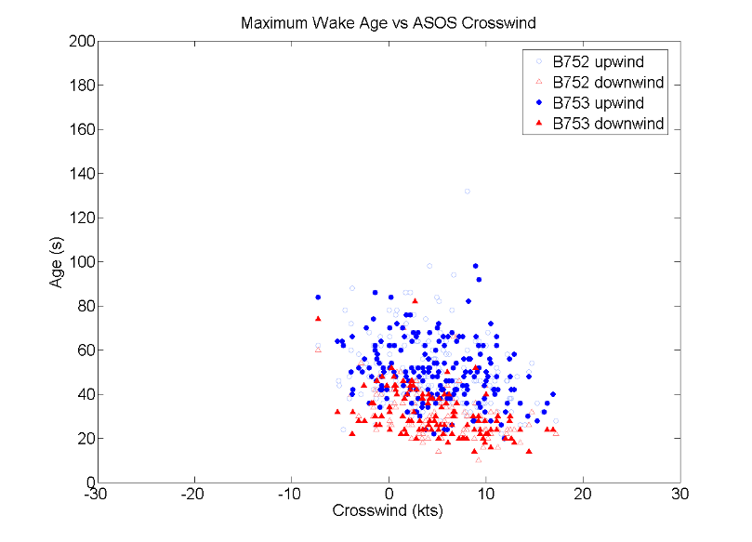
Figure 14. B752 and B753 Maximum Wake Age and Corresponding Crosswind – Similar Winds

The maximum wake age and its corresponding crosswind are shown in Figure 14 for the B752 and B753 cases. The tracks once again fall within similar bounds for both B757 series. The average wake age for both was 43 s. In Figure 15, the maximum wake age and corresponding lateral transport is plotted for both the B752 and B753. Both datasets follow similar trends. The average distance B752 wake vortices were transported was 146 ft compared to 142 ft for the B753 vortices.

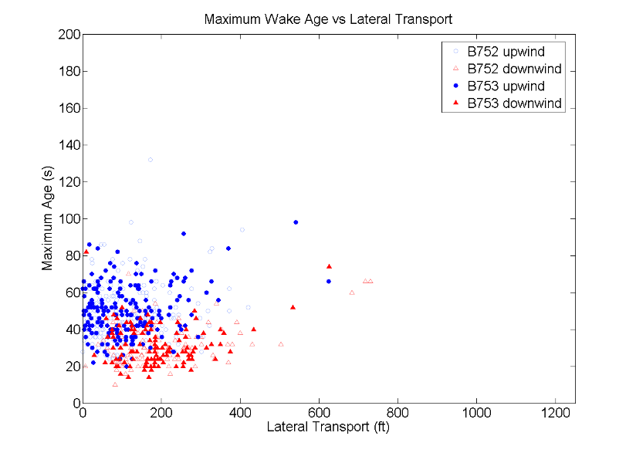
Figure 15. B752 and B753 Maximum Wake Age and Lateral Transport – Similar Winds

4.3.2 B752 Similar Winds - Subset 2

The B752 tracks were matched again by wind conditions to the 302 B753 vortex tracks. In the cases where there were multiple B752 tracks available for a particular headwind/ crosswind combination, it was ensured that the track used in Subset 1 was not repeated in Subset 2. When there were no exact matches, those B752 cases with the closest combination of the headwind and crosswind component values were used to choose a track. The winds for the Subset 2 cases are plotted alongside the B753 winds in Figure 16.

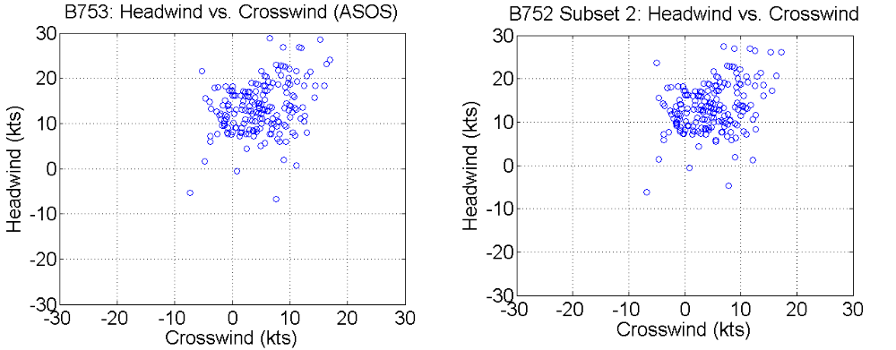
Figure 16. Winds for Subset 2

As shown in the description for the first similar winds subset, the B753 tracks are plotted over the B752 tracks in Figure 17, which again shows similar behavior between both series with very few tracks lasting longer than 80 s.

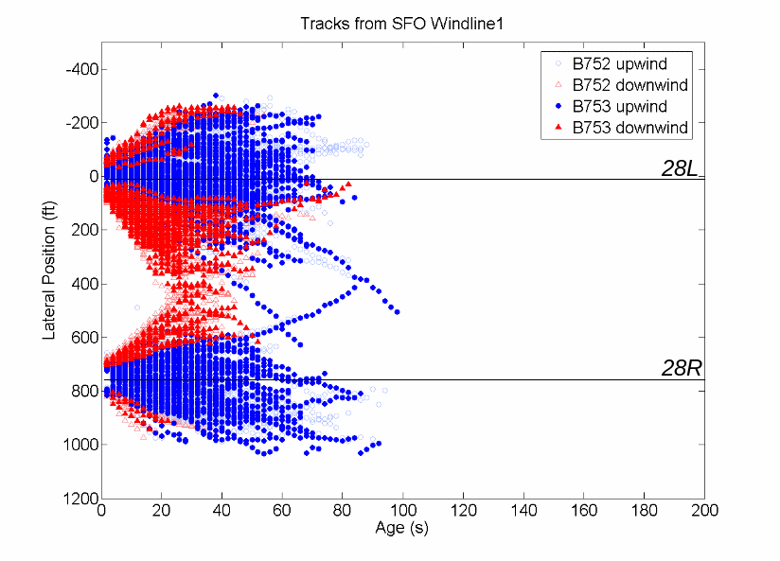
Figure 17. B752 and B753 Tracks with Similar Winds: Subset 2

Subset 2 had very similar wake ages to those in B753. When plotting the Maximum Wake Age versus the crosswind, the B753 and B752 datasets are quite comparable as seen Figure 18. The average wake age for the B753 was 43 s and the B752 dataset had an average wake age of 40 s. The longest duration was 98 s for the B753 and 94 s for the B752.

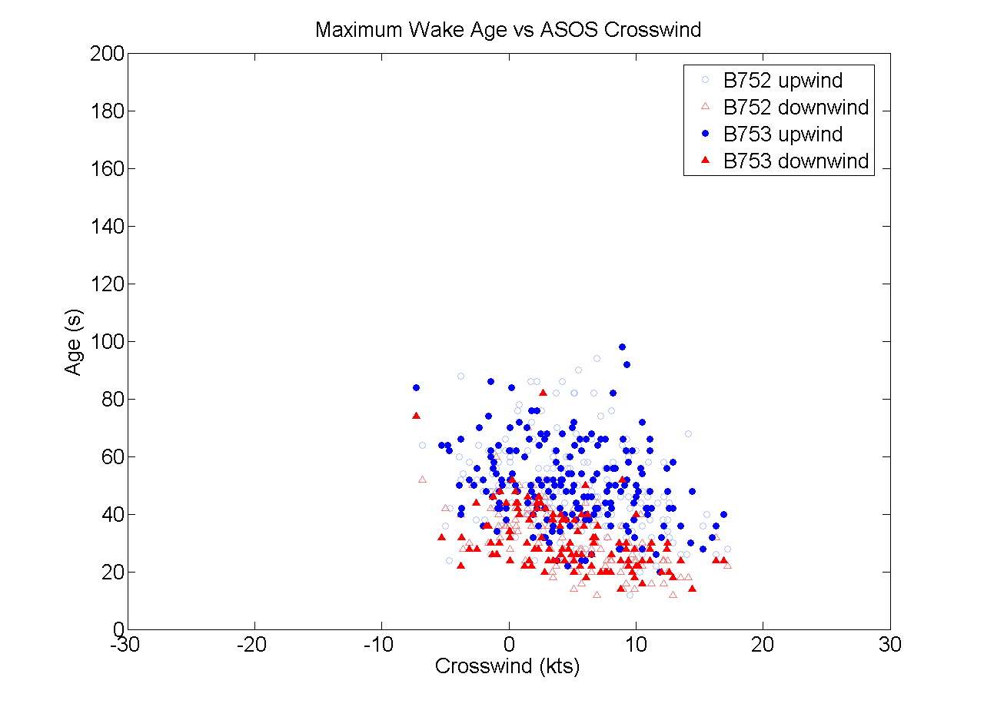
Figure 18. Maximum Wake Age vs. Crosswind -- Similar Winds: Subset 2

Maximum wake age and total lateral transport of the wakes in the B753 and B752 Subset 2 datasets are shown in Figure 19. The bulk of the datasets is quite similar. The B753 data points remain within the bounds of the B752 data with the exception of four wakes that were transported past 500 ft. Comparing the average lateral transport of both datasets, the B753 wakes were transported approximately 40% farther than the B752 Subset 2 wakes. Recall that in Subset 1, the B752 wakes as well as the B753 wakes were transported about 143 ft on average.

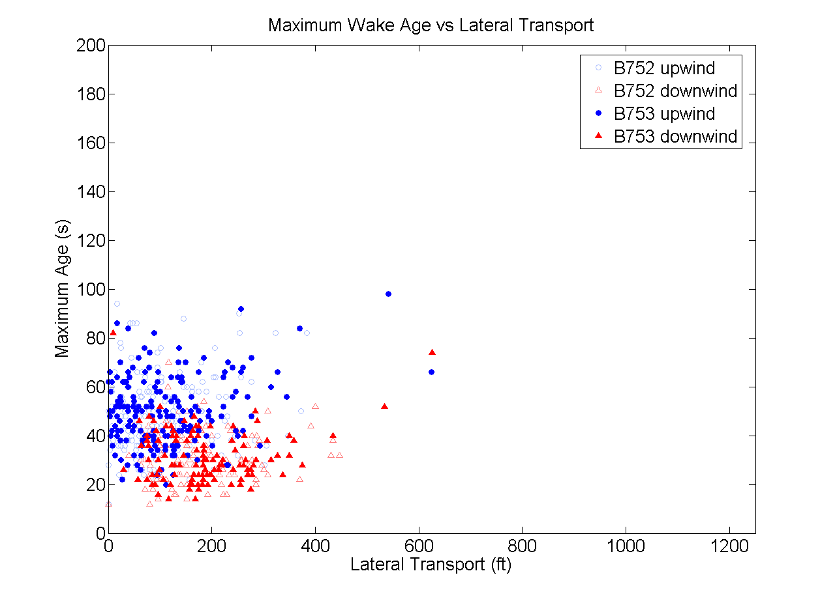
Figure 19. Maximum Wake Age vs. Lateral Transport -- Similar Winds: Subset 2

Table 4 contains a summary of the wake age, lateral transport and wind data for the B753, B752 Subset 1 and B752 Subset 2 vortex tracks. While the median and average lateral transport values were roughly 40 ft less than the B753 cases or B752 Subset 1, the standard deviation of the lateral transport of the wakes in B752 Subset 2 was also greater. The median and average wake ages are similar through all three datasets as is the Maximum Wake Age.

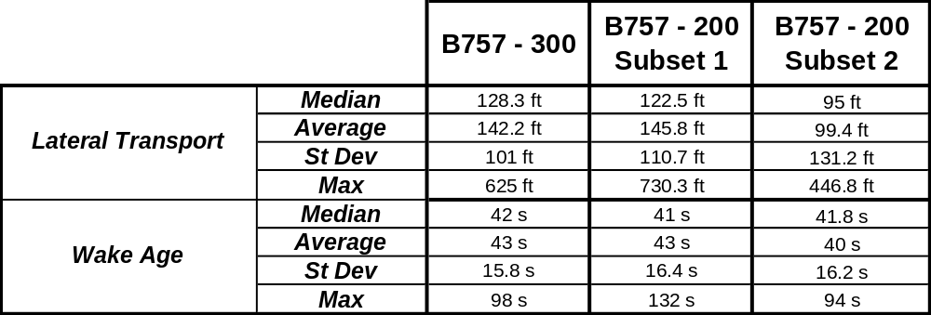
Table 4. Summary - Similar Winds Datasets

4.4 NORMALIZE TO SAME TIME OF DAY

In addition to comparing wake behavior under similar wind conditions, the B753 dataset was also compared to the B752 data during the same time of day. Although time of day is, at best, only weakly a measure of wake vortex lifetime, time of day was used to construct another subset of B752 data. The day and hour of each B753 case was matched to the B752 case in this dataset. If there was no corresponding day/hour match in the B752 dataset, the hour was first matched and the track with the closest date to the B753 date was chosen for this subset. The winds for these cases are shown in Figure 20. As before, these winds represent the crosswind and headwind component according to ASOS when available, else Met pole data was substituted.

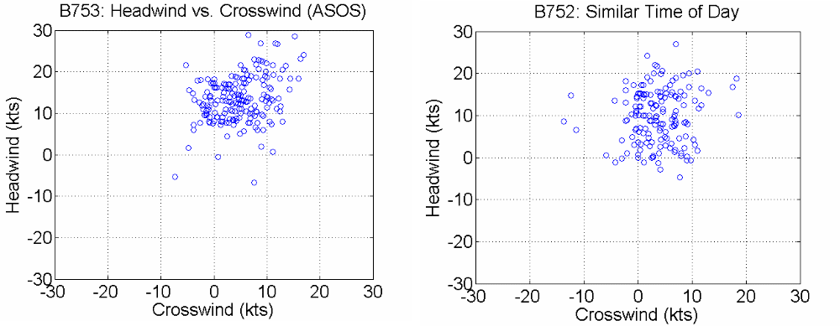

Figure 20. B752 and B753 Crosswind and Headwind Values -- Similar Time of Day

Once again, the B753 tracks were plotted over the B752 tracks in this data subset and the results are shown in Figure 21. Because there are more B752 cases under lower crosswind and headwind condition, some B752 vortices were tracked longer than 100 s.

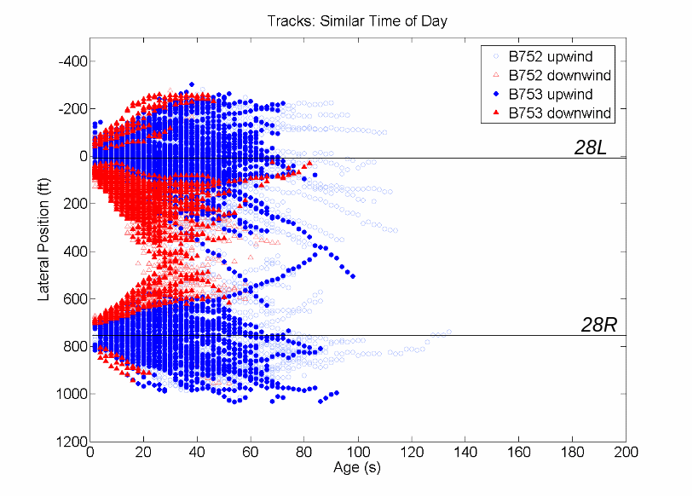
Figure 21. B752 and B753 Tracks -- Similar Time of Day

The Maximum Wake Age is plotted with its corresponding crosswind in Figure 22. Again, the B752 values are shown in lighter symbols, with the B753 points overlaid in darker symbols. Here it is possible to see the effect of lower crosswind values on wake age. The B752 tracks that lasted longer than 100 s generally had crosswind magnitudes less than 5 kts. The B753 cases once again fit within the outer bounds of the B752 subset. The maximum wake age observed for the B752 in this subset was 134 s.

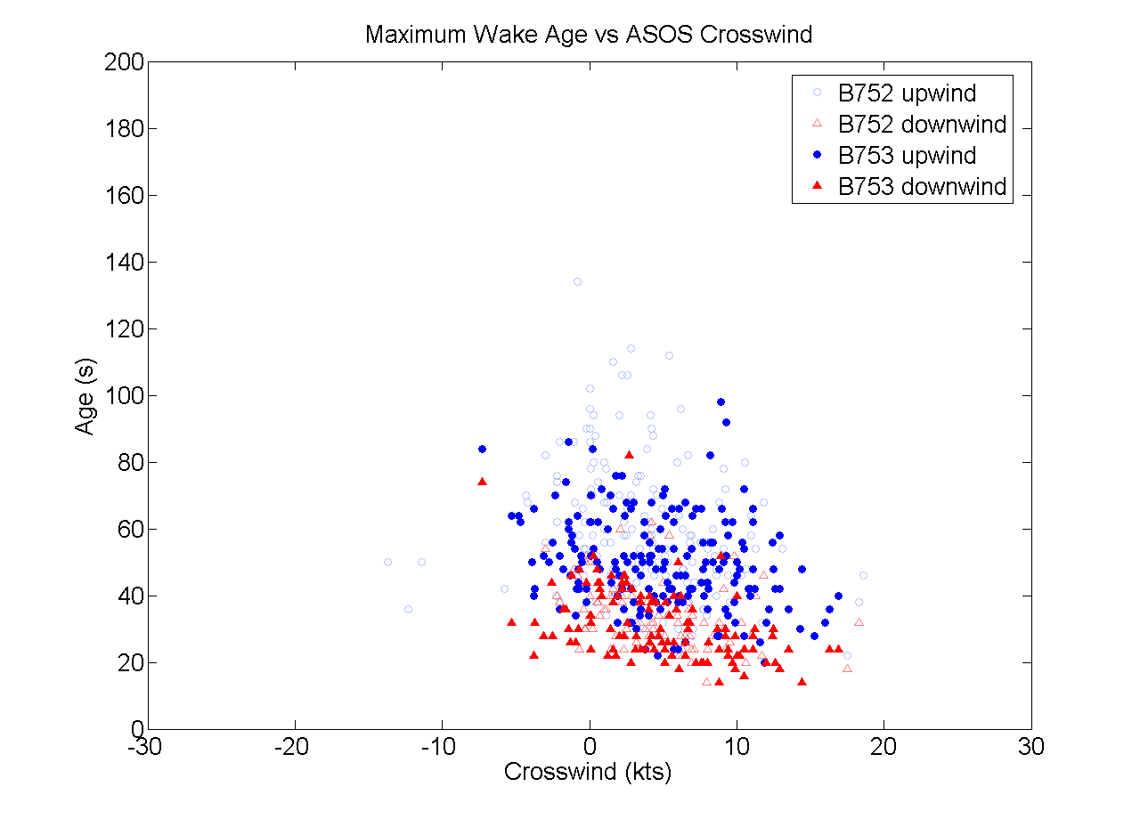
Figure 22. B752 and B753 Maximum Wake Age and Crosswind - Similar Time of Day

In Figure 23, Maximum Wake Age is plotted with the corresponding lateral transport of both the B752 and B753 wake vortices. The maximum distance a B752 wake vortex was transported is 866 ft compared to 625 ft for the B753 cases.

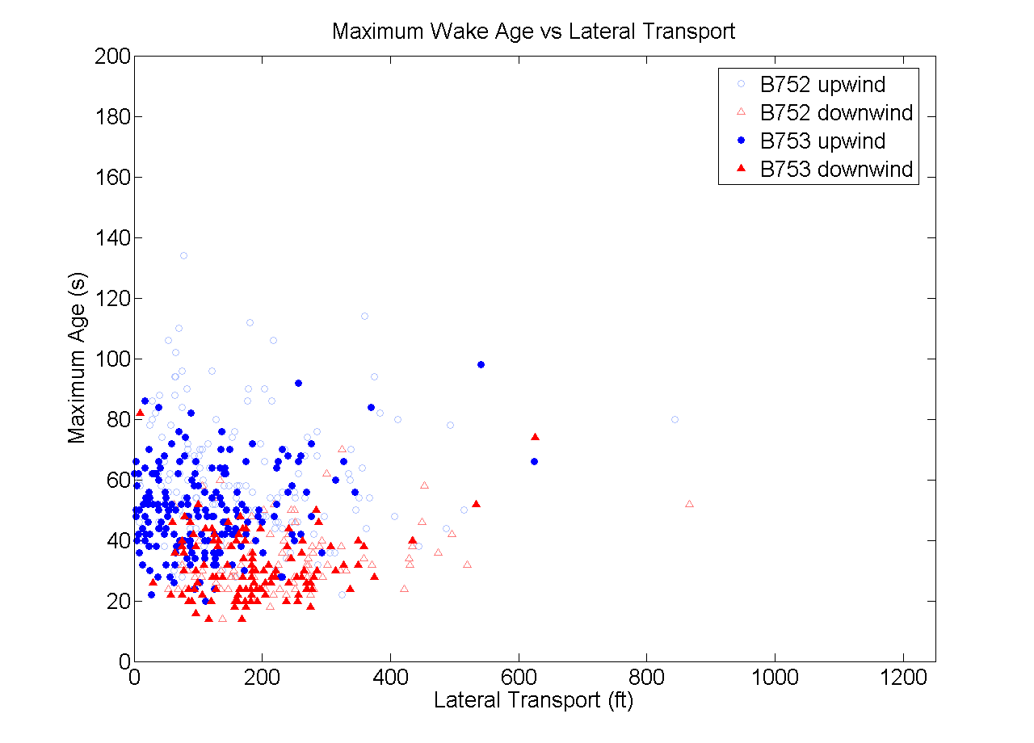
Figure 23. B752 and B753 Maximum Wake Age and Lateral Transport -- Similar Time of Day

A summary of the B753 and B752 datasets is available in Table 5. Overall, the B752 wakes lasted longer and were transported farther than the B753 wakes when compared only by time of day. However, the median and average wake ages are shorter for the Heavy B753 compared to the Large B752.

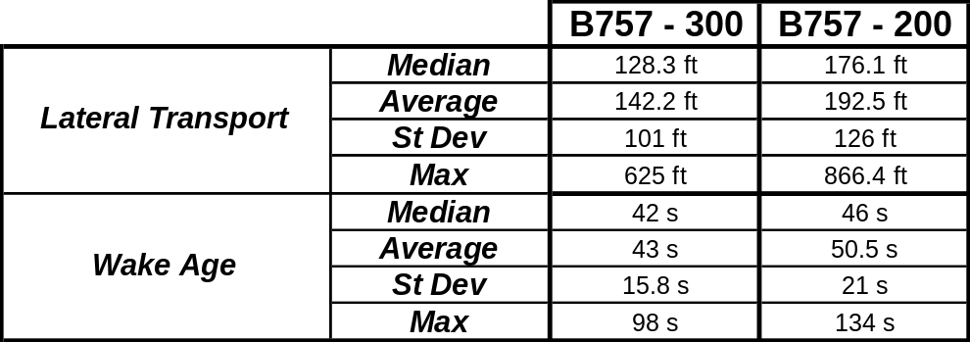
Table 5. Summary - Similar Time of Day Dataset

4.5 COMPARE BEHAVIOR TO HEAVY AND LARGE AIRCRAFT

The B753 series has been classified as a Heavy based on its weight. Throughout this report, the wake vortex tracks of the B753 have been compared to various subsets of B752 data which is currently classified as a B757 in air traffic operations. Recall both aircraft have the same wingspan; the B753 is a stretched version of the B752. This section will investigate whether the B753 wake vortices behave more like a B757, Heavy or perhaps even an aircraft in the Large class.

4.5.1 Track Duration Probability, B752 vs. B753

The following plots are the cumulative probability of the wake vortex lasting a particular time. The tracks’ maximum age were placed into 5-s bins and plotted for the B752 and B753 cases. Figure 24 shows the results of all tracks in both datasets. Both the upwind and downwind vortices of the B753 tend to decay faster than the B752 wakes.

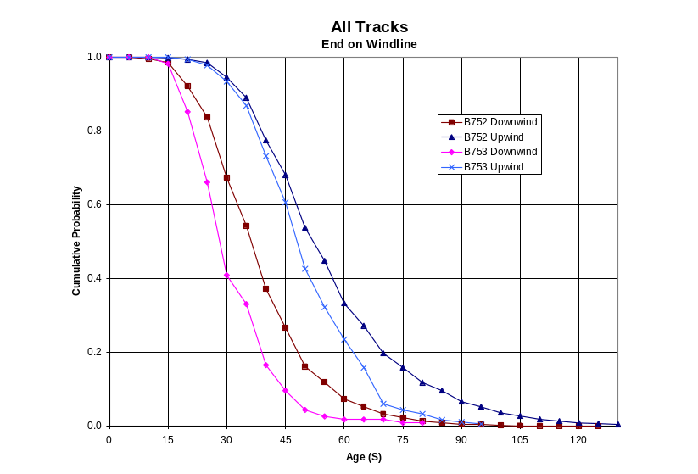
Figure 24. Cumulative Probability -- All Tracks

The same was done for the B752 subsets with similar winds as well as similar time of day. The resulting plots are shown in Figures 25 and 26, respectively.

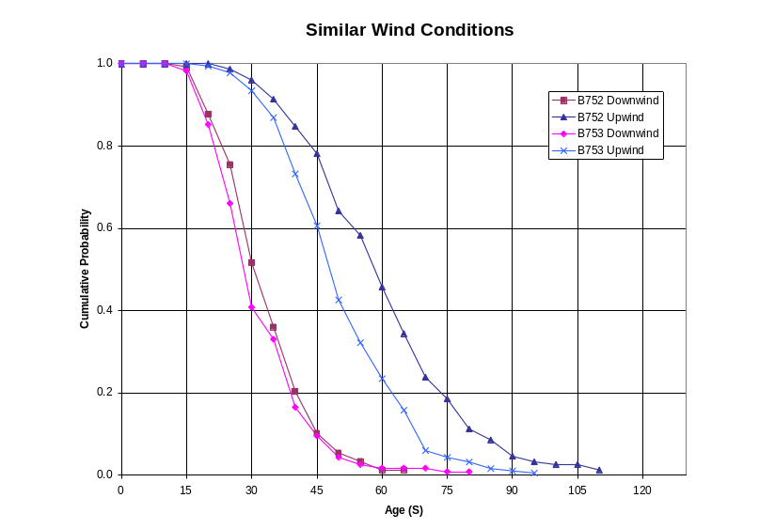
Figure 25. Cumulative Probability -- Similar Winds

Under similar wind conditions the downwind vortex of the B753 and B752 behaved very similarly. In both datasets, only about 10 percent of the downwind vortices last longer than 45 s. The upwind vortex of the B753 decayed faster than the B752 upwind vortex, although it followed the same trend as the B752 vortex probability.

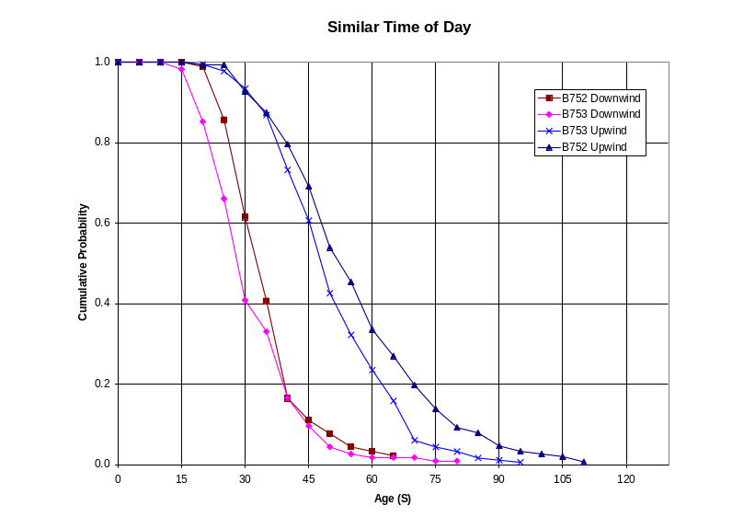
Figure 26. Cumulative Probability -- Similar Time of Day

Vortices generated at similar times throughout the day also decayed in a similar fashion. In this case, however, the B753 upwind and downwind vortices decay a few seconds faster than the respective upwind and downwind vortices of the B752.

4.5.2 Track Duration Probability, B757 vs. Large and Heavy

Due to weight, the B757 aircraft are placed in its own class between Large and Heavy. The following plots will help determine if in fact the B753 wake behaves more like a Heavy as it is currently classified, a B757 or a Large. In comparing the B752 and B753 to other aircraft classes, the cumulative probability was determined on wake vortex data from the B737, B777, A300, A320 and B767 collected at SFO in the second data collection period at SFO as described in Section 3.2. From the data collected at SFO, only tracks which ended on the Windline were studied as the behavior of those reaching the Windline end is not known. The downwind and upwind vortex probabilities are plotted separately for a comprehensive examination of the various aircraft types.

Figure 27 shows the cumulative probability plots for the B752, B753, Large aircraft (represented by the B737 and A320) and Heavy aircraft (represented by the A300, B767, and B777). The B757 curves are drawn with solid symbols and lines and are those shown in Figure 24. The B737 vortex is shown as a ‘+’; the A320 as a ‘*’; the A300 as a triangle; B767 as a circle; and B777 as a diamond. Looking at 45 s on the plot, the fastest decaying downwind vortex is actually the B753, followed by the A300, B752, A320, B737, and then the B767 and B777. The heavier B767 and B777 show approximately 60% of the vortices lasting longer than 45 s whereas only about 30% of the Large last beyond 45 s. Less than 20% of the B752 and B753 wake vortices lasted beyond 45 s.
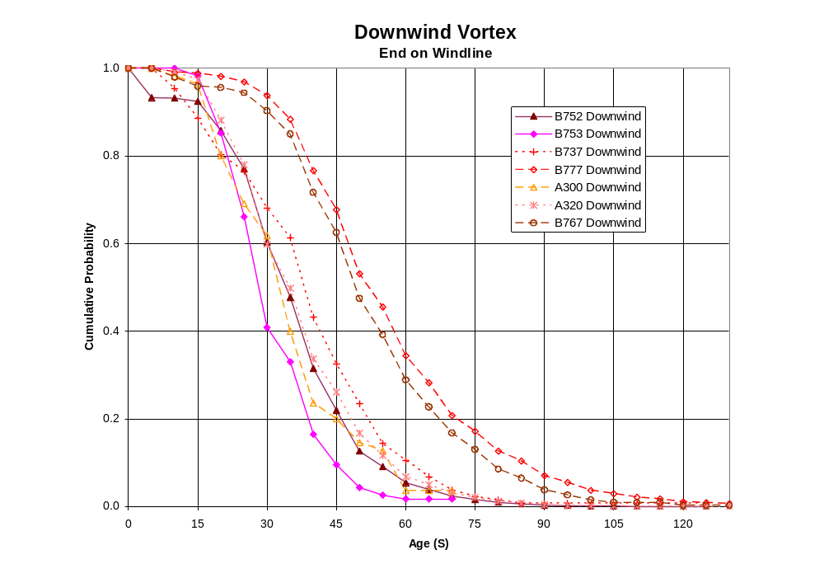
Figure 27. Cumulative Probability -- Downwind Vortex

Below 75 s the A300 downwind vortex seems to behave like a Large aircraft. However, above 100 s there is still one A300 downwind vortex remaining and the curve joins with the other Heavy curves. It should be noted that there were only 55 A300 downwind vortices detected. Looking at Figure 27, both the B752 and B753 series wake vortices behave much more like a Large wake vortex than a Heavy wake vortex.

The upwind vortex cumulative probability curves are slightly more difficult to distinguish by class as they behave similarly. Looking at 75 s in Figure 28, it is easier to distinguish the cumulative probability curves of each aircraft. As in Figure 27, the B753 vortex decays fastest, followed by the A320, B737, A300, B752, B767, and B777. Although the difference is not as obvious as in the downwind vortex cases, the B752 and B753 both decay faster than the Heavy B767 and B777. (Again, the A300 had very few data points, only 88 in this case, and its curve joins the other Heavy aircraft curves at about 90 s.) Once again, the B757 vortices behave more like those generated by a Large aircraft in their rate of decay.
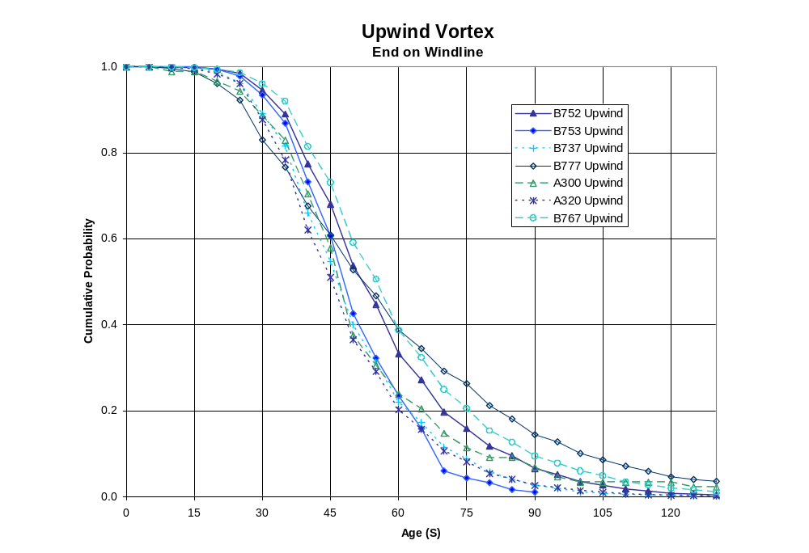
Figure 28. Cumulative Probability -- Upwind Vortex

4.6 STATISTICAL ISSUES

As stated previously, there were only 302 vortices generated by a B753 available for study. Because of the small number of tracks for the B753 in the much larger SFO dataset, it should be determined whether this dataset statistically represents a larger dataset such as the B752 data collected. This was done by subdividing the larger B752 dataset to determine whether a subset of 302 vortex tracks was representative of the larger set.

Wake vortex duration is affected by the environment in which the vortices are generated; the major factor being the ambient winds and a very weak factor being the time of day. The effect of these factors on the B753 dataset has been studied in detail in this report. A study to determine the statistical significance of the subsets of the B752 data was done based on ambient winds and also the time of day. If these subsets are a statistically significant representation of the larger data set, it is safe to assume the B753 data is a realistic representation of wake vortex behavior under these conditions.

The Central Limit Theorem (CLT) is the standard theoretical basis for just about every statistical test in common use. The CLT says that the average of samples taken from a distribution with constant variance tend to stabilize on the overall mean of the distribution. Having 302 B753 vortex tracks is sufficient to use the CLT (with fewer tracks, the Student T-test would need to be used).

Using the criteria described in Section 4.3, the first test was done with 10 randomly selected subsets of 302 vortex tracks from the B752 dataset which had corresponding crosswind and headwind (or close enough) to the B753 dataset. The CLT test performed on these subsets returned a value of 90%. In other words, the vortex behavior of a dataset with these wind values is a statistically significant representation of the greater dataset.

A second test was performed using time of day as the deciding factor when choosing subsets from the B752 dataset. The subsets were chosen using the criteria described in Section 4.4. Once again, the CLT test returned a value of 90%. Based only on time of day, the subset is a statistically significant representation of a larger dataset.
5. RESULTS AND RECOMMENDATIONS

5.1 RESULTS

This study of B757 wake vortices during landing operations has shown that B753 vortices are no different than B752 vortices. The added fuselage length of 23.3 ft increased the maximum certificated takeoff weight by 15,000 lb, but the wingspan and wing area remained the same for the two series. A simple model for vortex lifetime indicated that B753 vortices are expected to decay slightly faster (3%) than B752 vortices when landing at the maximum landing weight. Comparing lifetimes of the vortices (average, median and maximum observed values) under nearly identical wind conditions indicated that real wake vortices from the heavier B753 had somewhat shorter lifetimes when compared to the B752. The same result was obtained when comparing vortex lifetimes during the same time of day. And, finally, the B753 vortex decay behaved more like a Large aircraft than a Heavy aircraft, but always had a shorter lifetime than B752 vortices. Each of the four comparisons:

1. Simple model of vortex lifetime
2. Comparison of vortex lifetimes under similar wind conditions
3. Comparison of vortex lifetimes during similar time of the day
4. Comparison of vortex lifetimes with other Heavy and Large aircraft

lead to the same result, namely, that B753 wake vortices have shorter lifetimes than B752 wake vortices.

5.2 SEPARATION STANDARDS IMPLICATIONS OF MOVING THE B753 TO THE B757 CATEGORY

Moving the B753 from the Heavy category to the B757 category has additional wake vortex implications for the B753, both as a leader and a follower aircraft. As can be seen in Table 1, the landing wake vortex separation standards for the recategorization of the B753 would increase from 4 to 5 nmi when following behind a Heavy. This small decrease in capacity will be more than offset by the increase in capacity for situations where the B753 is the leader aircraft. From a safety standpoint, this increase in separation obviously increases the safety of B753s landing behind a Heavy aircraft.

The maximum landing weight of the B753 is 14,000 lb more than the B752 (see Table 2). This 6.7% increase in weight leads to a similar increase in the initial wake vortex strength of a landing B753. However, this small increase in strength is more than offset by the more rapid decay of B753 vortices, as shown theoretically in Section 2 and by measurements in Section 4. Safety is not compromised as B753 vortices are no different than B752 vortices and even appear to decay faster than B752 vortices.

5.3 RECOMMENDATIONS

This study only examined landing B757s. Based on the results, Air Traffic could safely place both the B752 and B753 within the B757 category for landing, regardless of the 15,000-lb gross certificated takeoff weight difference. No new series of B757s will be built as production of B757 aircraft has ended. However, rather than handling the B753 as a B757 category for landing and as a Heavy for takeoffs, it is recommended that the vortices from takeoffs of both B752s and B753s be examined to see if the B753 can be placed into the B757 category for all phases of flight. Data collection to support this effort is currently underway at IAH.

It is also recommended that the FAA take a new look at how aircraft are categorized for wake turbulence purposes. Not only are there new aircraft at the limits of the maximum certificated takeoff weight (A380 and the very light jets or microjets), but research is showing that wingspan may be a better measure of the vortex hazard, both from the vortex generating and vortex encountering points of view. This B757 study showed that an increase in the gross certificated maximum takeoff weight (keeping all other wake vortex critical parameters constant) can shorten the lifetime of the vortices rather than increasing the wake vortex hazard potential.
6. REFERENCES

- Boeing website: http://www.boeing.com/commercial/757family

- Burnham, D. C. and Hallock, J. N., “Wake Vortex Separation Standards: Analysis Methods,” DOT-VNTSC-FAA-97-04, May 1997, Volpe National Transportation Systems Center, Cambridge, MA.

- NTSB ID SEA93GA041, Cessna 550 Citation, Billings, MT, Dec. 9, 1993.

- NTSB ID LAX94FA073, Israel Aircraft Industries 1124A, Santa Ana, CA, Oct. 6, 1994.

- Hallock, J. N. and Wang, F. Y., “Summary Results from Long-Term Wake Turbulence Measurements at San Francisco International Airport,” DOT-VNTSC-FA27-PM-04-13, July 2004, Volpe National Transportation Systems Center, Cambridge, MA.

- Burnham, D. C., Clark, K. L., Hallock, J. N., Hannon, S. M., Jacobs, L. G., Rudis, R. P., Soares, M. A. and Wang, F. Y., “SFO Wake Turbulence Measurement System: Sensors and Data Descriptions,” DOT/FAA/AR-07/11, Oct. 2006, Volpe National Transportation Systems Center, Cambridge, MA.

