Soft system ANALYSIS to iNTEGRATE teChNOLOGY & Human IN Controller Workstation
James L. Poage, JLP Performance Consulting, Lexington, MA
Caroline Donohoe and Jonathan T. Lee, Volpe National Transportation Systems Center, Research and Innovative Technology Administration, U.S. Department of Transportation, Cambridge, MA

Abstract
Computer-based decision support tools (DST), shared information, and other forms of automation are increasingly being planned for use by controllers and pilots to support Air Traffic Management (ATM) and Air Traffic Control (ATC) in the Next Generation Air Transportation System (NextGen). Successful adoption of these automation concepts depends on both technology and human performance using the technology. System engineering and design needs to account for technology and human performance as co-partners to obtain the intended National Airspace System (NAS) benefits.
The particular subject of this work is to develop functional requirements for the en route controller workstation so that the controller can effectively and safely use the planned technology to obtain the desired benefits. The approach used to accomplish this is designed to: 1) focus on truly integrating technology and human performance by addressing requirements for each at the same time and 2) focus on how technology and human performance work to provide the desired benefits. This approach is called soft systems analysis in this study. The steps include:
- Define technology capabilities that will enable intended benefits. Typically technology functions are developed as the first steps in concept design, and these can be built upon for this step.
- Develop task descriptions for the roles of technology and humans.
- Develop functional requirements for technology that enable the technology and human performance to function as an integrated set.
- Develop benefit flow mechanisms and performance measures for technology and human performance.
- Identify feasibility issues of technology performing as intended and humans performing their tasks.
- Characterize interactions among technology and humans for multiple ATM/ATC concepts.
Examples of applying this approach to integrate and assess technology and human performance as co-elements in providing benefits are presented.

Characterization of Technology and Human Performance in NextGen
The Next Generation Air Transportation System (NextGen) is aimed at providing National Airspace System (NAS) benefits of capacity and efficiency increases. Capacity benefits include more aircraft arriving and departing at an airport during a time period and more aircraft in a sector at once. Efficiency benefits for aircraft operators and the flying public arise from reduced flight time and fuel use and increased predictability of operations. Air Traffic Service Provider (ATSP) benefit since controllers will be able to handle increased demand and be better able to match resources with demand. Environmental benefits include flying fewer noise sensitive routes and flying with less emissions.
To obtain these benefits, NextGen is bringing major changes to technology for Air Traffic Management and Air Traffic Control (ATM/ATC). This technology in turn is bringing major changes to the tasks of controllers and pilots to use the new technology for ATM/ATC operations. Technology and its human users must work together for the benefits to result, as expressed by:
{Dramatic new technology + Dramatic new tasks for controllers & pilot} → Benefits
NextGen technology and human tasks will be different from current ways of performing ATM/ATC. Requirements formulation for NextGen concepts must consider both the technology and the use of the technology by controllers and pilots since benefits will not result without the efficient use of the technology by controllers and pilots. The approach used described in this paper is designed to: 1) focus on truly integrating technology and human performance by addressing requirements for each at the same time and 2) focus on how technology and human performance work to provide the desired benefits.

Major Changes in Technology under NextGen
The following list discusses the characteristics of the new technology and associated significant changes in human roles and responsibilities that are part of the NextGen and together provide NAS benefits.
- Decision Support Tools (DSTs) – Automation will present advisories to controllers and pilots. Using DSTs to plan more efficient maneuvers and routes is a change from today where humans create the maneuvers and routes. The changes are not simple since achieving benefits of more efficient maneuvers generated by DSTs involves:
  - The controller understanding and trusting the advisories
  - DSTs formulating complex clearances, which are clearances with three or more pieces of information (e.g., lateral maneuvers, speed changes, and altitude changes), for the recommended maneuvers
  - The controller accepting a complex clearance and using Data Comm to send the complex clearance to the aircraft
  - The pilot accepting or rejecting the entire complex clearance even if only part of it is unacceptable
  - Possible follow up exchanges between the controller and pilot if clearance is rejected.
- More information and information sharing – Automation provides more information to NAS participants and enables sharing of this information. This increased information will result in more user requests, negotiation among controllers and pilots, and collaborative decision making.
- More precision – Tighter tolerances for aviation operations, including precise 4D trajectories, time-based metering, reduced separation, and more complex trajectories in the terminal airspace. This increased precision will require timely decision-making and execution of tasks by controllers and pilots.
- Flexibility – Dynamically changing airspace configurations and operations in response to changing conditions, such as weather, demand, and security needs. Flexibility will require controllers to work in a variety of conditions. This is not the case today because sector configurations are constant. Operations will expand to include Optimal Descent Profiles, RNAV/RNP routes, Interval Management, pairwise delegated separation, etc.
- Extended horizon for planning and operations –ATM/ATC operations will be planned for larger geographic areas and longer time horizons than today.
The many new technologies and operations will need to be integrated. The DSTs and operational changes to come from NextGen should not be designed as independent sub-systems since controllers and pilots need to work seamlessly among the DSTs and operations. A range of designs may be needed to address this, ranging from automatic transfer of data among DSTs to integrating some individual DST functions into common DSTs.
This list indicates that operations and controller and pilot tasks will change in the future. Developing requirements and designing future technology without considering the human use and interactions with technology will endanger the achievement of the desired system benefits of NextGen. The soft system analysis to be described will address both the precision of technology and the less precise behavior of human participants.

“Soft Systems Analysis” of Technology and Human Performance

Soft Systems Analysis
Several terms are in use to denote approaches for addressing human roles and responsibilities in the design of systems that involve both technology and humans. Human Systems Integration (HSI) is one such approach that focuses on humans and their interactions with a system and its environment. Another term, Human Factors Engineering (HFE), covers the comprehensive integration of human characteristics into the system definition, design, development, and evaluation to optimize the performance of human-machine combinations. The analysis described in this paper includes elements of HSI and HFE. However, a broader range of issues is being studied than typically included in the terms HSI and HFE, such as implementation, acceptability, and feasibility of the system under consideration.
Traditionally, systems analysis treats a system as a bounded physical entity existing in the real world, such as when one speaks of a computer system or a telecommunications system. In this paper, the term soft systems analysis is used to denote structured analysis of system that is, to some extent, ill-defined. In literature on soft systems, “soft” is taken to refer to problems that are ill-defined or not easily quantified, such as a business organization, while “hard” refers to systems that are well-defined and quantifiable, such as technology systems. ATM/ATC enhancements under NextGen include soft and hard aspects when the human and technology components are considered working together as a system.
The soft system analysis described in this study combines “systems analysis” with “soft,” refers to the use of structured methods to analyze the humans and technology working as co-elements in ATM/ATC systems. This analysis considers both the human and technology equally instead of placing more emphasize on one or the other.
Structured techniques that were applied as part of soft system analysis include:
- Define capabilities of the technology that will enable the intended benefits. Typically technology functions are developed as the first steps in concept design, and these can be built upon for this step.
- Develop task descriptions for the roles of technology and humans.
- Develop functional requirements for technology that enable the technology and human performance to function as an integrated set.
- Develop benefit flow mechanisms and performance measures for technology and human performance.
- Identify feasibility issues of technology performing as intended and humans performing their tasks.
- Characterize interactions among technology and human tasks related to multiple ATM/ATC concepts.

Case Study: Mid-term En Route Controller Workstation
This work examines issues associated with technology and controller performance in the en route controller workstation in the mid-term timeframe (i.e., around 2018). The focus is threefold. First is identifying functional requirements for the controller to interact with technology in the workstation. These include display, input mechanism, automation algorithms, information, and communication capabilities. The second is addressing HF issues regarding en route controller human performance. The third is to develop a HF research roadmap to support design of the future en route controller workstation. The emphasis is on functional requirements and HF issues as they influence obtaining the desired benefits of the NextGen capabilities.
This work examines issues associated with technology and controller performance in the en route controller workstation in the mid-term timeframe (i.e., around 2018). The focus is on: (1) identifying functional requirements for technology with which the controller will interact in the workstation (e.g., what information to display, input mechanisms, automation algorithms, information needed by controller, and communication capabilities); (2) identifying and characterizing HF issues regarding en route controller human performance; and (3) developing a HF research roadmap to support design of the future en route controller workstation. The emphasis is on functional requirements and HF issues as they influence obtaining the desired benefits of the NextGen capabilities. This effort did not go to the level of detail of addressing the actual display format of information on the workstation screen.

Overview of Approach
A systematic analysis was performed of the expected new en route technology in the mid-term and the associated tasks en route controllers are likely to perform. The analysis began by identifying “drivers” of change in the en route controller workstations that will arise from the capabilities and operations planned for the mid-term under NextGen. The drivers were identified by examining FAA planning and program documents. All the new operations, automation (including DSTs), and information related to en route controller workstations in the mid-term were compiled from the review of FAA documents. Then drivers of workstation change were compiled. The drivers defined (to date) are:
- Different Types of Airspace (e.g., high altitude-high performance, IFR cruise, and classic airspaces)
- Improved Weather Information & Integration of Weather into DSTs
- Data Comm
- Complex Clearances
- 4D Trajectories
- Flight Objects
- Different Types of Operations (e.g., Optimized Profile Descents, flexible routing in terminal areas, routes based on aircraft equipage)
- Automate Routine Controller Tasks
- Automated Conflict Resolution Advisories
- Pairwise Delegated Separation
- Oceanic
- Traffic Management Initiatives (TMIs) with Flight-Specific Trajectories
- Flexible Airspace
- Coordination and Shared Information among Stakeholders
- Time-Based Flow Management
The term “drivers” of workstation change is used since the above list considers a variety of factors ranging from new technology, to new operational practices, to new airspace structures.
After compiling the drivers of workstation change, capabilities of the new drivers were delineated, functions the controller would likely conduct related to each driver were identified, and requirements were developed for technology that will enable controllers to use the technology in such a manner that the system benefits will be obtained. Finally, controller tasks and use of technology in each driver were studied to identify and characterize HF issues for controller human performance. This analysis process is shown in Figure 1.

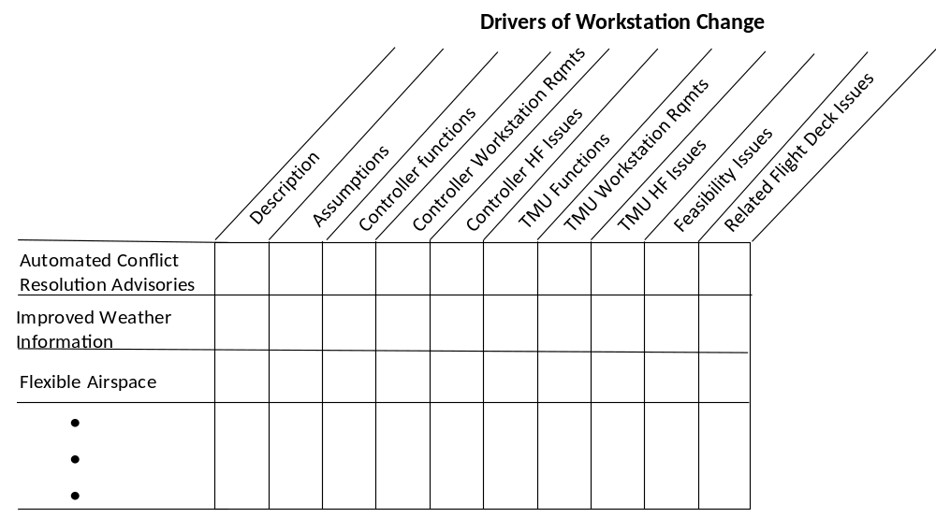
Figure 1. Analysis Topics for Drivers of En Route Controller Workstation Change

Figure 1 shows that the Traffic Management Unit (TMU) and flight deck were examined as well as the en route controller. However, the emphasis is on the controller, but requirements and HF issues for the TMU and flight deck were gathered where there were relationships to a particular driver.
A team of analysts with backgrounds in ATM/ATC, system engineering, and HF worked on the analysis of the drivers of workstation change. To be rigorous, several steps were followed in analyzing each driver: 1) one team member assessed several drivers to identify tasks a controller would conduct, identify workstation capabilities needed to perform each task, and consider HF issues for performing the tasks; 2) assessments were reviewed by the whole team as a group; 3) assessments were reviewed and commented upon by subject matter experts (e.g., former en route controller, HF expert); 4) assessments were refined; 5) reviews were conducted a second time by the team; and 6) assessments were finalized by the original analyst.

Application Example: Automated Conflict Resolution Advisories with Complex Clearances and Data Comm
The drivers listed on the previous page were assessed to address all assessment categories in the top row of Figure 1. The analysis approach and results will be explained by presenting the driver, automated conflict resolution advisories, as an example. Automated conflict resolution advisories will provide controllers with suggested resolutions to conflicts listed in a priority order. The priority for the automation to list the suggested resolutions will be based on a criterion, such as the impact of the recommend resolutions on flight time or fuel consumption. These advisories will likely contain complex clearances. A complex conflict resolution advisory might contain maneuvers to resolve the conflict and return the aircraft to its original trajectory. The complex clearance would be sent to the aircraft via Data Comm. Thus, the analysis of automated conflict resolution advisories also addresses the use of complex clearances and Data Comm to communicate and execute the automated conflict resolution advisories.
Soft systems analysis maintains focus on the desired benefits and what is needed to provide the benefits. Benefits of automated conflict resolution advisories sent via Data Comm are expected to be: a) an increase in sector capacity since automation generating an efficient set of maneuvers with complex clearances can enable more aircraft to fly in a sector at once and b) decrease in flight time and fuel consumption since automation planning multiple maneuvers in one complex clearance can result in a more efficient set of maneuvers compared to serially planning single maneuvers.

Controller Functions
Tasks were identified for the controller working with automated conflict resolution advisories. Because the development of the automated advisories capability is in early stages, it was necessary to speculate as to the tasks. This work developed a set of generic tasks to reflect expected controller activities for a range of possible automation instantiations and to allow identifying requirements and human factor issues with a reasonable level of confidence.
The controller tasks identified are:
- Automation detects potential conflict
- Automation generates rank-ordered conflict resolution advisories.
- Automation presents the rank-order conflict resolution advisories to controller
- Controller reviews and accepts or rejects the conflict resolution advisories
  - Controller selects or edits preferred conflict resolution advisory
OR
  - Controller rejects auto-generated advisories and initiates trial planning for manual resolution
- Controller issues clearance to aircraft (Data Comm is preferred for 4D trajectory changes, when available)
- Controller receives acceptance (or non-acceptance) from pilot
- If the pilot does not accept the clearance:
  - Controller negotiates with flight deck for mutually acceptable resolution
  - Controller issues clearance to aircraft
  - Controller receives acceptance (or non-acceptance) from pilot.

Controller Requirements
Requirements for the controller workstation associated with automated conflict resolution advisories and the related complex clearance and Data Comm capabilities were identified. This was done by considering what technological capabilities controllers need to effectively and safely conduct these tasks. The requirements are listed by task below. The symbol R indicates a requirement.
- Automation detects downstream conflict
  - Predict future flight paths from aircraft state, intent data, and models of aircraft performance
  - Flight object contains current aircraft state and intent data
  - Flight object updated automatically (e.g., with controller selections or entries)
- Automation generates rank-ordered conflict resolution advisories.
  - Conflict resolution advisories and prioritization scheme provide resolutions operationally acceptable from both the controller and flight deck perspectives
  - Automation capability to tailor conflict resolution advisories to communication medium (e.g., sending complex resolutions via Data Comm)
- Automation presents rank-ordered conflict resolution advisories to controller
  - Capability to effectively display conflict resolution advisories (e.g. language and abbreviations intuitive to controller)
  - Conflict resolution advisory presentation can be suppressed by the controller
- Controller reviews and accepts or rejects the conflict resolution advisories
- Controller selects or edits preferred conflict resolution advisory
    - Capability for controller to select resolution
    - Capability for the controller to edit a selected conflict resolution advisory and automation capability to ensure controller edits still resolves conflict without creating new conflict
OR
- Controller rejects auto-generated advisories and initiates trial planning for manual resolution
    - Trial planning capability still exists
    - Automation capability to identify TMI constraints that cannot be violated by resolution and display these constraints to controller
- Controller issues clearance to aircraft (Data Comm is preferred for 4D trajectory changes, when available)
  - Voice communications are available and used for tactical conflict resolutions
  - Data Comm capability to issue complex clearances. Conflict resolution loads into Data Comm
- Controller receives acceptance (or non-acceptance) from pilot
  - Data Comm or voice for pilot response, as appropriate
  - Trajectory is updated in the flight object
- If the pilot does not accept the clearance:
- Controller negotiates with flight deck for mutually acceptable resolution
    - Capability for controller and flight deck to communicate about potential trajectory changes
- Controller issues clearance to aircraft
    - Same as for Item 5 above
- Controller receives acceptance (or non-acceptance) from pilot.
    - Same as for Item 6 above.

HF Issues for Controller Performing Tasks
Referring to Figure 1, the next step is to identify HF issues related to the controller effectively and safely performing the tasks, by using technology that meets the listed requirements to obtain the desired benefits.
The HF issues identified for automated conflict resolution advisories employing complex clearances and Data Comm are listed below. They were developed by considering the attributes of the controller actions needed to perform their tasks. The HF issues are expressed as research needs so they can be organized as a roadmap of research needing attention. The HF research needs identified are organized by controller tasks/activities.
- Automation generates rank-order conflict resolution advisories. Research needed to:
- Analyze current controller conflict resolutions to understand key decision-making criteria
- Determine the criteria necessary for a prioritization scheme (e.g., flight time or fuel efficiency)
- Develop a prioritization scheme for conflict resolution advisories
- Evaluate means to update algorithms based on changes in FAA policies (e.g., “best-equipped, best-served”)
- Confirm the prioritization scheme using controller input on trust and acceptability
- Automation presents rank-order conflict resolution advisories to the controller. Research needed to:
- Determine when and how a controller should be alerted to a conflict and presented with related resolutions
- Determine levels of alerting based on criticality for conflict resolution advisories
- Examine effects of false and nuisance alerts on the trust of the controller in the automated conflict resolution advisories
- Examine acceptability to the controller of the conflict advisories generated by automation so that the controller will be comfortable with and trust the advisories
- Determine the optimal location on the display for conflict resolution advisories
- Determine the type of presentation (e.g., graphical versus textual)
- Determine the acceptable number of advisories to display to the controller
- Examine the time required by the controller to review a complex clearance and determine whether this time will interfere with the operation or other tasks that the controller needs to conduct
- Evaluate the ability of a controller to recognize an error in a complex clearance, as compared to clearances with a single maneuver; assess how this error recognition rate affects operations; and identify ways to assist error recognition (e.g., highlighting small changes in a trajectory)
- Evaluate the potential for an change in the duration of controller-pilot communications and the impact of this change on controller performance (e.g., effect on multi-tasking, limits on the number of complex clearances handled by a controller during a given time period, likelihood of communication errors)
- Controller sends message to aircraft via Data Comm. Research needed to:
- Compare flight deck response times to complex clearances issued by voice versus Data Comm to understand how differences may affect operations
- Determine the best procedure for a controller to remand a clearance after sending to the flight deck
- Determine how to identify messages that require the controller’s attention if not closed out by the controller or the flight deck
- Determine a time parameter appropriate to reminding the controller of such open messages
- Examine the impact of concatenated messages on pilot response, miscommunications, and time for pilot response; and the effect of these on controller operations
- Investigate any increase in pilot and controller response time in executing resolutions that may affect the continued validity of the resolutions.

Automated Conflict Resolution Advisory and Interactions with other Drivers
Since soft systems analysis is meant to be a comprehensive approach to considering technology, human performance, and other factors that relate to successfully obtaining the benefits desired from new systems, interactions among drivers listed in the Overview of Approach section were considered. Figure 2 shows other drivers whose interactions with automated conflict resolution advisories were examined.
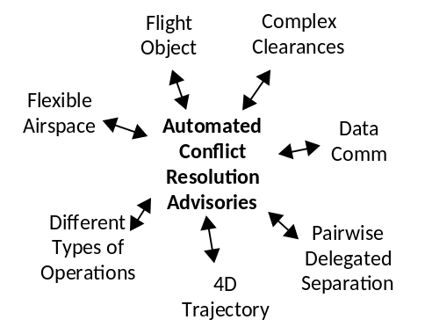
Figure 2. Interactions of Automated Conflict Resolution Advisories with other Drivers
Below are requirements for the drivers in Figure 2 to accommodate automated conflict resolution advisories.
- Data Comm
  - Capability for conflict resolution advisories automation to enter resolution messages directly into Data Comm
- Capability to view when a message related to conflict resolution advisories has not been closed by the flight deck
- Complex Clearance
  - Automation that generates complex conflict resolution advisories needs to be compatible with general automation that generates and allows controller to review and accept complex clearances for other purposes
- Pairwise Delegated Separation
  - Automation that generates resolutions involving aircraft in pairwise delegated separation.
  - Automation monitors spacing conformance between pair and notifies controller and pilot of trailing aircraft if spacing is not maintained. Suggests resolutions.
- Flexible Airspace
  - Conflict resolution advisory automation needs to notify proper controller during dynamic airspace reconfiguration, ensure that maneuvers are consistent with new airspace configuration, be transferred to correct ATC position when transferring display and control of aircraft, identify and apply protocol for notifying controller of incomplete maneuvers not executed by pilot when transferring display and control of aircraft
- 4D Trajectory
  - Able to use a 4-D trajectory as input when performing trial planning
  - Able to generate a 4-D trajectory for a conflict resolution advisory
  - Ability for automation to identify and display aircraft equipage necessary to meet 4-D trajectory
- Flight Object
  - Capabilities for conflict resolution advisories automation to access information in flight object including current intended trajectory, aircraft and flight crew capabilities, and user preferences
  - Capabilities to automatically update information in flight object with reroute from selected conflict resolution advisory

- Different Types of Operations
  - Conflict resolution advisory automation needs to check that aircraft equipage and crew capabilities are appropriate to execute resolutions designed for a particular airspace
  - Conflict resolution advisory automation needs to be used easily with other DSTs (have same look and feel and user interface).

Benefit Creating Mechanism for Automated Conflict Resolution Advisories
In performing soft systems analysis, there has been an emphasis on understanding how technology and human performance work together to provide the anticipated benefits from a new capability planned under NextGen. This requires understanding the benefits of the new capability and how the benefits are provided. The latter is referred to as the benefit creating mechanism. To understand this mechanism, diagrams were created showing the benefits and the benefit creating mechanism. Figure 3 shows this for automated conflict resolution advisories with complex clearances and Data Comm.

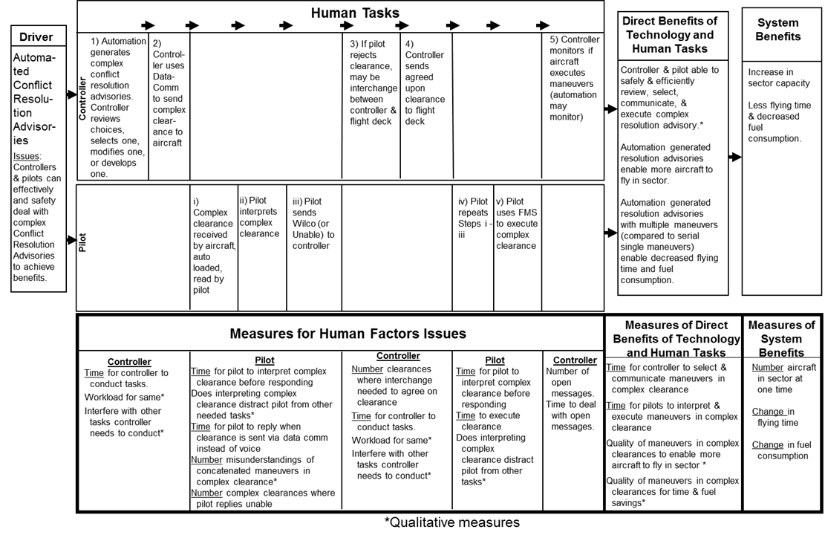
Figure 3. Benefits and Benefit Creating Mechanism for Automated Conflict Resolution Advisories with Complex Clearances and DataCom

Impacts of Automated Conflict Resolution Advisories on Traffic Management Unit and Flight Deck
Figure 1 shows that the analysis approach examined impacts of drivers of en route controller workstation change on the Traffic Management Unit (TMU) and the flight deck. The emphasis of the analysis was on the en route controller and workstation; however, any requirements and issues identified that would affect the TMU or flight deck were documented. One issue identified for the TMU concerns interactions of any automated conflict resolution advisories being generated after the TMU generates a traffic management initiative (TMI) containing flight-specific trajectories. One of the FAA Operational Improvements concerns TMU automation generating TMIs with individual flight-specific trajectories that will be disseminated for tactical approval and execution. An issue is that if any conflict resolutions are generated and executed after the TMI is generated, will TMI flight-specific trajectories still be valid.
One issue for the flight deck is the time for the pilot to review and understand a complex clearance and reply to the controller. This time will influence whether the resolution remains appropriate. Another flight deck issue is that if the pilot receives a complex clearance and finds part of the clearance acceptable but another part unacceptable, the pilot will need to reply Unable for the whole clearance. Further coordination between the pilot and controller would likely be necessary.

Concluding Observations
Future ATC/ATM under NextGen will have more automated DSTs, Data Comm for communication of complex clearances, a greater variety of operations, more shared information, more user requests, and more flexibility to change operations and airspace structures. These will likely result in major changes to NAS operations.
The success of these ATM/ATC enhancements to the NAS depends on performing systems engineering, and also applying an approach, such as soft systems analysis, to assure that technology and human performance are addressed as co-partners in obtaining benefits. While soft systems analysis has only been covered for technology and human performance in this paper, this approach can go beyond these aspects to cover a range of development and implementation considerations. Examples of other topics include: risks of successful development and operation of the concept; feasibility of designing the concept to provide its desired benefits; implementation issues; acceptability by users and stakeholders; likelihood of obtaining funding; and realism of benefit and cost estimates.

Acknowledgements
This work is funded by the Human Factors Research and Engineering Group (AJP-61) within the Federal Aviation Administration (FAA). The authors would like to thank Paul Krois (Manager, AJP-61), Dino Piccione (Technical Lead, Air Traffic Human Factors), and Barbara Wilper (Technical Specialist, Air Traffic Human Factors) for their guidance and support to this work.
In addition to the authors, the mid-term en route workstation team includes: Judith Burki-Cohen, Kim Cardosi, Tracy Lennertz, and Alan Yost from the Volpe Center; and Jeffrey Henderson, Husni Idris, and Zahra Khan from Engility Corporation.
The authors would like to thank Mary Stearns from the Volpe Center for providing valuable comments on the paper.

Disclaimer
The information in this paper is the personal opinion of the authors and does not represent the official views of the FAA.

Email Addresses
Email addresses of the authors are:
poage@post.harvard.edu
caroline.donohoe@dot.gov
jonathan.lee@dot.gov
Please contact Jonathan T. Lee for any additional information about the project.
30th Digital Avionics Systems Conference
October 16-20, 2011

