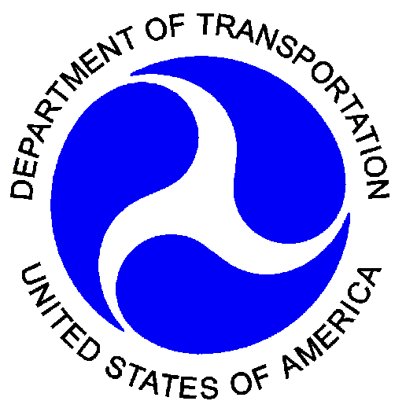
U.S. Department  of Transportation | Water Transportation Planning for Eastern Massachusetts: A Strategic Assessment of Passenger Ferry Services
Research and
Special Programs
Administration

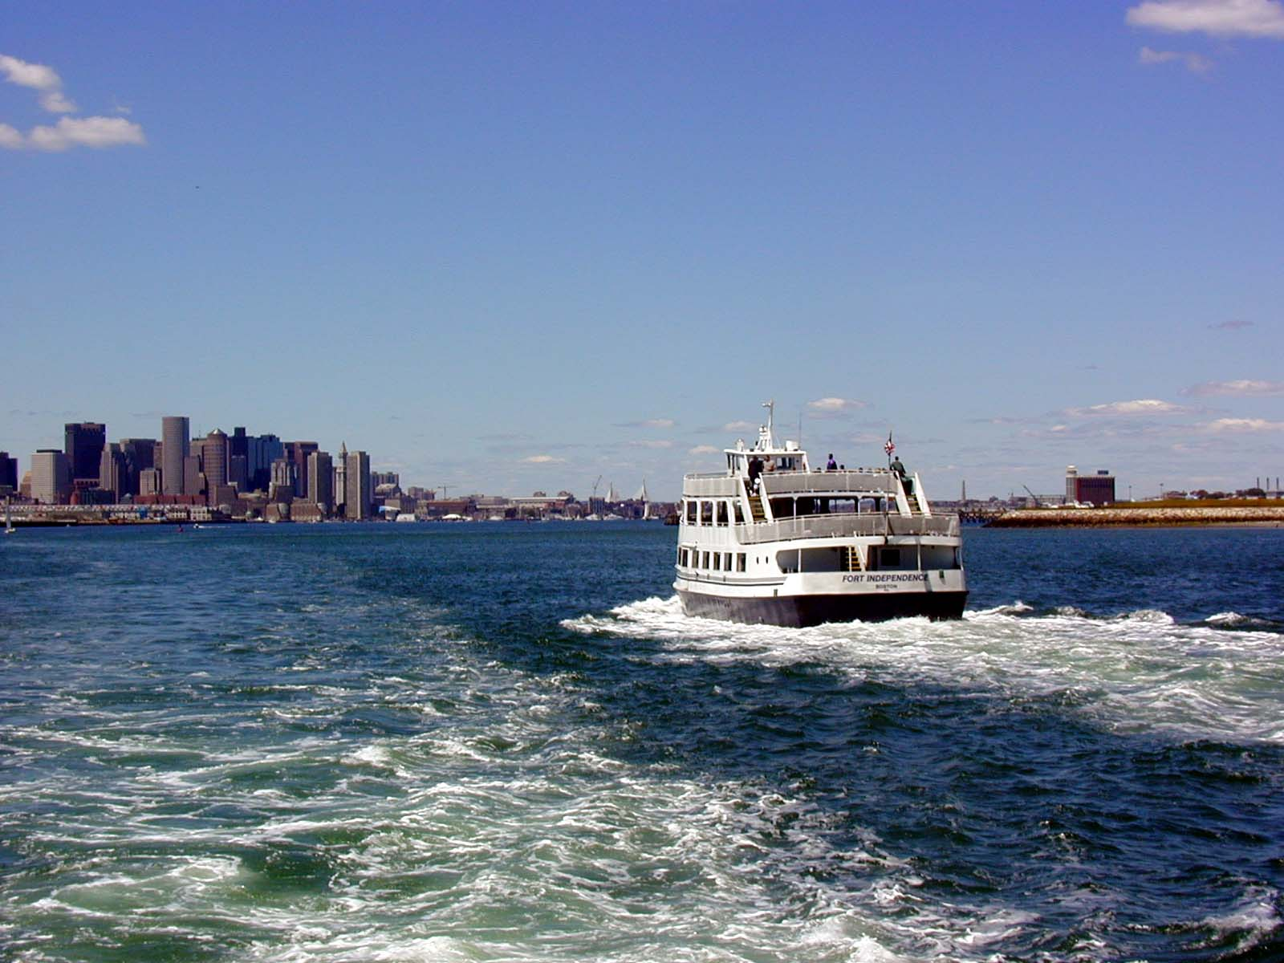

Prepared for:
Commonwealth of Massachusetts  Executive Office of Transportation and Construction | Boston, Massachusetts

Prepared by:
U.S. Department of Transportation  Research and Special Programs Administration  John A. Volpe National Transportation Systems Center | Cambridge, Massachusetts  March 2003

Water Transportation Planning for Eastern Massachusetts: A Strategic Assessment of Passenger Ferry Services

Michael G. Dyer, Eric J. Plosky, and Deirdre P. Carrigan (Volpe Center)
Charles R. Norris, Norris and Norris Associates
Clinton Bench, Vijay Majal, and Alicia Wilson (Central Transportation Planning Staff)

March 2003

Prepared by

U.S. Department of Transportation
Research and Special Programs Administration
John A. Volpe National Transportation Systems Center

Prepared for

The Commonwealth of Massachusetts
Executive Office of Transportation and Construction
NOTICE

Neither the United States Government nor any agency thereof, nor any of their employees, makes any warranty, express or implied, or assumes any legal liability or responsibility for the accuracy, completeness, or use of any information, apparatus, product, or process disclosed. Reference herein to any specific commercial product, process, or service by trade name, trademark, manufacturer, or otherwise, does not necessarily constitute or imply its endorsement, recommendation, or favoring by the United States Government or any agency thereof. The views and opinions of authors expressed herein do not necessarily state or reflect those of the United State Government or any agency thereof.

REPORT DOCUMENTATION PAGE |  |  |  |  |  | Form Approved  OMB No. 0704-0188
Public Reporting burden for this collection of information is estimated to average 1 hour per response, including the time for reviewing instructions, searching existing data sources, gathering and maintaining the data needed, and completing and reviewing the collection of information. Send comment regarding this burden estimates or any other aspect of this collection of information, including suggestions for reducing this burden, to Washington Headquarters Services, Directorate for information Operations and Reports, 1215 Jefferson Davis Highway, Suite 1204, Arlington, VA 22202-4302, and to the Office of Management and Budget, Paperwork Reduction Project (0704-0188,) Washington, DC 20503.
1. AGENCY USE ONLY (Leave Blank) |  | 2. REPORT DATE  March 2003 |  | 3. REPORT TYPE & DATES COVERED
4. TITLE AND SUBTITLE  Water Transportation Planning for Eastern Massachusetts: A Strategic Assessment of Passenger Ferry Services |  |  |  |  | 5. FUNDING NUMBERS
6. AUTHORS
Michael G. Dyer, Eric J. Plosky, and Deirdre P. Carrigan (Volpe Center); Charles R. Norris (Norris and Norris Associates); Clinton Bench, Vijay Majal, and Alicia Wilson (Central Transportation Planning Staff, Metropolitan Area Planning Commission)
7. PERFORMING ORGANIZATION NAME(S) AND ADDRESS(ES)  U.S. Department of Transportation  Research and Special Programs Administration  John A. Volpe National Transportation Systems Center  55 Broadway  Cambridge, MA 02142 |  |  |  |  | 8. PERFORMING ORGANIZATION REPORT NUMBER
9. SPONSORING/MONITORING AGENCY NAME(S) AND ADDRESS(ES)  Commonwealth of Massachusetts  Executive Office of Transportation and Construction  10 Park Plaza  Boston, Massachusetts 02116 |  |  |  |  | 10. SPONSORING AGENCY REPORT NUMBER
11. SUPPLEMENTARY NOTES

12a. DISTRIBUTION/AVAILABILITY |  |  |  |  |  | 12b. DISTRIBUTION CODE
13. ABSTRACT
A group of existing, proposed, and potential ferry services is the subject of a comprehensive assessment to assist the strategic planning process of the Commonwealth of Massachusetts for its future transportation system. The Volpe Center developed a tool for scoring all of the relevant factors for ferry service, including terminal and infrastructure, access, intermodal connectivity, navigational and operational matters, and environmental concerns. In addition, the assessment accounts for the costs of running the ferry services, and the anticipated passenger demand (per the analysis of the Central Transportation Planning Staff of the Boston Metropolitan Planning Organization). The result is a framework for addressing new services and service enhancements for use by the Commonwealth’s transportation decision makers.
14. KEY WORDS  Alternate transportation, ferry, bicycle, Massachusetts, MPO, EOTC |  |  |  |  |  | 15. NUMBER OF PAGES
 |  |  |  |  |  | 16. PRICE CODE
SECURITY CLASSIFICATION OF REPORT  None | SECURITY CLASSIFICATION OF THIS PAGE  None |  | SECURITY CLASSIFICATION OF ABSTRACT  None |  |  | LIMITATION OF ABSTRACT
NSN 7540-01-280-5500 |  |  | Standard Form 298 (Rev. 2-89)  Prescribed by ANSI Std. 239-18  298-102

Acknowledgements
The authors wish to thank the numerous organizations and individuals who graciously provided their time, knowledge and guidance in the development of this report. Our sponsors, Astrid C. Glynn and Todd M. Fontanella of EOTC, have been particularly supportive. Jeffrey Bryan of Volpe Center also deserves our thanks for his tenacious efforts to foster this new transportation partnership. Finally, we thank the stakeholders who contributed so greatly to our understanding of the water transport issues. Maurice Freedman and Jay Spence are the co-chairs of the Water Transportation Advisory Council, and they graciously allowed us to work through the Council to organize a Focus Group of operators, government agencies, and public interest groups to address many facets of operations and policy for inclusion in this report. The Focus Group was:

Rick Armstrong, Seaport Adv. Council (North Shore)
Alice Boelter, Boelter & Associates, Inc.
Sharna Small Borsellino, MBTA
Kristine Cheetham, Consultant North Shore
Mo Freedman, Pressley Associates
Michael Glassfeld, Bay State Cruises
Andrew Hargens, MassPort
Diane Haynes, Department Environmental Management
Rosemary Heard, Massachusetts Development Finance Agency
Tom Humphrey, Central Transportation Planning Staff
Ben Kelly, Save the Harbor
Ron Killian, Central Artery Project
Isabel Kriegel, Boston Redevelopment Authority
Peter Lewenberg, Executive Office of Environmental Affairs
Mike McGurl, Harbor Express
Jane Meade, Coastal Zone Management
Rick Nolan, Boston Harbor Cruises
George Price, National Park Service
Patrick Reffet, Design Consultants
Marty Reilly, Hy-Line
Murray Scudder, Hy-Line
Jay Spence, Massachusetts Bay Lines
Denise Sullivan, City of Salem
Kristin Decas, Massachusetts Seaport Advisory Council
Greg Ketchen, City of Gloucester
Jack Wiggin, Urban Harbor Institute-University of Massachusetts

Table of Contents

Executive Summary
- Introduction
  - Purpose of Report
  - EOTC Objectives
  - Project Partnership Team
  - Organization of Report
- Background
  - Description of Region
  - Eastern Massachusetts Transportation System
    - General Description
    - Ferry Services
    - Previous Initiatives and Relevant Studies
- Approach
  - General
  - Partnership Roles
    - Volpe Center
    - CTPS
    - Norris & Norris
  - Analytical Framework
    - Use of Focus Group
      - Purpose
      - Execution
    - Service Assessment Tool
      - Identification and Logic of Categorical Evaluation Elements
        - Policy
        - Feasibility
        - Demand estimation
        - Finances
      - Scoring
    - Candidate Ferry Services
      - Selection process
      - Descriptors of selected services
    - Service assessment process
      - Data acquisition
      - Field work
- Selection of Ferry Services for Assessment
  - WTAC focus group
  - Decision
- Assessment: Inner Harbor Services
  - General Characteristics and Guidelines
    - Operating area description
    - Similar services
    - Transportation policy choices
    - Vessel options
  - Russia Wharf to Pier 4/Navy Yard, with Long Wharf Combination Option
    - Characterization
      - Route and service area
      - Schedule and vessels
      - Terminal infrastructure
    - Field Work
    - Service Assessment
      - Maturity evaluation
      - Categorical evaluation
        - Policy
        - Feasibility
        - Demand estimation
        - Finances

    - Summary
  - Lovejoy Wharf, World Trade Center/Fan Pier
    - Characterization
      - Route and service area
      - Schedule and vessels
      - Terminal infrastructure
    - Field Work
    - Service Assessment
      - Maturity evaluation
      - Categorical evaluation
        - Policy
        - Feasibility
        - Demand estimation
        - Finances

    - Summary
  - Summary Findings and Recommendations
- Assessment: Outer Harbor Services
  - General Characteristics and Guidelines
    - Operating area description
    - Similar services
    - Transportation policy choices
    - Vessel options
  - Quincy- Hull - Long Wharf - Logan Airport
    - Characterization
      - Route and service area
      - Schedule and vessels
      - Terminal infrastructure

    - Field Work
    - Service Assessment
      - Maturity evaluation
      - Categorical evaluation
        - Policy
        - Feasibility
        - Demand estimation
        - Finances
    - Summary
  - Summary Findings and Recommendations
- Assessment: Massachusetts Bay Services
  - General Characteristics and Guidelines
    - Operating area description
    - Similar services
    - Transportation policy choices
    - Vessel options
  - Salem to Boston service
    - Characterization
      - Route and service area
      - Schedule and vessels
      - Terminal infrastructure

    - Field Work
    - Service Assessment
      - Maturity evaluation
      - Categorical evaluation
        - Policy
        - Feasibility
        - Demand estimation
        - Finances

    - Summary
  - Lynn to Boston service
    - Characterization
      - Route and service area
      - Schedule and vessels
      - Terminal infrastructure

    - Field Work
    - Service Assessment
      - Maturity evaluation
      - Categorical evaluation
        - Policy
        - Feasibility
        - Demand estimation
        - Finances

    - Summary
  - Scituate to Boston service
    - Characterization
      - Route and service area
      - Schedule and vessels
      - Terminal infrastructure

    - Field Work
    - Service Assessment
      - Maturity evaluation
      - Categorical evaluation
        - Policy
        - Feasibility
        - Demand estimation
        - Finances

    - Summary
  - Sandwich to Boston service
    - Characterization
      - Route and service area
      - Schedule and vessels
      - Terminal infrastructure

    - Field Work
    - Service Assessment
      - Maturity evaluation
      - Categorical evaluation
        - Policy
        - Feasibility
        - Demand estimation
        - Finances
    - Summary
  - Summary Findings and Recommendations
    - North Shore
    - South Shore
- Recommendations
- Process Findings
  - Assessment Tool
  - Finance Analysis and Results
  - Demand Analysis
Figures
  - Assessment Tool Schematic
  - Overall Categorical Scoring Scheme

  - The Port Imperial, Weehawken NJ-Wall Street Terminal, Pier 11 NY Services
  - Boston Inner Harbor Routes
  - Russia Wharf – Navy Yard Route and Catchment Areas
  - Russia Wharf – Navy Yard – Long Wharf Route and Catchment Areas
  - Lovejoy Wharf - WTC Route and Catchment Areas

  - Harbor Bay Maritime Alameda – San Francisco Service
  - Quincy – Hull – Long Wharf – Logan Airport Route and Quincy Catchment Area

  - Seattle-Bremerton (Passenger-Only) Service
  - Massachusetts Bay Services
  - Aerial Photograph, Lynn Waterfront

Tables

  - Maturity Evaluation Result
  - Terminal Infrastructure Needs by Geographic Area
  - Sample Schedule and Operating Data

  - Vessel Specifications, Inner Harbor Services
  - General Specifications, Russia Wharf – Navy Yard Service
  - Vessels and Schedules, Russia Wharf – Navy Yard Service
  - Terminal Infrastructure Status and Needs, Russia Wharf – Navy Yard Service
  - Assessment Tool “Policy” Summary, Russia Wharf – Navy Yard
  - Assessment Tool “Feasibility” Summary, Russia Wharf – Navy Yard
  - Annual Vessel Operating Costs, Russia Wharf – Navy Yard
  - Annual Vessel Debt Service Payments and Operating Costs Attributable to Commuter Service, Russia Wharf – Navy Yard
  - Assessment Tool “Finances” Summary, Russia Wharf-Navy Yard
  - Assessment Summary, Russia Wharf-Navy Yard
  - General Specifications, Lovejoy Wharf – WTC/Fan Pier Service
  - Schedule and Vessels, Lovejoy Wharf – WTC/Fan Pier Service
  - Terminal Infrastructure Status and Needs, Lovejoy Wharf – WTC – Fan Pier – Courthouse Service
  - Assessment Tool Policy Summary, Lovejoy Wharf – World Trade Center – Fan Pier – Courthouse Service
  - Assessment Tool Feasibility Summary, Lovejoy Wharf – World Trade Center – Fan Pier – Courthouse Service
  - Annual Vessel Operating Costs, Lovejoy Wharf – World Trade Center or Fan Pier Service
  - Assessment Summary, Lovejoy Wharf – World Trade Center – Fan Pier – Courthouse Service

  - General Specifications, Quincy – Hull – Boston – Logan Airport Service
  - Vessels and Schedules, Quincy – Hull – Long Wharf – Logan Airport Service
  - Terminal Infrastructure Status and Needs, Quincy – Hull – Boston – Logan Airport Service
  - Assessment Tool “Policy” Summary, Quincy – Hull – Boston – Logan Airport Service
  - Assessment Tool Feasibility Summary, Quincy – Hull – Boston – Logan Airport
  - Annual Vessel Operating Costs, Quincy Service
  - Annual Vessel Debt Service Payments and Operating Costs Attributable to Commuter Service, Quincy Service
  - Assessment Tool “Finances” Summary, Quincy Service
  - Assessment Summary, Quincy Service

  - General Specifications, Salem – Boston Service
  - Vessels and Schedules, Salem – Boston Service
  - Terminal Infrastructure Status and Needs, Salem – Boston Service
  - Assessment Tool Policy Summary, Salem – Boston
  - Assessment Tool Feasibility Summary, Salem – Boston
  - Annual Vessel Operating Costs, Salem – Boston Service
  - Assessment Summary, Salem – Boston Service
  - General Specifications, Lynn – Boston Service
  - Vessels and Schedules, Lynn – Boston Service
  - Terminal Infrastructure Status and Needs, Lynn – Boston Service
  - Assessment Tool Policy Summary, Lynn – Boston
  - Assessment Tool Feasibility Summary, Lynn – Boston
  - Annual Vessel Operating Costs, Lynn – Boston Service
  - Annual Vessel Debt Service Payments and Operating Costs Attributable to Commuter Service, Lynn – Boston Service
  - Assessment Tool “Finances” Summary, Lynn – Boston Service
  - Assessment Summary, Lynn – Boston Service
  - General Specifications, Scituate – Boston Service
  - Vessels and Schedules, Scituate – Boston Service
  - Terminal Infrastructure Status and Needs, Scituate – Boston Service
  - Assessment Tool Policy Summary, Scituate – Boston
  - Assessment Tool Feasibility Summary, Scituate – Boston
  - Annual Vessel Operating Costs, Scituate – Boston Service
  - Annual Vessel Debt Service Payments and Operating Costs Attributable to Commuter Service, Scituate-Boston Service
  - Assessment Tool Finances Summary, Scituate – Boston Service
  - Assessment Summary Scituate-Boston Service
  - General Specifications, Sandwich – Boston Service
  - Vessels and Schedules, Sandwich – Boston Service
  - Terminal Infrastructure Status and Needs, Sandwich – Boston Service
  - Assessment Tool Policy Summary, Sandwich – Boston
  - Assessment Tool Feasibility Summary, Sandwich – Boston
  - Annual Vessel Operating Costs, Sandwich – Boston Service
  - Assessment Summary, Sandwich – Boston Service

  - Assessment Summary, All Services

Appendices
A Focus Group Activities
B Assessment Tool, Blank Version
C Similar Services Surveys
D Russia Wharf, Pier 4/Navy Yard Data, Results
E Lovejoy Wharf, World Trade Center, Fan Pier Data, Results
F Quincy – Hull – Boston – Logan Airport Service Data, Results
G Salem – Boston Service Data, Results
H Lynn – Boston Service Data, Results
I Scituate – Boston Service Data, Results
J Sandwich – Boston Service Data, Results
ACRONYMS

ADA Americans with Disabilities Act

BECO Boston Edison Company

BHC Boston Harbor Cruises

BIHPWTP Boston Inner Harbor Passenger Water Transportation Report

BRA Boston Redevelopment Authority

CAANA Central Artery North Area

CA/T Central Artery/Tunnel
COI Certificate of Inspection
CTPS Central Transportation Planning Staff
DEM Department of Environmental Management
EOEA Executive Office of Environmental Affairs
EOTC Executive Office of Transportation and Construction
EPA U.S. Environmental Protection Agency
FEIR Federal Environmental Impact Report
GSA Federal General Services Administration
MAAB Massachusetts Architectural Access Board
MAPC Metropolitan Area Planning Council
MBTA Massachusetts Bay Transportation Authority
MDC Metropolitan District Commission
MLW Mean low water
MPO Metropolitan Planning Organization
MWRA Massachusetts Water Resource Authority
NOAA National Oceanic and Atmospheric Administration
SNAME Society of Naval Architects and Marine Engineers
TAZ Traffic Analysis Zone
VMT Vehicle miles traveled
WTC World Trade Center (Boston)
WTAC Water Transportation Advisory Council

Executive Summary
A group of existing, proposed, and potential ferry services are the subject of a comprehensive assessment to assist the strategic planning process of the Commonwealth of Massachusetts for its future transportation system. The Volpe Center developed an Assessment Tool for scoring all of the relevant factors for ferry service, including terminal and infrastructure, access, intermodal connectivity, navigational and operational matters, and environmental concerns. In addition, the assessment accounts for the costs of running the ferry services, and the anticipated passenger demand (per the analysis of the Central Transportation Planning Staff of the Boston Metropolitan Planning Organization). The Tool also rates the maturity of service proposals and concepts through a series of questions on the planning process, financial prospects, and implementation schedule.
The results are a prioritized ranking of new and proposed services and service enhancements for use by the Commonwealth’s decision makers. The Assessment Tool was useful in this context, even with little or no information available for some services. It should be more useful in the future in cases where more fully detailed proposals are submitted. Its spreadsheet format allows easy modification of technical elements and weightings by Commonwealth transportation staff.
The project included the organization and conduct of a Focus Group meeting, including operators, port and harbor managers, and other stakeholders, for the purpose of eliciting information and data. The Group conducted an initial screening of candidate ferry services as the project’s first step towards focusing on the most viable proposals. They also identified and helped to prioritize policy issues for consideration in the service assessment, and offered valuable insight for the structuring of its technical and economic portions.
Table E-1 shows the summary scoring for all the services considered. The specific technical findings appear in Chapters 5, 6, and 7 and are not repeated here. This summary is limited to a strategic overview and individual route and service recommendations.
Strategic Outlook
The two Inner Harbor routes examined were Russia Wharf – Navy Yard and Lovejoy – South Boston Waterfront. These are important because they would add core capacity to Boston’s transit system and significantly improve service for underserved origins and destinations by providing shuttle connections from North and South Stations to cross harbor destinations. They would also provide important services for tourist and recreational users during off peak and weekend hours. These services measure up financially to other transit modes fairly well and can be particularly attractive because the infrastructure costs are relatively quite low.
Quincy – Boston, the only “Outer Harbor” service included herein, should be considered one part of a South Shore ferry system functioning within the overall transit system. Expansion to a four boat service has potential, when integrated with the existing Hingham service and proposed Scituate service, to effectively provide commuting options for underserved communities and add capacity to the system overall prior to implementation of Greenbush. All capital and operating funding support decisions for South Shore services need careful consideration in the context of tradeoffs and collective effectiveness.
The North Shore Massachusetts Bay services examined were Lynn – Boston and Salem – Boston. These differ from the South Shore services because they would operate in cities directly served by MBTA rail transit. The success of either, singly, as a commuter service may depend on the full build out of the South Boston Waterfront and direct service there at fare rates equal to those of other public transit modes.
Service Assessments
Service thumbnails and recommendations follow Table E-1.
Table E-1

Assessment Summary
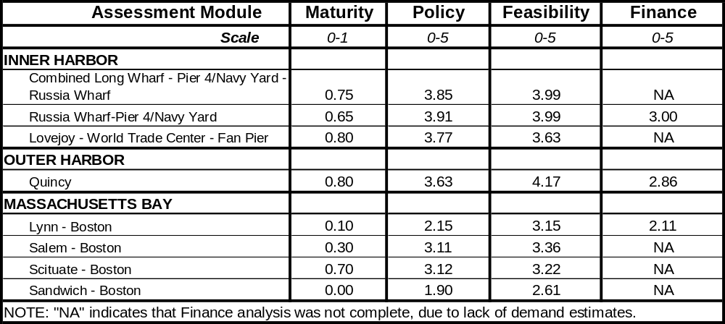
All Services

The individual recommendations are the following:
- Inner Harbor Services
  - Russia Wharf – Navy Yard. High scores for policy and feasibility, and fairly strong for finance. Recommend support for the development of infrastructure and vessel operations.
  - Lovejoy – WTC/Fan Pier. Very strong scores for policy and feasibility. No demand estimate completed for this report. Recommend a focused demand study with the best possible information on the future build-out of the South Boston waterfront, using an improved ferry demand methodology.
- Outer Harbor Services
  - Quincy - Boston. Very strong scores for policy and feasibility. Finance score is fairly strong, especially since there are no capital infrastructure needs. The expansion to four boat service has promise; therefore, the recommendation is that the demand should be studied more carefully in the context of a South Shore ferry and transit system. The ferry demand analysis method needs careful reassessment and calibration, as noted in Chapter 9.
- Massachusetts Bay Services
  - Salem - Boston. Fairly strong scores for policy and feasibility. Recommendation to provide carefully directed support to planning and analysis tasks, only if strong local support and activities are sustained.
  - Lynn – Boston . Modest scores for policy and finance, fairly strong for feasibility, although lower than Salem’s. Recommendation that support receive lower priority until local public support and planning commence.
  - Scituate - Boston. Fairly strong candidate, with good financial indicators relative to other public transit modes. Public support for this service should be given strong consideration in the context of prioritizing transportation investments in the South Shore as a whole.
  - Sandwich – Boston/Provincetown. Very modest candidate at this time, with no planning underway or visible public support. Recommend no action.
Demand Analysis
Demand estimates for three services were generated by the Central Transportation Planning Staff (unit of the Metropolitan Area Planning Commission) computer model. The model’s strength is the prediction of landside demand, mode choice, and assignment, but its application to ferry services should be examined and opportunities for improvement identified.
The issues that arose in this study were: 1) the apparent bias of the model in favor of multi-stop services (e.g., as offered by commuter rail) as opposed to point-to-point service as offered by ferries; 2) lack of data to model the mode preference of many ferry patrons; and 3) results showing zero automobile diversions for the proposed Quincy service, contrary to the evidence of the Hingham ferry and others.
Transportation agencies should consider examination of the transportation model to assess whether modifications can improve demand estimates for specific ferry services.

- Introduction
  - Purpose of Report
The Massachusetts Executive Office of Transportation and Construction (EOTC) has sponsored a collaborative effort of the Volpe Center and the Boston Metropolitan Area Planning Council (MAPC) to complete a water transportation study and, in doing so, to develop a planning tool for future use by EOTC. The study provides an assessment of existing, proposed, and other potential ferry services in eastern Massachusetts and prioritizes these projects for purposes of strategic funding decisions by EOTC. The assessment includes all the factors affecting passenger ferry markets: vessels, routes, terminals, and intermodal connections, as well as the integration of ferry services into a comprehensive transportation system in the area. The assessment tool delivered to EOTC will enable continued development of an effective water transportation program in the future.

  - EOTC Objectives
The Executive Office of Transportation and Construction (EOTC) has been working with a variety of stakeholders to develop water transportation services and facilities in the Commonwealth of Massachusetts (“the Commonwealth”). The Commonwealth is committed to developing and expanding ferry service throughout Boston Harbor and along its coastline, both to ease transportation headaches for commuters as well as to link tourists with downtown Boston destinations. Ferry service has emerged as a viable commuter transportation option for some communities in response to highway congestion and the Central Artery/Tunnel construction. Because of the success of ferry operations along coastal Massachusetts, the Commonwealth has seen a large increase in requests to enhance existing service or to create new service. However, unlike the highway and transit modes, water transportation in Massachusetts, as in many states, has not had the benefit of systematic planning and implementation. As a result, Massachusetts is seeking a strategic process to evaluate requests for new water transportation funding against anticipated future market demand and desired routes.
The scope of work for this study supports those needs and includes elements of a market analysis, technical, cost, and policy analyses of routes and services, and recommendations of routes and services with the best potential for success. EOTC receives a product including comparative assessments of current existing and proposed services and a tool for future similar service assessments. This report and the assessment tool will support strategic investment decisions by the Commonwealth in the near term and further into the future.

  - Project Partnership Team
EOTC has fostered a partnership of collaborative consultation between the Volpe Center and the MAPC, engaging in particular the latter’s Central Transportation Planning Staff (CTPS). Generally speaking, CTPS and the Volpe Center address the “demand” and “supply” issues, respectively. The Volpe Center has investigated the technical, cost, and policy aspects of the candidate ferry services, and provided the pertinent descriptors to CTPS for their development of demand calculations.
  - Organization of Report
Chapter 2 provides a general description of the area of interest (eastern Massachusetts) and its “global” transportation system, i.e., the network comprising all available modes of transportation and the role of ferry services within that greater whole. Chapter 3 describes the approach to the problem, elaborates the roles of the partners in the project, and details all the steps in the development of the assessment methodology and tools, as well as the execution of the study. Chapter 4 recounts the identification and selection of candidate services for the study. Chapters 5, 6, and 7 contain the service assessments by area, i.e., Inner and Outer Boston Harbor and Massachusetts Bay. Chapter 8 summarizes the findings of the report.

- Background

  - Description of Region
This scope of study includes ferry services in eastern Massachusetts, defined for these purposes as the coast from the New Hampshire border south to the Cape Cod Canal and Cape Cod waters on the Massachusetts Bay side only from the Canal to Provincetown. Waters south of Cape Cod, including Martha’s Vineyard and Nantucket, are not in the scope of this study.
Massachusetts Bay is generally defined by the eastward and northward sweeps of Cape Cod and the eastern shore of “mainland” Massachusetts from the Cape Cod Canal on the south to the easternmost point of Cape Ann (Eastern Point, Gloucester) in the north. Coastal Massachusetts waters north of Cape Ann, lying off Ipswich, Plum Island and Newburyport, are designated Ipswich Bay.
Boston is the hub of the waterway, the capital city and population center lying at the transect of the two diagonals of the North and South Shores. It is also the largest natural harbor in the State, with major shipping channels laid out through the approaches defined by the Harbor Islands.
  - Eastern Massachusetts Transportation System
    - General Description
Boston is also the hub of the entire transportation system in eastern Massachusetts, including the roads, rail service, air transport, subways, and ferry operations. As in most cities, the lion’s share of transportation funding and improvements have been in roadway and airport projects, while subway and bus services have accounted for most public passenger transportation expenditures.
    - Ferry Services
Boelter (1997), among others, gives an excellent account of the history of ferry services in the area of interest, from sailing and oared vessels to the modern arrival of high speed catamarans. Roadway congestion and the rising costs and difficulties of expanding landside transportation have renewed the interest of public transportation agencies and other policy makers in ferry services.
Current ferry services include year round operations from Hingham and Quincy to Boston, several shuttle services in Boston Harbor and seasonal services from both Boston and Gloucester to Cape Cod. These serve, variously, commuter and recreational markets and also provide point specific service to Logan Airport from Quincy and downtown Boston. The current services are discussed in detail in the relevant sections of the report.
    - Previous Initiatives and Relevant Studies
This report follows several important regional studies which have addressed transportation needs and opportunities for ferry services. These have been instrumental in shaping policy and laying the foundation of technical understanding of the issues unique to water transportation. They are:
- Boston Harbor Water Transportation Plan, 2000 (TAMS et al)
- Massachusetts Ferry Project, August 1997 (Boelter et al)
- Boston Inner Harbor Water Transportation Study, 1994 (TAMS et al)
- Cape Cod Marine Transportation Feasibility Study, 1994 (Cape Cod Commission et al)
There are also a number of feasibility studies and service proposals more narrowly focused on individual ports or services. Many of these have been submitted to the Commonwealth for consideration for grant programs through the EOTC, and are, in fact, the basis (as cited herein) for selection for analysis of some of the services.

- Approach

  - General
The approach agreed upon was one of collaborative consultation to provide EOTC with the information needed for near term strategic decision making, and the tools to evaluate future water transportation proposals. EOTC arranged the project as a partnership between the Volpe Center and MAPC’s Central Transportation Planning Staff (CTPS), and the Volpe Center added technical support from transportation planners with extensive knowledge of local water transportation issues. The result appearing here is an assessment of ferry system prospects in 2003 and the enhancement of EOTC’s internal resources for the analysis of water transportation systems, considered both as a form of public transit and as part of a regional transportation plan.
It was necessary to develop an efficient means to execute the task, as it involved a large number of ferry routes and services (actual numbers here) and a coordinated effort involving CTPS, a technical services contractor (Norris & Norris), and several internal Volpe Center personnel from different groups. The scope did not allow for customer survey work, the generation of large amounts of new data, or in-depth analysis. Rather, the Volpe Center developed an assessment tool addressing the policy, economics, and technical elements of each service, including ferry vessel operations and economics, navigation, safety, terminal and infrastructure, ADA access, intermodal connections, and rough estimates of capital improvement requirements. The tool also integrates the demand results imported from CTPS.
The analytical output is the quantified relative “efficacy” scores generated by the assessment tool, written summations of the work, and an overall strategic assessment of ferry services as an integral part of the eastern Massachusetts transportation system. The final product characterizes candidate services as high, medium, or low priorities for support by EOTC.
The main points of the project execution were:
- Development of the ferry service assessment tool, with collaboration of CTPS and Norris & Norris, and full review by EOTC.
- Bounding of the scope of the analysis through identification of ferry services of interest, including existing and proposed services, as well as other potential services identified by project staff and EOTC.
- Evaluation of services through site visits and interviews, use of the assessment tool and the Volpe Center ferry economic model (previously developed), results of a demand analysis by CTPS, and the application of professional judgment and experience.
- Preparation of a report to EOTC, with the results of the ferry systems assessment, the outlook for ferry passenger transport as an element of the regional transportation system, and a summary of findings intended to provide strategic planning support to EOTC.
  - Partnership Roles
    - Volpe Center
The Volpe Center provided engineering, transportation systems, and ferry systems expertise, leading, in particular, to a systems approach to the simultaneous analysis of many services. Previous work in ferry market assessments, ferry lines data base development and launch, and many facets of transportation systems, safety, and risk led to this assignment. The Volpe Center ferry economics model provided detailed financial projections for the services under consideration. Volpe Center was also responsible for project management and coordination of all organizations involved.
    - CTPS
CTPS was responsible for demand modeling for the candidate ferry services. Volpe Center provided detailed schedule data (fares, run times, headways, etc.) and CTPS generated demand, mode split, and assignment numbers.
    - Norris & Norris
Norris and Norris (Cambridge, Massachusetts) is a consultant firm offering city planning and ferry systems services, with long experience in the Boston area. The firm provided unique capabilities for carrying out the required assessment of Massachusetts terminals, island docking facilities, and gateway locations. Their more general knowledge of the history of ferry operations in Massachusetts, as well as of ferry systems technical matters, was also of great value.
  - Analytical Framework
EOTC administers an annual grants program for ferry services and, in so doing, must address a wide diversity of both service proposals and policy and program needs defined by the State. As such, the Volpe Center approach began with a very broad scope of inquiry and addressed the necessity of arriving at many answers quickly and effectively, and doing so in a way leading to meaningful results for Commonwealth decision makers. This applied particularly to the development of the service assessment tool, which is arguably the most important product of the project, designed as it is for EOTC’s future decision making.
The Focus Group served both needs, by 1) acting as a consultant on the content and structure of the service assessment tool and 2) helping to identify a spectrum of the ferry services of greatest interest. The assessment tool serves the general purpose of a long term analytical tool for the State and the focused purpose of assessing the seven candidate services herein. The Volpe Center team also conducted site visits and interviews aimed at specific service proposals and reviewed available studies and reports.
    - Use of Focus Group
It was agreed at the December 14th, 2001 meeting of the Water Transportation Advisory Council (WTAC) that the Volpe Center would organize and run a “Focus Group” meeting of operators, port and harbor managers, and other stakeholders for the purpose of eliciting information and data, in support of this study.
      - Purpose
The purpose of the Focus Group was to elicit the input of industry and policy professionals on several technical aspects of the project, and, in so doing, to most effectively harness their time and efforts, and get the best results as a result of group discussions. Such collective discussions would have otherwise been very difficult during the planned project team visits to operators and terminals.
The Focus Group’s work supported several project tasks, including development of the service assessment tool, selection of ferry services for the detailed assessment, and service evaluations data collection. The output was: 1) modified and finalized scoring elements and weightings for the Volpe Center ferry assessment tool; and 2) a finalized list of existing, proposed, and potential ferry services to be included in the report. It was also planned to obtain input from operators on particular cost elements in the Volpe Center ferry economics model; this element was addressed through individual interviews with operators.
      - Execution
The Group was prepared ahead of time with reading and study materials, including the roster of candidate ferry services (existing, proposed, and potential), draft assessment data sheet and scoring regime, and example(s) of the ferry economics model input and output. The group was asked to provide some preliminary input to the Volpe Center ahead of the time of the meeting, e.g., the identity of candidate ferry services not included in the Volpe Center’s roster at that time.
The Group had plenary sessions at the beginning and end of the meeting, which lasted the entire day of January 25, 2002. The first order of business was to reset the agenda, briefly review the process designed to achieve the meeting’s goals, and answer any questions about the background material distributed before the meeting. Volpe Center facilitators ran breakout groups discussing candidate service routes and assessment tool development. The concluding plenary session was for breakout session briefs and discussion, conclusions, and action items.
The meeting and breakout sessions were “scripted” with detailed agendas and lines of questioning to direct discussion and elicit the desired answers. Consensus was the goal in each case, but on some particular questions a majority or supermajority sufficed due to time limitations.
The Volpe Center prepared and distributed draft minutes, which were finalized after a period of time allowed for comments. Project staff also made substantial modifications to the service assessment tool based upon comments at the meeting and distributed the second draft for further input to participants.
A full accounting of the Focus Group’s activities appears in Appendix A.
    - Service Assessment Tool
The assessment tool allows quick (and comparative) address of ferry service proposals and concepts, whether for new services or for enhancements of existing services, at different stages of a proposal's development. The initial version was a single integrated Excel worksheet, mathematically combining scores for all technical, financial, and policy aspects. Following discussion and comment by the Focus Group, the project team decided to parse the tool into four separate modules. They are:
- "Maturity Evaluation", a short series of ordered critical issue questions serving as the means to define the stage of a proposal's advancement (e.g., development of technical aspects, execution of legal requirements, and support of key public agencies). It allows for evaluating a program at any stage of development from rough concept to polished and detailed (and permitted) service proposal;
- "Categorical Evaluation", a more detailed investigation consisting of three modules, which are, in each case and to varying extents, detailed by "strawman" particulars based on "real world" similar service characteristics, because of the lack of relevant data for most of the subject services. The Categorical Evaluation modules (illustrated in Figure 3-1) are:
  - "Policy" is a qualitative assessment of a project's benefits by way of public agencies' goals in transportation, environmental protection, and economic development. The Policy module was developed with close cooperation from EOTC and considerable input from the Focus Group. Its many public interest elements are subjectively scored by the team, and can be re-scored if the sponsoring organization sees fit to do so for reasons of judgment or changing circumstance. Detailed discussion appears below in 3.3.2.1.1.
  - "Feasibility", which measures all technical and operations aspects of ferry operations and infrastructure. This is the most extensively detailed module of the three; detailed discussion appears below in 3.3.2.1.2.
  - “Finance” module includes estimates of all capital and operating expenses, revenue estimates based on the results of CTPS demand analyses, and results in the form of long and short term profit/subsidy measures and assessment of finance arrangements and risk management. Detailed discussion appears below in 3.3.2.1.3 and 3.3.2.1.4. Input to this module includes ferry operations calculations from the Volpe Center ferry economic model, a description of which also appears in 3.3.2.1.4.
The Maturity Evaluation is a measure of the proponents’ progress in the planning process and is a guide for the kind of planning, construction, or operations activities EOTC would best support. It does not weigh into the technical scoring per se, but allows managers to make budget decisions at any one of several stages. That is, favorable categorical scores for immature proposals could lead to financial support for planning and feasibility studies; in the case of a fully developed proposal, the decision would be for funding of construction or operation. Table 3-1 illustrates.
For example, a high-ranking, mature proposal is the most desirable choice for funding and implementation and is therefore of the highest priority. On the other hand, a high-ranking, low-maturity proposal would indicate the need for EOTC funding to develop financial, technical, and environmental feasibility assessments. Then, the service would be re-assessed. If, at this more mature stage, it still scores and ranks highly in the Categorical evaluation, the proposal would merit additional consideration for capital investment . The maturity evaluation is, therefore, a management and planning tool, not a technical tool.
Figure 3-1
Assessment Tool Schematic

Feasibility

Finances

- Capital investment
- Funding plan
(startup, short- & long-term)
- Operating cost
  - Net profit/subsidy
  - Operating margin (%)
  - Profit/subsidy per passenger
  - Profit/subsidy per passenger-mile
- Route
- Boat
- Navigation
- Infrastructure
- Environment

(This section may vary depending on route’s maturity rating)

commutation

DEMAND

incidental
recreational

Policy
- Increased ridership
- Reduced travel time
- Intermodalism
- Cost-effective transport
- Rider satisfaction
- Reduction in auto VMT
- Chapter 91/public access

Related policy goals
- Environmental benefits
- Economic devlpmt.

Table 3-1

Maturity Evaluation Result
Overall Ranking | “Mature” | “Immature”
High (high scores in 3 Categorical modules) | Proposal is high-priority; most promising for implementation | Proposal has good potential, but needs further planning work for implementation
Medium (high scores in 2 Categorical modules) | Proposal is medium-priority | Proposal has some potential; additional work may make it medium-priority
Low (high scores in 1 or 0 Categorical modules) | Lowest priority; proposal is unlikely to be a reasonable choice for implementation | Proposal may have some potential, but will probably end up low-priority

The final assessment product for each proposal includes quantified scores for each module, a companion written assessment (Chapters 5, 6, and 7), and a “high/medium/low” ranking. The ranking is based on the composite score of the Categorical modules, which will be a score of the overall economic, technical, and policy value. Each of the Categorical modules – feasibility, cost, and policy – generates a score from 0 to 5, with 5 being the highest score. High scores (from 3.5 to 5.0) in all three Categorical modules yields an overall Categorical ranking of “high”; high scores in two modules yields a “medium” ranking; high scores in only one or in no Categorical modules yields a “low” ranking. The relative weightings of the modules are as determined through consultation between Volpe Center and EOTC. Relative weightings are important, so as to emphasize the relative importance of the modules in cases where close decisions are necessary.
Generally, the combined Categorical Evaluation score reflects the average of its three modules. It may also be taken as the preponderance of the three (e.g., two "H"s and one "M" would result in an "H" overall). This depends on how the user (e.g., EOTC) decides to weigh the three factors. The example shown in Figure 3.1 is for strong weighting assigned to the Policy outcome (designated by *). Figure 3-1 illustrates this approach with an example where Policy is the most highly weighted element. The dummy numbers shown in the example would result in a high priority ranking, despite the low cost ranking, because of the high scores for Policy and Technical Feasibility.
Figure 3-2

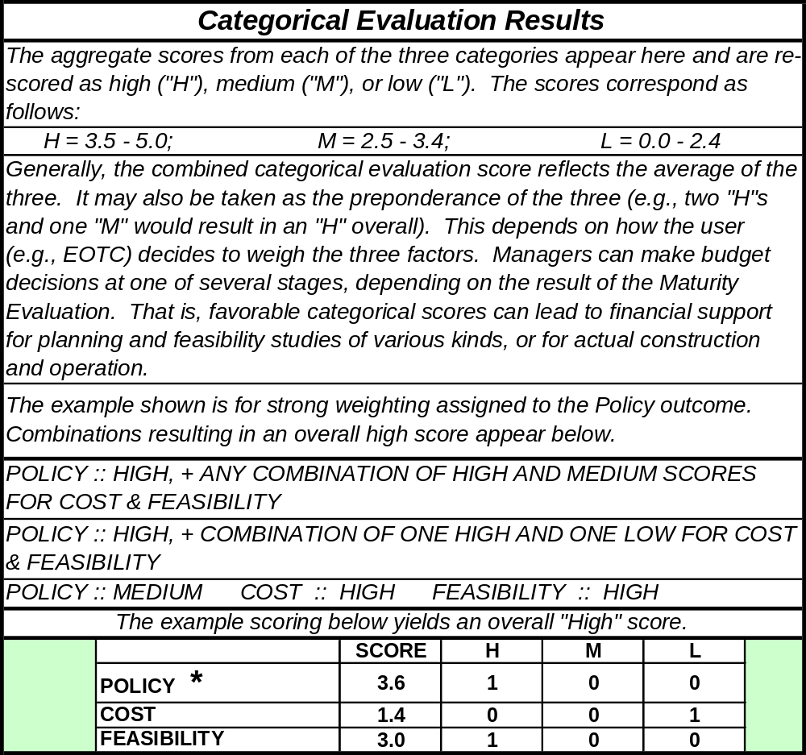
Overall Categorical Scoring Scheme

The Categorical Evaluation modules are to be based on input received from the applicant. This, in many cases, will be incomplete to varying extents, and must be detailed by "strawman" particulars based on real world similar service characteristics. This was the case for most of the services assessed for this report; project staff filled in the blanks based on local knowledge and their experience in ferry systems around the country. This part of the process must be conducted by knowledgeable technical people with a grasp of local ferry transportation issues.
The great benefit of the Tool is its flexibility. Its spreadsheet format allows for easy modification of its constituent elements and, more importantly, of the weightings assigned to each. This ensures the Tool’s usefulness over the long haul, as priorities shift and technological developments change the focus of ferry operations.

      - Identification and Logic of Categorical Evaluation Elements
The Categorical Evaluation modules are the product of several design iterations and the review and comments of both the EOTC and the various members of the Focus Group. The following are detailed descriptions of the three modules.
        - Policy
The "Policy" module was developed with close cooperation from EOTC and the Focus Group. Its many public interest elements were subjectively scored by the team. These are subject to re-examination by EOTC and, if necessary, re-scoring. It addresses the quality of the proposal with respect to the policy goals of the EOTC and related goals of other agencies of the Commonwealth. These were developed through cooperation with EOTC and the input of other Commonwealth agencies participating in the Focus Group. General guiding principles may also be found in the report "Massachusetts Ferry Project" (1997), Chapter 91 legislation, Massachusetts Executive Order #385, and the discussions of the Focus Group.
The Policy module addresses five major transportation themes articulated by the State, and weighted for these purposes as shown parenthetically: mobility (0.4), environment (0.2), access (0.1), economic development (0.2), and emergency planning (0.1). Each theme has a number of questions, themselves weighted. The blank form appears in Appendix B; completed forms for the ferry services assessed herein appear those respective appendices.
        - Feasibility
The feasibility worksheet addresses shoreside infrastructure and route and navigation related matters facing the proponent/operator. The major elements are weighted to include consideration of the comments of the WTAC Focus Group, which felt that “Vessel/Route” (0.4) and “Infrastructure” (0.4) together were the obvious major factors. Environmental management issues (0.2) are also significant, but are secondary to the others. The sub-elements are designed to account for the diversity of services and locations that EOTC is likely to encounter, and will therefore be tailored somewhat on a case-by case basis. Those items deal with the variety of shoreside infrastructure issues found for different terminal types and locations, and are shaded blue in the form.
In addition, "critical" items, those for which a negative outcome may imply high or fatal impact for a project, are shaded red. The only critical item identified at this time is “depth of water” (appears twice, for two terminals), which addresses the possibility of dredging projects requiring environmental review and permitting question. Compliance with applicable safety regulations and construction standards is assumed for both vessels and infrastructure.
The "Feasibility" module's categories and individual elements are weighted (per project team judgment and WTAC Focus Group development and review) and scored (per proposal document review, site visits, and interviews by project team). Discussion of the scoring methodology appears in 3.3.2.2.
The "Feasibility" module's categories and individual elements are weighted (per project team judgment and WTAC Focus Group development and review) and scored (per proposal document review, site visits, and interviews by project team). The Feasibility module includes several critical elements for which a negative finding is termed a "critical flaw", e.g., a dredging issue requiring environmental review and permitting. Financial matters are not directly addressed in the Feasibility module, but "strawman" infrastructure and vessel selections are based on common sense and the idea that essential service and safety standards must be met. The required infrastructure elements are tailored to terminal locations and service type for each proposal.
“Infrastructure” includes “Terminal 1” and “Terminal 2” elements, each with several sections addressing waterside and shoreside matters in some detail. These must be tailored to some extent to meet the circumstances of individual service assessments, i.e., whether or not there are existing assets and what type of facilities are required. The project team developed a table of “standard” infrastructure assets needed for ferry terminals in different areas, e.g., Inner Harbor, outer harbor, Massachusetts Bay (see Table 3-2).
The notional Inner Harbor infrastructure is consistent with the specifications of the Boston Inner Harbor Passenger Water Transportation Plan 2000. The same generally holds true for Outer Harbor and Massachusetts Bay terminals, where the key difference is the requirement for parking facilities. Most differences among terminals will be local variations, for example, an existing wharf rather than a pier at a particular place.
        - Demand estimation
The Central Transportation Planning Staff (CTPS) regional traffic model was used to estimate demand for three of eight alternatives, Russia Wharf to Pier 4/Charlestown Navy Yard, Quincy and Hull to Long Wharf and Logan Airport, and Lynn to Boston. Projected ridership data and service assumptions appear for each service in the relevant sections of Chapters 5, 6, and 7. Daily trip totals refer to the sum of inbound and outbound boardings, for peak weekday commuter hours runs only.
Travel demand was forecast for the year 2010 using a set of computer-based supply and demand models that account for such factors as future study area population, downtown employment and travel time and cost characteristics of the competing highway and transit modes of travel. This set of models was developed at CTPS and has been used extensively over the course of the last few years for a variety of projects. These types of models are used in most large urban areas in North America.
All of Eastern Massachusetts, subdivided into several hundred traffic analysis zones (TAZ), is represented in the model. The model set simulates travel on the entire transit and highway system in the geographic area. As such, it contains all MBTA rail and bus lines, all MBTA boat service, and all private express bus carriers. The model contains service frequency (i.e. how often trains and buses arrive at any given transit stop), routing, travel time, and fares for all these lines. In the highway system, all express highways and principal arterial roadways and many minor arterial and local roadways are included. The outputs of the model set contain detailed information relating to the transportation system. On the highway side, the model output contains traffic volumes, congested travel speeds, vehicle miles traveled, average travel times on the roadway
Table 3-2
Terminal Infrastructure Needs by Geographic Area

Inner Harbor, Outer Harbor, and Massachusetts Bay:

Common Elements
Waterside | Landside
- Dock needs  - Float and berthing  - Ramps/ADA access  - Lighting utilities  - Safety and railings | - Ticketing/sheltered waiting  - Benches  - Wind and sun protection  - Restrooms  - Signage/ITS
- Watersheet  - Channel approach  - Dredging | - Lighting and utilities  - Safety  - Bus/taxi dropoff
- Bulkhead/pier/wharf  - Modifications for ramps  - Stabilization and repair | - Intermodal links  - Commuter rail  - Subway  - Bus  - Ferry  - Bicycle

Outer Harbor, and Massachusetts Bay:

Common Elements
- Parking

links etc. On the transit side, the output provides information relating to the average weekday ridership on different transit sub modes (commuter rail, rapid transit, local buses, express buses, boats, and private carriers), station boardings, park-n-ride demand, peak load volumes etc.
The models are based on the traditional four-step, sequential process known as trip generation, trip distribution, mode choice, and trip assignment. The model set employs sophisticated and involved techniques in each step of the process. The following paragraphs describe very briefly what each step does.

The Four-Step Process
Trip Generation: This is the most important step of the model chain. In this step, the model estimates the number of trips produced in and attracted to each traffic zone. The model uses estimates of projected population, employment and other socioeconomic and household characteristics of that zone to do this. Trips are divided into four major categories, home-based work trips, home-based school trips, home-based other trips and non-home based trips. The trip generation model is run for each trip purpose.
Trip Distribution: The distribution model links the trip ends estimated from trip generation to form zonal trip interchanges or movements between two zones. The output of this second step is a trip table, which is a matrix containing the number of trips occurring between every origin-destination zone combination. Trip distribution is performed for each trip purpose.
Mode Choice: The mode choice model allocates the person trips estimated from the trip distribution step to the two primary competing modes, automobile and transit. This allocation is based on the desirability or utility of each choice a traveler faces, based on the attributes of that choice and the characteristics of the individual. The resulting output of the mode choice model is the percentage of trips that use the automobile and transit for each trip interchange. The transit trips are further divided into two modes of access: walk-access transit trips and drive-access transit trips. The auto trips are further divided into single-occupancy and multiple occupancy trips.
The mode choice model set consists of a model for each of the four trip purposes. The computerized transit and highway networks supply the inputs, transit travel times and costs, highway travel times, and socio-economic data, to the mode choice model.
Trip Assignment: In this final step, the model assigns the transit trips to different transit modes such as subway, commuter rail, local bus, express bus, water ferries etc. The model uses the shortest transit path from one zone to another to accomplish this. This path may involve just one mode such as a local bus or commuter rail or multiple modes such as a local bus and a transfer to the subway line, etc. The highway trips are assigned to the highway network. Thus, the future year traffic volumes on the highways and forecasted transit ridership on different transit lines can be obtained from the model outputs.
Population and employment are key inputs to the demand forecasting process. Those used in this study were obtained from the Metropolitan Area Planning Council (MAPC).
The real cost of parking in downtown was assumed to increase in the future. The models also assume that people in general wish to minimize transfers. They may also wish to minimize travel time even if it costs more.
Preparing the Model for Application
Before applying the model set to a specific study, it is first run and adjusted several times until it replicates the existing highway volumes and transit ridership data at an acceptable level of accuracy. This adjustment is called model calibration. It is usually performed by adjusting the highway and transit access links and travel times from each zone in the study area. Then inputs to the model set for the forecast year are created and the entire model set is run to simulate future year travel.

Model Application

In the current study, the 2010 forecast year transit network was updated by incorporating two new ferry routes and upgrading an existing route. Appropriate market areas were delineated for each route (based on comparable service in the area and/or region) and proper transit and walk access connections were coded. The 2010 network contains the Silver Line Phase II and the AITC (serving the Logan terminals directly).
Using the updated transit network information and other future year model inputs, the entire model set was run. The daily AM (6:30-9:30 AM) and PM (3:30:6:30 PM) peak period transit ridership on each route was obtained directly from the model outputs.
Catchment areas
Catchment areas are defined as “primary” (5 to 7 minute walking radius) and secondary (8 to 12 minute walk) areas. These descriptors have been established by surveys of users in Boston and other U.S. center city ferry settings. The primary area serves the greatest concentration of riders including commuters who are most time sensitive, as well as visitors or other off peak users. The secondary area serves a smaller but still significant group of users including the recreational/discretionary users, who are less time sensitive, as well as more hearty commuters.
        - Finances
The "Finances" module takes account of estimated capital and operating costs and includes data from both the Volpe Center Ferry Economic Model and the CTPS demand analysis. The demand analysis is a ROM estimate based on descriptive operating data for the Volpe Center "strawman" and application of CTPS's global transportation system knowledge and data processing capability.
This portion of the model is aimed at a somewhat detailed financial projection by the proponent and generally favors independent, private funding and potentially profitable operations over those requiring subsidy. Details appear in Appendix B.
The model produces only estimates; it is not an actual cash flow, profit-and-loss, or asset-and-liability statement. Expenses are classified into three mutually exclusive categories of vessel debt repayment, direct operating costs and indirect operating costs. Vessel debt repayment includes principal and interest payments on the portion of the vessel purchase price not funded by the equity investment of the owners. Direct operating costs are defined here as vessel direct operating costs, which are generally considered to include crew costs (in this case deck and engine crew only, excluding passenger service crew), fuel and lubricant costs, hull insurance, and vessel maintenance. Indirect operating costs are defined here as including items that are not included under the direct operating costs category, for example, passenger service crew costs (if applicable), terminal related costs such as passenger facility charges and docking fees, marketing and advertising, and general administration.
In evaluating vessel attributes that affect operator financial performance (e.g., fuel consumption, vessel maintenance, vessel purchase price, etc.), historically observed data were obtained whenever possible from sources such as the current operators of the vessel(s) or operators of similar vessel(s), or vessel designers and shipyards.
Capital expenses/debt service
Operators will bear debt service whether the vessel is new or used. To calculate the debt repayment expense in each of the case studies, unless otherwise specified for a particular scenario, an equal payment amortization schedule is assumed, with a required owner equity (down payment) of 20% of the purchase price, a loan term of 15 years, and a fixed interest rate of 10%. The value of a used vessel is the value as a new vessel, depreciated by 2.3% of the new vessel purchase price annually.
New vessel costs have been derived from regression formulae relating length and cost for several types of passenger vessels, developed by the Volpe Center from market data for a high speed service market study conducted by the Volpe Center for the Office of Naval Research (1999). As points of comparison, project staff used conversations with shipyards (data not attributed herein) and reports in industry publications. The equation for catamarans is:
Purchase price ($) = 1.061 x 1,010 x L^{2.3634}
Where L = meters, and
1.061 is the inflation adjustment from 1999 at 1.5% per year
In this financial analysis, vessel depreciation and/or debt service payments do not figure into the overall route operating cost; that issue is treated separately and discussed for each route in connection with estimated capital investments in terminal facilities and other non-vessel infrastructure.
Labor
Hourly compensation rates by labor function and job classification represent the cost of salaries, wages and benefits (i.e., fully burdened rates). Total expense for this income statement category is therefore a function of the hourly compensation rate by job function and job classification, vessel operating hours or block hours, plus an additional amount of time equal to 25% of vessel operating hours, added to account for labor time required for vessel preparation and vessel turnaround activities. The fully burdened labor rates used were $23.75 per hour for captains, and $11.00 per hour for deck hands.
Consumables
For a specific vessel type, total annual fuel and lubricant expense is a function of total vessel hours by operating mode, fuel consumption rate by operating mode, and the unit fuel and lubricant cost. Fuel consumption at idle is accounted for by assuming that vessel hours at idle are equal to 15% of vessel operating hours or block hours. Purchased in bulk at a wholesale price, the average year-round price per gallon for Diesel No. 2, including all taxes, is taken as $1.00 in 2002. Based on discussion with shipyards and vessel operators, the quantity of lubricant consumed is assumed to be 0.4% of the quantity of fuel consumption, with the unit cost of lubricant assumed to be $8.00 per gallon.
The spreadsheet calculates annual consumption by summing engine operating hours by speed (service, slow, idle), for which the inputs are the route descriptors and schedule particulars.
Maintenance
The maintenance calculation by the ferry economics model is an algorithm based on the new cost of the vessel, the vessels annual operating hours, and its age. This application required a simplified rough-order-of-magnitude calculation, which was addressed as follows:
- The baseline nominal maintenance is found to be 3.5% of the new purchase price of the vessel. The formula developed assigns as fixed 60% of total maintenance expenses. The remainder varies as a proportion of total annual operating hours to nominal hours (the latter is assumed to be 1,000 hours, in which case total maintenance is exactly 3.5% of purchase price). For a vessel operated less than 1,000 hours annually, total maintenance expense is reduced somewhat, and above 1,000 hours, it is increased. Note that the resulting value for vessel maintenance, expressed as a per hour rate, may actually be less for higher operating hours, since although total maintenance expense increases, it increases at a slower rate than do total annual operating hours, resulting in somewhat lower hourly figures for maintenance.
- The formula also accounts for vessel age by increasing annual maintenance expense, as found above, by 2% for each year. For instance, the annual maintenance expense for a ten year old vessel would be 20% more than that for a similar new vessel.
Insurance
Marine hull insurance policies are treated here as "actual cash value" policies, which pay the depreciated value of the vessel, rather than the full replacement value of a new vessel, in the event of a loss. Shipyards, ferry operators, and other feasibility studies suggest that annual marine hull insurance expense is typically between 1% to 3% of the vessel’s value. A value of 2.5% of the vessel value is used here as a reasonable estimate of annual insurance expense. Insurance costs are included in overall route operating costs.
Indirect costs related to passengers
The model, as developed, ties certain indirect costs directly to passenger revenue -- general and administrative costs (estimated at 11% of passenger revenue), advertising and publicity costs (9%), and dockage costs allocated on a per passenger basis ($0.50). Because these costs may be treated differently by operators already engaged in ferry service provision, they are not currently included in the overall operating cost estimates.
Schedule and service hours
Labor, consumables, and maintenance costs are directly related to hours of operation. The model requires input describing the each service and route, i.e., distances at both operating and slow speeds. The analyst also inputs the daily numbers of trips for peak and off-peak weekdays and weekends; if a given vessel is used for other purposes outside commuting times on weekdays, then only the costs attributable to running the commuting service are considered by the model. Table 3-3 shows the input (“Operating Costs” worksheet), the standard multipliers for year round service (“Schedule” worksheet), and the resulting total annual number of one-way trips. That result is the multiplier for operations at service speed, slow speed, idle, and “block” hours (the factor applied for down time between runs).
Demand estimation and revenues
Based on CTPS-provided demand figures for three routes (Russia Wharf-Navy Yard, Lynn-Boston, Quincy-Boston modified), estimated revenues could be calculated and compared to operating expenses in order to yield figures to compare with existing terrestrial transit services (heavy rail and commuter rail).
Table 3-3
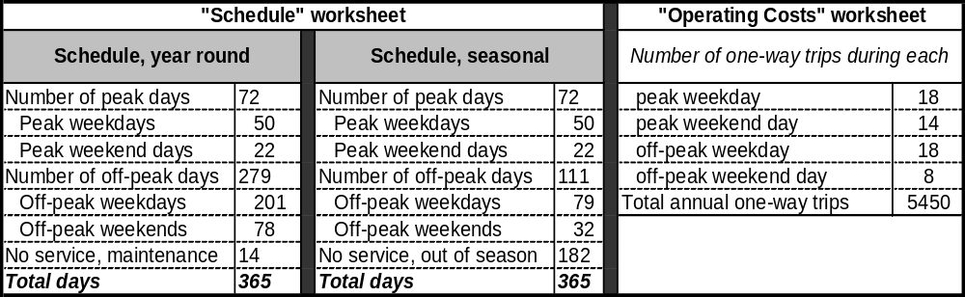
Sample Schedule and Operating Data

      - Scoring
The scoring of all questions in the Assessment Tool is on a 0 – 5 scale, with the exception of the Maturity module which is scaled 0.0 – 1.0. All scores reflect a positive bias toward high scores; that is, high value or potential score highly. This is also so for cases where negative answers indicate positive value, e.g., the question: “Are there negative impacts on other existing ferries or landside transit operations?”
The rationale for the scoring of all the elements is attached in Appendix B with the blank copy of the Assessment Tool. Some answers are binary in nature, i.e. yes/no = 5/0. Others are numerically (and, therefore, somewhat objectively) derived, as in the case of economic measures with estimated costs or revenues. Neutral scores (2.5) have been assigned in cases with lack of input data, e.g., benefit of air quality improvements (emissions reductions) where no analysis is presented or data available.
    - Candidate Ferry Services
The project team initially compiled a list of all candidate ferry services, including existing services, proposed services on file with State, and other potential services identified in collaboration with EOTC. The latter are those for which no formal proposals have been submitted, but which were identified at an initial meeting among Volpe Center, CTPS, and EOTC staff by perusal of a State map. Project staff later conducted a further review of municipal populations, harbors and access, and potential market demand to finalize this list. The result of this process was a roster of candidate services for consideration by project staff, EOTC, and the Focus Group.
Project staff also undertook a comparison of eastern Massachusetts waterways and the candidate service list to successful ferry services elsewhere in the United States. The work included a search of the Volpe Center National Ferry Data Base for similar markets and route parameters and geographies, i.e., ridership characteristics, service features, connections to other modes, and marketing and finances. Examination of these services enabled better understanding of key factors for the market analyses and informed the process of screening and selecting the best candidate ferry services for the full assessment. Additionally, surveys were sent to the operators of the selected parallel services in order to obtain a better understanding of their specific operations. Copies of the completed survey forms appear in Appendix C.
      - Selection process
The project team first conducted the Focus Group screening of the candidate service roster. The Group first had the opportunity to add to the candidate service list, and then scored the efficacy (high, medium, or low priority) of all the services on the roster under a multi-voting system. The results of this exercise provided the “short list” of services for detailed consideration using the Volpe Center Assessment Tool. The final selection of ferry services for the assessment phase of the project was agreed upon by EOTC, Volpe Center, and CTPS during a meeting held for that specific purpose.
      - Descriptors of selected services
Each ferry service may be substantively described and assessed by data on vessels, schedule, and terminal infrastructure. Vessels data are as originally developed for the Volpe Center Ferry Economic model, whose financial input and output were described above. They include hull type, principle particulars (length, breadth, depth, draft), powering and speed, passenger capacity, crew complement, build year and new purchase price.
Operating schedules are based on comparison to existing services, input from EOTC and the Focus Group, and experience of project staff. These have generally, for the services considered herein, been developed as “strawmen” since there are no available schedules for these proposed or potential services.
Terminal infrastructure elements are, as previously stated, per the results of the Boston Inner Harbor Passenger Water Transportation Plan 2000 and further consideration by project staff, who developed a “standard” set of these elements for each of the major defined project areas (Inner Harbor, Outer Harbor, and Massachusetts Bay). Those standard elements appear previously in Table 3-2.
    - Service assessment process
The application of the assessment tool to the selected services is a matter of acquisition of relevant and accurate data and the use of good professional judgment in instances where the data are unavailable. The latter is particularly so for the “Policy” module, where subjective judgments by project staff require thoughtful review by State officials.
      - Data acquisition
The population of the candidate service spreadsheet files includes hard data obtained from the ferry economics model, scoring of other technical matters by judgment of project staff, and demand data derived from CTPS market analyses. Cost estimates for shoreside infrastructure resulted from field work and analysis by Norris and Norris.
The important inputs to the ferry cost model include elements common to all services such as fuel and crew costs; these were found by consultation with shipbuilders, operators, and commodities dealers in the area (these have been confirmed by comparison to a ferry cost analysis performed by CTPS (Humphrey, September, 2001)). There are also boat and route specific data required individually for each service. Boat data are from the Volpe Center Ferry Lines Data Base and internally maintained files, as well as reinforcing data for particular craft acquired directly from shipbuilders. The route specifics (distances and speeds) were worked out by examination of NOAA charts, conversation with local operators and harbormasters, and judgment of project staff.
      - Field work
Project staff visited the terminal sites for all of the assessed services and met with local operators, municipal officials, and interest groups. These representatives also provided data and feasibility documentation in some cases. Infrastructure at shoreside terminal sites was examined, as were the landward approaches and transportation connections.

- Selection of Ferry Services for Assessment
  - WTAC Focus Group
The selection process was centered about the activities of the Focus Group, a sub-group of which was presented with the full roster of candidate services and asked to prioritize them on a high/medium/low basis. These results were followed by a final consultation with EOTC and identification of the services for analysis.
The “Routes” sub-group first reviewed the roster of all candidate routes and were given the opportunity to suggest modifications and additions. They then discussed and agreed upon the criteria for scoring the services, which were as follows:
- Ridership applies to transit ferries providing point to point service. Comments included:
  - Commuter ferries are the focus of state and federal funding programs.
  - Off-peak and seasonal recreational service requires other funding sources.
  - Trip purpose should be identified as “recreational” or "commuter".
  - There should a trip time advantages of waterborne service over land based alternatives.
  - Quality of service should be equivalent or better than land-based modes.
  - Fare structure should be competitive with land-based modes.
- Landside terminal and dock infrastructure should be in place or planned:
  - Operational terminal needed for existing or proposed routes.
  - Dock site and feasibility analysis needed for potential routes.
- Landside intermodal links are important:
  - Transit connections: bus, trolley, subway , and/or commuter rail.
  - Auto dropoff always required; parking needs vary with site.
  - Pedestrian and bicycle access: particularly for downtown terminal sites
- Environmental and marine conditions must be feasible for ferry operation:
  - Tidal and seasonal wind and weather conditions must be considered in terminal location and route planning.
  - Dredging and other environmental permitting must be in place.
- Community Support is essential for existing and new routes:
  - Timeframes for vessel operations and associated parking, transit etc. must be compatible with local use patterns.
- Multi-directional passenger flow is beneficial to operations.
- Demand time frames for new routes may vary; short, medium, and long views are needed.
- Flexibility of routes and vessels for different uses in addition to primary scheduled services is a plus, e.g., special events, emergency response, construction mitigation.
Following the Focus Group meeting and review of the results, the project team and EOTC agreed on several points of reference for the final selection of routes for analysis. It was agreed that the study should include services with both near and long term prospects, as well as with both geographic (inner and outer harbor, Massachusetts Bay) and service type (e.g., peak/offpeak/seasonal) variety. There would, however, be a focus on currently existing passenger markets, and on commuter services, the latter since it clearly addresses EOTC’s programmatic interest.
  - Decision
The following summarizes the results of the Focus Group discussions on route selection, and subsequent decisions by the project team and EOTC to accept or modify those results. The latter was in some cases necessary, both to more effectively meet the criteria articulated above (4.1), and to satisfy project needs for diversity of service types and distances.
The specific selection decisions and some non-selection decisions follow. The Focus Group’s raw scoring data for all candidate routes appear in Appendix A.
- Inner Harbor decisions were:
  - Russia Wharf, Pier 4/Navy Yard: This service was a selection of the Focus Group and considered to be a strong candidate. The passenger market for downtown work sites is in Charleston. There is also a Central Artery project commitment for infrastructure development at Russia Wharf. Selected for assessment.
  - Lovejoy Wharf (North Station), World Trade Center/Fan Pier: This service was also a selection of the Focus Group WTC routes. It would serve commuters looking for a quicker option from North Station to South Boston, and also provide off-peak service for other users. Selected for assessment.
  - Long Wharf, Pier 4/Navy Yard combined with Russia Wharf, Pier 4/Navy Yard: This essentially combines an existing service with the projected future Russia Wharf service, a recommendation of the 1994 study. The Group felt that this would make sense from the operations and cost standpoints and should be explored in detail. This option was selected for assessment, but is included as a possible future option for the Russia Wharf, Pier 4/Navy Yard service.
  - Lewis Mall (East Boston) routes: Indications are that there is currently no significant market here. The development and buildout of Clipper Ship Wharf and Pier 1 at some point in the future are likely to generate some future market demand. The project team notes that the ferry service operated 4-5 years ago and did not perform well. The service would also duplicate Blue Line service.
  - WTC, Rowes Wharf, Logan Airport: The Group liked this service, but it was not carried through due to the focus on Inner Harbor routes on the city side. We note that it was originally a water taxi with $10 fares.
- Outer Harbor and Massachusetts Bay
  - Scituate - Boston: The Group was reserved on the prospects for this service. Project staff and EOTC decided, however, that the 1999 “Scituate Ferry Feasibility Study” was a well executed point of comparison for the assessment tool and that this would be a good, mature proposal for the test. Furthermore, the 1999 Study indicated some promise for at least a low subsidy rate for a two boat operation. Selected for assessment.
  - Sandwich, Boston: The Group preferred the Barnstable service; this route is preferred, however, by the Cape Cod Commission, for several good reasons. It has better inter-modal possibilities, a shorter route to Boston, and ample space for parking (noticeably lacking in Barnstable). Selected for assessment.
  - Salem, Boston and Lynn, Boston: These routes had modest support from the Group. There is a need to re-examine North Shore transportation options, particularly to Salem, where there is the prospect of significant recreational patronage in addition to commuters. Another positive point is the experience (and report) of the 1999 Salem demonstration service. Lynn serves as a good point of comparison and is of interest as an intermediate distance Massachusetts Bay route. Selected for assessment.
  - Quincy (Fore River), Long Wharf, Logan Airport:: The Group liked this as a direct service to Boston only. Its recent acquisition and operation by the MBTA raises interest in its current triangulation configuration, which includes Hull and Logan Airport service. Conversation with the operator indicates that a future four-boat service may be worth investigating. This might be seen as redundant to the Hingham to Logan service, but serves different people and has more available parking. Selected for assessment.
  - Gloucester, Nova Scotia: The Group expressed mild support for this cargo and passenger service. The feasibility study for this service has been assessed separately by the City of Gloucester, with assistance from EOTC.

- Assessment: Inner Harbor Services
  - General Characteristics and Guidelines
Of the many candidates for Boston Inner Harbor service, two routes were selected for evaluation including the proposed new Russia Wharf (downtown/South Station) to Pier 4 Navy Yard (Charlestown) route, and modifications to the existing Lovejoy Wharf (North Station) to World Trade Center and Fan Pier (South Boston) route. The importance of these two routes is the provision of new or expanded transit links from commuter rail termini to employment destinations which currently have only limited and/or time consuming transit connections: from South Station (Russia Wharf) to Charlestown and the Navy Yard, and from North Station (Lovejoy) to the South Boston Waterfront, which is currently served by infrequent ferry service.
In conjunction with the Russia Wharf to Navy Yard service, the existing Long Wharf to Navy Yard service was also considered for possible consolidation, as proposed in the Boston Inner Harbor Water Transportation Study (1994), which was prepared for the Massachusetts Highway Department Central Artery/Tunnel Project. The focus on these particular routes was based on several factors:
- Their importance as connectors for commuters passing through North and South Stations to work destinations with limited transit linkages;
- The potential role and impact on the MBTA acquisition and operation of a shuttle fleet; and
- Response to demands anticipated form emerging new projects in the South Boston area such as Fan Pier and Pier 4.
The existing and proposed cross harbor ferry routes form the basis of the Inner Harbor shuttle network and provide a variety of peak commuter and off-peak visitor and resident short distance trips. The Long Wharf to Navy Yard shuttle has grown to be the most actively used ferry shuttle service in the Inner Harbor with over 600,000 riders annually, with almost half being off-peak and weekend users. The new Russia to Navy Yard service is projected to offer residents to the south and south west of the city an incentive to use rail and subway services to get to work, while also providing Charlestown waterfront residents a direct link to the downtown business district around South Station. In addition to a direct route from Russia Wharf to Navy Yard, an alternative was considered to merge the new Russia to Navy Yard service with the existing Long Wharf to Navy Yard shuttle into a single triangular route. The current Lovejoy to South Boston Waterfront service has recently begun to attract more commuters as the World Trade Center office buildings have been completed and occupied. As greater numbers of commuters are attracted to new jobs along the waterfront and as the Convention Center opens in 2004, increased frequency of service and more direct routes are being evaluated to determine potential ridership and service demand.
The identification of the new Russia/Navy Yard and expanded Lovejoy/South Boston Inner Harbor shuttle routes was based on several factors:
- Importance as connectors for commuters passing through North and South Stations to work destinations with limited transit linkages;
- Potential role and impact on the possibility of MBTA acquisition and operation of a shuttle fleet;
- Response to demands anticipated from emerging new projects in the South Boston Waterfront area and in the Charlestown Navy Yard and City Square; and
- Provision of reverse commute opportunities for residents from Charlestown and south Boston to downtown and the two rail terminals.
    - Operating area description
Boston’s Inner Harbor is defined for these purposes to include all water lying westward of a line between the southeastern point of Logan Airport and Castle Island in South Boston. The Inner Harbor is a compact operating area with most trip distances less than 1 ½ nautical miles (nm) in each direction. Because of the limited watersheet area in the Inner Harbor, the vessel speeds are regulated by the City of Boston and limited to 10 knots in channel areas and to 5 knots and/or no wake in sensitive areas within 500 feet of the shore. Other harbor operating conditions that affect trip times and navigation include the harbor traffic which varies between the busier summer season, which includes considerable recreational boating traffic, and other seasons which have fewer boats in the harbor. Wind and weather conditions vary with seasons, but are rarely cause for trip cancellation in the relative narrow and protected Inner Harbor area.
The general geography of the Inner Harbor with its multiple channels and riversheds is characterized by separation by water of the multiple Inner Harbor residential neighborhoods. With limited transit links, bridge and tunnel crossings, some of the neighborhoods and work destinations are separated by small water distances, but require long and/or time consuming land-based trips. The inner harbor shuttles routes have evolved primarily to connect residential areas and work destinations that have limited transit connections to waterfront areas, such as the Charlestown Navy Yard to downtown or North Station to South Boston.
The northern edge of the Inner Harbor includes Logan International Airport and, to its west, the East Boston waterfront with several docks, marine facilities, and a public park. The Chelsea River runs northward from the East Boston waterfront; facilities on its banks include the Texaco U.S.A. Chelsea Terminal Dock, the Mobil Oil Corporation Wharf, and the Gulf Oil Co. Chelsea Terminal, Tanker Wharf (U.S. Coast Pilot, volume 1). At the western end of the Inner Harbor, the Mystic River separates East Boston from Charlestown, and hosts the Exxon Co. U.S.A. facility, the Everett Terminal Wharf, the Prolerized New England Co. Scrap Metal Wharf, and the Distrigas Facility.
Charlestown lies between the Mystic and Charles Rivers and its waterfront is dominated by the Charlestown Navy Yard, where the U.S.S. Constitution and other historical Navy ships are moored. The Navy Yard has been redeveloped to a complex of residential and business uses. The southern Harbor edge runs eastward from the Charles River dam to the North End waterfront, including the U.S. Coast Guard Support Center. The downtown waterfront includes the Aquarium, Long and Rowes Wharves, and the Russia Wharf/South Station area fronting Fort Point Channel. The South Boston waterfront lies east of the Channel and includes the Fan Pier/Federal Courthouse area, the World Trade Convention Center, U.S. Conley Terminal, Moran Terminal, and the Black Falcon Terminal.
Larger commercial traffic in the Inner Harbor includes the liquefied natural gas (LNG) tankers that deliver LNG to New England. LNG tankers transit through Boston Harbor and unload at the Distrigas Facility located in Everett, Massachusetts. The U.S. Conley Terminal is used for containerized cargo shipments and the Moran Terminal is currently leased to Boston Autoport for the import and distribution of automobiles. The Moran Terminal handles more than 1.3 million tons of general cargo, 1.5 million tons of non-fuels bulk cargo and 12.8 million tons of bulk fuel cargos yearly (www.massport.com). The Black Falcon Terminal served 123 ship calls and over 250,000 cruise passengers in 2001.
Ferry services currently operating in the Inner Harbor include routes from Quincy to downtown/Logan Airport, Hingham to downtown, the downtown to Logan Airport shuttle, and several routes connecting the Lovejoy, Long Wharf, Federal Courthouse, and World Trade Center stops. Commercial excursion vessels include the Boston Harbor Island and whale watching boats, and dinner boats operating from Rowes Wharf. Recreational boats and commercial excursion vessels also use the Inner Harbor, primarily during the summer months, docking at local marinas.
Passenger landing locations and terminal conditions have improved greatly during the past decade with the addition of new ADA accessible docks, and plans for further new terminals. At present few of Inner Harbor shuttle vessels themselves are accessible, largely due to varying vessel freeboard heights and other traditional features of older monohull vessels, such as multiple deck levels. Many of the docks are at the protected inboard shore end of former shipping piers such as at Long Wharf, and Commonwealth Pier creating easy docking conditions, but these require slow approaches.
A recent development that may affect scheduled services is the recently implemented harbor security zones and procedures that limit navigation within certain areas. These might cause some routes to be longer around non-navigation zones such as the Coast Guard Support Center and Logan Airport; there are also periodic interruptions of harbor traffic during the arrival and departure of LNG tankers and other designated ships.
    - Similar services
There are few successful ferry services in the United States similar to the proposed Inner Harbor candidate services ; it is useful, however, to compare operational practices, vessels, and schedules to assist in the characterization of these routes. These services were selected based on similar route length, service type, and service area, with data found in the U.S. Department of Transportation National Ferry Database. Additionally, surveys were sent to the operators of these services in order to obtain a better understanding of their specific operation.
Outside of the Boston area, New York cross-harbor shuttles are comparable to Boston operations, yet have several important differences. The Hudson River and East River passenger ferries operated by NY Waterway are larger, faster and until recently, received no public subsidies. In addition, most of these are park and ride services requiring substantial parking and good highway access at their origins. The Boston ferries by contrast provide transit links and do not rely on auto parking.
New York Waterway is the largest ferry and excursion fleet in New York Harbor and operates the following routes.
- Port Imperial, Weehawken NJ-Wall Street Terminal, Pier 11 NY route (Figure X) is approximately 4.8 nautical miles with an approximate trip time of 20 minutes. This route operates year round and, in 1999, approximately 120,730 passengers sailed this route. Connecting bus service exists in both Manhattan and New Jersey (source: www.nywaterway.com). The operator did not respond to inquiries about these services.
- The Hoboken Rail Terminal (NJ) - World Financial Center, Battery Park City, Manhattan route is approximately 1.9 nautical miles with an approximate travel time of 8 minutes. In 1999, 2,352,317 passengers traveled this route.
- The Port Imperial, Weehawken (NJ)-W. 38th Street Ferry terminal (NY) has a route length of approximately 1.1 nautical miles with a travel time of 5 minutes. The patronage in 1999 was 2,955,129 passengers.
Figure 5-1
The Port Imperial, Weehawken NJ-Wall Street Terminal, Pier 11 NY Services

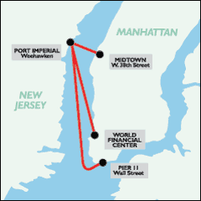

New York Fast Ferry operates a route from the Wall Street Ferry Terminal to Pier 11 at the East 34th Street Ferry Terminal. This is a New York City “inner harbor” route 3.4 nautical miles in length. It is not operationally similar to the contemplated Boston Inner Harbor services in that it is part of the Highlands, New Jersey service to Manhattan. The route has been in service for four years and has an annual ridership of approximately 350,000 passengers, according to the questionnaire returned by the operator. The operator makes fifteen one way vessel trips per day on a year round basis as its boats have two pickup and dropoff points in Manhattan for its commuter service from New Jersey. The operator uses two fast catamarans with capacities of 325 and 354 passengers. Approximately 90% of the passengers are commuters.
In the Boston Inner Harbor, services that are most similar to the proposed shuttle routes include the long established route linking Long Wharf to Pier 4/Navy Yard, the current service linking Lovejoy Wharf to World Trade Center and the Federal Courthouse, and the shorter Lovejoy Wharf to Pier 4 Navy Yard connection. The current services are provided by private operators (Boston Harbor Cruises) by contract to the MBTA. The routes and schedules are primarily oriented to weekday trip to work commuters. The services were initiated as required impact mitigation measures to provide alternative transit options across the harbor during construction of the earlier Central Artery North Area (CANA) and the current Central Artery / Tunnel (CA/T), and continue to be subsidized with public funds. The funding subsidies are scheduled to end on substantial completion of the CAT project. Other Boston Harbor ferry services that are less similar include the Rowes to Logan Airport shuttle, which is essentially used by airline passengers, hotel visitors, and a relatively small number of Logan Airport employees. All of the services described are intended to provide convenient and affordable options to auto commuting, and thereby reduce traffic and parking burdens on the downtown and other Inner Harbor destinations.
The Inner Harbor ferry services candidates herein would provide service among terminals in Boston proper, have public ownership, and be served by dedicated, lower speed vessels built or modified for the purpose. They would serve as alternatives to city traffic and other public transportation links, for both commuters and other users. While these routes appear to connect points on one contiguous shore line, there are water crossings in the service area at Fort Point Channel and the Charles River (the scale is smaller than the Hudson and East Rivers in New York). The bridge crossings and transit options across both those waterways are somewhat limited, so the Inner Harbor ferry services would emerge as true alternatives to city surface transportation options. The three candidate service routes appear in Figure 5-2.
The services seen elsewhere are either high volume commuter services connecting opposite shores (New Jersey – New York routes), adjuncts to longer commuter routes (the New York Fast Ferry case), or services more clearly aimed at tourist and recreational passengers (Tiburon service). Other tourist based services such as those operating in Savannah, Georgia and Charleston, South Carolina, come to mind, but both their ridership and route configurations are significantly different than these Boston routes. The proposed Inner Harbor services have several geographical and operational aspects that, taken together, will probably be unique in the United States.
Figure 5-2

Boston Inner Harbor Routes

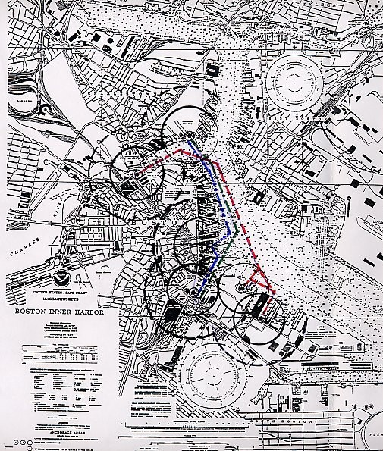
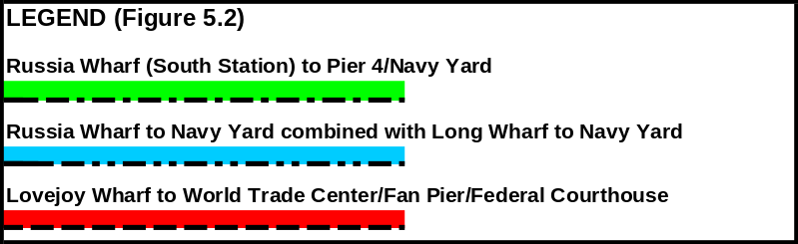
    - Transportation policy issues
Previous studies of waterborne Inner Harbor transportation have emphasized the diversion of automobile commutes and other trips by providing links both across the Harbor and among downtown destinations along its west and south shores, i.e., the area from Charlestown to South Boston. The need for multi-modal links to ground transit options has been clearly articulated, to maximize the attraction of the ferry option for travel to work as well as tourist and recreational trips. The transportation and environmental policy goals addressed in the service candidates here are:
- Reduction of vehicle miles traveled (VMT) and reduction of congestion through diversion of automobile commutes;
- Progress towards air quality attainment for the metropolitan area;
- Use of funding options after completion of Central Artery and Tunnel (CA/T) mitigation projects, including State Chapter 91 contributions for new projects in catchment areas and MBTA subsidies;
- Fare structures for total trip and for shuttles consistent with land transit options and extension of MBTA pass use for commuters and visitors; and
- Cost efficiency, where possible, by reducing fleet and crew demands through route consolidation for same amount of peak and off-peak service.
    - Vessel options
The technical specifications for the boats selected for the analyses herein are generally similar to those found in the MBTA’s “Technical Specification” for harbor passenger service in a 2002 Request for Information. The MBTA specified vessels of 120 passenger and 49 passenger capacities, with ADA access, low wake and wash signature, freeboard and air draft limitations, service speeds between 10 and 15 knots, compliance with all applicable safety regulations, and adherence to good marine design and construction practices. The analysis for this and the other Inner Harbor services considered herein includes the consideration of two boats: 1) a monohull; and 2) an optimized catamaran. Table 5-1 summarizes the specifications and includes approach speeds and loading/unloading times, as developed by project staff.
Table 5-1

Vessel Specifications

Inner Harbor Services
Vessel Alternatives:
Specifications and Performance
A. Conventional Monohull | B. Optimized Catamaran
- 49-120 passengers  - 10-12 knot service speed  - Approach Speed; 3 knots  - Low wake design  - Load/Unload:  49 PAX = 4 min.  120 PAX = 5 min.  - Lakes, Bays, and Sounds Certificate of Inspection | - 49-120 passengers  - 12-15 knot service speed  - Approach Speed; 6 knots  - Low wake design  - Load/Unload:  49 PAX = 3 min.  120 PAX = 4 min.  - Lakes, Bays, and Sounds Certificate of Inspection
The MBTA issued the specification with a request for information (RFI), and received several responses from shipbuilders with suggested designs. Project staff concluded that the boats selected for the analysis should also be bow loading and have good maneuvering qualities for operations in tight areas.
Both boats selected for analysis are based upon proposals among those submitted to the MBTA in response to the RFI, for the obvious reason that designers and builders (some of them local) have thought the specifications through and made the submissions. Two points need strong emphasis here: 1) these vessel selections are for comparative purposes only and do not represent an endorsement by any State transportation agency; and 2) Volpe Center is making very limited use of the proposed specifications to provide rudimentary input into the ferry cost model, i.e., powering and personnel data.
The monohull selected for analytical purposes is a 19.6 meter long, 101 passenger, 2 crew design. The service speed is 10 knots, powered by an approximately 250 hp marine diesel engine. The boat is similar to a passenger boat currently operating on both the Charles River and Boston Harbor and would require design modifications for the intended service, notably improved ADA access and more efficient loading and unloading arrangements. The assumed purchase price for this boat is $650,000.
The catamaran selected for analytical purposes is a 17 meter long, 49 passenger, 2 crew catamaran ferry design. The service speed is 14 knots, powered by an approximately 250 hp marine diesel engine. This boat is similar in powering and performance to several small, low speed catamarans found in the National Ferry Lines Data Base (e.g., Caladesi Connection I {Caladesi Island Ferry Service, 12.9 meters length, 15 knots, 66 passengers, 230 hp} and the Lady Christina {Delaware River and Bay Authority, 15.1 meters length, 9 knots, 76 passengers, 260 hp}).
Price information was not directly available for the vessel designs selected for the analysis of these services. The price algorithm appearing in Chapter 3 yields a cost of $866,000. This number tracks well with data independently supplied by a west coast builder for a 17 meter catamaran. That particular boat does not have a closed cabin and was sold for approximately $700,000. The catamaran’s operating specifications for purposes of this study are 12 knots service speed, 6 knots slow (approach) speed, and two crew (captain and deck hand).
  - Russia Wharf to Pier 4/Navy Yard, with Long Wharf Combination Option
    - Characterization
The proposed new service from Russia Wharf to Pier 4 was originally identified as a key component of the CA/T mitigation in the 1994 report, providing a link between South Station and the Financial District to and from the Charlestown Navy Yard. The service would provide two-way transport for commuters traveling through South Station (commuter rail or Red Line) to work destinations such as the MWRA, Massachusetts General Hospital, or the Navy Yard, as well as bringing Navy Yard and Charlestown residents to downtown Boston work destinations. The 1994 report identified a strong potential ridership market for the two way service. While the primary markets identified remain relatively constant, there have been some increases in both work destinations and residential stock at the Charlestown end. Since the proposed service is still at least one year away (scheduled for fall 2004 start-up), this study selected the route for a more detailed evaluation in terms of potential market demand and operations.
Two variations of the South Station to Charlestown shuttle route are evaluated. Route 1A consists of a direct peak period service from Russia to Pier 4/Navy Yard with a modified triangular off-peak route stopping at Long Wharf. Route 1B consists of merging the Russia to Pier 4 route with the existing Long Wharf to Navy Yard route into a triangular service at peak and off peak periods, as proposed in the Boston Inner Harbor Water Transportation Study (1994). The two proposed routes are shown in Figure 5.2. The detailed assessment focuses on the Russia Wharf – Navy Yard route only.
The service from Russia to Navy Yard was originally to start in 1996, but was delayed initially by continued vehicular use of the low clearance Old Northern Avenue Bridge, and more recently by the construction of the Silver Line under the channel. The new terminal is to be built by the CA/T at the former Boston Edison Company (BECO) portion of the proposed site (now known as 500 Atlantic Avenue) by 2004. Access to low clearance ferries will require a reconfiguration of the Old Northern to allow for high tide clearance of a minimum of 16 feet to match the Moakley Bridge clearance.
The 1994 report also indicated that there was potential for the new service to be combined with peak hour service from Long Wharf to the Navy Yard, and thereby reduce the total number of ferries required to meet the schedule and service needs for the two routes. This evaluation will include an analysis of both combined and separate peak hour service and schedule models. Table 5-2 shows the general specifications for this service, which are discussed in turn and in more detail below.
This proposed route would include off-peak stops at Long Wharf to better serve tourist and recreational passengers. Detailed treatment of Long Wharf follows in Section 5.3, which addresses peak hours service among the Russia Wharf, Navy Yard, and Long Wharf terminals.
Figure 5-3

Russia Wharf – Navy Yard Route and Catchment Areas

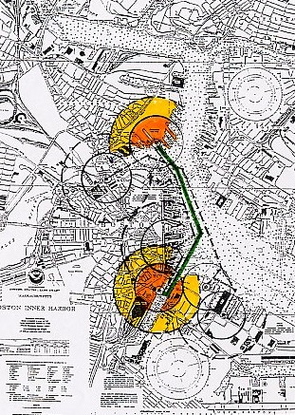
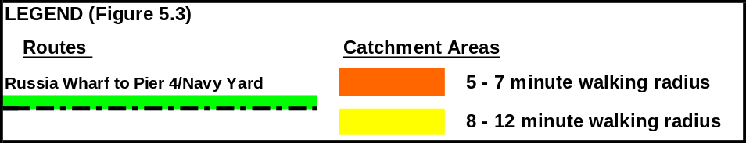

Table 5-2
General Specifications
Russia Wharf – Navy Yard Service
Infrastructure:  Dock, Water and Landside |  | Vessel Specific-  ations | Route and Schedule:  Peak, Off-Peak | Implementation Matters
Origin | Destination(s) | Vessel Specific-  ations | Route and Schedule:  Peak, Off-Peak | Implementation Matters
Russia Wharf (BECO/500 Atlantic): Construction by fall 2004; requires opening of Old Northern Ave. Bridge | 1) Pier 4 Navy Yard;  add floats to existing | 49- 120 pass.;  16 foot height limit for Moakley Bridge; low wake for Fort Point Channel  Speed = 10-15 knots  New MBTA vessels or private vessel concession. | Weekday Peak: 6-9:30 am, 3:30-7 pm  Weekday Off-Peak: 9:30 am – 3:30 pm; 7:00 pm – 9:00 pm  Weekend off-peak: 9:00 am – 7:00 pm | - Public operation: to use new MBTA shuttle vessels  - New dock/terminal by CAT  - CAT subsidy for 15 months after dock completion. Then, Chapter 91 funds plus MBTA. C91 contribution fund distribution mechanism needed  - Fare structure consistent with land transit and Inner Harbor shuttles. MBTA pass use for commuters and visitors.  - Service start in late 2004; after Silver Line completion and Northern Ave Bridge opening.

      - Route and service area
This route would serve two distinct markets. The first, during peak hours, is the two way commute including Charlestown to downtown and the South Shore to Charlestown via South Station. The market here encompasses the residential and business sectors of Charlestown, in particular the redeveloped Navy Yard. There is also two way off-peak demand for the cultural, recreational, and retail destinations both downtown and at the Navy Yard. The frequency of the service proposed here is consistent with or better than land transit options (bus or subway).
The Russia Wharf Terminal site was proposed based on an analysis of alternatives in the 1994 Inner Harbor study, as the nearest navigable location in Fort Point Channel within a short (4 minute) walk of South Station. This selection was reaffirmed in the Boston Inner Harbor Passenger Water Transportation Plan of 2000, which is frequently consulted by the City in matters of ferry terminal siting. Closer proximity of a terminal to South Station was precluded by the Congress Street Bridge, which in its current and proposed renovated state has a 6 vertical foot clearance at high tide. This low clearance limits scheduled ferry travel up the Fort Point Channel, since the vessel clearance or air draft required by conventional ADA-accessible ferry vessels is closer to 14 feet.
A Downtown/Fort Point Channel Municipal Harbor Plan is being prepared for the area in addition to the Forth Point Channel Watersheet Activation Plan; both documents address Russia Wharf. This area is included as one with several proposed new Chapter 91 development sites at various stages of design and permitting, including 500 Atlantic Avenue, the Post Office, and anticipated Surface Artery Park projects such as the proposed Horticultural Hall.
Catchment Areas
The catchment areas on the downtown side of the Channel for Rowes Wharf and Russia Wharf (see Figure 5-3) overlap. Russia Wharf will serve downtown users, and proposed Chapter 91 sites including 470 Atlantic Avenue. Rowes Wharf will continue to serve primarily as an outer harbor commuter terminal and secondarily as a possible expanded shuttle site. Russia Wharf will serve solely as a smaller vessel shuttle terminal, as a ferry link to South Station and the Financial District because of the vessel clearance (air draft) restrictions under the Moakley Bridge. Service to this site still requires provision of the required clearance (vessels’ air draft) at the old Northern Avenue Bridge.
Russia Wharf/500 Atlantic Avenue Terminal. Based on an analysis of alternative sites in the 1994 study, the new terminal was proposed at the property line between Russia Wharf and the Boston Edison (BECO) site, as the nearest navigable location in Fort Point Channel within a short (4 minute) walk of South Station. The site was verified in the Boston Inner Harbor Passenger Water Transportation Plan of (2000). Closer proximity of a terminal to South Station was precluded by the Congress Street Bridge, which in its current and proposed renovated state has a 6 vertical foot clearance at high tide. This low clearance limits scheduled ferry travel up the Fort Point Channel, since the vessel clearance or air draft required by conventional ADA-accessible ferry vessels is closer to 14 feet. A Downtown/Fort Point Channel Municipal Harbor Plan is being prepared for the area including implementation and management plan additions to the Forth Point Channel Watersheet Activation Plan. Bridge clearance restrictions preclude scheduled shuttle ferry service further up the Fort Point Channel beyond the Congress Street Bridge.
The area is included as one with several proposed new Chapter 91 development sites at various stages of design and permitting, including 500 Atlantic Avenue, Russia Wharf, and the Post Office, as well as anticipated Surface Artery Park activities such as the proposed Horticultural Hall.
There are two distinct catchment areas around the Russia/500 Atlantic Avenue site anticipated for patrons of the new service. For Navy Yard and other Charlestown residents, the catchment area is the downtown Financial District as a primary work destination with a walking radius of 5 to 7 minutes, and a secondary area of 8 to 12 minutes. The Russia Wharf catchment area shown in Figure 5.3 indicates inclusion of some portion of the Fort Point Warehouse District in South Boston across the Congress Street Bridge in its primary and secondary areas. The second catchment area for ferry patrons with work destinations in Charlestown and the Navy Yard is a much larger area encompassing all of the areas south and west of South Station connected by commuter rail or Red Line. For these commuters, the ferry trip represents the next to last leg of their multi-modal work trip. For these longer more complex work trips, the ferry leg needs to be have frequent departures, a short travel time and an affordable price, preferably included as part of an MBTA commuter pass. For off peak services, visitors and residents are likely to use the service as a convenient link from downtown to such attractions as the Boston National Historic Park, the USS Constitution and the Bunker Hill Monument in Charlestown.
The catchment area for Russia Wharf includes the downtown Financial District as a primary work destination with a walking radius of 5 to 7 minutes, a secondary work destination area within 8 to 12 minutes walking distance, and at least a portion of the Fort Point Warehouse District in South Boston across the Congress Street Bridge. A secondary work destination catchment area encompasses all of the areas south and west of South Station connected by commuter rail or Red Line. For commuters using the ferry as part of a multi-modal work trip, the ferry leg needs to be have frequent departures, a short travel time, and an affordable price, preferably included as part of an MBTA commuter pass. For off peak services, visitors and residents are likely to use the service as a convenient link from downtown to such attractions as the Boston National Historic Park, the USS Constitution, and the Bunker Hill Monument in Charlestown.
The addition of a ferry connection to the South Station end of the downtown would complement the existing Long Wharf to Navy Yard service. The catchment area for the Navy Yard/Pier 4 terminal includes most of the Navy Yard as well as portions of the City Square area, including recently completed residential areas. A 5 to 7 minute walking radius represents the primary service area for the ferry service as shown in Figure 5.4. The secondary catchment area of 8-10 minutes walking distance includes portions of the City Square area residential and business locations. In the past, the catchment area has been extended by a circulator bus system connecting to the eastern Yard’s End area of the Navy Yard, serving departing residents as well as arriving workers. A similar service could extend the catchment into areas of the Charlestown residential area to complement the Orange Line Station at Bunker Hill Community College. During off–peak periods, the ferry would be used by Navy Yard and Charlestown residents for quick access to the downtown, as well as by visitors returning to Boston from the historic sites on the Freedom Trail such as the Constitution and Bunker Hill Monument.
Pier 4 Navy Yard. The catchment area for the Pier 4 terminal includes most of the Navy Yard as well as portions of the City Square area in Charlestown, including recently completed residential developments. A 5 to 7 minute walking radius represents the primary service area for the ferry service as shown in Figure 5.3. The secondary catchment area of 8-10 minutes walking distance includes portions of the City Square area residential and business locations. In the past, the catchment area has been extended by a circulator bus system connecting to the eastern Yard’s End area of the Navy Yard, serving departing residents as well as arriving workers. A similar service could extend the catchment into areas of the Charlestown residential area to complement the Orange Line Station at Bunker Hill Community College. During off –peak periods, the ferry is likely to be used by Navy Yard and Charlestown residents for quick access to the downtown, as well as by visitors returning to Boston from the historic sites on the Freedom Trail such as the Constitution and Bunker Hill Monument. The addition of a ferry connection to the South Station end of the downtown would complement the existing Long Wharf to Navy Yard service.

Long Wharf . The catchment area for Long Wharf encompasses two areas; the walking radius for downtown and CBD areas, and a subway catchment area for the nearby Blueline stop at Aquarium. The walking distance catchment areas are shown in Figure 5.4. The walking distance catchment areas consist of the primary 5 to 7 minute radius which includes Quincy Market, portions of the Financial District, and portions of the North End, while the 8-10 minute radius extends to City Hall and larger segments of the Financial District and North End. The Blue line catchment area extends much further into other sections of Boston.
Figure 5-4

Russia Wharf – Navy Yard – Long Wharf Route and Catchment Areas
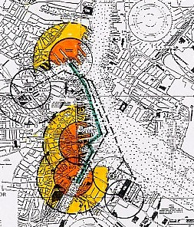

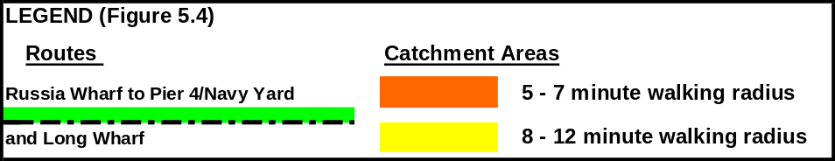

      - Schedule and vessels
Success of peak hours service depends on frequent departure times to attract the maximum number of potential users, including the long distance commuters through South Station as well as the shorter distance downtown commuters from Charlestown. The schedule options considered appear in Table 5.3, including departure headway times of 10 minute and 15 minute intervals during peak periods, and consideration of the monohull and the catamaran. The boats would be dedicated to this service.
The terminology in Table 5-3 is as follows. A1 and A2 are the two headway options for the monohull, based on current harbor speed and wake regulations. B1 and B2 are schedule options for the optimized low wake and wash catamaran with modified harbor speed regulations allowing for somewhat faster operating speed.
Table 5-3

Vessels and Schedules

Russia Wharf – Navy Yard Service
Routes, Distances | Peak Route Cycles, Schedules, and Vessels Needed |  | Off-Peak Schedule and Vessels Needed.
Routes, Distances | Weekday Peak: 6-9:30 am and 3:30-7 pm; Headways 10 or 15 Min. |  |  | Weekday Off-Peak: 9:30 am – 3:30 pm and 7 pm – 10 pm; Headway 30 min.  Weekend Off-Peak:  9:00 am – 7:00 pm
Routes, Distances | A. Conventional Monohull | B. Optimized Catamaran
Peak Route: Russia to Pier 4 to Russia  Trip Distance:  - One way = 1.3 nm  - RT = 2.8 nm  Off-Peak Route:  Morning: Russia to Pier 4 to Long to Russia  Afternoon: Russia to Long to Pier 4 to Russia  Trip Distance:  - One Way = 1.5 nm  - RT = 3 nm | A1→Headway: 15 min.  - Trip Time: 12 min  - Cycle Time: 29 min.  - Vessels Needed: 2  A2→Headway:10 min.  - Trip Time: 12 min  - Cycle Time: 29 min.  - Vessels Needed: 3 | B1→Headway: 15 min.  - Trip Time: 8 min  - Cycle Time: 25 min.  - Vessels Needed: 2  B2→Headway: 10 min.  - Trip Time: 8 min  - Cycle Time: 25 min.  - Vessels Needed: 3 |  | Cycle Time:  Vessel A: 36 min.  Vessel B: 27 min.  Vessels Needed:  Vessel A: 3  Vessel B: 2

      - Terminal infrastructure
Russia/500 Atlantic Avenue. The Russia Wharf terminal at 500 Atlantic Avenue is scheduled for completion by the CA/T by the end of 2004. The design is to include a Massachusetts Architectural Access Board (MAAB) compliant float and ramp system, a ticketing and waiting kiosk, lighting, and signage. The facility will be incorporated into the channel side of the proposed new hotel complex at 500 Atlantic Avenue and will provide pedestrian access from Congress Street and from Atlantic Avenue via Pearl Street. As described in Table 5.4, the estimated cost for the CA/T constructed dock and ramps is $1.0 million. The ticketing and waiting area is to be built as part of the 500 Atlantic development, most likely as a Chapter 91 obligation, at an as yet undetermined cost. A service start-up from the new terminal will require action on the part of the City of Boston, which is committed to providing a minimum clearance at the channel of 16 feet for the Old Northern Avenue Bridge to meet the existing high tide clearance of the Moakley Bridge.
Pier 4/Navy Yard. The Pier 4 terminal at the Navy Yard was built in 1988, and has served multiple ferry routes for over 14 years. The existing infrastructure is serviceable for its current uses, although it is technically non-compliant with current MAAB access guidelines and would require expansion for the proposed service. The design predates the MAAB guidelines for marine terminals and has ramp lengths exceeding 30 feet. It is unclear at what point additions or reconstruction might necessitate full compliance with MAAB standards.
It is assumed that if the separate Russia to Navy Yard route is selected, while maintaining the existing Long Wharf to Pier 4, and possibly the Lovejoy to Pier 4 routes, that additional capacity berthing may be required. As shown in Table 5.4, the summary of service needs, it is estimated that a new 30’ by 60’ float would be needed. Other needed infrastructure improvements would include a waiting shelter and signage. The Pier 4 improvements are estimated at approximately $400,000 in 2002 dollars.
Table 5-4

Terminal Infrastructure Status and Needs

Russia Wharf – Navy Yard Service
Infrastructure Status:  Dock, Water and Landside |  | Infrastructure Construction Costs (New or Renovated)  Dock, Water and Landside
Russia Wharf | Navy Yard, Pier 4 | Russia Wharf | Navy Yard, Pier 4
Proposed: to be constructed by CAT by 2004. Requires opening of Old Northern Ave. Bridge | Existing: Pier 4  Needs: Expansion | Russia Wharf (BECO/500 Atlantic): Cost: $1M | 1) Pier 4 Navy Yard; new 30’ X 60’ float, shelter, and signage - $400K  2) Long Wharf; new ADA  Central south landing - $800K

Long Wharf. The Long/Central Wharf area includes five distinct terminal landing sites as described in the BIHPWTP, several of which could serve as shuttle service stops. The individual project components are based on evolving plans which are at various stages of funding, design and implementation. Taken together, the five potential project initiatives offer by far the greatest opportunity to add docking and berthing capacity to the downtown waterfront. The two projects of interest to the shuttle analysis, including short and mid term, consist of the following components: 1) Long Wharf/Central Wharf MBTA Shuttle Terminal (completed in 2002 by the City of Boston with a grant from EOTC), and 2) Central Wharf South Pier.(scheduled for completion in 2003-2004 by the New England Aquarium with grant assistance from EOTC). Assuming completion of these two facilities, there would be ample capacity for increased shuttle service to the Long Wharf complex.
    - Field Work
Site visits to the proposed Russia Wharf/500 Atlantic site and the existing Pier 4/Navy Yard were conducted in April of 2002. In addition, the recently completed Long Wharf/Central Wharf shuttle terminal was visited at the same time. The site visits included a shuttle ferry trip from Long Wharf to Pier 4.
    - Service Assessment
Each service assessment in this text follows the organization and order of the spreadsheet tool. That is, the maturity evaluation comes first, followed by the categorical assessments of policy, technical feasibility, and cost. Summary results of each will appear in tabular form in the body of the report, with commentary text. The full results of the assessment tool’s numerical evaluations appear in the appendices. The full Russia Wharf/Navy Yard route results appear in Appendix D.
      - Maturity evaluation
Indications are that this route is underpinned by substantial planning and support, although some key elements are either missing or somewhat dated. The 1994 Inner Harbor Water Transportation Study examined both routes and operations and terminal infrastructure issues. It included demand estimates and finance projections which are now eight years old. The ridership projections did not indicate prospects for a successful operation in the absence of a subsidy. The 2000 Boston Inner Harbor Water Transportation Plan offered an in-depth analysis of terminal development options for both Russia Wharf and Pier 4 at the Navy Yard. Neither document included a service operations plan indicating vessel of choice, scheduling, manning, safety planning, etc. The Chapter 91 process has been followed in both cases; there appears to be no need for an environmental assessment or impact study at this time.
The important infrastructure elements are either in place (Navy Yard/ Pier 4) or in planning and construction stages (Russia Wharf). It appears that this service has the public support. Funding for the Russia Wharf project will come from the CA/T, and operation of the service by the MBTA is in prospect.
The summary “Maturity” score for this service is 0.65 on a 0.0 – 1.0 scale.
      - Categorical evaluation
        - Policy
This route scores very well (3.9 on a scale of 5.0), on the strength of public transit enhancements, waterfront access and disability accommodations, and public private partnership in development of the City’s waterfront. Summary scores appear in Table 5-5. Detailed scoring appears in Appendix D.
Table 5-5

Assessment Tool “Policy” Summary
Russia Wharf – Navy Yard
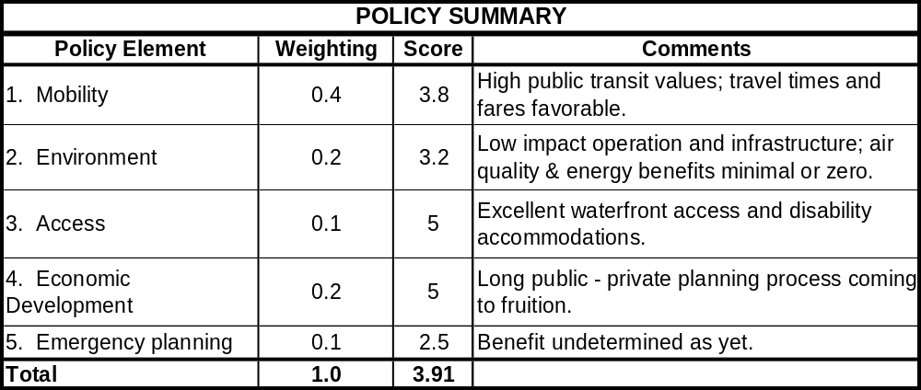
        - Feasibility
The Russia Wharf – Navy Yard route scored 3.99, on a scale of 5.00, with high values in all three categories of infrastructure, vessel, and environment. Russia Wharf has the planning, design, and permitting elements in place and should provide all the features expected of a modern ferry terminal. The recently built Navy Yard, Pier 4 terminal requires some improvements (e.g., rest rooms, adequate signage, bicycle accommodations), but is otherwise quite sufficient and a good site for expansion and upgrade.
The boats selected here to meet the MBTA’s specifications would be very well suited to operation on this protected route. Each terminal has some drawbacks associated with congestion and navigational restrictions.
The environmental values of this operation are generally high. There will be no adverse waterway impacts (dredging, sensitive areas), but, like all services considered herein, the impacts or benefits on air quality are uncertain. Removal of a some automobiles from the city’s roads is possible, but the benefit will be expansion of choices for transit riders and expansion of core transit system capacity, potentially reducing congestion in other modes.
The air quality and emissions performance of ferries relative to other modes, particularly of high speed ferries, have been the subject of recent claims and counter claims. Mobile source regulations governing commercial vessel power plants will come into force in 2006 and marine engineering technology will improve emissions . Comparisons cannot be made with confidence at this time; therefore, the assumption for this service, and others considered herein, is that the air quality impact is neutral.
The summary results appear in Table 5-6. Full details of the assessment appear in Appendix D.
Table 5-6

Assessment Tool “Feasibility” Summary
Russia Wharf – Navy Yard
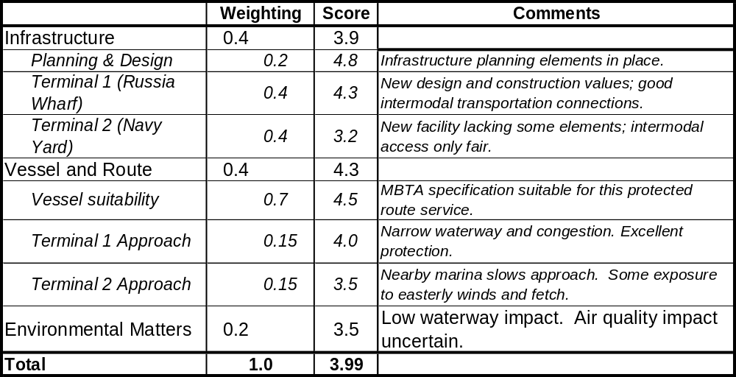
        - Demand estimation
The service assumptions for the Charlestown to Russia Wharf service included a $1.00 fare, 10-minute peak period headways in both peak and off-peak directions, a 12-minute one-way travel time and no parking. The model forecasted 900 trips during the morning and afternoon peak periods in 2010. All of these trips would be diverted from other transit services, 625 from commuter rail and buses, and 275 from other commuter boat routes, i.e., from the current Charlestown - Long Wharf service.
        - Finances
The overall financial assessment is for the monohull service with 10 minute peak hours headway, as for the demand estimation. The operating costs for all four boat and service (headway) combinations appear in Table 5-7 (with the selected service shaded), showing estimated expenditures for year round peak hours, and including the calculated debt service as an operator would expect to pay. Note that the overall financial analysis treats capital expenses and debt service for the boats as separate from operating costs (italicized figures in Table 5-7), enabling more direct performance comparison to landside transit modes. Certain indirect costs tied directly to passenger revenue (i.e., general and administrative, advertising and publicity, and dockage costs) are not included in the operating cost estimates because these costs may be treated differently by operators already engaged in ferry service.
The catamaran operation entails higher costs because of fuel for running at higher speeds, and higher debt service, maintenance, and insurance costs due to the purchase price differential. Although the catamaran completes its runs more quickly, the numbers of boats required for both 10 and 15 minute headways were the same as with the monohull. The potential gain in demand due to the trip time advantage is counterbalanced by longer idle times per cycle relative to the monohull, and labor costs are virtually identical.
Table 5-7

Annual Vessel Operating Costs

Russia Wharf – Navy Yard

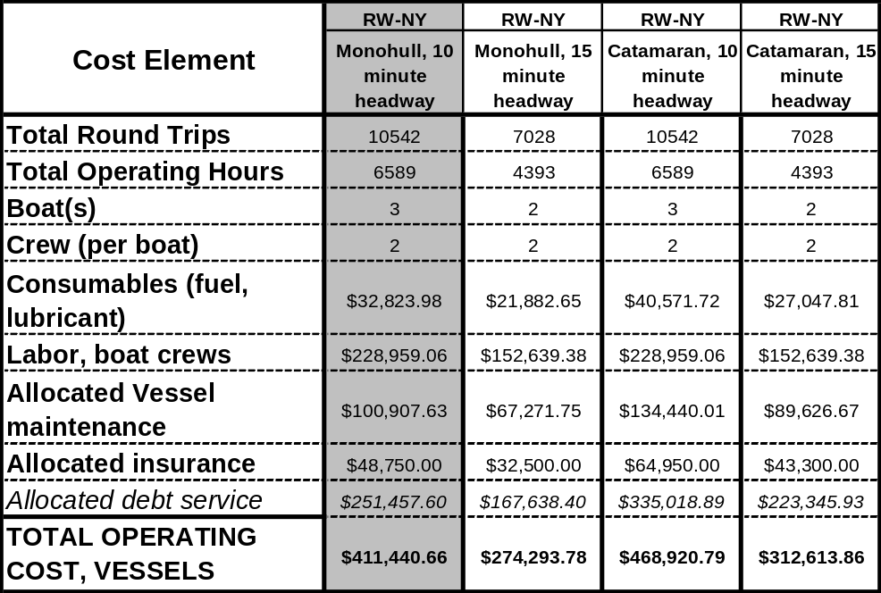
Capital costs and debt service. As described in section 5.2.1.3 and shown in Table 5-4, total capital costs for infrastructure on this route are $2.2 million, of which $1 million is be provided for Russia Wharf construction through the Central Artery/Tunnel Project, as part of the 500 Atlantic Avenue development. Debt-service payments for the boats would vary according to service options, as shown in Table 5-7, above. Operating costs are for peak hours service only and include only peak hours operation, to allow direct comparison of cost and demand estimates.

Demand, revenue, and subsidy estimates. Based on the CTPS demand model for the selected service, a total of 900 commuter boardings per day were forecast, assuming a $1 fare. Assuming a year-round weekday operation of 251 days (as per Table 3-3), there are 225,900 annual commuter boardings, with $225,900 in annual commuter revenue. Table 5-8 below presents the summary results of the ferry economic model, assuming demand and revenue figures as estimated by CTPS.

Table 5-8 also shows a financial performance comparison of this service with rail modes. Measures for the latter are based on preliminary FY 2002 data, aggregated for all MBTA commuter and heavy-rail subway lines. The overall score for the Russia Wharf – Navy Yard ferry service is 2.98, fairly strong. It compares well as measured by farebox recovery and per passenger subsidy, but poorly in terms of subsidy per passenger-mile.
Table 5-8
Operating Cost Evaluation for Commuter Service
Russia Wharf – Navy Yard
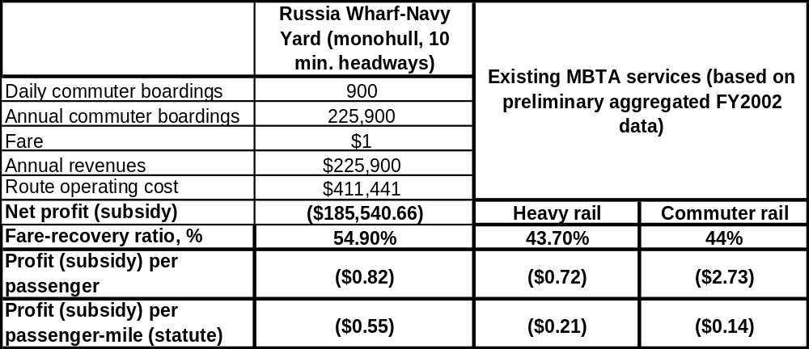

Table 5-9
Assessment Tool Finances Summary

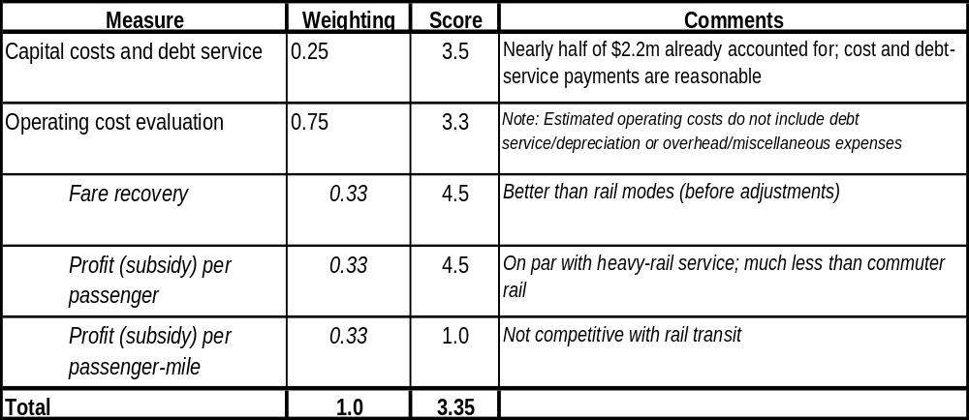
Russia Wharf – Navy Yard

    - Summary
The Russia Wharf – Navy Yard service has considerable strengths as a mature proposal with funding and public support in place and strong technical feasibility scores from both the infrastructure and vessel operations aspects. It contributes significantly to the major policy goals articulated by the Focus Group, especially mobility, access, and economic development. In particular, it would offer an excellent transit option for a currently underserved market (Charlestown) and indications are that current and future demand would be significant, nearly 55 percent at the farebox.
The financial assessment shows strong performance as compared to other transit modes. Capital expenses for infrastructure are already partially committed and are modest ($2.2 million) relative to most proposed landside transit projects appearing in the 2003 draft PMT report. The PMT measures unit capital expense per new transit rider (i.e., not diverted from other transit modes). The Russia Wharf – Navy Yard service would most likely not result in significant new riders because of its setting in central Boston (as indicated by the demand analysis); its value lies in providing improved convenience for Charlestown residents and commuters and recreational users needing access to Navy Yard businesses and tourist attractions. Farebox recovery and per passenger subsidy measures are strong for this service, although subsidy per passenger-mile does not compare well with rail transit modes.
The assessment summary appears in Table 5-10 and shows strong scores in all three categories. The policy score, given prime importance in the development of this model, is very strong, as is the technical feasibility score. This is therefore a mature proposal and the recommendation is to support the development of its infrastructure and vessel operations.
Table 5-10

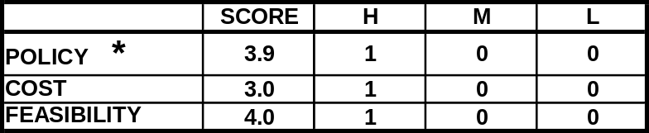
Assessment Summary
Russia Wharf – Navy Yard

  - Lovejoy Wharf, World Trade Center/Fan Pier
    - Characterization
The proposed service from Lovejoy Wharf to World Trade Center was originally identified as a key component of the CA/T transportation mitigation in the 1994 report. It is intended to link North Station and the South Boston waterfront. At the time, major expansion of the World Trade Center (WTC) was proposed including the Seaport Hotel and two adjacent office towers. The 1994 report recommended peak hour weekday service at headways of 15 minutes to serve as a through connection for commuters from northeast and northwest of Boston through North Station with work destinations in the South Boston waterfront area. The report projected substantial ferry ridership potential assuming completion and lease up of the WTC hotel and office complex, as well as other adjacent Fan Pier area development. The ridership projections assumed frequent direct service from WTC to Lovejoy and limited competition from private shuttle buses.
A temporary terminal was constructed at WTC on the northwest side of Commonwealth Pier, and service was started in 1999. The service operated on an irregular schedule of 20 to 35 minute headways during peak hours that was intended to connect with commuter rail arrivals. In 2000, a new South Boston stop was added at Federal Courthouse resulting in a longer trip to World Trade Center. Service did not attract the projected ridership for several apparent reasons:
- Scheduled headways were too infrequent and irregular to serve as the short, third seat ride for commuter rail or MBTA Orange Line/Green Line commuters;
- Private shuttle buses were operated at more frequent headways and a closer boarding location than the ferry at North Station;
- The walking trip from North Station to the Lovejoy landing was longer and more unpleasant than projected because of intense artery construction;
- The added Federal Courthouse stop made the ferry trip 5 to 8 minutes longer for the larger pool of WTC destined riders;
- The temporary WTC terminal was located 300 feet further out on Commonwealth Pier in a location not visible form Northern Avenue; and
- Completion and occupancy of the WTC hotel and office towers took longer than expected.
In 2001, this service was again modified to include an additional boat with direct peak hour service to Lovejoy to improve headways and reduce trip time. This change has resulted in increased ridership. With the completion and occupancy of the West Office Building in 2002, ridership demand was expected to increase further.
In order to fully capture the new demand, as well as build in capacity for future expansion of the waterfront area at such proposed development sites as Fan Pier, Pier 4, and Parcels G and J west of WTC, several modifications to the existing service have been proposed for operations and demand evaluation. It has also been recommended that the WTC terminal be relocated and expanded at Northern Avenue on the east side of Commonwealth Pier in the BIHPWTP and the Boston Inner Harbor Chapter 91 Passenger Water Transportation Report. The following modified route options have been identified:
1) Lovejoy to World Trade Center to Federal Courthouse during morning peak hours, reversing direction during the afternoon peak, at 15 minute headways (2002 - 2005). The purpose would be to offer more frequent headways (comparable to bus route frequency) and to provide a direct trip to and from the WTC area, which has a much greater number of commuter jobs than the Federal courthouse area.
2) Alternating direct routes from Lovejoy to WTC and Lovejoy to Fan Pier during morning and afternoon peaks (eliminating the Federal Courthouse route), at 10 minute headways (2005 –2010). At such time as there is a substantial pool of commuters to the Fan Pier catchment area, an alternating direct route would serve the Fan Pier, Pier 4, and the Federal Courthouse at more frequent headways than current services provide.
3) Lovejoy to WTC to Long to Lovejoy at off-peak and evening, at 20 minute headways weekdays and 30 minutes weekends (2004 or when Convention Center opens). The route would connect WTC to the downtown waterfront and provide connecting service to other ferry and transit links. The service would attract South Boston waterfront employees and visitors.
- WTC to Rowes to Airport: at peak and off peak periods with limited weekend service (2005-2010): The expanded Rowes shuttle would come on line as the Convention Center is completed and new waterfront hotels are added to the waterfront area. The triangular shuttle would serve business and visitor needs, while also offering a quick connection between WTC and Rowes Wharf.
The analysis herein addresses the Lovejoy Wharf to World Trade Center (or Fan Pier) shuttle service, with an off peak option to Long Wharf. The general specifications for the new and modified routes from Lovejoy to the South Boston waterfront, addressed herein, appear in Table 5-11.

Table 5-11
General Specifications

Lovejoy Wharf – WTC/Fan Pier Service
Infrastructure:  Dock, Water and Landside |  | Vessel Specific-  ations | Route and Schedule:  Peak, Off-Peak | Implementation Matters
Origin | Destination(s) | Vessel Specific-  ations | Route and Schedule:  Peak, Off-Peak | Implementation Matters
Lovejoy Wharf:  Existing 120’ dock, “temporary” location is likely to become permanent. No expansion of dock projected. | 1)World Trade Center: existing 80’ x 10’ ADA dock, future expansion to east face.  2) Fan Pier: requires future dock 200?  3) Federal Courthouse: existing 120’dock  4) Rowes or Long Wharf (off-peak): existing docks  5) Logan Airport (peak and off-peak): expansion of existing ADA dock | 49- 120 pass.;  low wake to pass Constitution Marina  10-15 knot operating speed | Weekday Peak: 6 - 9:30 am, 3:30 - 7 pm  Weekday Off-Peak: 9:30 am – 3:30 pm, 7 pm – 10 pm; 30 minute headway  Weekend Off Peak: 9:00 am – 7 pm; 30 minute headway | - Public operation: to use new MBTA shuttle vessels or private vessel concession.  - Funding after CAT; Chapter 91 funds plus MBTA. C91 contribution fund distribution mechanism needed, e.g., shared c91 and other contributions by all projects in catchment areas.  - Fare structure consistent with land transit and Inner Harbor shuttles.- Full MBTA pass use for commuters and visitors.-  - Modify existing Lovejoy –Federal Courthouse – WTC routes. Shuttle as complement to Silver Line and buses.  - Fan Pier service requires dock and partial buildout of Fan Pier and/or Pier 4 projects (2005-7 start?)  - Federal Courthouse service to be modified with all new routes
      - Route and service area
The South Boston Waterfront has developed steadily as a new core area work destination focusing to date around the World Trade Center complex, which has just opened its west office tower. With the Convention Center under construction (scheduled for 2004 completion) and the Fan Pier appearing to commence construction, the waterfront is expected to see an increasingly diverse new mix of uses during the next several decades. In order to fully understand the importance of the World Trade Center terminal location and proposed Lovejoy services, it is useful to understand the relationship of the four terminal sites designated for the South Boston Waterfront in the Boston Inner Harbor Passenger Water Transportation Plan adopted by the City of Boston in 2000. They include Federal Courthouse, Fan Pier, World Trade Center, and Wharf 8. The text and maps following are adapted from descriptions in the Boston Harbor Chapter 91 Passenger Water Transportation Report prepared for EOEA in 2002.
Catchment Areas, South Boston Waterfront
The combined South Boston Terminal catchment areas appear in Figure 5-5. The terminal sites are those shown in the BIHPWTP. Both primary (5 to 7 minute walking radius) and the secondary (8 –12 minute walking radius) areas have substantial overlaps, depending on the sites. For example, Federal Courthouse and Fan Pier terminals have a significant overlap for both circles, suggesting that services such as those to Lovejoy Wharf or the Airport be divided between the sites rather than duplicated. Redundancy of shuttle and commuter routes should be avoided for terminals with overlaps in primary catchment areas. The Wharf 8 site is expected to be the last of the four activated for commuter period services since the ridership is likely to be limited. It is not further considered herein.
There are several noteworthy aspects of the designated terminal sites and their respective catchment areas in South Boston:
- Relocation of the World Trade Center terminal from the west face to the east face of Commonwealth Pier is beneficial in terms of diminishing primary catchment overlaps of the two major terminal sites. Keeping the terminal on the west side of WTC could diminish the usefulness of the Fan Pier terminal.
- The Convention Center entrance plaza is within the secondary catchment area for World Trade Center, but not for Fan Pier or Wharf 8. Convention oriented shuttle services may be best concentrated at WTC.
- Federal Courthouse has a small primary catchment area because of the location on a curved site.
- MBTA Silver Line stops fall within the primary catchment areas of all four terminals with relatively equal walking distances of approximately 4 to 6 minutes from and to potential ferry locations.
- Locating the terminals and boarding areas as close to Northern Avenue as possible increases the primary and secondary catchment areas, while moving them further north on the piers diminishes their effective catchment potential.
Federal Courthouse. The courthouse dock has a limited catchment area because of its geographic location on the curving convex site. Much of its catchment area is literally in Boston Harbor. While some as yet undetermined development and ridership demand will take place on the adjacent McCourt/Broderick site, much of the development to the east will occur in the Fan Pier catchment area. Depending on future security needs, the Fan Pier may or may not prove a suitable site for seasonal services to the Harbor Islands and other visitor destinations. The primary catchment area overlaps with that of Rowes Wharf across the channel and with the proposed Fan Pier terminal, thereby limiting future expansion of services. The heightened security (following September 11, 2001) at the Courthouse and its perimeter further limits the likelihood of expanded service.

Figure 5-5

Lovejoy Wharf - WTC Route and Catchment Areas

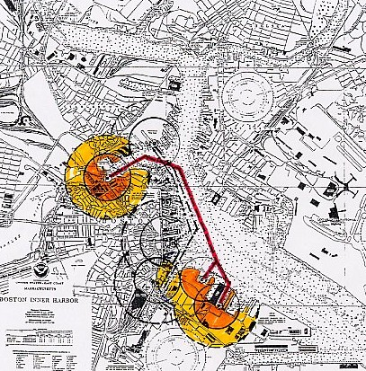
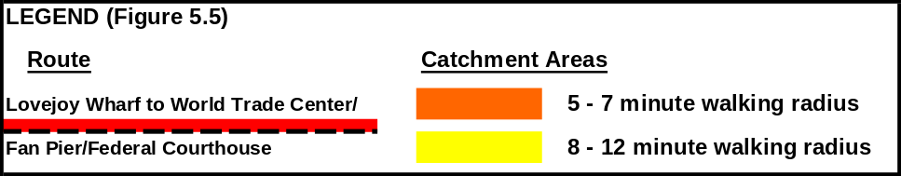

Fan Pier. The geography of the site on the Fan Pier combined with the higher density of buildout at the site and backland areas allows for larger primary and secondary areas than at the Federal Courthouse. The primary catchment area overlaps with that of Federal Courthouse and the existing World Trade terminal (see Figure 5.5). The proposed terminal will serve the Fan Pier, Pier 4 and the backland McCourt/Broderick property. The projected substantial buildout of these properties at the time of the report would be in the mid to long term period (2006 to 2020). Depending on the pace of development, a buildout of approximately 50 percent of the Fan Pier and Pier 4 projects (1.3 to 1.5 million square feet) would be needed to develop a critical mass of ridership for shuttle and commuter services based on the World Trade Center experience. At some point in the buildout period, the Fan Pier ridership in the overlapping catchment area will become substantially greater than the Federal Courthouse demand, and service may need to be shifted to the Fan Pier Terminal.
World Trade Center. The geography of the proposed new site allows for the maximum area of catchment since the dock location is further inland than Fan Pier or Federal Courthouse and expands the circles of primary and secondary areas. The catchment areas are based on relocating and expanding the shuttle terminal on the east side of the pier for the purpose of separating the catchment area away form Fan Pier and better serving sites further east along Northern Avenue. The World Trade Center site is likely to be the closest walking distance to the new Convention Center. In the short to mid-term, the terminal is likely to have the highest ridership demand since the exposition center and four adjacent buildings will be complete and fully occupied representing approximately 2,000,000 square feet of leased space.
Catchment Areas, Downtown Boston
Long/Central Wharf. The catchment area is the same as that described for the Russia Wharf service in section 5.2.2 and Figure 5.4.
Rowes Wharf. The Rowes Wharf catchment area overlaps substantially with the Long Wharf catchment, area extending a bit further west into the Financial District.
Lovejoy Wharf. The primary Lovejoy Wharf catchment area includes North Station, the Orange Line/Green Line MBTA station, the Fleet Center, various commercial office buildings in the Bulfinch Triangle area, and portions of the North End and City Square in Charlestown (Figure 5.5). The larger radius walking distance includes larger segments of residential and commercial areas in the Bulfinch Triangle, North End, West End and Charlestown, all areas that are experiencing new and renovation development. The area remains impacted by the Central artery construction and will be one of the last segments opened. Connections from the Lovejoy terminal area to North Station and the Fleet Center will be greatly improved by a new park after the artery is completed.
      - Schedule and vessels
The analysis for this service includes the consideration of both monohull and optimized catamaran, identical to those described for the Russia Wharf, Pier 4/Navy Yard service (see 5.2.1.2). Off peak options serving Rowes and Long Wharves and Logan Airport may be available in the future, but are not given detailed consideration herein. The proposed options require varied schedules depending on the markets served. The peak weekday commuter shuttles connecting from commuter rail and rapid transit need to be scheduled at frequent headways to appeal to multi-seat commuters from the north area. The future residents of the South Boston Waterfront headed for the downtown waterfront or the North Station area can be well served by less frequent schedules such as 15 or 20 minute headways. Off peak and weekend users can benefit from even less frequent mid-day and weekend services, at 20 to 30 minute headways, as they are able to schedule trips around the service schedule and are less likely to be transferring modes.
The route options evaluated are shown in Table 5.13. “Peak Service #1” is Lovejoy to WTC (or Fan Pier), with off peak service including stops at Long Wharf as well. “Peak Service #2” is Lovejoy to WTC to Federal Courthouse (reversing order during the afternoon peak hours), also with off peak service stops at Long Wharf. In both cases, the purpose would be to offer more frequent headways (comparable to bus route frequency) and to provide a direct trip to and from the WTC area, which has a much greater number of commuter jobs than the Federal courthouse area. If shuttle bus routes (MBTA or privately operated) were to continue, it might be useful to stagger the schedule to complement the ferry departures and offer commuters a choice of modes with 7-8 minute headways. Peak Service #1 is the subject of the detailed policy, feasibility, and finance assessment.
Other possible future service configurations include the following:
- Alternating direct routes from Lovejoy to WTC and Lovejoy to Fan Pier at morning and afternoon peaks. This service would eliminate the Federal Courthouse route and provide 10 minute headways (2005 –2010). At such time as there is a substantial pool of commuters to the Fan Pier catchment area and a larger overall ridership catchment for the central South Boston Waterfront, the alternating direct route would serve the Fan Pier, Pier 4, and the Federal Courthouse at more frequent headways than current services provide.
- Lovejoy to WTC to Long to Lovejoy at off-peak and evening. Provided at 20 minute headways weekdays and 30 minutes weekends (2004 or when Convention Center opens). The route would connect WTC to the downtown waterfront (at existing Long or proposed Central Wharf shuttle landings) and provide connecting service to other ferry and transit links. The service would attract South Boston waterfront employees, convention Center attendees, and general visitors.
Table 5-12

Schedule and Vessels

Lovejoy Wharf – WTC/Fan Pier Service
Routes, Distances |  | Peak Route Cycles, Schedules, and Vessels Needed |  | Off-Peak Schedule and Vessels Needed.
Service Option #1 | Service Option #2 | Weekday Peak: 6-9:30 am and 3:30-7 pm; Headways 10 or 15 Min |  | Weekday Off-Peak, Route #3: 9:30 am – 3:30 pm and 7 pm –9 pm; Headway 30 min
Service Option #1 | Service Option #2 | A. Conventional Monohull | B. Optimized Catamaran
Peak Service: Lovejoy to WTC (or Fan Pier)  Trip Distance:  - One Way = 1.9 nm  - RT = 3.8 nm  Off-Peak Service: WTC to Long Wharf to Lovejoy  Trip Distance:  - One Way = 2.1 nm  RT = 4.2 nm | Peak Service: Lovejoy to WTC to Federal Courthouse  Trip Distance:  - One Way = 2.4 nm (1.9 nm return)  - RT = 4.3 nm  Off-Peak Service: WTC to Long Wharf to Lovejoy  Trip Distance:  - One Way = 2.1 nm  RT = 4.2 nm | A1-15→ Peak Route #1, 15 min headway  - Trip Time: 16 min  - Cycle Time: 35 min.  - Peak Vessels Needed: 3  A1-10→ Peak Route #1, 10 min. headway  - Trip Time: 16 min  - Cycle Time: 35 min.  - Peak Vessels Needed: 4  A2-15→ Peak Route #2, 15 min. headway  - Trip Times: 16/6/15 min  - Cycle Time: 45 min.  - Peak Vessels Needed: 3  A2-10→ Peak Route #2, 10 min. headway  - Trip Time: 16/6/15 min  - Cycle Time: 45 min.  - Peak Vessels Needed: 4 | B1-15→ Peak Route #1, 15 min headway  - Trip Time: 12 min  - Cycle Time: 27 min.  - Peak Vessels Needed: 2  B1-10→ Peak Route #1, 10 min. headway  - Trip Time: 12 min  - Cycle Time: 27 min.  - Peak Vessels Needed: 3  B2-15→ Peak Route #2, 15 min. headway  - Trip Time: 12/5/12 min- Cycle Time: 35 min.  - Peak Vessels Needed: 3  B2-10→ Peak Route #2, 10 min. headway  - Trip Time: 12/5/12 min  - Cycle Time: 35 min.  - Peak Vessels Needed: 4 | Weekend off-peak: 9:00 am – 7:00 pm  Cycle Time:  Vessel A: 50 min  Vessel B: 40 min.  Vessel A – 30 min. headway  Vessel B: 20 min. headway  Vessels Needed:  Vessel A:2  Vessel B: 2

      - Terminal infrastructure
Comprehensive development guidelines for the area were described in the South Boston Public Realm Plan completed by the BRA in February of 1999. Chapter 91 offsets and water transportation objectives were described in the South Boston Waterfront Municipal Harbor Plan completed in the fall of 2000, and approved with conditions in the Secretary’s Decision of December 2000. Many aspects of the district ferry plan presented in the infrastructure description were included as water transportation infrastructure components of the BIHPWTP, and were further modified in the “Boston Harbor Chapter 91 Passenger Water Transportation Plan” prepared for EOEA in 2002. The updated infrastructure plans were developed in conjunction with specific emerging projects, parcel development, and stakeholder interests. All possible future landing sites are described following; emphasis for the purpose of this assessment should be upon the World Trade Center, Fan Pier, and Lovejoy sites, as per Table 5-14.
World Trade Center. As the primary terminal in South Boston, the existing World Trade Center Marine Terminal is proposed for expansion on both sides of Commonwealth Pier, which is currently the most active and diversified area along the South Boston Waterfront. With the proposed reconfiguration of Viaduct Street as a key pedestrian link, the terminal will be best situated to serve the new Convention Center and related new development. As described in the short term and in the mid term, the terminal will accommodate a full range of interlinking services including Inner Harbor shuttle, seasonal excursion, water taxi and cultural loop, as well as charter, and possibly commuter service. By locating components of the expanded ferry terminal along Northern Avenue as well as the inboard ends of the pier apron, the ferry landings will have the greatest exposure and access for pedestrians. In addition to passenger terminals, the WTC apron is large enough to provide layover berthing, as well as to accommodate other excursion services.
Both northwest and southeast faces of Commonwealth Pier are well protected from wind and wave action. The deck height is 18 feet above mean low water (MLW), creating the need for a longer ramp to the floats than at many other inner harbor sites. Because of the considerable length of the pier, 1200 feet, the Northern Avenue ends of the apron are strongly favored for shuttle and other services. While the southeast (east) face is favored year round owing to longer hours of sun, the northwest (west) face is in sunlight during the afternoon, which can be important during winter months. The pier is owned by Massport, and leased to and managed by the World Trade Center.
A variety of terminal locations and services are provided from WTC at present. A shuttle service to Lovejoy Wharf and Federal Courthouse was initiated by the MBTA in 1997, and continues to attract expand ridership as it becomes better known to commuters from the north areas. Seasonal services to Provincetown are provided by Baystate Cruise Lines from the west face. A variety of other excursion and charter services are also based at floats on the east face. Future services may include; expanded year round shuttle services to a variety of inner harbor sites including downtown and Logan Airport, seasonal transit/excursion services to the Harbor Islands, North Shore, South Shore and Cape Cod. In addition, water taxi and Cultural Loop landings are needed in conjunction with public landing space. The rate at which new or expanded terminal facilities would be required will depend on the schedule and location of new development within walking distance of the various terminal locations.
The preferred option would be to add a new landing on the east face. The east face components would include a 120-foot commuter and excursion dock parallel to the apron. In addition, a 100-foot shuttle dock would be installed parallel to Northern Avenue. The two new east face float docks would be served by a covered waiting area and accessible ramp system located at the corner of the apron and Northern Avenue, with an appearance similar to the existing west face Marine Terminal entrance.
Further expansion of the east face dock facilities is proposed for the mid-term in response to completion of the Convention Center and related hotel, office and retail development. On the east face, the initial commuter dock could expand and/or move to the north, allowing additional shuttle dock space at its original dock site. The area parallel to Northern Avenue would be filled in with floats for water shuttle and water taxi/cultural loop landing, with a new entry ramp connecting to the west face of the Fish Pier.
Land based improvements would include further expansion of intermodal shuttle bus and pedestrian pathways, as well as adequate curb-based bus storage for package tour groups. Further signage would be completed to announce new services and dock locations.
Fan Pier. The Fan Pier basin terminal site is included as a featured element in the master development plan for the mixed use waterfront complex currently in the planning and design process. The project recently received approval under the MEPA review (November 2001). The currently exposed basin area would be protected by the addition of a breakwater along the harbor edge, and a floating multi-purpose dock facility added in the central area. While the details of such a terminal are still emerging, there are several terminal design guidelines which might be considered for the final layout and organization as described in the mid-term component section.
The phasing of overall Fan Pier construction is still evolving, but generally anticipates a major build-out of the site during the next 4- to 5-year period. For purposes of this report, it is assumed that the ferry terminal transit and excursion uses are most likely to occur early in the mid-term time frame.
The mixture of recommended uses is based on the current understanding of land-use and density proposed for the site. At full build-out, there may be future demand for shuttle connections to such sites as North Station, Downtown, and Airport. In addition, water taxi and cultural loop landings would be useful, as well as excursion type links. The organization of such uses would include the smaller water taxi and cultural loop landing at the inland end, followed by the shuttle dock zone in the middle and the excursion and charter activities at the outer end.
The short and mid-term components (as described in the final project EIR) would include Fan Pier Basin terminal infrastructure as the surrounding site is developed. Ferry services could be added as sufficient demand is created for transit or excursion services. The figure shows a multi-purpose floating terminal superimposed on the current site master plan. The inboard western corner of the basin appears to be the best location based on the proposed landside street and harborwalk plan. In addition, the terminal floats are located over a shoal area in the middle of the basin which is the remnant of a former pier site, which should reduce the need for dredging. The terminal will need an adequate turning basin for harbor shuttle and excursion vessel access. Protection of the basin area from the general harbor chop and the northeast fetch will be important to the success of the ferry terminal. The protected basin and terminal can serve as an activity generator, and could have the character of a Rowes Wharf depending on the type of adjacent building development and ground level uses that evolve. Landside improvements which should be included would be an accessible ramp system, a covered waiting area and ticketing area, signage throughout the site and along Northern Avenue, vehicular drop-off area, and preservation of view corridors to the terminal location.
Federal Courthouse. The existing Federal Courthouse Terminal was completed along with the site landscaping in 1998. The dock facility was served initially by a single ramp and was not compliant with access requirements. When the federal management entity, the General Services Administration (GSA), requested that the MBTA include the Courthouse in a shuttle route from North Station to World Trade Center, commitments were made to adding a mechanical ramp/lift commercially called a Ramp-Rider, the first such device to be installed in the Boston Harbor. In addition to the dock facilities, there is an enclosed waiting and ticketing area, along with rest rooms and office facilities, located in the nearby arcade of the Courthouse. It is now compliant with ADA requirements.
A program of vessel uses has evolved including the North Station/Lovejoy shuttle, a seasonal ferry to Little Brewster Island and its lighthouse as part of the Harbor Islands National Recreation Area service, and a variety of excursion services. The GSA has declined to have a water taxi dock or public landing at the site, for security reasons, but would accommodate a cultural loop service if it were activated. Security concerns post 9/11 in late 2001 curtailed any use of the docks including shuttle connections for several months.
Mid-term considerations include dock facilities with the potential to be expanded with the addition of two finger piers, of 120 feet each. These would allow for tripling berthing capacity at the Courthouse. The diversified terminal is expected to be used by visiting vessels such as the schooner Ernestina, as well as other scheduled shuttle, cultural loop activities, and Harbor Islands links. It should be noted that tightened Federal Courthouse security may affect the availability of the dock for scheduled harbor ferry services, which in turn may alter the need for terminal expansion.
Long Wharf and Central Wharf. Several of the route options being considered would involve stops at one of the existing or proposed Long/Central Wharf landings. The landing infrastructure is described above in section 5.2.1.3.
Lovejoy Wharf. The existing terminal at Lovejoy Wharf was constructed in 1997 to provide a ferry link to North Station as part of a package of environmental mitigation measures required as part of the Central Artery project. The floating terminal is located within a three to four minute walk of commuter rail and subway platforms. The specific terminus location was intended to be temporary, with the floats and ramps to be relocated to a reconstructed Lovejoy Wharf at a later date. The terminal is currently used for shuttle services to Pier 4/Navy Yard, Federal Courthouse and World Trade Center. A water taxi landing is also available.
Terminal Design and Service Objectives: The current dock facility is one of the fully accessible terminals in the inner harbor. The 120-foot long float has two freeboard heights at 4 feet for shuttle vessels, and at 2 feet for water taxis. An ample sheltered waiting area is included at the site. Capacity for berthing of ferry vessels is limited by the single loaded configuration, which was originally intended for the relocation parallel to Lovejoy Wharf.
Projected route expansion at the terminal for multiple new shuttle routes indicates a potential need for doubling berthing capacity. Other needs would include a vehicular drop-off area, and more direct and attractive pedestrian connections to North Station commuter rail platforms and subway locations. The water-taxi, cultural loop, and public landing area may also require future expansion. However for purposes of this evaluation, no landing expansion is projected as needed for the expansion of existing south Boston routes alone. A detailed description of proposed Lovejoy landing expansion and landside support facilities is described in the BIHPWTP, and updated in the EOEA Chapter 91 Water Transportation Report. The description is summarized as follows:
Proposed Concept Plan As part of the Central Artery project, the original master plan for the continuation of the esplanade park past North Station included relocation and expansion of the current Lovejoy Wharf Terminal from its present location on Lomasney Way to a reconstructed Lovejoy Wharf in front of the Hoffman Building. The configuration of the walkway and park in that area is currently undecided, and leaves two options for the future site of the terminal: 1) in its present location or 2) in the original master plan site with potential modifications. Until the plans are finalized for the park and walkway, and decisions finalized with respect to the reconstruction of Lovejoy Wharf proper, it will be difficult to determine the final siting of the terminal. For purposes of the study, the current location, with expansion modifications, is described as the short term site.
Table 5-13
Terminal Infrastructure Status and Needs
Lovejoy Wharf – WTC – Fan Pier – Courthouse Service
Infrastructure Status:  Dock, Water and Landside |  | Infrastructure Construction Costs (New or Renovated)  Dock, Water and Landside
Lovejoy Wharf | WTC, Fan Pier, Courthouse | Lovejoy Wharf | WTC, Fan Pier, Courthouse
Existing, constructed by CAT in 1997: no improvements no improvements or relocation projected at this time, | 1) WTC: Existing dock has limited capacity; future relocation to east face and expansion.  2) Fan Pier: requires new dock.  3) Federal Courthouse: existing | None planned at this time. | 1) WTC: future relocation and expansion to east face $1.2M.  2) Fan Pier: Proposed new dock with Chapter 91 funding of $1.5M. No schedule for completion available at this time.

    - Field Work
Site visits to the existing World Trade Center, Federal Courthouse, Rowes Wharf, Logan Airport, and Lovejoy Wharf sites as well as the proposed Fan Pier site were conducted in April of 2002. In addition, the recently completed Long Wharf/Central Wharf shuttle terminal was visited at the same time. The site visits included a shuttle ferry trip from Long Wharf to Pier 4 to Lovejoy Wharf to World Trade Center.
    - Service Assessment
      - Maturity evaluation
This service has been the subject of several Commonwealth and Inner Harbor-wide studies, and scored quite well on the maturity evaluation (0.8 on scale of 0 – 1.0). The 1994 Inner Harbor Study included detailed financial and service projections, although without the rudiments of a ferry operations plan. The 2000 Inner Harbor Passenger Water Transportation Plan included interim and long-term terminal concept plans for all three sites. Construction plans are not yet complete, however, and some permitting for each still lies in the future.
The MBTA currently runs service among these three terminals. Near term operations as described herein (new boats and higher service frequency) are likely only between Lovejoy and WTC. The ridership projections developed in 1994 indicated the probable need for a subsidy on this route; an up-to-date demand analysis appears below.
Financial backing for the service is partially in place through Chapter 91 agreements. Funding for an improved WTC terminal will likely be sought by Massport.
      - Categorical evaluation
        - Policy
This route scores very well (3.77 on a scale of 5.0), on the strength of public transit enhancements, waterfront access and disability accommodations, and public private development of City waterfront. The service will be run by the MBTA, with fare comparability, and at least will add capacity to the MBTA system. The service will offer an excellent alternative to commuters into North Station who must travel to the emerging work destinations in South Boston.
Environmental aspects are on the whole favorable because there are no impacts on sensitive areas and wake and wash does not figure to be a problem. Again, the air quality impact score is neutral because of data uncertainties. Public access to the waterfront will certainly be enhanced, especially at the Lovejoy landing where activity is now somewhat light. All the facilities will have disability access as well.
These terminal development projects are closely linked to ongoing and future development projects, both public and private. The Inner Harbor Transportation Plan shows physically integrated landing facilities and Chapter 91 permits have put financial partnerships in place as well.
Summary scores appear in Table 5-14. Detailed scoring appears in Appendix E.
Table 5-14

Assessment Tool Policy Summary

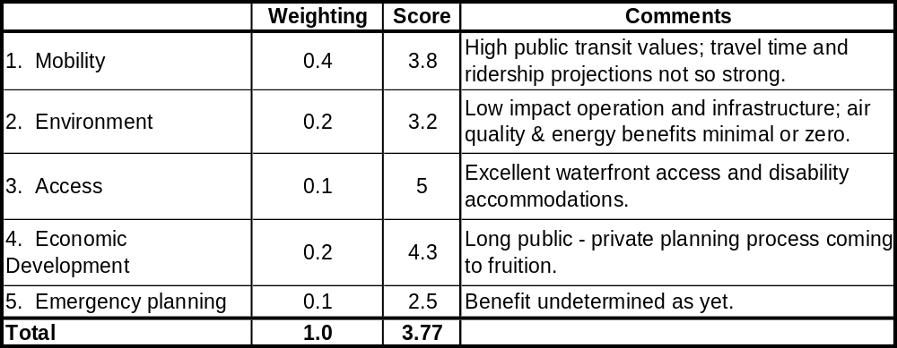
Lovejoy Wharf – World Trade Center – Fan Pier – Courthouse Service

        - Feasibility
This route scored 3.63, on a scale of 5.00, with high “vessel and route” and “environmental matters “values. The infrastructure score was slightly above average because, while the conceptual planning products are in place, they are missing certain elements such as lighting, rest rooms, and bicycle accommodations, especially at WTC & Fan Pier. These three sites should otherwise provide the features expected of a modern ferry terminal. Intermodal access to public transportation is good in all cases, but the South Boston terminals lack dropoff and bicycle accommodation designs at this point.
The boats selected here to meet the MBTA’s specifications would be very well suited to operation on this protected route. Each terminal has some drawbacks associated with tight navigational approaches and proximity of marinas. The Lovejoy Wharf is very well protected, but the WTC and Fan Pier sites will be exposed to easterly winds and considerable fetch over the Harbor.
The environmental values of this operation are generally high. There will be no adverse waterway impacts (dredging, sensitive areas), but, like all services considered herein, the impacts or benefits on air quality are presently uncertain. Removal of a small number of automobiles from the city’s roads is possible. The service will provide additional choice choosing among public transit options and will enhance system capacity.
The summary results appear in Table 5-15. Full details of the assessment appear in Appendix E.

Table 5-15

Assessment Tool Feasibility Summary
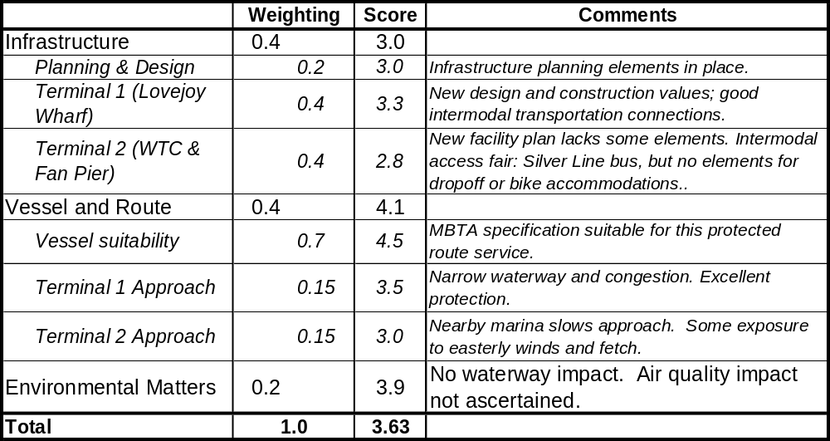
Lovejoy Wharf – World Trade Center – Fan Pier Service

        - Demand estimation
There was no demand estimate prepared for this service due to schedule constraints.
        - Finances
The result of the vessel operating cost analysis is quite different from that for the Russia Wharf – Navy Yard service and is instructive. The catamarans’ higher service speed results in a significant cost advantage on this route because this route is longer. One less boat is therefore needed for both the 10 and 15 headway schedules, relative to the monohulls. Debt service, insurance, and maintenance costs are virtually even because the catamarans’ unit cost is higher, and fuel costs are very close as well because of varying consumption rates.
Labor costs would be approximately $132K and $157K lower with catamarans for the 10 and 15 minute headway services, respectively. The total cost is lower by $126,555 and $202,267, for the 10 and 15 minute headway services, respectively. The reader should note that these costs include all off peak hours as indicated in Table 5-13, as opposed to the peak hours only estimates which appear for the Russia Wharf – Navy Yard service (for the purpose of direct comparison to the peak hours only demand estimate). The full hours estimate for the Lovejoy Wharf service illustrates total costs for an Inner Harbor route as it would be likely to actually operate. The summary appears in Table 5-17.
Capital infrastructure costs total $2.7 million for future WTC landing relocation and expansion to east face ($1.2 million) and the proposed new dock at Fan Pier ($1.5 million) to be completed with Chapter 91 funding. There is no schedule for completion available for these projects at this time.
Table 5-16

Annual Vessel Operating Costs

Lovejoy Wharf – World Trade Center or Fan Pier Service
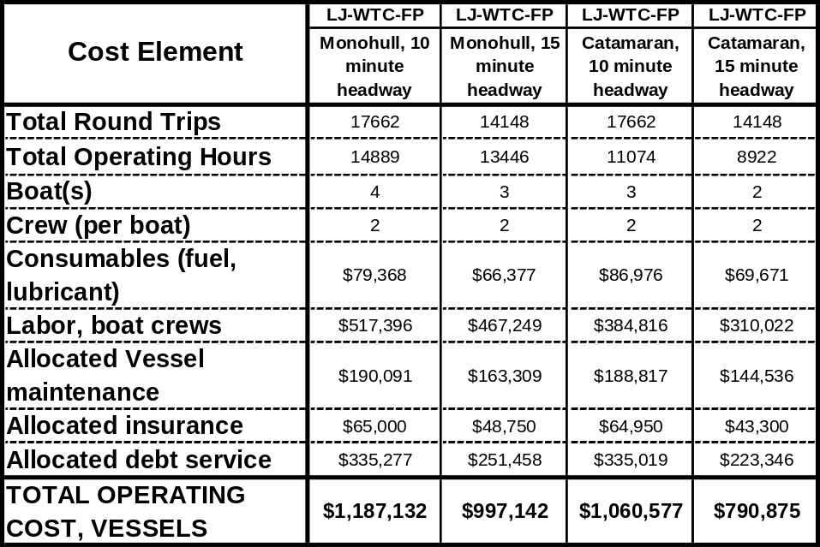
    - Summary
The Lovejoy Wharf to South Boston waterfront service scores very strongly in the policy and technical feasibility categories, the latter including the assumption that suitable new vessels, as per the recent MBTA specification, are brought into service. The financial analysis is incomplete because of the lack of demand estimates. The estimated cost results are very similar to those for the Russia Wharf to Navy Yard service, with the advantage that the speed of optimized catamarans would provide a significant savings, i.e., one less boat operating at the same headways at lower operating cost.
The Lovejoy service must be viewed as a very strong candidate for future public support, on the strength of its policy and feasibility scores. It requires a detailed market and demand analysis, however, before commitment of resources to infrastructure and operations. The recommendation is to conduct the demand analysis with the best possible information on the future buildout of the South Boston waterfront, with an improved ferry demand methodology as discussed in Chapter 6.
Table 5-17

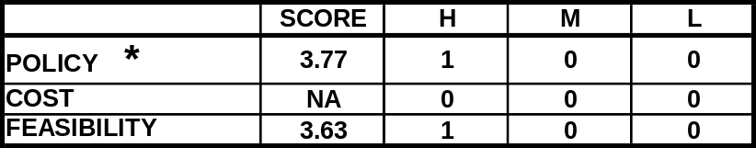
Assessment Summary
Lovejoy Wharf – World Trade Center – Fan Pier – Courthouse Service

  - Summary Findings and Recommendations
The two Inner Harbor candidate services were selected based on their role as missing links in the multi-modal commuter transit network serving downtown and nearby work destinations. The new Russia Wharf to Charlestown Navy Yard service would offer Navy Yard and City Square commuters a through connection from South Station connecting with south sector commuter rail services and the Red Line subway, while also providing an additional choice for Charlestown residents commuting to downtown. The expansion of existing Lovejoy Wharf to World Trade Center/Fan Pier services would provide a through connection for South Boston Waterfront destined commuters from North Station connecting with north sector commuter rail and subway lines, while also providing a link from future South Boston residents to North Station employment destinations. Off peak and weekend routes may include additional stops to serve weekday workers as well as visitors. Numerous other Inner Harbor services are also likely to contribute to a future network of cross harbor ferry links, including Logan Airport and East Boston shuttles, but were not addressed in this report.
The Russia Wharf to Navy Yard service is a mature proposal that scores well in all three categories of policy, feasibility, and finance. The finance assessment has a strong result overall; the farebox recovery ratio and per passenger subsidy compare well with MBTA rail operations. The caveat is that the per passenger-mile subsidy is at least four times higher, because the route is much shorter. The recommendation is to support the development of its infrastructure and vessel operations. In addition, there should be further exploration of the idea of combining this route with the Long Wharf – Navy Yard route using catamarans. Such a service could offer frequent headways and quick trips and do so with fewer boats than two separate services.
The Lovejoy Wharf to South Boston waterfront service scores very strongly as well in terms of policy and feasibility; the finance assessment is incomplete in the absence of a demand estimate. The overall indication is good for public support of this service, and the recommendation is to conduct a demand analysis with the best possible information on the future buildout of the South Boston waterfront, and with an improved ferry demand methodology.
While the Russia Wharf – Navy Yard service indicates fair economic competitiveness with rail transit, it and other Inner Harbor services may be seen to compare poorly on the basis of adding new transit riders, i.e., those who have not used transit before. The true value of ferry service is that it can add core system capacity in the downtown area for relatively small capital expense, compared to landside projects. The value as a carrier of off peak riders is difficult to quantify, but should certainly be borne in mind as the Harborwalk and other improvements knit the waterfront’s old and new attractions more closely together.
Transportation System Policy Issues
- These services fill and improve two transit gaps in the Inner Harbor by providing ferry shuttle connections from North and South Stations to cross harbor destinations.
- They provide intermodal links for MBTA transit and rail service, as well as augmented core system capacity.
- Addition of time and cost competitive land/water transit connections should attract a combination of current transit riders, and possibly divert future auto commuters.
- Current transit alternatives to the North and South Station ferry connections include public and private land-based shuttle buses with varying headways and fares.
Technical Feasibility
- Status of infrastructure varies for different sites: new facilities are needed at Russia Wharf (projected for completion by CA/T in 2004), expanded facility at WTC (in study by Massport), and new facility at Fan Pier (Chapter 91 license requirement).
- Previously considered MBTA shuttle fleet specification boats could be used to achieve desired headways and trip times.
- Optimized new bow-loading, highly maneuverable shuttles can reduce headways and trip times while also providing more service with fewer vessels. Such vessels would be beneficial on all Inner Harbor routes.
Finance
- Inner Harbor shuttle services currently managed by the MBTA (Long/Navy Yard, Lovejoy/Navy Yard, Lovejoy/South Boston) are currently supported by Central Artery/third Harbor Tunnel Chapter 91 and MEPA mitigation obligations through Artery completion (early 2005). Alternative funding from the MBTA, Chapter 91 obligations for other licensed projects, and/or other sources, will need to be identified to continue existing operations and to initiate new services.
- Fare levels for new and expanded services need to be kept at levels comparable to other inner core zone transit fares, and should be included in pass programs to attract riders.
- It appears unlikely from the ridership demand and service evaluation that peak period fare-box collection will be sufficient to cover operations costs and/or make such services attractive as for-profit private shuttle operation. However, the Russia Wharf service compared well to MBTA rail modes in terms of fare box recovery and per passenger subsidy, when accounting for capital costs and debt service was treated consistently with the MBTA’s financial analysis. The relatively modest capital expense of getting an Inner Harbor ferry service started is a strong feature of these operations.
- Where strong linkage between Inner Harbor ferry routes and rail services can be shown, the unit subsidy value should be calculated for the total multi-seat transit trip rather than for just the link itself.
- Catamarans have higher unit costs and unit per time unit costs than the monohulls and each, therefore, is more expensive to operate on an annual basis. Their speed advantage results in a significant cost advantage over the longer Inner Harbor routes (Lovejoy Wharf to South Boston waterfront and the combined Long Wharf – Russia Wharf – Navy Yard service), in which cases one less boat is needed for the 10 and 15 minute headways.
- The Navy Yard to Russia Wharf service has a shorter route distance and monohull and catamaran fleet sizes are the same for both headways examined. In this case, catamaran fleet total costs are 18 and 16 percent higher for the 10 and 15 minute headways, respectively.

Operations
- These assessments have stressed the importance of service improvements, including more frequent headways and shorter trip times. For the shuttle connections to attract riders, especially on multi-seat commuter trips, the peak period headways should be frequent and consistent with connecting modes.
- Operations may include direct ownership and management of vessels by MBTA or concession to private operators as currently exists.
Russia Wharf to Charlestown Navy Yard Service Findings
- Ridership demand projections by CTPS for 2010 (using the metropolitan area transportation model) are for 800 peak period trips per weekday, or the equivalent of 16 boatloads of passengers at 50 passengers per trip.
- This service is financially competitive with other public transit modes as measured by farebox recovery and per passenger subsidy, although not as strong on a per passenger-mile subsidy basis. This is due in large part to the short distance covered by the service.
- The proposed ferry services compare well time-wise, for users in their catchment areas, to current land transit alternatives, which include infrequent cross downtown bus service from Downtown Crossing to Charlestown Navy Yard.
- There is an opportunity to combine the existing Long Wharf - Navy Yard and the proposed Russia Wharf - Navy Yard services into a single triangular route to save on boats needed and operating costs. Service consolidation would require further demand and financial evaluation.

Lovejoy to World Trade Center/Fan Pier Findings

- No ridership demand projections were developed for this report. It is recommended that such projections be developed with a modified ferry shuttle transportation model.
- Full utilization of the North Station to South Boston Waterfront will depend on substantial build-out of proposed development.
- The Fan Pier Terminal and vessel operations support are required as a Chapter 91 license conditions for the Fan Pier project. Other South Boston waterfront development projects are also likely to have operations support license requirements as well.
- More frequent headways, lower fares, and direct routes appear to be needed for Lovejoy to South Boston, compared to the current service, in order meet commuter rail and subway links and attract increased ridership. .
- Current land transit alternatives to the proposed ferry service include several free, privately operated shuttle services and cross downtown MBTA bus service from North Station to WTC. Future ground alternatives would be more frequent headway scheduled MBTA bus services or new public shuttle buses.
- Off peak services could include downtown stop at Rowes or Long Wharf.

- Assessment: Outer Harbor Services
This assessment is limited to the proposed expansion of the Quincy to downtown and Logan Airport service.
  - General Characteristics and Guidelines
    - Operating area description
Boston’s Outer Harbor is defined for these purposes to include the area lying within a line between Deer Island (Winthrop) on the north and Point Allerton (Hull) on the south shore. The Boston Harbor Islands lie within the Outer Harbor and attract many visitors during the summer and shoulder seasons. Many of these islands are now part of the Harbor Islands National Recreation Area, including Georges Island, Grape Island, Spectacle Island and Little Brewster Island. Park passenger ferries, free water shuttles, and park tour boats serve several of these islands.
The Boston Harbor Islands National Recreation Area became a unit of the National Park System in November 1996 by an Act of Congress (Public Law 104-333). It includes 34 islands that lie within the large "C" shape of the Boston outer Harbor. The Boston Harbor Islands Partnership represents a range of federal, state, city, and private agencies, and coordinates the activities of the managers of the islands in the development and implementation of a management plan for the national park area. Members of the Partnership include: National Park Service, U.S. Coast Guard, Massachusetts Department of Environmental Management, Massachusetts Port Authority, City of Boston, Boston Redevelopment Authority and several other agencies.
The other prominent feature of the Outer Harbor is President Roads, the designated commercial shipping channel from Massachusetts Bay to Boston Harbor. It runs between Deer Island on the north and Spectacle and Long Islands on the south, with depths of 30 to 60 feet. It is approached from the northeast by the Boston North Channel and the Boston South Channel (U.S. Coast Pilot, volume 1). Nantasket Roads lies between Hull and Peddock’s Island on the south George’s and the Brewster Islands on the north, and is the main channel from Massachusetts Bay to Quincy and Hingham Bays in the southern area of the Outer Harbor.
Existing ferry operators in the outer harbor include Boston Harbor Cruises and the MBTA Fore River Quincy service. Boston Harbor Cruises provides excursion service to and from the Boston Harbor Islands and provides a commuter service from the Hingham Shipyard to Rowes Wharf. The MBTA Fore River Quincy service provides service between Quincy-Boston-Logan Airport and Hull.
    - Similar services
Several routes in San Francisco offer commuter services, and are also actively used by visitors and residents during off- peak weekdays and weekends. San Francisco’s Blue and Gold Fleet operates from Tiburon (Marin County) to Pier 41 (Fisherman's Wharf), a route approximately 4.4 nautical miles in length. This route has existed for thirty-seven years and is a year round service ferry operation. The route serves both commuter and recreational passengers and is also a good analogy because San Francisco is similar in size and scale to Boston. Blue and Gold also operates from Tiburon to the San Francisco Ferry Building, a route more dedicated to commuter service, approximately 6.3 nautical miles long.
The Ferry Building route carries an average of 700 one-way riders a day, 14,000 a month and 170,000 a year, on a vessel whose capacity is 388. The Fisherman's Wharf service carries approximately 135,000 passengers a year. Blue and Gold Fleet use different vessels depending on the time of year ranging from 388-693 passenger capacities for this route. Mode splits may be similar since the Tiburon traveler’s other choice is the Golden Gate Bridge, often a long, tedious journey, similar to the Route 3/Southeast Expressway option for the Quincy area traveler.
Another similar route in San Francisco is the Harbor Bay Maritime service operating from Bay Farm Island, Alameda to the Ferry Building, San Francisco. The route is approximately 7.5 nautical miles (see Figure 6-1) and has been successful for ten years. This year round service attracts approximately 135,000 passengers a year and most of those passengers are commuters. Harbor Bay Maritime operates a 250-passenger high-speed catamaran with an average speed of 24 knots. The traveler’s choices here are also similar, i.e., the Bay Area Rapid Transit system or the Oakland Bay Bridge-Tunnel (Route I 80).

Figure 6-1
Harbor Bay Maritime Alameda – San Francisco Service
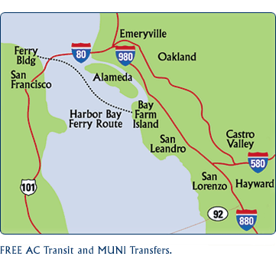
Harbor Bay Maritime webpage, www.harborbayferry.com

The Monmouth County, New Jersey commuter ferry services have somewhat longer routes than the Quincy and Hull service, but use similar 30 knot catamarans, and operate within semi-protected waters in a climate similar to Boston’s. The routes are:
- Highlands, New Jersey to Pier 11/Lower Manhattan and E. 34th St./Midtown (SeaStreak and New York Fast Ferry)
- Atlantic Highlands, NJ to Pier 11 and E. 34th Street (SeaStreak)
- Belford, NJ to Pier 11 and E. 34th St. (New York Waterway)
    - Transportation policy issues
Transportation policy issues and choices vary with each of the Outer Harbor route segments and their respective catchment areas. The Quincy to Downtown and Hull to Downtown components have similar peak commuter policy implications, while the Quincy to Logan service addresses a distinct market. There are several important common transportation policy choices relating to all components of the Quincy services and the nearby Hingham ferry route. These choices tend to reflect current state and metropolitan Boston transportation policies, primarily relating to diversion of single or low occupant auto commuters. The main difference between the Quincy service and the Inner Harbor and Massachusetts Bay candidate service is that the Quincy routes are all currently in operation. The policy choices concern public policy and investments to expand service and ridership, rather than start-up of new routes. They are:
- Diversion of auto commutes. Ferries would provide South Shore communities with expanded and more competitive water-based transit alternatives to the current ground transportation options. The Quincy and Hull ferry routes offer an improved alternative to auto commutes in coastal neighborhoods without convenient transit access. The most effective diversion of auto commutes is primarily achieved through reliable year round mode transfers.
- Improved multimodal choices tailored to local catchment areas combined with enhancement of local feeder bus links. Communities near the Quincy Fore River ferry site currently have Red Line subway park-and-ride stops at Braintree, Quincy Adams, and Quincy Center with varying parking capacity and time availability depending on the location. Hull is limited to bus service as a local transit option, and a longer auto travel distance from the peninsula. The future Greenbush line is expected to ease demand for the Red Line somewhat, but will add no local stations in Quincy. For communities with commuter rail or express bus service, the ferry routes could provide complementary transit options with downtown destinations less directly served by current transit routes. For communities with very limited or no transit, new ferry routes could offer time and cost efficient alternatives to auto commutes.
- Reduction of vehicle miles traveled (VMTs). Diversion of auto users to ferries can incrementally assist in reduction of VMTs along heavily traveled highway corridors for commuters, seasonal visitors, and Logan Airport users.
- Regional air quality attainment through traffic congestion reduction. New ferry routes could contribute incrementally to reducing congestion and air pollutants within the heavily traveled highway corridors. In order to achieve net gains for different types of emissions, new marine propulsion technologies will be required for the medium to high speed vessels required for these routes. The technology is available and proven internationally, but is not yet required for new ferry vessels on a state or federal basis.
- Economic development stimuli. Both Hull and Quincy have potential for connections to cultural and residential resources, currently feature visitor attractions that could benefit from regularly scheduled ferry connections to downtown Boston, and in turn would also send residents to Boston at off-peak weekday and weekend periods. There would be a seasonal bias for such recreational visitor uses.
    - Vessel options
The current Harbor Express vessels were built to be licensed for off-shore operation within 20 miles of shore. Although all segments of the candidate routes are partially protected from wind and wave action, the entrance to Boston Harbor can be exposed in northeast storm conditions. Several relatively long fetch corridors can result in substantial wave buildup in unfavorable wind conditions, and the sea keeping of the vessels becomes important. The Outer Harbor routes also require higher operating speeds than the Inner Harbor because of the longer route distances, particularly for those trips serving commuters. Operating experience with the Hingham and Quincy routes has proven the effectiveness of mid to larger sized, higher speed, and highly maneuverable catamarans with good sea-keeping and ride stability characteristics for passenger comfort in a range of operating conditions.
Aggregated vessel traffic during peak season periods and weekends in particular can also become a controlling factor in scheduling, i.e., speed reductions and longer trip times. Outer Harbor vessel requirements would include:
- Lakes, Bays, and Sounds Certificates of Inspection (COI), although the operator may prefer a Limited Coastwise COI for greater operational flexibility.
- Operating speed of 30+ knots.
- Ride control.
- Heating and air conditioning for year round operations.
- Passenger capacity of 149 or greater depending on route.
There are several vessels that are currently operating or have recently operated on similar Outer Harbor routes, including Quincy, Hull and Hingham. The Flying Cloud and Lightning catamarans were built in 1996 by Gladding-Hearn to a design by Incat Designs and currently operate on the Quincy Harbor Express service. The particulars of these boats are: 23.3 meters in length, 30 knots service speed, 3 crew (captain and two deck hands), 1930 horsepower with waterjet propulsion, and 149 passenger capacity. The 1996 purchase price was $2,627,900.
There are designs available for larger capacity (250 to 300), higher speed catamarans, if needed to meet future rider demand increases. One example is the 375 passenger, 35 knot Friendship V, and Millennium class catamarans operated by Boston Harbor Cruises on the Hingham route Such boats would require fitting with bow-loading arrangements for the most efficient use of the existing landings. The vessel used for the Outer Harbor operations evaluations in this report was a modified 149-passenger 30 knot catamaran similar to the Flying Cloud and Lightning assuming that the demand for most candidate routes would be adequately served by the smaller vessels.
The vessel selected for use in the Quincy – Boston service assessment is the same as the high speed catamarans now in use for this service, the Flying Cloud and Lightning. It is assumed for the future hypothetical four boat service that two more identical boats would come into service. These boats would likewise require Lakes, Bays, and Sounds Certificates of Inspection (COI), although, again, the operator may prefer a Limited Coastwise COI for operational flexibility.
The Flying Cloud type is also used for analytical purposes in the Massachusetts Bay services from Salem, Lynn, and Scituate, the subjects of Chapter 7. The capacity and speed of these boats are suitable for these mid-length services, and the design is well proven in local service.
It is considered good practice for the operator to have access to a backup vessel in order that regularly scheduled ferry route maintains a reliable schedule and to allow for periodic maintenance. It is assumed based on past Outer Harbor ferry operations that there will be several days a year when the weather conditions will require cancellations. In such circumstances, a landside back-up system of bus and/or transit is needed.
  - Quincy- Hull - Long Wharf - Logan Airport
    - Characterization
Quincy is a South Shore community with a population of 88,025. The home of President John Quincy Adams, Quincy has a celebrated history in Boston Harbor. Quincy has been served by the Harbor Express ferry from its terminal in the former Fore River shipyard since 1997. Harbor Express has provided year round service to Downtown Boston and Logan Airport year round, 7 days a week since its opening. In 2002, the MBTA with assistance from EOTC, purchased the privately owned service and continues to run the routes from Quincy and weekday commuter services from Point Pemberton in Hull.
Passenger transportation demand for the triangular routes include year round trips for commuters and residents to Long Wharf in downtown Boston, year round connections for Logan Airport passengers, and year round and peak seasonal visitor trips to Boston’s many historic, cultural, and commercial attractions. Highway connections from the south side of Hull and areas around the Fore River to Boston and the region are congested and circuitous, despite the relatively short driving distance of 10 miles to downtown. The ferry route by water is roughly the same at 10.1 nautical miles or 11.1 statute miles.
During the private operation of the Harbor Express service, the route, schedule, and marketing had always focused on the Logan Airport riders by stopping at Logan first in the morning and last in the evening. Not surprisingly, ridership on the morning and afternoon commuter trips to Long Wharf had always been well below the Logan ridership. When the MBTA took over the service in 2002, the routes and schedules were altered to favor the downtown commuter, and fares were made equivalent to those on the Hingham service. The current evaluation of the Harbor Express service is intended to identify future ridership demand by testing schedules offering more frequent service comparable in frequency to Hingham, and fares comparable to the equivalent Red Line zones.
In addition to the Harbor Express and nearby Hingham ferry, public transportation services to South Quincy and Weymouth currently consist of the Red Line subway at Braintree, Quincy Adams and Quincy Center, and commuter bus links. The subway terminals are located on the west side and center of town, somewhat removed from the South Quincy and Weymouth harbor residential areas.
The Hull ferry service component runs from Point Allerton at the far eastern end of the Hull peninsula to Long Wharf in Downtown Boston. A small but dedicated group of Hull residents currently supports the weekday commuter and mid-day service. The water distance by ferry to downtown Boston from Point Pemberton is only 8.1 nautical miles or 9 miles compared to much greater land distance of 24 miles, making the ferry trip much more time and distance effective than landside bus or automobile options.
The general specifications and implementation issues for this service appear in Table 6-1.
      - Route and service area
The candidate routes shown are those Harbor Express routes currently operated by the MBTA (see Figure 6-2). The Quincy to Long Wharf/Logan Airport route provides weekday peak hour commuter service to downtown and all-day service for Logan air passengers. The service is also used actively during seasonal weekends and evenings by Quincy and local neighborhood residents for trips to Boston for entertainment, shopping and cultural visits. The more limited Hull to downtown schedule provides weekday commuter service for Hull residents. With a shuttle bus link, the Hull service could also be used during the summer by beach visitors. While additional stops on any of the routes are currently difficult to schedule with the two vessels operating, the routes do pass many of the Harbor Islands close at hand, most notably Georges, Spectacle, and Peddocks. If additional vessels were in operation on the Quincy routes, there would be opportunities to have stops at the islands during off-peak and weekend periods.
Catchment areas for the Quincy Fore River terminal include auto distances of a fifteen minute driving radius and pedestrian walking distance of 15 minutes (see Figure 6-2). The driving catchment area would include portions of South Quincy, Braintree, Weymouth and Hingham. Pedestrians within walking distance would come from several nearby residential clusters and potential future residential development in nearby areas. Bus access is also possible via the 221 route that passes the ferry entry gate on route 3A. The catchment area for Point Pemberton includes auto park-and-ride residents from the Hull Peninsula and some mainland neighborhoods.
Catchment areas at the downtown Boston terminal are the primary and secondary walking radii around the Long Wharf landing, shown in detail in Figure 5-3.
A more recent factor that may affect demand is the recent sale of the Quincy Shipyard to an owner who has expressed interest in a mix of uses rather than the previously proposed revival of shipbuilding in the yard. In addition to the shipyard, there is considerable potential for development of greater residential density in the catchment area for the ferry, including plans for redevelopment of the Weymouth Naval Air Base.
Table 6-1
General Specifications
Quincy – Hull – Boston – Logan Airport Service
Infrastructure:  Dock, Water and Landside |  | Vessel Specific-  ations | Route and Schedule:  Peak, Off-Peak | Implementation Matters
Origin | Destination(s) | Vessel Specific-  ations | Route and Schedule:  Peak, Off-Peak | Implementation Matters
1) Quincy Fore River:  Existing ADA dock, terminal and parking;  Improved bus transit would improve ridership.  2) Hull /Point Pemberton:  Existing ADA dock and parking for weekday commuters  No added infrastructure cost. | 1) Long Wharf: existing ADA dock on west side; minor dredging and expansion of basin would improve approach.  2) Logan Airport: expanded existing ADA dock and bus connections.  3) World Trade Center as a possible future option. | 149, 250, 350 passenger.  Low wake and wash.  ADA access.  Partially protected waters COI.  Load/Unload:  - 149 pass. = 3 min.  Similar to existing: Flying Cloud (149 pass.) or Millennium (350 pass.) | Weekday peak commuter: 6:00 – 9:00AM, 3:30 – 6:3-0 PM; from Quincy and Hull (selected runs only) to Long Wharf and Logan Airport.  Weekday and Weekend peak/off-peak: 6:00AM to 10:00PM; from Quincy to Logan | - Public operation: current Harbor Express routes to be acquired and operated by MBTA. Expanded fleet: add new MBTA vessels or private vessel concession.  - Funding: MBTA commuter, Massport, Quincy, c91$.- C91 contribution fund distribution mechanism needed.  - Fare structure consistent with land transit (MBTA Red Line, Greenbush) and Hingham commuter shuttles.- MBTA pass use for commuters and visitors.  - Rerouting to give priority to downtown commuters from Hull and Quincy. Hull stops for selected runs only, with morning trip time priority to Quincy riders.  - Future commuter stops at WTC depend on market demand and would require additional vessel(s).  - Future seasonal off-peak service to Harbor Islands would require additional vessels  - Bus shuttle between Hingham Shipyard and Fore River for interchangeable ferry use. Improved bus service (221and others) to Quincy Fore River and Hingham Shipyard.

Figure 6-2

Quincy – Hull – Long Wharf – Logan Airport Route and

Quincy Catchment Area
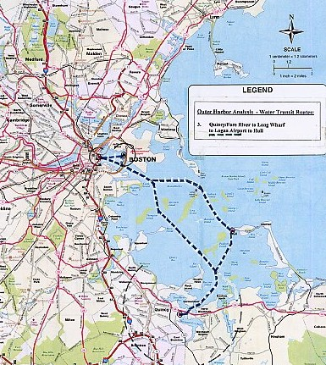

      - Schedule and vessels
Proposed schedules, “Peak Service #1” and “Peak Service #2” are summarized in Table 6.2. They are a “circle” service including all four destinations (intermittent peak hours service to Hull) and separate boat service to Boston and Logan Airport, respectively. The options for each are 20 minute and 30 minute peak hours headways. The selection for detailed assessment here Peak Service #1, 20 minute headways. This service would require four catamarans, whose particulars are as described above.
Table 6-2

Vessels and Schedules

Quincy – Hull – Long Wharf – Logan Airport Service
Routes, Distances | Peak Route Cycles, Schedules, and Vessels Needed |  | Off-Peak Schedule and Vessels Needed.
Routes, Distances | Weekday Peak: 6-9:30 am and 3:30-7 pm; Headways 20 – 30 Min. |  |  | Weekday Off-Peak: 9:30 am – 3:30 pm and  7 pm – 10 pm;  Weekends: 8 am – 11 pm
Routes, Distances | Peak Route 1* | Peak Route 2*
Peak Route 1  Combined Boston/Logan route.  AM: [Hull] to Quincy to Boston to Logan to Quincy  PM: Quincy to Logan to Boston to [Hull] to Quincy  Trip Distance:  - RT = 20.6 nm  Peak Route 2  Separate Boston and Logan routes  2A: Quincy/Boston  Trip Distance  - One Way = 10.1 nm  - RT = 20.2 nm  2B: Quincy/Logan  Trip Distance  - One Way = 9.5 nm  - RT = 19 nm | Headway - 30 min.  - Trip Time: 35 min. for Quincy – Long Wharf  - Cycle Time:  Quincy/Long/Logan - 75 min.  Quincy/Hull/Long/Logan – 85 min.  - Vessels Needed: 3  Headway - 20 min.  - Trip and cycle times: Same.  - Vessels Needed: 4 | Headway - 30 min.  - Trip Time:  2A = 35 min.  2B = 35 min.  - Cycle Time:  2A= 65 min.  2B = 55 min.  - Peak Vessels Needed: 4  Headway - 20 min.  - Trip Times: same  - Cycle Times: same  - Peak Vessels Needed: 6 |  | Same for all options: Quincy to Boston to Logan  Weekday**  - Headway 45 min.  - Trip Time: 25 min.  - Cycle Time: 75 min.  - Vessels Needed: 2  Weekend  - Headway 45 min.  - Vessels Needed: 2
* Hull/Pemberton route is included as per existing Quincy schedule; (2)AM and (2)PM commuter trips.
** Logan Service with downtown stop is included during weekday off-peak hours from 9:30 am to 3:30 pm and from 6:30 to 10:45 pm.

      - Terminal infrastructure
The terminal in Quincy will continue to be at the Fore River site, and likewise for the Point Pemberton site in Hull. These facilities are adequate in all important aspects at this time and requires no capital improvements for the service as proposed. The Long Wharf north terminal improvements are discussed below in the context of service for multiple Outer Harbor and Massachusetts Bay ferry operations. The treatment of the Logan Airport terminal focuses on landings by Massachusetts Bay catamarans, rather than harbor shuttles. Terminal conditions, needs and costs are summarized in Table 6.3:
Table 6-3
Terminal Infrastructure Status and Needs
Quincy – Hull – Boston – Logan Airport Service
Infrastructure Status:  Dock, Water and Landside |  | Infrastructure Construction Costs (New or Renovated)  Dock, Water and Landside
Origin | Destinations | Origin | Destinations
1) Quincy Fore River:  Existing ADA dock, terminal and parking;  Improved bus transit recommended  2) Hull /Point Pemberton:  Existing ADA dock and parking for weekday commuters | 1) Long Wharf: existing ADA dock; limited dredging of basin would improve approach, but not necessary.  2) Logan Airport: expanded existing ADA dock and bus connections | No new infrastructure costs for either location. | Long Wharf and Logan Airport  - Adequate capacity and accommodations at existing site. No new infrastructure costs for either location.  :

The terminal needs for the outer harbor Quincy service are somewhat different than for the Inner Harbor, and require more extensive site area, ground access, and land and waterside facilities. The “origin” sites for commuters require park-and ride and more extensive bus and kiss-and-ride drop-off areas. The terminal landing, where Harbor Express operations are based at Quincy, also requires layover berthing capacity.
Waterside Terminal Needs:
- Dock Facility with ADA/MAAB Access
- Clear and open channel and fairway approaches
- Layover berthing

B. Landside Terminal Needs:
- Terminal support: sheltered waiting and ticketing.
- Auto and bus drop-off.
- Shuttle bus links to residential areas and Hingham/Hewitts ferry terminal.
- Parking: Autos (900 cars), bicycles, buses.
The preferred landing sites are known and currently in operation on the existing service. They are Fore River (Quincy), Point Pemberton (Hull), Long Wharf North (Boston), and Logan Airport South. Potential future landing sites would include seasonal Harbor Island National Historic Area landings at Georges and Spectacle.
Quincy Fore River. The Quincy Fore River Terminal is a fully integrated park-and-ride ferry terminal, originally completed by the then privately owned and operated Harbor Express Ferry service. The site is located on the Quincy side of the Fore River Bridge on Route 3A, and is conveniently located for residents described in the service area in south Quincy and other nearby South Shore communities. The property was leased from the MWRA as a portion of the Quincy Shipyard property. The MBTA assumed the lease and ownership of all infrastructure and vessels when Harbor Express was acquired in 2002.
The landside and waterside components of the Quincy Fore River Terminal as well as the Long Wharf North Terminal and two vessels were designed to be fully accessible by MBTA and State Massachusetts Architectural Access Board (MAAB) standards. The seamless boarding system with the bow loading terminals and vessels has been recognized by the disability community as a model of passenger marine transit in Massachusetts and nationally. The terminal layout also works very well for the Logan Airport riders as the covered ramp access is helpful to those with luggage and children in tow. The integrated terminal and vessel access system has recently been used as a model for the new Bermuda ferry system implemented in 2002, with the planning, design and vessel construction all having been exported from Massachusetts.
The terminal site infrastructure includes a 30’ by 100’ double sided and end loaded floating barge landing connected by ADA ramps to a terminal waiting and ticketing building. A secure, ticket entry/exit, 900 car parking area is divided into short and long term parking areas to accommodate the daily commuters to Long and the longer term Logan Airport patrons. There is potential for capacity expansion of the lot in several directions. A portion of the parking is shared with the USS Salem, which is a maintained as a historic naval vessel museum and draws passengers by ferry from Boston. At present, there are plans to relocate the Salem to another site. All layover and maintenance of the ferries takes place at the Fore River landing which is located in a well protected basin.
Navigation to the site is by way of the federally maintained Fore River shipping channel that serves the Quincy shipyard. In the basin where the terminal landing is located the depths and width are more than ample for the relatively small Harbor Express vessels, as the basin is maintained for berthing of deep draft ships along the two adjacent pier faces. There is ample basin breadth and length for the possible expansion of the ferry landing because of the generous fairway provided for the ship berthing.
As a mitigation for the reconstruction of the Route 3A Fore River Bridge, an alternative accessible landing was constructed east of the bridge for use at times when the bridge channel is not open. The landing will be available for intermittent use for the duration of bridge construction.
Infrastructure needs for the proposed expansion of the Harbor Express service appear to be minimal. There is ample excess parking capacity for projected ridership demands, and space for expansion when and if needed. The terminal waiting and vessel repair/ storage area is ample for expansion needs. The current curbside drop-off would accommodate MBTA bus service links. The barge landing is sufficient for additional vessel stops. Layover berthing can technical be achieved by rafting vessels, or by leasing adjacent or remote slip space. No new infrastructure costs are projected for the Quincy site for candidate route expansion.
Hull/Point Pemberton. The other South Shore commuter origin is located at the outer most end of the Hull peninsula at Point Pemberton next to the high school and at the site of the former Hull Life Saving Station. In 1999, a fully ADA/MAAB accessible, bow and side loading floating landing and ramp terminal was constructed at Hull attached to the existing fixed town pier. Grade parking is free and provided adjacent to the site.
Even with its multi-function role as a town landing, the terminal dock is capable of accommodating additional ferry vessel landing slots. There is limited space for parking expansion, but also limited demand because of the relatively remote site location.
Since no expansion of the Hull commuter service is projected in this study beyond the current level of service and schedule, there are no additional infrastructure costs projected for the Hull to Downtown route.
Logan Airport. The Logan Airport ferry terminal is located in Jeffries Cove along the southwest edge of the airport, adjacent to the Harborpoint Hotel and the Massport administrative office complex. It is also a short walk from the Jeffries Point residential neighborhood in East Boston. The site is linked by shuttle buses to the airport terminals. A heated waiting area is provided next to the ferry landing. Since Logan is a “destination” site and service are intended to reduce auto travel to the airport, no commuter parking is provided or needed at the site. The terminal landing was expanded to provide ADA/MAAB access, and increase berthing capacity for the multiple services using the site. Harbor Express has had a concession agreement for South Shore ferry service since 1997, and has a dedicated bow loading landing berth. The MBTA assumed the concession agreement and terms when it acquired the service in 2002.
The proposed expansion of the Quincy service would require additional landing slots, which can be readily accommodated as long as the berth remains dedicated to Quincy service use. The short duration of the bow-loading boarding (3 to 5 minutes) easily allows for up to 10 landing slots per hour at a single slip. No other landside infrastructure needs are projected for the expanded service. Hence there are no infrastructure expansion needs or costs projected for Logan for the proposed service expansion.
Long Wharf North. The existing terminal on the north face of Long Wharf was completed in two phases. The initial barge and ramps were installed in 1997 by Harbor Express at a site leased from the BRA as a dedicated downtown terminal site. The barge and ramps were moved and a small area cleared of pilings and dredged by the BRA in 2001 to re-orient the initial ramps and bring the floats closer to the bulkhead as the first phase of a the Long North master plan prepared for the BIHPWTP. The public ground floor lobby of the adjacent Marriott Hotel serves as the protected waiting area. A later phase of the plan to expand berthing capacity and create a permanent Harbor Islands Gateway includes the addition of 180 feet of barge floats to the east and providing a new ramp access point at the end of the new floats opposite the Chart House restaurant, and a new ticketing and waiting area near the new ramp location. At present the BRA has no scheduled completion date for the next phase.
The current Harbor Express landing is now owned by the MBTA, which also assumed the lease arrangements with the BRA. The current bow loading slot has considerable extra capacity based on the short boarding time needed and could accommodate as many as 10 berthing times per hour. While the proposed dredging of the basin in front of Christopher Columbus Park would benefit the catamarans by allowing a larger turning basin, it is not essential to continuing or expanding operations, and has therefore not been included as an infrastructure cost. No other essential infrastructure improvements were identified as need for the proposed service expansion.
Projected Infrastructure Costs. Because of built-in additional capacity in the existing infrastructure as described for the individual sites, there have been no additional infrastructure costs associated with the proposed expanded service.
    - Field Work
The vessel route and Harbor Express terminal were visited by the Volpe team on April 7, 2002. Interviews and a tour were conducted by Mike McGurl, manager of the Harbor Express service. Additional phone interviews with the Harbor Express management have also been conducted.
    - Service Assessment
      - Maturity evaluation
The maturity evaluation resulted in a score of 0.8 (scale of 0.0 – 1.0), largely on the basis of the existing service now in operation as a publicly run transit asset. The infrastructure is mostly in place, albeit with some desirable, though not critical, improvements needed at the Boston and Logan Airport terminals. While there is no formal proposal for the four-boat operation, the success of the existing service implies relatively good prospects for future support by public agencies, and minimal environmental review needs for the incremental changes expected.
      - Categorical evaluation
        - Policy
The proposed four-boat service scores very well because of the potential to draw more riders to the lower headway service and time savings available to some users, particularly in Hull. Environmental impacts are relatively low because of the terminal sitings in previously used areas, especially the industrial area at Fore River, Quincy. The access value is good because of ADA accommodations at the existing terminals. Economic re-development and enhance waterfront usage rate lower because all sites are currently in use; future opportunities generated by service growth are impossible to estimate.
Table 6-4

Assessment Tool Policy Summary

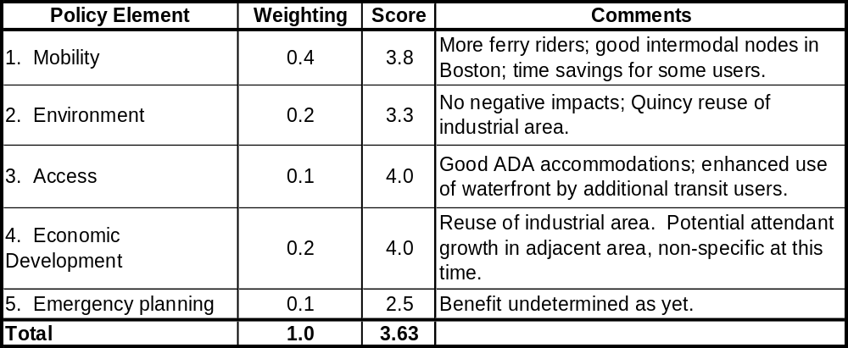
Quincy – Hull - Boston – Logan Airport

        - Feasibility
The strengths of this service expansion are clearly seen as an extension of the current service, i.e., the continued use of publicly owned terminal facilities, the proposed fleet expansion using similar boats, and the low environmental impacts associated with reuse of industrial land. Neither of the Quincy terminals have significantly developed intermodal transit connections as they are somewhat remote from other Quincy transit stations. The Harbor Express facility at Long Wharf is adequate in its current condition, although future planned improvements would help with shoreside accommodations and the navigational approach. The Logan Airport landing has good intermodal access to Logan International and Massport provides a free shuttle bus service to connecting terminals and to the MBTA Blue Line. .
The approaches to the Quincy and Hull terminals are relatively well marked, and the entire route is in protected waters inside the Boston Harbor Islands.
Full results appear in Appendix F.
Table 6-5

Assessment Tool Feasibility Summary
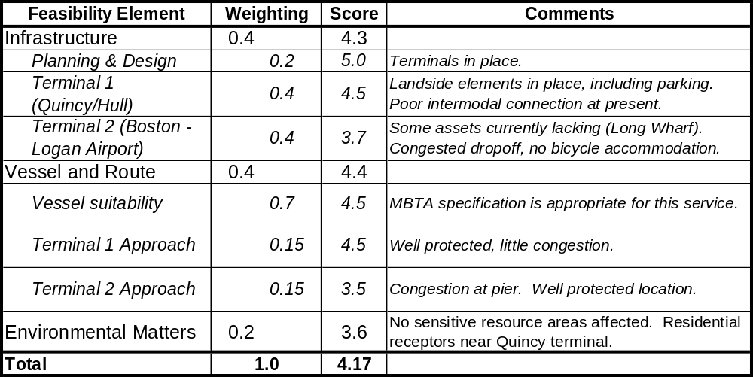
Quincy – Hull – Boston – Logan Airport

        - Demand estimation
Estimates were prepared by CTPS using the Traffic Demand Model. The service assumptions for this route include fares of $2.00 to Boston, equivalent to the current commuter rail fare from Quincy, and $9.00 to the airport, as charged currently by Harbor Express, 20-minute peak period headways in the peak direction, a 40-minute one-way travel time, and available parking without constraint. The model forecasted 400 peak period trips in 2010 when the Greenbush Line is in place and 850 such trips prior to implementation of Greenbush service. The model also forecast that would be no significant diversions from automobiles (the auto diversion obtained from the model is well within the margin of error of the mode and cannot be stated with confidence). All of the 850 trips would therefore be diverted from other transit alternatives: 340 from the Red Line and its feeder buses, 450 from commuter rail and its feeder buses, and 60 from other commuter boats.
These results are an accurate expression of the CTPS transit model, whose primary focus has always been the measurement of demand and choice among land-based transport options. There are two qualifying points that must be made relative to its treatment of ferry demand. The first is that the model, according to conversations with CTPS, favors modes such as commuter rail which offer continuous multi-stop service, as compared to a point-to-point service, as provided by ferries. Secondly, the mode diversion results indicate that the model does not account for the experience of the Hingham ferry service and others which have successfully served many former automobile commuters.
The Hingham ferry service was started in the 1970’s to serve several coastal communities that were somewhat removed from Route 3, the Southeast Expressway, and rail transit lines. When the Southeast Expressway was scheduled for a multi-year widening project, ferry service was expanded and subsidized by Federal Highway funds to provide transit mitigation for the cluster of coastal communities near Hingham. The mitigation was intended to divert automobile commuters and lessen the traffic burden on the highway during reconstruction. It has been found that a sizable percentage of the initial Hingham passengers were auto commuters diverted to a faster and more convenient commuter mode. The service has consistently been well patronized; when the Expressway project was completed, dedicated riders lobbied to retain the ferry service, which has continued to grow to the point of full capacity of the parking facilities at the Hewitt’s Cove terminal.
It is possible that the CTPS transportation model, if used to estimate Hingham ferry ridership, would attribute virtually all of the approximately 3600 daily ferry trips to transit diversion from the Red Line and the commuter rail line. In demand projections for the Greenbush Line, these same Hingham ferry riders would be re-diverted to commuter rail simply because the model rates a continuous multi-stop, multi-mode corridor as preferable to a single point-to-point ferry service, based on short headways of combined services. This model is not able to future account for actual commuter behavior. Most commuters indeed travel point-to-point every day, as well as the fact that many people, particularly in coastal communities, have a preference for ferry transportation over other modes, including automobiles. Survey results from Hingham and comparable ferry systems such as the Larkspur and Sausalito routes in San Francisco Bay, indicate that given a choice of automobile commute or bus transit, many commuters in ferry service areas choose the ferry for qualitative reasons in combination with quantitative measures (trip time, cost, headway).
Proposed Quincy Operating Scenario. An idea for future investigation is the operation of the Quincy and Hingham services as a linked system providing more frequent and flexible service to commuters. This apparently is the transit mode favored by the CTPS model, and might prove to be favored by riders in this service area. In this scenario, the four vessel, Quincy triangular route would be effectively scheduled at offset departure times with the Hingham service, both at 20 minute headways, to offer a combined peak period headway of 10 minutes from the two departure points. With a shuttle bus connecting arriving vessels from Hingham to Quincy and back, and an interchangeable ticket/pass system, commuters could ride one ferry into town and take the other back and still be guaranteed a return to the original parking site. If the shuttle bus were also a distributer bus route such as the 220 bus on Route 3A, the intermodal link might be equally attractive to bus and ferry commuters.
The real beneficiaries of this system would be those residing in the overlapping catchment area of the Hingham and Quincy services. Those people have commented that the original Quincy route (which stopped at Logan Airport first) had a longer trip time to downtown Boston than the Hingham service (45 minutes compared to 30 minutes), and that Quincy offered half as many trip times at longer headways. The trip times are now roughly equal since the Quincy boats have made the downtown stop first as a result of route adjustments since the MBTA acquired the service.
The real test of rider preference for ferry versus rail and model demand accuracy along the coastal communities from south Quincy to Marshfield may only be resolved when the Greenbush line is completed and the actual diversion of transit and automobile commuters can be measured. If past experience with Hingham ferry ridership choice patterns is any indication, there may be far fewer diversions from ferry to rail than predicted by the CTPS model. The same is also likely to be true of Quincy as the commuter base builds and a dedicated ferry ridership develops over an extended time frame, as was the case in Hingham.
        - Finances
The overall financial assessment is for the four-boat service. The operating costs for both “Peak Service 1” options, corresponding to 30 and 20 minute peak hours headways, respectively, appear in Table 6-6 below (with the selected service shaded), showing estimated expenditures for year round peak hours, and including the calculated debt service as an operator would expect to pay. Note that the overall financial analysis treats capital expenses and debt service as separate from operating costs, enabling more direct performance comparison to landside transit modes.
The operating cost for the four-boat service relative to the three-boat service is roughly proportional to the ratio of the operating hours.

Table 6-6

Annual Vessel Operating Costs

Quincy – Boston
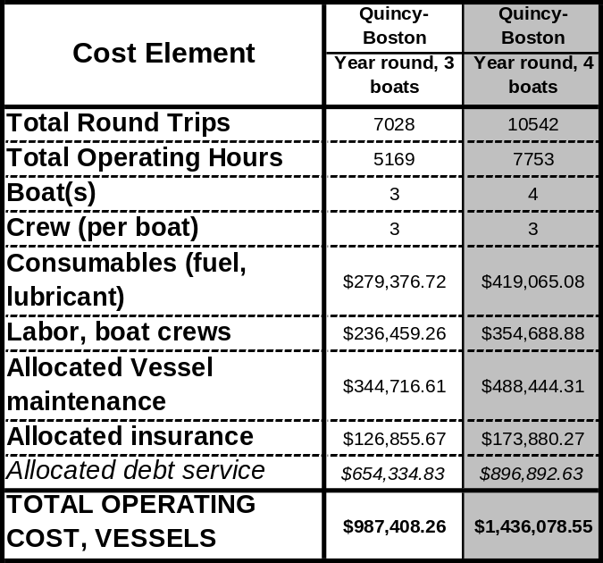

Capital costs and debt service. As described in Section 6.2.1.3 and shown in Table 6-3, there are no new capital costs for infrastructure on this route. Debt service payments assume two existing seven-year-old boats and new boats (one for the 3-boat service and two for the 4-boat service) for each service, yielding average boat ages of 4.7 and 3.5, respectively. Also, debt-service and insurance payments assume that boats would also be used during off-peak times for other services, so that commuter service – and, hence, capital and operating costs attributable to the commuter service – would represent only about 75% of the boats’ activities by time.

Demand, revenue, and subsidy estimates. Based on CTPS’s demand modeling for the selected service, a total of 850 commuter boardings per day were forecast: 775 boardings, at a $2 fare, for Boston service, and 75 boardings, at a $9 fare, for Logan service (yielding an average fare of $2.62). Assuming a year-round weekday operation of 251 days (as per Table 3-3), there are 213,350 annual commuter boardings, with $558,977 in annual commuter revenue. Table 6-7 below presents the summary results of the ferry economic model, assuming demand and revenue figures as estimated by CTPS.

Table 6-7 also shows a financial performance comparison of this service with rail modes. Measures for the latter are based on preliminary FY 2002 data, aggregated for all MBTA commuter and heavy-rail subway lines. The overall score (shown in Table 6-8) for the Quincy – Boston ferry service is 2.86, a middling score. It compares somewhat evenly to rail transit (except in subsidy per passenger mile); that no infrastructure expenditure is necessary raises the score.

Table 6-7
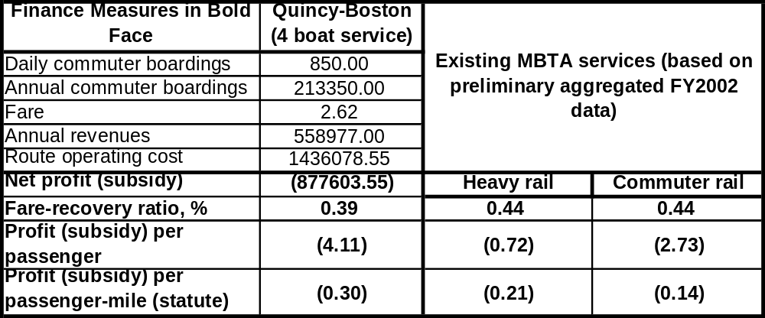
Operating Cost Evaluation for Commuter Service
Quincy – Boston

Table 6-8
Assessment Tool “Finances Summary”

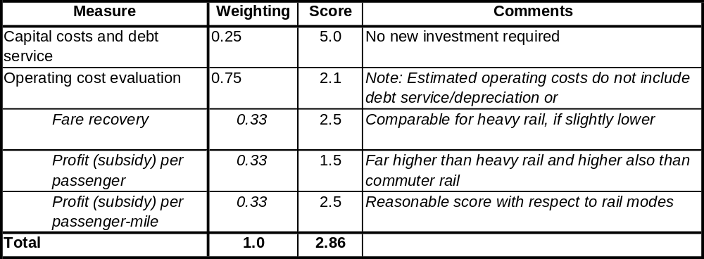
Quincy – Boston

    - Summary
See section 6.3.
  - Summary Findings and Recommendations
The only candidate service in the Outer Harbor was the Harbor Express system is an enhancement of the service currently running from Quincy/Fore River and Hull/Point Pemberton to Downtown/Long Wharf North and Logan Airport. The service has been operated by the MBTA since it was purchased in January of 2002. The other outer harbor service currently managed by the MBTA is the Hingham/Hewitt’s to Rowes/Downtown commuter route. While they offer complementary services, the Hingham and Quincy routes attract coastal residents from overlapping catchment areas. Projected future plans for the Quincy service provide an opportunity to strengthen both routes through staggered departure schedules and new bus links.
The four vessel Quincy triangular route, with 20 minute headways, could be scheduled at offset departure times with the Hingham ferry service (same headway) to offer a combined peak period headway of 10 minutes from the two departure points. With a shuttle bus connecting arriving vessels from Hingham to Quincy and back, and an interchangeable ticket/pass system, commuters could ride one ferry into town and take the other back and still be guaranteed a return to the original parking site. If the shuttle bus were also a distributor bus route such as the 220 bus on Route 3A, the intermodal link would be equally attractive to bus/ferry commuters.
The expansion of the Outer Harbor MBTA ferry fleet to provide four vessel service to Quincy has the potential benefits of economies of scale in operations and maintenance and the flexibility to operate profitable peak services on other routes such as Harbor Islands or Salem. Alternatively, one or both of the additional vessels needed to expand to a four boat fleet could be leased as a concession in the same manner as the Hingham service. The operators would then be able to optimize use of the vessels during off-peak periods for such services as excursion, charter, Harbor Islands or whale watch activities.
The expanded Quincy service scores the highest for technical feasibility on the strength of the existing service and the infrastructure assets (high quality in particular at Fore River) already in place. The policy score is also high on the strength of excellent access and mobility values. These are especially strong for ADA access, enhancement of waterfront uses, and shortening of travel times for commuters from some origins. The environmental score is good as well because of the reuse of existing land and terminal assets at all four landings.
The financial picture is based on the analysis of all four boats for the proposed service (not two extra boats relative to the existing service). Farebox recovery compared well with rail modes. Unit subsidy measures were mixed; subsidy per passenger-mile is more than double that for commuter rail, but the subsidy per passenger is 50% higher. It is important to note that there are no infrastructure capital costs, and, therefore, no planning, design, or permitting necessary for this service.
Table 6-9

Assessment Summary
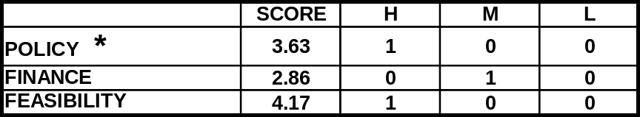
Quincy – Hull – Boston – Logan Airport Service

The overall Quincy service scores are very good, particularly the policy and feasibility aspects. The high point of the finance picture is that infrastructure capital costs would be zero for this service expansion.
The recommendation is to study carefully the potential for expanded ridership on a four boat service, which includes Hull and Logan Airport stops and could be integrally structured with the Hingham service as a system offering far greater choices than either can do separately. The demand analysis should be enhanced and tailored more closely to point-to-point ferry services, as suggested below. Then, a more precise, and possibly brighter, picture of service demand would emerge.
Transit System Policy Issues
- All Outer Harbor services should be treated as a single system in terms of complementary schedules including Quincy, Hingham and Hull (see further comments, Chapter 7 summary).
- Total fares including parking fees should be equalized for Outer Harbor ferries with corresponding transit fare zones.
- Capacity for combined South Shore services can be increased by optimizing use of Quincy and Hingham parking resources.
- Quincy parking capacity should be preserved and future expansion options kept open.
- Bus shuttle links from Quincy to Hingham and feeder buses to residential neighborhoods should be added along route 3A.
The demand results from CTPS must be examined critically for all ferry service assessments. This study yielded the following observations with regard to the transport model used:
- There is an evident bias of the model in favor of multi-stop services (e.g., as offered by commuter rail) as opposed to the direct line (point-to-point) service as offered by a ferry to Boston. This point affects longer commuter service routes in particular. Also, there are apparently no data to model mode preference, i.e., the choice of many ferry patrons to do so because of the enjoyment of the ride. This preference is probably not a significant factor in the population as a whole, but most likely does influence a sizable group of people living in or adjacent to coastal towns.
- CTPS reports zero automobile diversions to the proposed Quincy ferry service, contrary to the evidence of the Hingham ferry and others. There is an opportunity for transportation agencies to re-examine the transportation model’s data base and coding and assess whether modifications can improve demand estimates for specific ferry services.
- The real test of rider preference for ferry versus rail and model demand accuracy along the Coastal communities from south Quincy to Marshfield may only be resolved when the Greenbush line is completed and the actual diversion of transit and auto commuters can be measured. If past experience with Hingham ferry ridership choice patterns is any indication, there may be far fewer diversions from ferry to rail than predicted by the CTPS model. The same is also likely to be true of Quincy as the commuter base builds and a dedicated ferry ridership develops over an extended time frame, as was the case in Hingham.

- Assessment: Massachusetts Bay Services
  - General Characteristics and Guidelines
    - Operating area description
Massachusetts Bay lies south and west of a line connecting Cape Ann (Gloucester) to northwestern point of Cape Cod and includes Boston Harbor and Cape Cod Bay. Cape Cod Bay is found between the peninsula of Cape Cod, on the east and south, and the mainland of Massachusetts on the west. Race Point, the northwestern extremity of Cape Cod is the eastern point; and Gurnet Point, on the north side of the entrance to Plymouth Bay, is the western point of the entrance into Cape Cod bay. Plymouth, Sandwich, Barnstable, Wellfleet and Provincetown harbors are all within Cape Cod Bay. The Cape Cod Canal connects Cape Cod Bay with Buzzards Bay to the south (U.S. Coast Pilot, Volume 1).
The coast of Massachusetts Bay to the north of Boston includes at the north-most Gloucester Harbor, approximately 26 miles from Boston, and in succession southward Manchester Harbor, Beverly Harbor, Salem Harbor, Marblehead Harbor, Lynn Harbor, and Nahant Harbor. Harbors on the South Shore are found at Hingham, Scituate, Green Harbor, Marshfield, Duxbury, and Plymouth.
A traffic separation zone for ships approaching Boston Harbor crosses Massachusetts Bay. The zone includes two directed traffic lanes, one-way inbound and one-way outbound and each approximately 1.8 nautical miles wide, with a separation zone about 0.9 miles wide. There are also two precautionary areas to prevent vessel collisions. The scheme is recommended for use by vessels approaching or departing Boston Harbor. Smaller vessels, such as tugs and tows don’t necessarily follow the traffic separation scheme since these vessels normally operate closer to shore (U.S. Coast Pilot, volume 1).
Commercial traffic includes all merchant shipping trade into Boston and passage of coastal traders through the Cape Cod Canal to points north. Inshore fishermen ply these waters, as do offshore boats from Gloucester and New Bedford, among other ports. Commercial excursion vessels, primarily from Boston, cruise the inshore waters, as do whale watching vessels that usually operate May-September. Ferry transportation in the Bay is limited to a Provincetown to Boston 90-minute high-speed ferry service operated by Boston Harbor Cruises during the summer months. There is also a significant seasonal presence of recreational vessels in the Bay.
    - Similar services
Services similar to the Massachusetts Bay services, selected for similar route lengths, service type, and service area, were routes in the Washington State Ferries system, one of the largest ferry systems in the United States, serving eight counties within Washington and the Province of British Columbia in Canada. Washington State Ferries has 10 routes and 20 terminals served by 29 vessels. In fiscal year 1999, the system carried over 11 million vehicles and 26 million people. More than 75,000 Puget Sound residents commute to work or school daily onboard Washington State Ferry vessels (www.wsdot.wa.gov).
Among several similar routes, Washington State Ferries operates a year round commuter service between Seattle and Pier 52 in Bremerton (passenger-only). The route is approximately 13.5 nautical miles with a sailing time of approximately 40 minutes (Figure X). The two vessels that sail this route are high-speed catamarans with a typical speed of 36 knots and have a capacity of 350 passengers. In 1999, the patronage was approximately 849,734 passengers and the vessel made 35 one-way trips per day that year.
Figure 7-1:
Seattle-Bremerton (Passenger-Only) Service

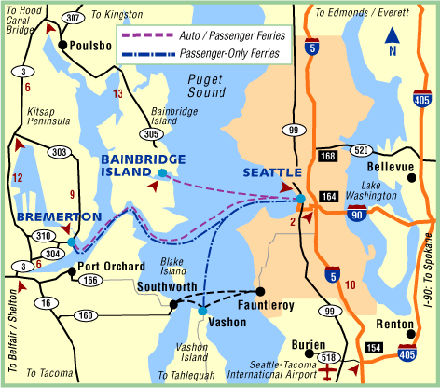
Washington State Ferries home page:http://www.wsdot.wa.gov/ferries
The analogy to the Massachusetts Bay area is the range of longer route distances and, in the case of the Bremerton route, the passenger only service. The passenger volumes handled by Washington State Ferries arise from the heavy growth in the residential populations of the Puget Sound Islands and the eastern shore of the Olympic Peninsula. The transportation options for those commuters have limited similarities to those for the Massachusetts north and south shore commuters who would be served by these proposed Massachusetts Bay services. Even for the mainland residents of Olympic Peninsula, Washington State Ferries is essentially an island service, since land transport options to Seattle involve a very long trip around the southern end of Puget Sound through Tacoma.
New York Fast Ferry operates the Highlands (New Jersey) to Wall Street (Ferry Terminal, Pier 11) route as a year round passenger-only service. The route is approximately 18.4 nautical miles with a travel time of 40 minutes. In 1999, the estimated patronage was 105,000 passengers. The commuter market and route distance bear strong similarity to the Massachusetts Bay routes, particularly those proposed for Scituate and Salem. The land transport options for Highlands commuters have stronger similarity to those from the north and south shores to Boston, i.e., routes parallel to the coast which, in the case of automobiles, feed into one or two main thoroughfares to the city.
Two successful services to San Francisco with similar route characteristics and transportation alternatives are the City of Vallejo service to Pier 1/2/Embarcadero and the Larkspur to Embarcadero Ferry Terminal operated by Golden Gate Ferries. Both offer commuters waterborne alternatives to a limited number of high volume automobile routes, and both have operated successfully for many years.
    - Transportation policy issues
As with the other two geographic areas, transportation policy issues and choices vary with each of the Massachusetts Bay candidate sites and their respective catchment areas. North Shore and South Shore candidate locations differ in terms of existing transit alternatives, ferry route distances, and prevailing sea conditions, among other considerations. There are, however, several important common transportation policy choices relating to potential ferry services shared by the North and South Shore sites. These choices tend to reflect current state and regional transportation policies, primarily relating to diversion of single or low occupant automobiles. These policies are:
- Diversion of auto commutes by providing coastal towns with water-based transit alternatives to prevailing ground transportation. The Massachusetts Bay ferry routes can offer a reliable alternative to automobile commutes in areas without convenient transit, or where ground transit may become over loaded. The most effective diversion is through year round mode transfers, and, secondarily, by seasonal shifts.
- Improved multi-modal choices and enhancement of local feeder bus links. Some of the candidate Massachusetts Bay communities have limited, distant, or no alternative commuter transit, and new ferry routes could offer time and cost efficient alternatives to automobile commutes. For communities with commuter rail or express bus service, the ferry routes could provide complementary transit options with downtown destinations that are different than those offered by current transit routes.
- Reduction of vehicle miles traveled (VMTs). Diversion of automobile users to ferries can incrementally assist in reduction of VMTs along heavily traveled highway corridors for commuters, seasonal visitors, and Logan Airport users. It is not clear at this stage, and has been somewhat controversial, whether high speed ferries can provide a net reduction in emissions on a per passenger-mile basis. A study by the Society of Naval Architects and Marine Engineers (2000) indicated a rough parity with automobiles, based on tradeoffs among several types of pollutants, and higher emissions overall than buses.
- Economic development stimuli for small coastal towns with seasonal and/or year round cultural attractions. Most of the coastal communities considered currently feature visitor attractions that could benefit from regularly scheduled ferry connections to downtown Boston, and in turn would also send residents to Boston at off-peak weekday and weekend periods. There would be a seasonal bias for such recreational visitor uses. New ferry services in other metropolitan areas have also brought economic stimulus to the coastal destinations outside the city.
It is possible that community stakeholders with an interest in providing commuter and visitor links to these Massachusetts Bay sites could propose a new service.

    - Vessel options
The vessel selected for analytical purposes for these routes is similar to the Flying Cloud, built in 1996 by Gladding-Hearn to a design by Incat Designs. The particulars of these boats are: 23.3 meters in length, 30 knots service speed, 3 crew (captain and two deck hands), 1930 horsepower with waterjet propulsion, and 149 passenger capacity. The 1996 purchase price was $2,627,900. The capacity and speed of these boats are suitable for mid-length service such as this, and the design is well proven in local service. See detailed discussion for Outer Harbor services, 6.1.4.
As with any land-based transit mode, it is assumed based on past outer harbor and Massachusetts Bay ferry operations that there will be several days a year when the weather conditions will require service cancellations. In such circumstances, a landside back-up system of bus and/or transit is needed for such cancelled runs.
  - Salem to Boston service
The assessment includes a year round two boat service and a seasonal one boat service. The detailed schedules appear in Appendix G.
    - Characterization
Salem is a North Shore port town with a population of 40,407. The city has a long and celebrated maritime history, which continues today with a combination of uses, including a power plant that is served by a deep draft ship channel and active seasonal recreational boating throughout much of the harbor. The City serves as a residence for many Boston-bound commuters, and in turn attracts many visitors to its many historic and cultural attractions including the House of the Seven Gables, the Salem Maritime National Historic Site, the Peabody-Essex Museum, and the historic center of town. Passenger transportation demands include year round trips for commuters and residents to Boston, and year round and peaking seasonal visitor trips to Salem’s many historic and cultural attractions. Highway connections from Salem to Boston and the region are congested and circuitous, despite the relative close driving distance of 24 miles to downtown.
Public transportation services to Salem currently consist of the North Shore Commuter Rail and buses. The rail terminal is located on the west side of town, somewhat removed from the harbor residential areas, and cultural attractions. Regional transportation planners have for many years considered the reinstatement of ferry service to Boston to complement Salem’s commuter rail service to North Station.
The 1998 Ferry Demonstration Project was conducted with funding from an EOTC grant, to test the combined demand for visitors and weekday commuters. A single 149-passenger, 25 knot catamaran was used for the 4 month demonstration period, with some success. Findings from the demonstration included the following:
- Commuter use was limited by the single vessel operation and short duration of the services, but was endorsed by those who used it.
- The one vessel schedule with a limited number of trips worked well for the visitors.
- Demand for Logan Airport was limited by the infrequent service and the close proximity of Logan to Salem.
- Substantial two-way recreation and tourism use was experienced with a good balance of residents going to Boston and Boston visitors traveling by water to Salem.
- Weekday visitor ridership was heaviest during the school summer vacation period, and dropped off during the fall months.
A private ferry oriented primarily for tourists and recreational users operated for several seasons following the demonstration, and was discontinued after the 2001 season.
      - Route and service area
The Salem service route would follow that used in the 1998 demonstration project (Figure 7.2). The primary route would run from Salem Harbor to downtown Boston.
In Salem Harbor, there are two potential landing sites: Central Wharf and Blaney Street. The Central Wharf site has the advantages of an existing ADA accessible landing and closer proximity to town center cultural attractions, with the disadvantage of limited parking options and a longer, slower approach for the vessels through Salem Harbor. Blaney Street has been selected for the analysis because of two advantages: an existing parking area and shorter on-water travel time at slow speed in Salem Harbor. The disadvantages there are the needs for a new landing float and ramps to respond to the more exposed nautical setting. It was estimated that service from the Central Wharf landing would add another five to eight minutes for each one-way trip, because of the long, slow approach through the inner harbor area.
In Boston Harbor, the downtown landing site could be at Long Wharf or Rowes Wharf depending on berthing availability. An optional stop for commuters which may be considered in the future would be at the South Boston Waterfront (World Trade Center or Fan Pier). An optional stop for seasonal off peak hours recreational users would be the Boston Harbor Islands, at either Georges or Spectacle Island.
Table 7-1
General Specifications

Salem – Boston Service

Infrastructure:  Dock, Water and Landside |  | Vessel  Specifications | Route and Schedule:  Peak, Off-Peak | Implementation Matters
Origin | Destination | Vessel  Specifications | Route and Schedule:  Peak, Off-Peak | Implementation Matters
1) Blaney Street site proximate to Salem Power Station requires new ADA dock, shelter, improvements to dirt parking area, and signage.  2) Salem Central Wharf: existing ADA dock at NPS site; needs parking within short walk.  Goal: multiple use public landing. | 1) Rowes Wharf or Long Wharf. Long Wharf: existing ADA dock on west side; minor dredging and expansion of basin would be needed.  Possible future options:  2) World Trade Center or Fan Pier.  3) Boston Harbor Islands (seasonal off-peak). | 149 passenger.  Low wake and wash.  ADA access.  Coastwise or Limited Coastwise Certificate of Inspection.  New construction, similar to Flying Cloud/Lightning modified for off-shore conditions.  Speed = 30 - 35 knots | 2 – Boat Year Round Service:  Weekdays to Boston at roughly one hour headway from 6:00 am – 9:30 pm.  Weekends: 2 – boat service, 6 months; 1 – boat service 6 months  1 – Boat Seasonal Service:  Weekdays, 6 round trips daily.  Weekends, 5 round trips daily | Funding: to be determined.  - Fare structure consistent with land transit, i.e., commuter rail. MBTA pass use for commuters and visitors.  - Analysis for optimal markets and destinations needed, i.e., seasonal visitor and/or year round commuter market, or seasonal off-peak visitor service (two- way seasonal cultural and tourism stimulus) combined with year round Lynn commuter service; and commuter stops Boston and/or South Boston.  - Resumption of limited seasonal Harbor Islands route possible when attractions and programs are expanded.  Important decision for siting and financing of Salem terminal. - Bus shuttle to commuter rail, Salem Center and Beverly  -

Figure 7-2
Massachusetts Bay Services

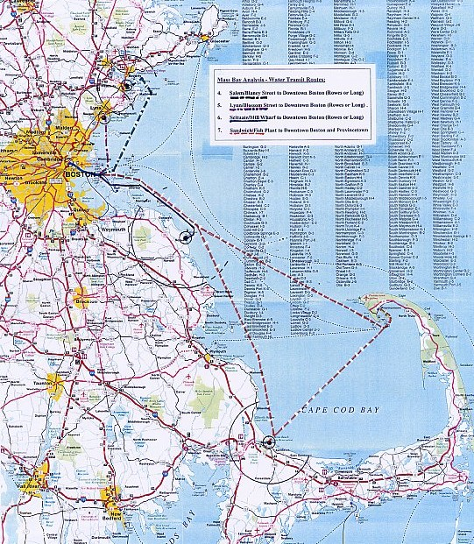

The route tested in this evaluation is the primary route only, based on the demonstration project finding that Salem to Downtown ridership was much higher than Harbor Islands or Logan. Commuter demand for a stop in South Boston may be sufficient at a later date, depending on the job market there when the waterfront buildout is more substantially complete.
The service area for this ferry would include residents and visitors within a 10 to 15 minute walking distance and residents within a 15 minute driving distance by automobile or bus, shown by the two concentric circles in Salem on Figure 7.2. The larger circle represents an estimated 15 minute driving radius, while the smaller circle represents a 10 minute walking radius. While the circles are similar for the Blaney Street and Central Wharf sites, the circles are drawn from the Blaney Street location. Planning for this service should include consideration of shuttle buses for: 1) the Salem commuter rail station to allow people to take a late train back and return to the ferry parking lot; and 2) feeder buses from Salem and Beverly as intermodal links to reduce auto dependency.
      - Schedule and vessels
The vessel(s) selected for analysis is the Flying Cloud, as stated in 7.1.4.
Several schedule variations were considered for the Salem route as shown in Table 7.1. The primary route for evaluation purposes consisted of Salem to downtown on weekdays, with an additional stop at the Harbor Islands during seasonal weekends and weekday off peak hours. Two boats would be required for both the year round and seasonal services to attract commuters. With a 30 to 35 knot catamaran departing from Blaney Street, the trip time would be 55 minutes, with a cycle time of one hour, 55 minutes. The two schedules considered were:
- Seasonal service. Peak commuter hours, Salem to downtown, at 60 minute headways (two vessels required). Weekday and weekend off peak service to downtown and the Harbor Islands at 2 hr 30 min headways (one vessel required).
- Year-round service. Peak commuter hours, Salem to downtown, at 60 minute headways (2 vessels required). Seasonal weekday and weekend off peak service to downtown and the Harbor Islands at 2 hr 30 min headways (one vessel required).
Table 7-2

Vessels and Schedules

Salem – Boston Service
Routes, Distances | Peak Route Cycles, Schedules, and Vessels Needed | Off-Peak Schedule and Vessels Needed.
Routes, Distances | Weekday Peak: 6-8:00 am and 4:00-6:00 pm | Weekday Off-Peak: 10:00 am – 3:00 pm and 7:00 pm – 9:30 pm; Weekend Off-Peak:  9:00 am – 9:00 pm
Peak Route, Year Round and Seasonal Service Options:  Blaney Street to Long Wharf  Trip Distance:  - One way = 20 nm  - RT = 40 nm  Off-Peak Route:  Blaney Street to Harbor Islands to Long Wharf | - Trip Time: 50 min  - Cycle Time: 110 min.  - Headway:  2 – Boat Service: 60  1 – Boat Service: 120 min. | - Trip Time: 60 min  - Cycle Time: 130 min.  - Headway: 150 min.  - Vessels needed: 1

      - Terminal infrastructure
The infrastructure elements for a Salem terminal as a commuter origin and visitor destination would include:
- Waterside Terminal Needs
  - Deck Facility with ADA Access
  - Channel and Fairway Approaches
- Landside Terminal Needs
  - Terminal support: sheltered waiting and ticketing
  - Auto and bus drop-off
  - Parking: Autos, bicycles, busses
The two alternative terminal sites considered in Salem Harbor were the existing Central Wharf Landing at the Salem Maritime National Historic Site, and the Blaney Street site further east a the proposed site of a future town pier.
Central Wharf currently has a city-owned landing that meets ADA access requirements. The landing is in a protected basin between two wharves with minimal exposure to harbor wave action. The landing is a floating structure which has a series of short landing platforms to accommodate different vessel loading heights, but has no bow loading capability and a limited length for tie up and layover. The float does not appear to be appropriate for relocation to the Blaney Street site without substantial additions and/or modifications. The National Park Service may have an interest in providing a landing within their site as a contribution to the project and a enhancement to the maritime uses of the site. Capital improvements needed for the infrastructure at Central Wharf would consist of the following to accommodate the proposed route:
- Berthing dolphins to compensate for the short float face length ($50K).
- Landside waiting shelter, walkways, lighting and auto/bus drop-off.
- Parking for approximately 300 cars (depending on the demand): to be designated within existing structures or new lots within a 5 minute walk of the landing ($250K).
Blaney Street was used as the site of the demonstration service and the subsequent private seasonal operation. The existing parking area could accommodate 250-300 cars and a drop-off if resurfaced and re-striped. The former privately owned landing float did not meet ADA standards, and a compliant replacement landing would be required. Planning for the landing area would need to be to be coordinated with the city’s proposed town pier project proposed for the area adjacent to the east. The infrastructure improvement costs here are estimated at $800,000, based on comparable dock facility and landside improvements in the Scituate feasibility report (1999).
The Long Wharf Harbor Express landing and the Rowes Wharf finger pier are both capable of handling the proposed Salem vessels without modification and would provide good access to downtown work destinations. Harbor Express dock is on the north side of Long Wharf and would have the needed capacity for expanded Massachusetts Bay services. Planners may have to address overall capacity requirements there in the case of concurrent expansion of Quincy service and/or other Massachusetts Bay service startups. The BRA has future plans but no timetable (BIHPWTP) to expand the berth by up to 320 feet. Because bow loading vessels are anticipated, a second slip could be added at Long Wharf North, adding extra capacity for 5 to 10 minute berthing slots and avoiding the immediate need for new slots. If, however, several such services were using only Long Wharf North, then a study of total capacity might indicate the need to make more use of Rowes wharf.
As stated for the Quincy service, small amount of dredging and scrapping of old piles would improve the approach in that basin, but is not essential. Estimates for this work vary widely depending on whether the dredging is piggy-backed with other harbor projects.
    - Field Work
The Salem sites were visited and interviews conducted in June of 2002. The Central Wharf landing site was inspected with representatives of the Salem Maritime National Historic Site. The Blaney Street site was visited with a representative of the marine community. A group meeting was held with representatives of city planning, community development, the National Park Service, and community advocates.
Table 7-3
Terminal Infrastructure Status and Needs
Salem – Boston Service
Infrastructure Status:  Dock, Water and Landside |  | Infrastructure Construction Costs (New or Renovated)  Dock, Water and Landside
Origin | Destination | Origin | Destination
1) Salem Central Wharf: existing ADA dock at NPS site; needs parking within short walk  2) Blaney Street:  Unimproved site needs all infrastructure assets for a Massachusetts Bay terminal. | 1) Long Wharf:  2) Rowes Wharf  See Chapter 5 discussion | Blaney Street: Improvements estimated at roughly $800K.  Central Wharf improvements estimated at $300K. | See Chapter 5.

    - Service Assessment
      - Maturity evaluation
Current efforts in Salem are focused on use of the Blaney Street site, proximate to the Salem Power Station, for a ferry terminal. The City of Salem has worked closely with Pacific Gas and Electric, owner of the property, local businesses, the National Park Service, and interest/advocacy groups (including the Harbor Partnership) to promote the development of the site and the start of ferry service. The demonstration service on this route has been evaluated and there is continued belief by public and private concerns that the combination of commuter and recreational markets can provide for adequate demand here. This project is only in the conceptual stage. There is no detailed financial or operations plan in place at this time, nor has there been any consideration of possible environmental impacts.
The proposal does have merit as a public – private partnership, particularly since the Blaney Street land would be publicly owned and required to meet ADA access requirements. The City offers the political support for the project, although the financial backing for the considerable expense of land improvement and construction is not yet in place.
The “Maturity” score of 0.3 indicates that the preliminary feasibility and planning have shown strong potential and that City and private support for the project is in place. The indication is that public support in detailed and final planning activities (operational, financial, environmental) would be appropriate, given a strong score in the Categorical Evaluation.
      - Categorical evaluation
        - Policy
The Salem service scores 3.19, above average, for policy implications, primarily on the strength of the enhanced public waterfront access that would be afforded by the Blaney Street wharf site, and the associated sustainable growth benefits. Its mobility impact is neutral, in total, because it offers no travel time benefit and also has poor intermodal connections with other public transit options. Ridership on previous ferry services, including the 1998 summer demonstration, was concentrated in the recreational market; ferry operators have not since viewed this route as a self-supporting business opportunity. There are no known environmental impacts at this time, partly due to lack of detailed input. The reuse of an industrial area is a strong positive feature, but proponents have yet to investigate the sensitivity of shoreline receptors along the approach to the landing.
Table 7-4

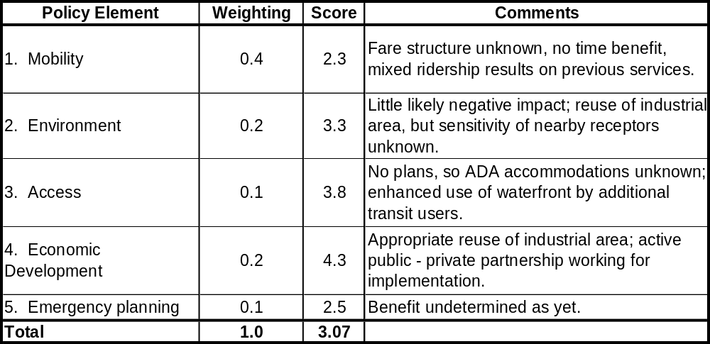
Assessment Tool Policy Summary

Salem – Boston

        - Feasibility
The overall score for the Salem service is 3.43, subject to certain assumptions about the Blaney Street terminal and the terminal at the Boston end. The plans currently proposed for Blaney Street are the basis of strong scores for most of the “Terminal 1” elements; those items not specified by the plan are assumed to be adequate (score = 3) due to the plan’s overall quality. The Boston terminal at Long Wharf is assumed to be adequate throughout (scores = 3) in the absence of specific knowledge and specific responsibility by the Salem proponents.
The boat assumed for this service (Flying Cloud) scores well; it is a tested and proven 30 knot boat for Massachusetts Bay service. Some additional speed would perhaps be helpful and winter service conditions in the exposed waters of this run will sometimes be a problem. The approach (relatively short) and protection afforded by the outer Salem Harbor landing are good; there is a moorage close by and recreational boating traffic (mostly summer), which lower the score “traffic and congestion” score somewhat.
The environmental elements score well, particularly so since the Salem site is industrial in nature and there are, as yet, no identified environmentally sensitive areas nearby. There are, however, adjacent residential and historic (Derby Street) areas at further remove which would have to be considered by a diligent operator. Noise and air quality impacts are not quantified at this time and are scored neutrally. Wake and wash in proximity to the moorage are assumed to be addressed by the speed limitation in Salem Harbor.
Table 7-5

Assessment Tool Feasibility Summary

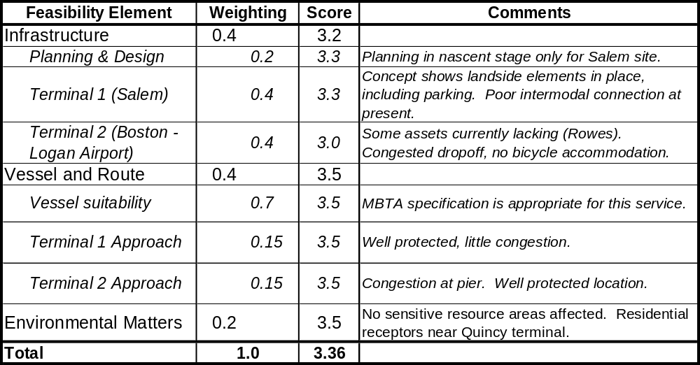
Salem – Boston

        - Demand estimation
No demand estimation was performed for this service.
        - Finances
The estimate for the seasonal service includes the assumption that the boats spend half their operating hours in other services, e.g., in warm weather operations elsewhere during the winter. For both year round and seasonal services, it is assumed that one seven year old boat and one new boat (average age of 3.5 years) are in operation. Costs overall for the two services are nearly proportional to numbers of trips and operating hours. The boats in seasonal service would have slightly in excess of ½ the operating hours of those in year round service.
Table 7-6

Annual Vessel Operating Costs

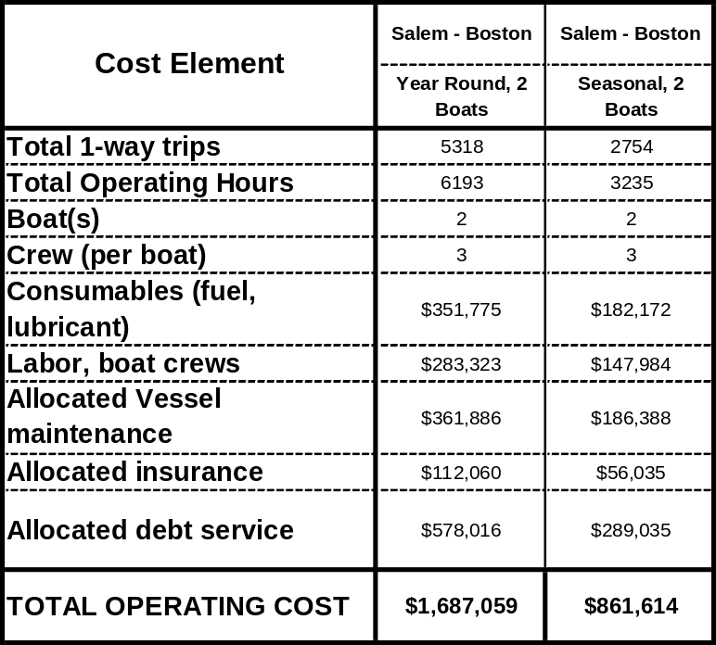
Salem – Boston Service

Initiation of a new service to Salem would also entail a significant capital expenditure for infrastructure improvements. The 1998 demonstration was run from the Blaney Street site with temporary docking facilities, use of the unimproved dirt lot for parking, and a lack of shoreside amenities. Site selection will drive the design and costs of a permanent landing facility. Current thinking in Salem is that the Blaney Street site is preferred, because of available space for parking and the historical preservation and visitor experience constraints at the National Park Service site. Our rough estimate for providing a landing at Blaney Street is $800,000.
    - Summary
The notion of a new Salem-to-Boston ferry service continues to receive support in Salem and is attractive because of the combination of commuter and recreational markets it would serve. The patronage during the 1998 demonstration project showed some promise, but headways and speed were somewhat lacking for a sustained commuter ridership. The lack of a permanent, attractive landing and the uncertainties of the ridership market in competition with the commuter rail service in Salem are the probable reasons that service has not since been sustained by private sector operators.
The analysis herein shows that a Salem service has strong positive values from a policy point of view, particularly with regard to waterfront access in a city with a long maritime tradition and many cultural attractions. It scores fairly well in the feasibility category, in part because of the strong potential of the Blaney Street site. The finance assessment is incomplete because there are no adequate demand estimates for the service as proposed. Past experience indicates some potential demand, but this has not been sustained in the services thus far attempted. The indication overall is that some public support in detailed and final planning activities (particularly financial and market related) would be appropriate. An important first step would be market analysis and the development of an operations plan for the service that best meets those needs, i.e., seasonal versus year round, and identification of commuter and recreational demand. Proponents in Salem, both public and private, will need to show strong and sustained interest in moving the infrastructure planning and support building processes along as well.
Table 7-7

Assessment Summary

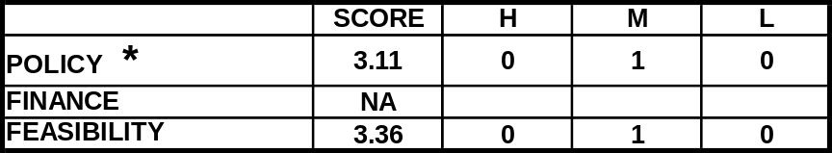
Salem – Boston Service

  - Lynn to Boston service
    - Characterization
Lynn is a North Shore community with a population of 89,050. The industrial heritage of Lynn is characterized by its stock of older industrial buildings concentrated in the downtown and waterfront areas, along Route 1A. The town’s extensive residential areas are predominantly further inland to the north of Rte.1A. Lynn has a substantial work force that commutes to central Boston for employment.
By land, Lynn is a relatively short distance from Boston, with the center being only 12 miles from downtown. The trip by auto or bus has always been a disproportionately long commute, however, because of highway congestion and the limited Harbor crossings of the Sumner and Callahan tunnels. The commuter rail service ends at North Station, which is some distance away from most job locations. The Lynn-to-downtown travel time benefit of the Central Artery and harbor tunnel projects is not known at this time and cannot be factored into a mode comparison discussion.
The City has long considered the possibility of direct ferry service to downtown to complement other transit services. City representatives indicated continued interest on the part of Lynn residents to have improved transit alternatives to central Boston, including ferry service as a possible compliment to the desired extension of the Blue Line from Wonderland. To be successful, a ferry alternative would require comparable speed and passenger fares, and a Boston terminus close to employment locations.
A seasonal ferry service operated for several years in the late 1990’s from Lynn to Georges Island during the summer months. Patronage on the ferry was low, owing in part to the limited number of trips offered on the single excursion vessel service.
Table 7-8
General Specifications
Lynn – Boston Service
Infrastructure:  Dock, Water and Landside |  | Vessel Specific-  ations | Route and Schedule:  Peak, Off-Peak | Implementation Matters
Origin | Destination(s) | Vessel Specific-  ations | Route and Schedule:  Peak, Off-Peak | Implementation Matters
Lynn Blossom Street: requires new 120’ x 30’ ADA dock; parking at grade, and structures and accommodations available near dock site.  Goal: multiple use public landing. | 1) Rowes Wharf or Long Wharf  2) World Trade Center or Fan Pier.  3) Possible future service options to South Boston waterfront, or Boston Harbor Islands (seasonal off-peak). | 149 passenger.  Low wake and wash.  ADA access.  Coastwise or Limited Coastwise Certificate of Inspection.  New construction, similar to Flying Cloud modified for off-shore conditions.  Speed = 30 - 35 knots | Weekday peak commuter: 6:00 am – 9:00 am; 4:30 pm – 7:00 pm; (A1) to Rowes or Long and (A2) WTC or Fan Pier and Rowes or Long  Seasonal Weekend Off-peak: to downtown and Harbor islands. | - Seasonal Salem off-peak visitor service could be combined with year round Lynn commuter service, but operation of both not likely. Commuter stop in South Boston needs analysis. Seasonal visitor service demand to Lynn appears limited.  - Funding: commuter, public-private partnership for infrastructure improvements  - Fare structure and parking costs consistent with land transit, i.e., commuter rail and Blue Line at Wonderland. MBTA pass use for commuters and visitors.  - Bus shuttle to Lynn commuter rail, and Swampscott- - Expanded fleet: add new vessels or private vessel concession

      - Route and service area
The route (Figure 7.2) would provide direct commuter ferry service from Lynn to downtown Boston during weekday commuter hours, with other possibilities for off-peak seasonal services. The ferry route is somewhat longer than the land routes, being some 13.6 nautical miles (15 statute miles) as compared to 10-12 miles by land. This is due primarily to the looped approach channel from the Bay which roughly parallels the Nahant and Lynn shorelines.
The Lynn service catchment area (Figure 7.2) would be primarily for park and ride auto commuters within a 15 minute driving distance, as well as for feeder bus users from a similar area. Swampscott would also lie within the driving catchment area, as well as parts of Marblehead, Salem, and Peabody. This service area overlaps with that described for Salem; so it is unlikely that the these communities would be able to support separate commuter vessel services.
The City is currently served by the North Shore commuter rail, bus lines, and the Blue Line terminus at Wonderland. The commuter rail terminal is located just off Route 1A near the center of the commercial district. There is an ample parking garage attached to the station, but circulation by automobile and on foot is somewhat awkward because of the relationship of the elevated rail platform and its two access points to the street. Many residents use the Blue Line service because of its fare and frequency advantages, accessing the service by driving and parking on-site or nearby.
This service could benefit from the provision of a feeder bus shuttle to the Lynn commuter rail station and Swampscott and other residential areas, to give people an option to automobile commuting and a connection back to the ferry terminal for those who took the train home.
For Lynn and other services, the main question for ferry service is how well it would serve as a compliment to other transit options, in particular how it would compare to an extension of the Blue Line in terms of cost effectiveness for adding transit capacity for the area. The general specifications and implementation issues appear in Table 7-8.
      - Schedule and vessels
The vessel(s) selected for analysis here is also the Flying Cloud, as for Salem and the other Massachusetts Bay services.
The combination of the Nahant causeway and Nahant provide good protection to the Lynn Harbor from the northeast and east, but leaves the harbor open to the south and southwest. The long approach channel connects to the main shipping channel entering Boston Harbor; the route includes a relatively short leg in the exposed waters of Massachusetts Bay before the westward turn into Outer Boston Harbor through President Roads. The route then follows the shipping channel westward past Logan Airport and into the Inner Harbor.
Several alternative schedules were considered for the Lynn (Blossom Street) to downtown ferry service; the two choices for the analysis are summarized in Table 7.9. The primary route for evaluation purposes is a year round weekday commuter route to downtown Boston (Long Wharf), scheduled to provide an equivalent number of trips as the commuter rail. Three vessels would provide 30 minute headways and 35 minute trip times during weekday peak hours. More frequent headways could be achieved with a larger fleet of dedicated vessels, but the choice for this analysis was to test the potentially more cost effective approach of relatively high average occupancy on the three vessel service. During seasonal off peak hours in mid-day and on weekends, there would be an additional stop at the Harbor Islands, whose one-way trip time would be 55 minutes, with a cycle time of 1 hour, 55 minutes and two hour headways.
The second option is for year round peak hours service to downtown and South Boston at 60 minute headways, which would require two boats for 45 minute trip times and one hour, 40 minute cycle times. Off peak service would be similar to that for the first service option.
Future service options could include intermittent or off peak stops at Logan Airport, commuter service stops at the South Boston waterfront when trip-to-work demand is adequate, and off peak service to the Harbor Islands.
Table 7-9

Vessels and Schedules

Lynn – Boston Service
Routes, Distances | Peak Route Cycles, Schedules, and Vessels Needed | Off-Peak Schedule and Vessels Needed
Routes, Distances | Year Round Weekday Peak: 6-9:00 am and 4:00-7:00 pm | Weekday Off-Peak: 10:00 am – 3:00 pm and 7:00 pm – 9:30 pm; Weekend Off-Peak:  10:00 am – 8:00 pm
Peak Route, Year Round and Seasonal Service Options:  1. Blossom Street to Long Wharf  2. Blossom Street to Long Wharf and South Boston  Trip Distance:  - One way = 13.6 nm  - RT = 26 nm  Off-Peak Route:  Blossom Street to Harbor Islands to Long Wharf, seasonal.  Trip Distance:  - One way = 14 nm  - RT = 28 nm  Blossom Street to Long Wharf, off-season for year round service only. | 1. Year Round, 30 min. headway:  - Trip Time: 35 min.  - Cycle Time: 90 min.  - Vessels needed: 3  2. Seasonal, 45 min. headway  - Trip Time: 35 min.  - Cycle Time: 90 min.  - Vessels needed: 2 | Headway: 120 min. for all options.  Year Round Service (seasonal trips only):  - Trip Time: 45 min  - Cycle Time: 90 min.  - Vessels needed: 1  Seasonal Service  - Same values.

      - Terminal infrastructure
The general terminal needs for Lynn as a commuter origin would include:
- Waterside Terminal Needs
  - Deck Facility with ADA access
  - Channel and fairway approaches
- Landside Terminal Needs
  - Terminal support: sheltered waiting and ticketing
  - Shuttle bus links to residential and commercial areas
  - Auto and bus drop-off
  - Parking for automobiles, bicycles, and busses
The project team’s preferred landing site among several alternatives was the Blossom Street site (see “Field Work” discussion below) and was also recommended by the local stakeholders interviewed. The site was well situated with respect to the road system, relatively close to the downtown, and with good proximity to the channel in Lynn Harbor. It is an underutilized industrial area and part of a Commonwealth Designated Port Area, and appears to have ample land available for the parking spaces needed, as well as room for automobile and bus drop-off. Much of the needed property, including an older short pile supported pier, is currently owned by the City of Lynn. The pier structure would require repair and stabilization, but could serve as the take-off point for new ramps and a float landing near the channel. While no bathymetry was available, the proximity of the channel indicated good water access and the likelihood that dredging probably would not be required. The site had once been considered as a possible landing for Deer Island construction phase ferry service.
Site infrastructure needs would include a 30’ by 100’ barge or floating dock, new ramps, landside waiting shelter, auto/bus turnaround, and parking for 300 to 350 cars. Since no designs have been prepared for a new pier, the cost estimate herein is based on approximate component costs. The dock required would be similar in specification and design to facilities studied for Scituate Harbor. The total estimated cost for these improvements is $950,000. A summary of infrastructure status and needs appears in Table 7-10.
Table 7-10
Terminal Infrastructure Status and Needs
Lynn – Boston Service
Infrastructure Status:  Dock, Water and Landside |  | Infrastructure Construction Costs (New or Renovated)  Dock, Water and Landside
Origin | Destination | Origin | Destination
Blossom Street: Requires new 120’ x 30’ ADA dock; parking at grade for 300 to 350 cars, shelter, and dropoff area. | 1) Long Wharf: existing ADA dock; minor dredging of basin would improve approach, but is not critical.  2) Logan Airport, Harbor Islands, and World Trade Center are possible future destinations for peak and off peak service. | Rough estimate:  $950,000 | Total cost of future Long Wharf improvements uncertain as are possible cost sharing arrangements.

    - Field Work
A site visit was conducted to Lynn on May 3, 2002. Interviews and site inspection were conducted with Peter DeVoe, Executive Director of the Lynn Executive Development and Infrastructure Council, Bob Walsh, vessel operator and dock manager, and Jim Derry, Harbormaster.
Six alternative terminal sites were considered in Lynn Harbor as shown in the aerial photograph of the harbor in Figure 7-3. The sites considered from south to north are the following:
1. South Harbor at the Revere Bridge: The site has good highway access to route 1A. It would, however, be located on north edge of Revere and would be much closer to the Wonderland Blue Line. From the waterside, there are several critical concerns, including lack of channel access, substantial dredging needs, and other potential environmental impacts. The site would also create a much longer slow speed channel run away from Boston, back through the Lynn Harbor.
2. Mass. Electric Bulkhead: Near the south west end of the current Lynn channel and several hundred yards beyond the existing Town Pier is a stretch of bulkhead with several privately owned, capped industrial sites adjacent that could be used for parking. Dredging might be required to extend the channel. Floating landings could be attached to the bulkhead. The site is a reasonable alternative to the nearby Town Pier if it proved to be too busy to accommodate the ferry.
3. Town Pier: At first glance the town pier seemed to be a good potential site for a ferry landing since it was a publicly owned site with a pile supported pier in good condition next to several parking sites. However the current use as a landing for the Horizons Casino vessel combined with other commercial vessel operations, including commercial fishing, appear to conflict with the parking needs of a ferry operation. Most of the nearby parking is leased or owned by the casino, and ferry parking would need to be further away. A new floating landing would probably be required, most likely to the south west end of the pier. The site can be quite exposed to southwest winds and wave action.
4. Blossom Street: The site of a formerly active pier and landing, Blossom Street seemed to have several advantages. Access to Route 1A is clear and direct. The existing city owned short-pile supported pier with nearby channel access could serve as the landside connection for a new ramp and float system. Several nearby city owned areas along Blossom Street could provide nearby drop-off and parking areas. While the industrial setting with fuel storage tanks didn’t appear very attractive from a passenger comfort standpoint, much of the Lynn harbor front has a similar character.
5. Belkan: The privately owned Belkan industrial site further to the northeast consists of five acres, largely occupied by building structures, and is adjacent to the federally maintained turning basin. A new pile supported pier would be needed to connect to the channel over tidal flats. Landside access seemed circuitous. The site appeared to be a costly alternative.
6. Heritage Park: A series of floats and landings exists around the attractive and popular Heritage park. While well located at the turn of the channel, there appeared to be no way to find a nearby parking area. The neighboring condominium complex occupies all of the grade parking and has not yet provided the 100 spaces for the park and marina required by the project’s Chapter 91 license.
Based on the availability of City owned property, proximity to the existing channel, and the availability of nearby parking areas, the Blossom Street site is the preferred option.

Figure 7-3

Aerial Photograph, Lynn Waterfront

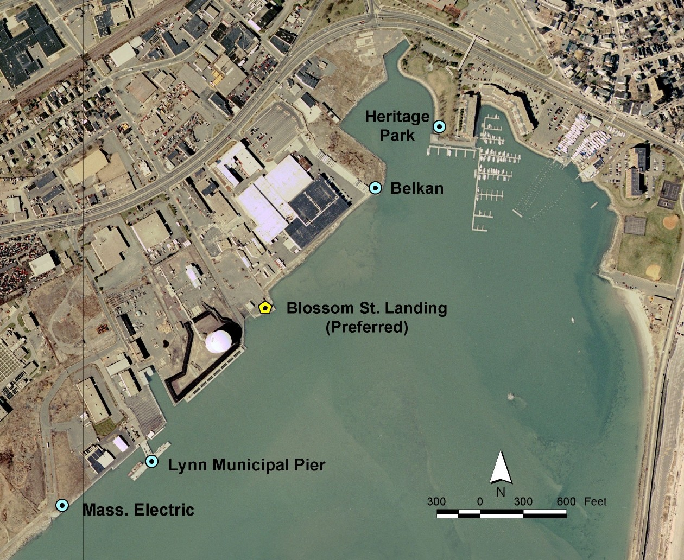
Source: Lynn Economic Development and Industrial Corporation

    - Service Assessment
      - Maturity evaluation
The Lynn to Boston service has had very little active planning work, and little visibility in the City, particularly since Blue Line extension is viewed by many as the priority project for the City’s residents. The only positive answer of the eight questions in this category results from the public ownership of the land where a terminal facility would be considered. The overall score was 0.1 on the scale of 0.0 – 1.0.
      - Categorical evaluation
        - Policy
The Lynn service scores modestly from a policy standpoint (2.15) at this time because of the low existing level of planning and public support for such service, and because of current initiatives for land-based transport options. This score would in fact be lower except that the Blossom Street site does score well because of the potential for improved public waterfront access and the degree of apparent environmental compatibility in this industrial area. A potential service would require significant land-based intermodal transportation improvements and active economic development projects immediately adjacent. See Table 7-11.
        - Feasibility
The overall feasibility score is 3.05, somewhat lower than Salem’s. The lack of terminal assets at Blossom Street or development plans is the main difference (and, again, need for access to intermodal connections). The route is slightly better suited to the Flying Cloud because of the shorter distance in exposed waters, although the approach and landing site are more exposed (a long southern fetch to the opening between Nahant and the mainland). The Lynn site scores highly in environmental conformity because of its highly industrial nature and the low impacts to human and natural receptors. See Table 7-11. Full results appear in Appendix H.
Table 7-11

Assessment Tool Policy Summary

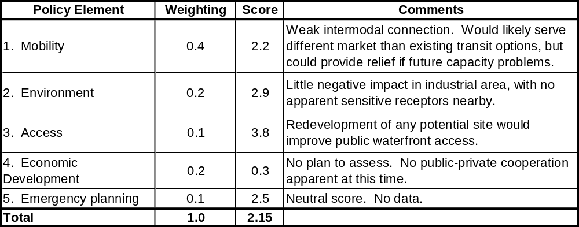
Lynn – Boston

Table 7-12

Assessment Tool Feasibility Summary

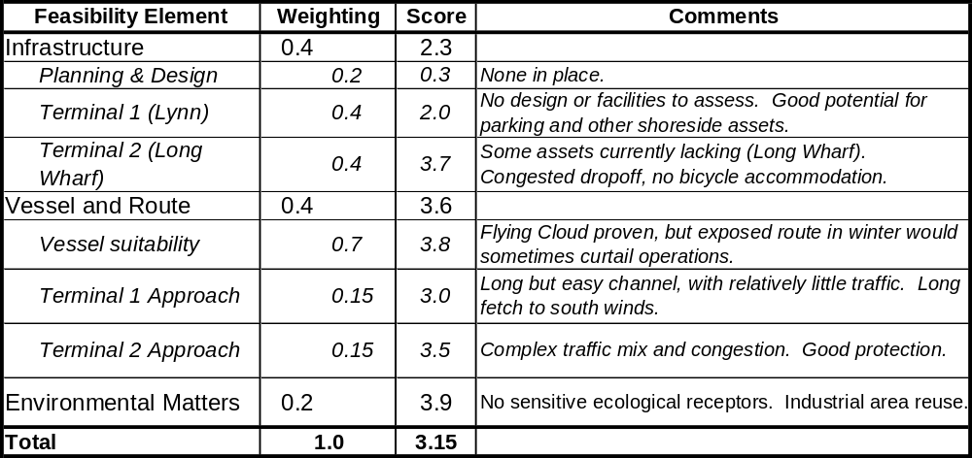
Lynn – Boston

        - Demand estimation
CTPS use service assumptions for this route include a $2.00 fare (equal to commuter rail fare from Lynn to Boston), a 30-minute peak-period headway in the peak direction, and available parking at the Lynn Garage or next to the boat terminal. The model forecasted 250 trips during the peak periods if parking is provided at the Lynn Garage and 600 trips if parking is provided next to the terminal. CTPS reported all trips in the second case would be diverted from buses and commuter rail.
        - Finances
The overall financial assessment is for the year-round, three-boat service with 30-minute headways during peak hours service. The operating costs for both boat and service (headway) combinations appear in Table 7-13 below (with the selected service shaded), showing estimated expenditures for year round peak hours operations only, and including the calculated debt service as an operator would expect to pay. Note that the overall financial analysis treats capital expenses and debt service as separate from operating costs, enabling more direct performance comparison to landside transit modes.
Table 7-13

Annual Vessel Operating Costs

Lynn – Boston

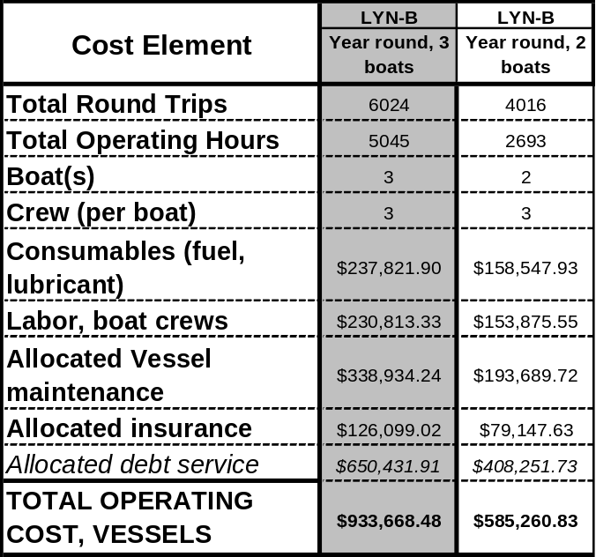

Capital costs and debt service. As described in Section 7.3.1.3 and shown in Table 7-10, estimated total capital costs for infrastructure on this route are $950,000. The estimated cost for the three boats would be $7.83 million, and the annual debt service for the year round service option, as shown in Table 7-13, would be $650,432. It was assumed that for the year-round service option, the three boats would also be used during off-peak times for other services, so that commuter service – and, hence, capital and operating costs attributable to the commuter service – would represent only 75% of the boats’ activities by time. Similarly, for the seasonal service, the two boats could be used at other times, so that commuter service would represent slightly less than 71% of the boats’ operating hours.

Demand, revenue, and subsidy estimates. Based on CTPS’s demand modeling for the selected service, a total of 600 commuter boardings per day were forecast, assuming a $2 fare. Assuming a year-round weekday operation of 251 days (as per Table 3-3), there are 150,600 annual commuter boardings, with $301,200 in annual commuter revenue. Table 7-14 below presents the summary results of the ferry economic model, assuming demand and revenue figures as estimated by CTPS.
Table 7-14 also shows a financial performance comparison of this service with rail modes. Measures for the latter are based on preliminary FY 2002 data, aggregated for all MBTA commuter and heavy-rail subway lines. The overall finances score modestly at 2.11(shown in Table 7-15) Its projected performance is lower in all categories to rail transit except subsidy per passenger mile.
Table 7-14
Operating Cost Evaluation for Commuter Service
Lynn – Boston

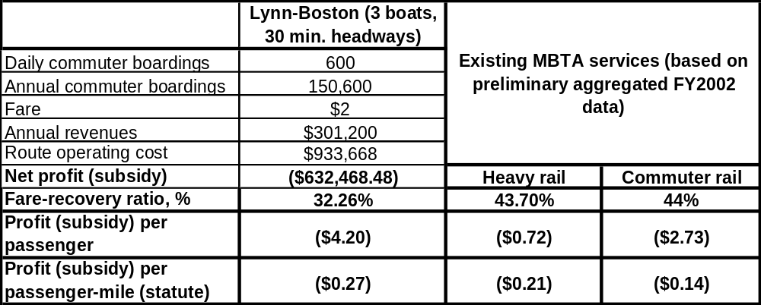

Table 7-15
Assessment Tool Finances Summary

Lynn – Boston

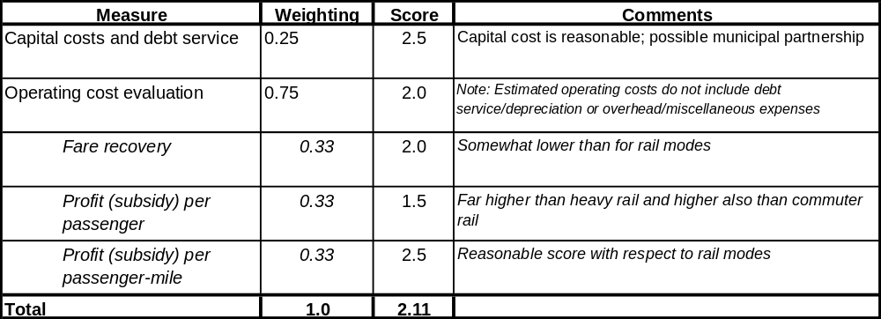

    - Summary
The Lynn service scores modestly from both the policy (2.15 on a scale of 0 - 5) and finance (2.11) standpoints at this time. The policy score relates to the current level of planning and public support developed for such a service. The Blossom Street site helps both the policy and feasibility scores because of its available space for shoreside infrastructure needs, its potential for improved public waterfront access, and the level of environmental compatibility in this industrial area.
The overall feasibility score is 3.15, somewhat lower than Salem’s. The lack of terminal infrastructure or development plans and limited access to intermodal connections require improvement. The route is more favorable because of the shorter distance in exposed waters, although the approach and landing site are more exposed. Environmental impact would be low due to the industrial nature of the waterfront and the probable low impacts to human and natural receptors.
The financial analysis for this service shows modest performance. The demand analysis for a 3-boat service providing ½ hour peak service headways at fares equal to the commuter rail option indicates that there would be 300 commuter round trips per day. Farebox recovery (32%) and unit subsidy values ($4.20 per passenger) are slightly worse than those for Quincy, and lower by comparison with similar measures for MBTA rail services. The major difference is that there would be significant infrastructure costs in Lynn, where no facility exists, and where nothing has been done in the way of partnering, siting, planning, or permitting for a terminal.
The indication at present is that it would be appropriate to assign a low priority to fund planning or implementation of a service at this time, due to the current ridership projections in the CTPS analysis and potential for extension of the Blue Line to Lynn. This outlook would change given two conditions. The first is stronger public support in the form of public-private partnership and an active planning effort to develop infrastructure siting, and market and route/schedule development. The second would be an indication of capacity issues on the commuter rail and Blue Line transit options. In such a case, ferry service could provide extra capacity, at least in the short term, for relatively minor capital investment, which could offset the farebox and subsidy performance.
Table 7-16

Assessment Summary

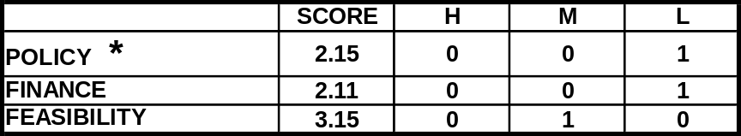
Lynn – Boston Service

  - Scituate to Boston service
    - Characterization
Scituate is a South Shore community with a population of 17,863 (2000 census). The town commercial center is located on Scituate Harbor with direct access to Massachusetts Bay. For many years, a significant proportion of Boston transit commuters from Scituate have used the Hingham ferry as their primary mode of travel. Prior to and during the planning of the proposed Greenbush commuter rail line, some ferry commuters have sought to have a dedicated water transit link to downtown from Scituate Harbor. In 1999, the Scituate Ferry Feasibility Study of potential ferry service and market demand was completed and described several scenarios for year round ferry operations including siting options and concept design for a new terminal. The study was funded by a grant from EOTC. This study revisits the assumptions and findings of that report. There are no new demand data herein, so the 1999 market analysis is re-examined in light of the service assumptions for this assessment.
By contrast with the Salem and Lynn candidate routes, the water distance from Scituate to downtown Boston is considerably shorter than the land distance. By highway, the distance is approximately 35 miles, while the water distance is roughly 24 miles or 20 nautical miles. The peak period land trip time by auto or bus along the Southeast Expressway has always been somewhat unpredictable because of variable traffic congestion. Scituate and other nearby South Shore communities also differ from their North shore counterparts because they have no immediate access to commuter rail or subway transit. The Greenbush commuter rail line would provide a commuter rail terminus in Scituate, and offer a transit alternative to town residents and communities south of Scituate.
Current Scituate ferry commuters drive to the Hingham terminal for service to downtown, with the automobile trip taking from 10 to 15 minutes depending on residential origin. Provision of a new ferry service form Scituate would divert many of these peak hour commuters for whom the combined auto/ferry trip from Scituate was more time efficient than the current Hingham service.
A two month EOTC-funded demonstration service was operated during January and February of 1996 to test the viability of Massachusetts Bay winter operations. During the Scituate feasibility study, interviews indicated that the service was considered a success both operationally and ridership-wise, despite a limited schedule and several weather related trip cancellations.
      - Route and service area
The route (Figure 7.2) would provide direct commuter ferry service from Scituate to downtown Boston during weekday commuter hours, with possibilities for off-peak seasonal services. As noted, the water route is considerably shorter than the land routes (24 statute miles compared to 35). As with the other Massachusetts Bay routes, a portion of the trip would be within the more protected Outer Harbor. Nearly 8 nautical miles of the Scituate route would be within the Outer Harbor, entering at Point Pemberton near the Hull ferry landing.
The Scituate service catchment area includes park and ride auto commuters within a 15 minute driving distance, as well as for feeder bus users from a similar area. A portion of the riders would be residents near the Harbor within a 10 to 15 minute walking distance. The Scituate ferry driving catchment area would be similar to that of the proposed Greenbush commuter rail terminus and would include Scituate and Norwell with portions of Cohasset, and Marshfield. The 1996 ferry demonstration also attracted
residents of Duxbury and Kingston, beyond the normal 15 minute driving radius assumed for auto users. To the northeast, there would be an overlap in service area with the Hingham ferry catchment area, and a smaller overlap with the Hull/Pemberton catchment area.
Table 7-17
General Specifications
Scituate – Boston Service
Infrastructure:  Dock, Water and Landside |  | Vessel Specifications | Route and Schedule:  Peak, Off-Peak | Implementation Matters
Origin | Destination(s) | Vessel Specifications | Route and Schedule:  Peak, Off-Peak | Implementation Matters
Scituate Mill Wharf | Boston Long or Rowes Wharf  Possible future inclusion of South Boston waterfront stop at WTC or Fan Pier | 149 passenger.  Low wake and wash.  ADA access.  Coastwise or Limited Coastwise Certificate of Inspection.  New construction, similar to Flying Cloud modified for off-shore conditions.  Speed = 30 - 35 knots | Year round or seasonal to downtown Boston. | - Potential future direct transit to South Boston. Two- way seasonal cultural and tourism stimulus.  - Funding: MBTA commuter fare structure consistent with proposed land transit (Greenbush commuter rail). MBTA pass use for commuters and visitors.  - Bus shuttle to commuter rail.

For transit alternatives, the Town is currently served by the Hingham ferry and bus lines. Depending on resident location, there are also options to use more the remote Red Line station at Braintree, or Old Colony commuter rail stops to the west. When the proposed Greenbush line is completed, the line will offer numerous boarding opportunities. The commuter rail terminal is located just off Route 1A near the center of the commercial district. Ample parking is proposed at the Greenbush station. Currently the preferred transit option for Scituate catchment area residents is the Hingham ferry.
      - Schedule and vessels
The vessel(s) selected are similar to the Flying Cloud, built in 1996 by Gladding-Hearn to a design by Incat Designs, per 7.1.4.2.
Based on interviews with City representatives, there appears to be a long-standing interest on the part of Scituate residents to have improved transit connections to central Boston. The ferry route was considered as an interim service prior to implementation of Greenbush, and possibly complementary to the Greenbush line after its completion.
Several alternative schedules were considered for the Scituate to downtown ferry service as summarized in Table 7.18. The schedules considered in the current evaluation were similar to those evaluated in the 1999 study. The primary route for evaluation purposes consisted of Scituate to Downtown on weekdays, with an additional stop at the Harbor Islands during seasonal weekends. A 30 knot catamaran would provide a trip time of 45 minutes, with a cycle time of 1hour 40 minutes.
Schedule variations considered included:
- Year-round peak hours service. Scituate to downtown at 50 minute headways. Includes seasonal weekday and weekend off peak service to downtown and the Harbor Islands at 2 hr headways.
- Seasonal peak hours service. Scituate to downtown at 50 minute headways. Includes seasonal weekday and weekend off peak service to downtown and the Harbor Islands at 2 hr headways.
- Year-round peak hours service to downtown and South Boston. Service at 60 minute headways. Includes seasonal weekday and weekend off peak service to downtown and the Harbor Islands at 2 hr headways.
The seasonal and year round weekday commuter route to downtown would provide three morning and three afternoon departures for commuters. The year-round service with a stop at South Boston would offer three peak hour round trips, morning and afternoon. A single vessel service was not considered as it would not provide adequate peak hour service frequency.
Table 7-18

Vessels and Schedules

Scituate – Boston Service
Routes, Distances | Peak Route Cycles, Schedules, and Vessels Needed | Off-Peak Schedule and Vessels Needed
Routes, Distances | Weekday Peak: 6:00-9:00 am and 4:00-7:00 pm |  | Weekday Off-Peak: 10:00 am – 4:00 pm and 7 pm – 10 pm; Headway 30 min.  Weekend Off-Peak:  9:00 am – 7:00 pm
Routes, Distances | 23.3 Meter Catamaran
Year round service,  Scituate to Boston  Trip Distance:  One way = 20.0 nm  Off-peak seasonal route,  Scituate – Spectacle Island – Long Wharf  Trip Distance:  One way = 20.3 nm | 50 min. headway:  - Trip Time: 45 min.  - Cycle Time: 1hr 40 min.  - Vessels needed: 2 |  | 2 hour headway  - Trip Time: 55 min.  - Cycle Time: 90 min.  - Vessels needed: 1

      - Terminal infrastructure
The general terminal needs for Scituate as a commuter origin and visitor destination would include:
A. Waterside Terminal Needs:
- Dock Facility with ADA Access
- Channel and Fairway Approaches
B. Landside Terminal Needs:
- Terminal support: sheltered waiting and ticketing
- Auto and bus drop-off
- Shuttle bus links to residential areas and future Greenbush terminal
- Parking: Autos (300 cars), bicycles, buses
The preferred landing site is at Mill Wharf, adjacent to the harbor commercial area, as recommended in the Scituate Ferry Feasibility Study (1999). The site was verified to be the preferred location by the project team and was also the site recommended by the group interviewed. The site is well situated with respect to the road system, within the harbor “downtown” area, and close walking distance to residential neighborhoods. The landside and waterside components of the site as recommended in the 1999 report would require cooperation with the adjacent property owners for the landing, the drop-offs and some of the parking. From the waterside, the site is well protected and has good proximity to the channel in Scituate Harbor. The greatest concerns expressed by residents and merchants in the harbor area during the 1999 study were: 1) the loss of public parking near the terminal, and 2) seasonal water-use conflicts with the fishing and recreational boating fleet.
Site infrastructure needs as detailed in the 1999 study would include a 30’ by 85’ barge, pedestrian ramps, landside waiting shelter, auto/bus turnaround, and parking for 300 to 350 cars in several lot locations within a short walk of the terminal. In addition several existing vessel berths at Mill Wharf and a gas dock would need to be relocated .
Estimated Infrastructure Costs. The Mill Wharf ferry terminal site was studied in some detail in the 1999 study. The recommendations were reviewed by the current project team and provide the basis for the current estimates, inflated to 2003. Of the total infrastructure costs of $950,000, approximately $600,000 would be for waterside elements and $350,000 for landside terminal, circulation and parking improvements. In the absence of specific terminal designs for the other Massachusetts Bay sites, the Scituate concept designs and cost allowances were used as prototypes for the other three sites.
Table 7-19
Terminal Infrastructure Status and Needs
Scituate – Boston Service
Infrastructure Status:  Dock, Water and Landside |  | Infrastructure Construction Costs (New or Renovated)  Dock, Water and Landside
Origin | Destination | Origin | Destination
Mill River  - 30’ by 85’ barge  - Pedestrian ramps  - Landside waiting shelter  - Auto/bus turnaround  - Parking for 300 to 350 cars | 1) Long Wharf: existing ADA dock; some dredging of basin would improve approach  2) Rowes Wharf | Total cost = $950K | - Adequate capacity and accommodations at existing site. Future expansion needs for possible multiple Massachusetts Bay services and its cost allocation are not known at this time.

    - Field Work
A site visit was conducted to Scituate on May 7, 2002. Interviews were conducted with the Town Manager, Peter Agnew, and site inspections were conducted by the team.
    - Service Assessment
      - Maturity evaluation
This proposal has been thoroughly researched and analyzed in the 1999 feasibility study. The Maturity score of 0.7 indicates that the planning issues have all been addressed, with the caveat that some of the answers were not favorable. The study indicated that a subsidy would be needed for the service and that the Scituate dock would not be publicly owned. Environmental matters have been identified, but not fully addressed. There is no indication that near term start-up is likely.
In total, this proposal is by far the most fully realized of any considered herein, except for the Quincy service, which is already in operation.
      - Categorical evaluation
        - Policy
This proposal is strong on the whole. There are questions about public waterfront access enhancement that are not fully addressed, and also some landside environmental issues require analysis and permitting. Mobility is a strong point, as travel times into Boston could be improved with the right boat. Terminal development and partnering issues have been thoroughly explored.
Table 7-20

Assessment Tool Policy Summary

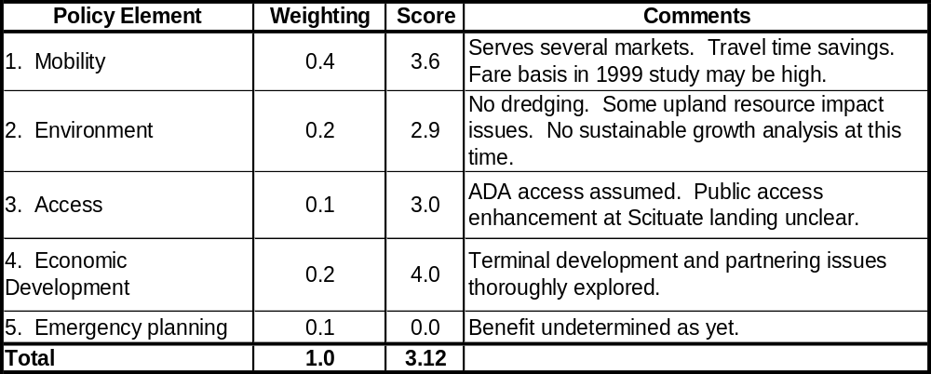
Scituate – Boston

        - Feasibility
The 1999 study identified all the issues thoroughly. While it addressed most of them effectively, it also revealed several issues which will require the attention of planners. There will be difficulty finding parking capacity and favorable siting in the Scituate waterfront area. The problem of identifying land leads to a potential upland resource (bordering wetland) issue. Intermodal connections in Scituate are poor.
Scituate Harbor is quite congested in summer and would pose maneuvering, wake and wash, as well possibly as noise control issues. Finally, the choice of a boat will be important. The 1999 study selected a boat very similar to that put forward here. Winter operation of a 25 – 35 meter long catamaran in the exposed waters between Scituate and President Roads will bring with it exposure to rough weather and the possibility of occasional service cancellations. Full results appear in Appendix I.
        - Demand estimation
CTPS did not prepare demand estimates for this service. The data from the 1999 feasibility study are instead used. A fare of $5 was suggested for rough parity with the Hingham ferry. The year 2010 projection for commuters only was 407 round trips per day (204,314 one way trips annually). The study also estimated 28,960 “non-commuters” (57,920 one way trips annually). These are not included in the finance analysis.

Table 7-21

Assessment Tool Feasibility Summary

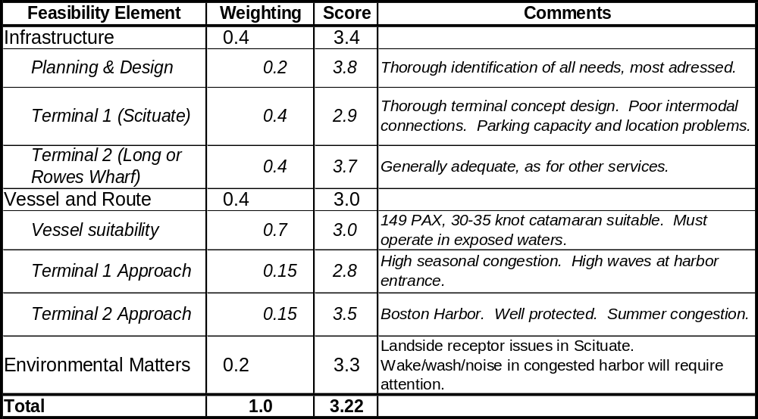
Scituate – Boston

        - Finances
The overall financial assessment is for the year-round, two-boat service with 50-minute headways during peak hours service. It is assumed that this schedule is similar to that contemplated by the 1999 Scituate study. The operating cost summary for this service appears in Table 7-23, showing as for other services estimated expenditures for year round weekday peak hours operations only (for comparison with the commuter demand estimate only). The calculated debt service for the boats is included for information but not added into the total operating costs. Note that the overall financial analysis treats capital expenses and debt service as separate from operating costs, enabling more direct performance comparison to landside transit modes.
Capital investment for this service would be approximately $950K for infrastructure and two new boats approximately $5.5 million. This is much cheaper than landside transit projects, but high in the context of the routes considered for this study.
Approximately 25 percent of the total hours (1470) are allocated to other service, as for the Lynn service. Table 7-22 shows total annual vessel operating costs of $793,103. Table 7-23 shows very strong economic performance indicators for this service, using the method developed for comparison to public transit services. Three important caveats must be kept in mind:
- This service is not necessarily intended to be publicly operated. The annual operating costs include no infrastructure or vessel capital costs or debt service, for consistency of comparison to the other ferry services in this report.
- The $5 one-way fare chosen in the 1999 Scituate study is retained. This is considerably higher than the stipulated fares for the Lynn and Quincy services, although the commuter rail fare from Scituate would be certainly be higher than $2.
- The demand analysis for the 1999 Scituate study was not the same approach as used by CTPS for other routes herein.
Table 7-22

Annual Vessel Operating Costs

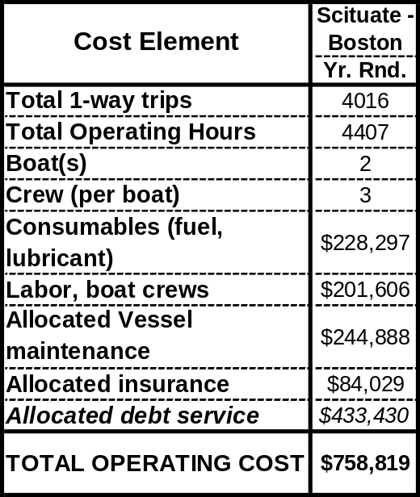
Scituate – Boston Service

Table 7-23
Operating Cost Evaluation for Commuter Service

Scituate – Boston
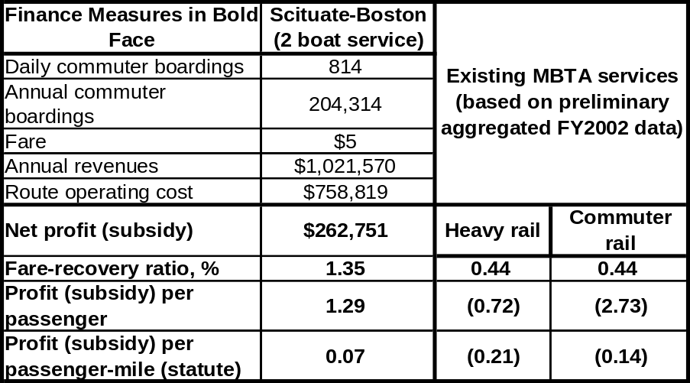
With these factors in mind, the finance scores (Table 7-24) are tempered somewhat relative to the finance data in Table 7-23. We note that the 1999 study concluded that higher fares or public subsidy would be required for the service; it is clear that the mode of comparison to public transit operations employed here significantly changed the result by removing capital expenses from the equation.
Table 7-24
Assessment Tool Finances Summary

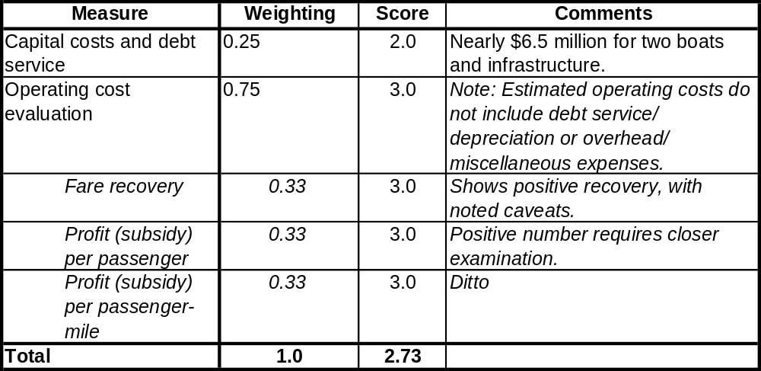
Scituate – Boston

    - Summary
The Scituate – Boston service as proposed in this study is operationally quite similar to that advanced in the Scituate Feasibility Study (1999). The proposal is mature because of the identification of issues and conceptual planning in the Study. It scores in the mid-range for all categories. In the policy aspect, uncertainty about the management mode of this service (public or private) affected the access and economic development scores. Landside environmental and parking issues pulled down the feasibility score, as did the congestion in Scituate Harbor, wave convection at its entrance, and exposed water operations for the propose catamaran.
The finance assessment was a departure from others herein because the 1999 study’s demand analysis and results were used because no CTPS data were available. The relatively high assumed fares and elimination of capital and debt service from the operating expense line resulted in positive farebox and subsidy values. Our conclusion is tempered by knowledge of the caveats involved; this case confirms the idea that CTPS should make a serious effort to develop a more sophisticated and precise ferry demand estimation method.
There is no recommendation for support of service development activities at this time. The proponents have already done a thorough and credible technical investigation. There is some promise for this route as the finance data show, but there should be a clearly articulated management approach and a renewed effort to address some of the technical issues raised by the 1999 study. It is possible that resolution of these points will point to more active implementation measures for this ferry service in the future.
Table 7-25

Assessment Summary
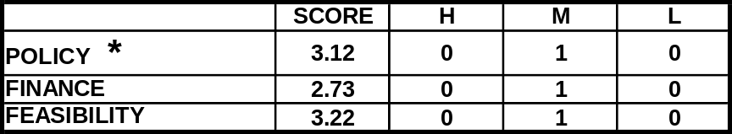
Scituate – Boston Service

  - Sandwich to Boston service
    - Characterization
Sandwich is a Cape Cod community with a population of 20,136 (2000 census). The town borders on the Cape Cod Canal and Mass Bay, with an active harbor at the East Boat Basin, a commercial fishing and recreational boating harbor near the east entrance to the canal. The town center is located inland about 2 miles from the harbor. There has been no scheduled ferry service to Sandwich in recent years. Transit access year round and during the busy summer season is provided by private bus carriers. The nearest commuter rail site is in Kingston on the Old Colony Line.
In 1998 the Cape Cod Marine Transportation Feasibility Study was completed by the Cape Cod Commission and the Cape Cod Economic Development Council with funding support from EOTC. Included in the study was an assessment of the potential for seasonal or year round service from Sandwich to Boston and Provincetown. A limited market demand assessment was completed and several scenarios were described for seasonal and year round ferry operations. The study included an assessment of the siting options. This study revisits the assumptions and findings of that report.
The distance from Sandwich to downtown Boston is somewhat shorter by land than by water; approximately 50 miles and 60 miles (50 nautical miles), respectively. The distance from Sandwich to Provincetown is considerably shorter by water than by land. By highway the distance is approximately 60 miles, while the water distance is roughly 29 miles or 24 nautical miles. The peak period land trip time by auto or bus from Sandwich to and from Boston varies by season, with substantial delays around summer weekend periods. Similarly, the trip from Sagamore Bridge in Sandwich to Provincetown can vary greatly from summer peak periods to off- season times. While there are fewer daily commuters to Boston from Sandwich and the inner Cape, the numbers are increasing as the year round population grows. Travel from Sandwich and mainland points to Provincetown and the outer Cape is generally limited to visitors during the summer months, and accounts for a considerable portion of the peak traffic congestion on the Sagamore Bridge and Route 6.
There has long been interest in exploring ferry service as a seasonal transit alternative to relieve pressure on the Cape Highway and Sagamore Bridge. Table 7-26 presents the principal characteristics of the service as developed by the project team.
Table 7-26
General Specifications
Sandwich – Boston Service
Infrastructure:  Dock, Water and Landside |  | Vessel Specifications | Route and Schedule:  Peak, Off-Peak | Implementation Matters
Origin | Destination | Vessel Specifications | Route and Schedule:  Peak, Off-Peak | Implementation Matters
Sandwich Fish Plant/East Basin | 1) Boston Long or Rowes Wharf  2) Provincetown | 149 passenger.  Low wake and wash.  ADA access.  Coastwise or Limited Coastwise Certificate of Inspection.  New construction, similar to Flying Cloud modified for off-shore conditions.  Speed = 30 - 35 knots | Seasonal peak commuter and off-peak visitor; Sandwich to Boston  Possible option to add Provincetown as part of a triangular route. | - Potential direct transit to Downtown Boston. Two- way seasonal cultural and tourism stimulus. Relief of seasonal weekend traffic on Sagamore Bridge and route 6 to Provincetown.  - Funding: Public and/or private sources.  -Potential conflict with private bus operations.  - Fare structure consistent with proposed land transit, i.e., Greenbush commuter rail + bus shuttle to Sandwich, E. Barnstable, Bourne.

      - Route and service area
The candidate Routes appear in Figure 7.2) as a triangular route, which includes three potential services from the Sandwich landing:
- Sandwich to Downtown Boston
- Sandwich to Provincetown
- Sandwich to Boston to Provincetown to Sandwich
The Sandwich to Boston route would provide direct commuter ferry service from the inner Cape communities to downtown Boston during weekday commuter hours, with a return trip for inner Cape visitors, and a visitor oriented service on the weekend. The Sandwich to Provincetown and return route would serve outer Cape visitors by offering a park and ride service from the Sagamore Bridge area as a bypass for the longer seasonally congested trip on Route 6. The triangular route would connect from downtown Boston to Provincetown to Sandwich and back to Boston, primarily for seasonal visitors.
Nearly 8 nautical miles of the Sandwich route to Boston would be within the Outer Harbor, entering at Point Pemberton near the Hull ferry landing. The rest would be in the exposed waters of Massachusetts Bay.
The Sandwich service catchment area would differ for commuters and recreational and tourism travelers. For commuters to Boston, the area would include park and ride automobile commuters from the inner Cape and canal communities within a 15 to 20 minute driving distance, as well as for feeder bus users from a similar area. Off peak seasonal users, including Cape residents and visitors, might come from a somewhat larger radius of 20 to 25 minutes distance within the same communities. Inner Cape and canal communities within a 10 –15 mile radius would include Sandwich, Bourne, and Buzzards Bay, with portions of Falmouth, Barnstable, and Hyannis. Also included would be the sizeable and sparsely populated Edwards Military Reservation/Otis Air Force Base. Few residents are within walking distance of the proposed landing location.
The catchment area for potential Sandwich to Provincetown riders would be much larger drawing on seasonal visitors to the outer Cape traveling from the Boston suburban region to the south and west outside Route 128. The park and ride option could appeal to seasonal weekend travelers wishing to avoid the long trip on Route 6.
Transit Alternatives. The inner Cape communities are currently served by privately operated bus lines connecting Boston to principal Cape destinations. The nearest commuter rail line is at the Kingston terminus of the Old Colony Line.
The Sandwich service would most likely generate the least interest on the part of the MBTA because Cape Cod is outside its jurisdiction. There is, however, significant potential intermodal impact in the catchment area communities on the Kingston commuter rail line. This ferry service would need support from Cape Cod transit entities, but would most likely have to be a private operator initiative. The key issue is whether or not a multi-purpose Sandwich/Canal town landing would encourage Sandwich - Boston and other seasonal ferry services, and if so whether Commonwealth funding would be appropriate for the infrastructure.
      - Schedule and vessels
Several alternative schedules were considered for Sandwich as shown in Table 7.28 and are variations of those considered in the 1998 Cape Cod Commission study. The primary route for evaluation purposes consists of seasonal peak period Sandwich to downtown Boston service on weekends and weekdays, combined with a separate off peak Sandwich to Provincetown route. With a 35 knot catamaran departing from the Sandwich fish plant, the Sandwich to Boston trip time would be 1 hour and 45 minutes, with a cycle time of 4 hours. Using the same vessel the Sandwich to Provincetown trip time would be 50 minutes one way and a cycle time of 1 hour 50 minutes.
The alternative route considered would be a reversible triangular service connecting Sandwich, downtown Boston, and Provincetown with the direction determined by user demand at different times of the day and week. Adding the 1 hour 45 minute trip time for the 50 nm crossing from Provincetown to Boston, the triangular trip cycle would be 4 hours and 45 minutes, with a headway equivalent of 5 hours. This service would run seven days per week during the peak summer months, and weekends only during the shoulder season.
· Route A1/A2 (Seasonal Peak and Off Peak): A1- Sandwich to Downtown at 2 hour headways during AM and PM peak periods; A2 – Sandwich to Provincetown at 1 or 2 hour headways during off –peak periods; 2 vessels required plus a backup.
· Route B1 (Seasonal Peak and Off Peak): B1- Sandwich to Downtown to Provincetown at 2 hour 30 minute headways during AM and PM peak periods; 2 vessels required plus a backup.
The seasonal (A1/A2) point to point routes would provide 2 morning and 2 afternoon departures from Sandwich to Boston, scheduled at an average of 2 hour headways with 2 vessels operating. The A1/A2 service would then offer 3 midday and evening runs from Sandwich to Provincetown with 1 to 2 hour headways.
The seasonal triangular route (B1) could offer 2 AM and 3 PM departures from Sandwich with 2 vessels.
A single vessel service could work for the A1/A2 scenario with reduced trips and longer headways. A 1 vessel service for the triangular route would be less effective as it would only offer 2 trips per day from Sandwich.
Table 7-27

Vessels and Schedules

Sandwich – Boston Service
Routes, Distances | Route Cycles, Schedules, and Vessels Needed
Sandwich to Boston  Trip Distance  One way = 50 nm  Sandwich to Provincetown  Trip Distance  One way = 24.0 nm  Circle route = 124 nm | Sandwich to Boston to Provincetown, Triangular Service, Seasonal Schedule (April-Oct.)  - Seasonal schedule: 6:00 am - 7:00 pm, 7 days per week during summer months, weekends only during shoulder season.  - Headway: 2 hr 30 min-  -Trip Times  Sandwich to Boston - 1 hr 45min  Boston to Provincetown: 1 hr 55min  P-town to Sandwich: 50 min-  - Cycle Time: 5hr .-Peak  - Vessels Needed: 2 | Sandwich to Boston Seasonal Schedule (April-Oct.)  - Peak hours: 6:00 am - 10:00 am; 5:00 pm - 7:00 pm  - Headways: 4 hrs.  - Trip Time: 1 hr 45 min. (30 kts)  - Cycle Time: 4hr –  - Peak Vessels Needed: 1  - Off Peak hours: 10:30 am - 2:30 pm; Sandwich to Provincetown  - Trip Time: 50 min.  - Cycle Time: 1 hr 55min  -Peak Vessels Needed: 1

      - Terminal infrastructure
The general terminal needs for Sandwich are as for a commuter origin and visitor destination, and would include:
A. Waterside Terminal Needs:
- Dock Facility with ADA Access parallel to the Cape Cod Canal bulkhead just west of the current fish plant wharf.
- Channel and fairway approaches provided by the Canal
B. Landside Terminal Needs:
- Terminal support: sheltered waiting and ticketing structure
- Auto and bus drop-off
- Shuttle bus links to residential areas and inner Cape town centers
- Parking: Autos (200 cars), bicycles, buses
Preferred Landing Site. The preferred site is a terminal dock site just west of the vacant Fish Plant wharf and adjacent to the parking for the Canal Park and trail system. It was recommended after consideration of alternative locations in the nearby East Basin area. which have no available space. Barnstable Harbor was also considered, but dropped due to considerably longer route distance to Boston (by about 16 nautical miles), poor road access, and very limited parking capacity.
The Fish Plant site on the canal was verified to be the preferred location by the project team and was also the site suggested by the representatives of the Cape Cod Commission. The site is well situated on Route 6A with respect to the inner Cape road system, and close to the Sagamore Bridge and Route 6. From the waterside, the site is well protected by the canal and has good proximity to its east entry and Massachusetts Bay. The site is under the ownership and jurisdiction of the Army Corps of Engineers.
Site infrastructure needs would include a 30’ by 85’ barge, pedestrian ramps, landside waiting shelter, automobile/bus turnaround, and parking for 200 to 250 cars in a lot located within a short walk of the terminal. The siting of the landing would need to be clear of larger vessel berthing at the existing fish plant wharf. The fully accessible spud barge landing could also serve as a multi-purpose town landing for Sandwich for other passenger vessels if acceptable to the Army Corps of Engineers.
Estimated Infrastructure Costs. The Fish Plant landing site has not been studied in detail by this or previous reports. Infrastructure needs would include those described above for a commuter service. The total assumed infrastructure costs are $900,000, including approximately $600,000 for waterside elements, and $300,000 for landside terminal, circulation, and parking improvements. The landside elements would have to be arranged independently of the existing recreational area and parking lot located on the site. All improvements would require coordination with and approval by the Army Corps of Engineers, which has full jurisdiction over the properties and navigation along the canal. In the absence of specific terminal designs for the Sandwich site, the Scituate concept designs and cost allowances were used as a basis for the cost estimate.
Table 7-28
Terminal Infrastructure Status and Needs
Sandwich – Boston Service
Infrastructure Status:  Dock, Water and Landside |  | Infrastructure Construction Costs (New or Renovated)  Dock, Water and Landside
Origin | Destination | Origin | Destination
Fish Plant wharf  All waterside and landside terminal elements needed. No planning yet completed. | Long Wharf, Boston  Provincetown | $900,000 | Adequate as is.

    - Field Work
    - Site visits were conducted to potential ferry landing sites at the East Boat Basin and Fish Plant in Sandwich, and the whale watch landing in Barnstable harbor on April 11, 2002. An interview was conducted with Clay B. Schofield, transportation engineer for the Cape Cod Commission in Barnstable on the same date. Service Assessment
      - Maturity evaluation
The Sandwich – Boston service scores 0.0 for the maturity of the proposal; that is, there is no proposal or any indication of current interest in a route serving Sandwich.
      - Categorical evaluation
        - Policy
This service scores modestly in several areas because there is no concept or plan to assess. In their absence, mobility, sustainable growth, and partnership opportunities must be scored low. The environment element scores fairly well because the reuse of the Fish Plant area would represent low impact. This service would offer slower travel times to Boston than other modes and there is no analysis, or other indication, that it would remove significant numbers of automobiles from the roads.
The overall Policy score is 1.90 (see Table 7-29).
Table 7-29

Assessment Tool Policy Summary

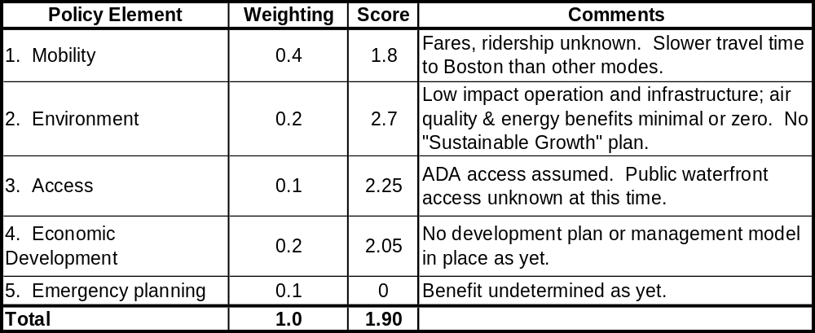
Sandwich – Boston

        - Feasibility
The feasibility assessment for this service also scored modestly because a proposal and management model remains to be developed. The potential Fish Plant terminal site in Sandwich has positive elements such as available space for parking and a good navigational approach. Otherwise, its provisions for infrastructure cannot be assessed and, therefore, it scores poorly.
The selection of a suitable vessel or vessels for this route will be difficult. The notional selection for this analysis, similar to the Flying Cloud catamaran as for the other Massachusetts Bay routes, probably has insufficient size and speed for the length and exposure of the route. A 40-45 knot boat would be considerably more attractive in terms of trip time. Such speed generally comes with more size. The capital expense for a faster boat could be twice as much as for the 23 meter, 30 knot boat, and maintenance, fuel, and insurance costs would all rise as well. In the absence of a demand analysis and/or market survey which looks at trip times (speeds) and headways, boat selection is very difficult.
Finally, the environmental score for this service is quite good because the previous use of the Fish Plant and the nature of the area around that site indicate very low potential impact. This attribute actually raises the feasibility score artificially.
The score overall is 2.61, as seen in Table 7-30. Full results appear in Appendix J.
Table 7-30

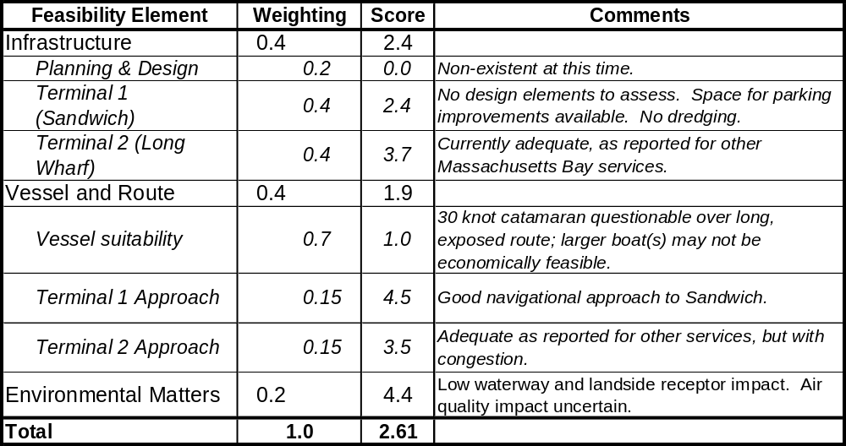
Assessment Tool Feasibility Summary

Sandwich – Boston

        - Demand estimation
There was no demand estimate prepared for this service.
        - Finances
The annual vessel operating costs for both seasonal services appear in Table 7-31. The assumption for both services is that the boat(s) operate equivalent hours elsewhere during the offseason, so that debt service, insurance, and maintenance costs are allocated only 50 percent to the Sandwich services.
The capital expense would be approximately $900,000 for the Sandwich terminal infrastructure and $2.7 million per 30 knot boat.
Table 7-31
Annual Vessel Operating Costs
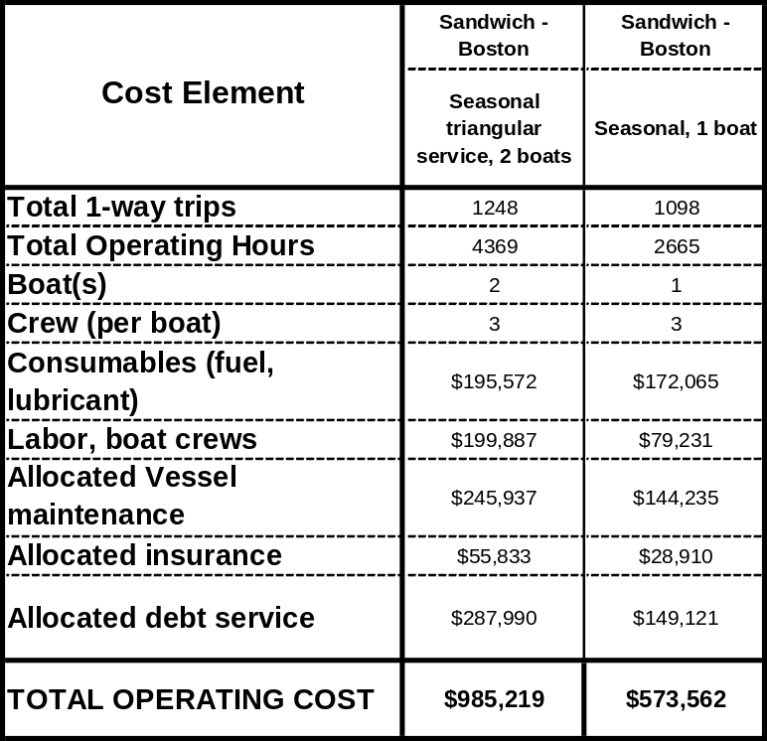
Sandwich – Boston Service

    - Summary
Table 7-33 summarizes the results, which are low with respect to both policy and feasibility. The lack of even a conceptual management model and proposal weighed heavily in the scoring. The preferred site has promise for a terminal, with ample space for parking and other amenities and a good navigational approach; use of the site would require close cooperation with the Army Corps of Engineers.
The length of the route makes vessel selection difficult. Most likely, something larger and faster than the 30 knot vessel used in this analysis would be needed to provide adequate trip times and the seakeeping desired for the exposure of the route.
This would most likely be a private operation for which the possibility of partnering with Cape Cod transit agencies would be most desirable.
There is no recommendation for action at this time. There can be none until a credible service plan and realistic private-public management emerge.
Table 7-32

Assessment Summary
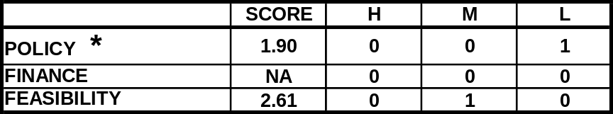
Sandwich – Boston Service

  - Summary Findings and Recommendations
The Massachusetts Bay candidate services for evaluation included two on the North Shore (Salem to downtown and Lynn to downtown) and two on the South Shore routes (Scituate to downtown and Sandwich to Downtown and Provincetown). None of the candidate routes are currently in operation. The candidates can generally be discussed in terms conditions for Mass Bay operations, North Shore findings and South Shore findings.
The general conditions for year round or seasonal operations of offshore Mass Bay routes require that vessels meet specifications for safe, comfortable, and reliable travel in a wide range of wind and weather conditions. The capital expenses for Massachusetts Bay operations are therefore likely to be higher than for Inner or Outer Harbor services because those services require larger, faster boats.
The North and South Shores are distinct markets with distinct operating conditions and public transit situations. They are considered separately.
    - North Shore
The two North Shore candidates were evaluated to determine whether either or both would be feasible as a supplementary transit route to the existing MBTA North Shore commuter rail that currently serves both communities. With the proposed terminal locations within a mile of existing rail stations, the services would be catering to market areas already well served by weekday commuter service and seasonal off-peak schedules. Therefore a new ferry service would either need to provide advantages over the rail service to attract new riders, or to divert riders from existing rail and auto trips. Since the driving service or catchment areas for Lynn and Salem overlap to a considerable degree, it was determined that only one of the two services should be considered for commuter travel purposes. Operating both services would result in competition for riders in the overlapping service area and would probably favor a Lynn route over Salem as being en route to Boston and a shorter ferry trip. The Lynn route would be primarily a weekday, peak period commuter operation, while the Salem route would combine peak commuter uses with seasonal off-peak visitor functions.
Salem to Downtown
The notion of a new Salem-to-Boston ferry service continues to receive support in Salem and is attractive because of the combination of commuter and recreational markets it would serve. The patronage during the 1998 demonstration project showed some promise in terms of seasonal and recreational use, but headways and speed were somewhat lacking for a sustained commuter ridership. The lack of a permanent, attractive landing and the uncertainties of the ridership market in competition with the commuter rail service in Salem are the probable reasons that service has not since been sustained by private sector operators.
The target commuter market would be the same pool of riders as are currently using the MBTA North Shore commuter rail, with the possible future exception of riders to the South Boston Waterfront at such time as that area is substantially built out. The catchment area for Salem would overlap with Lynn’s to the southwest. With the exception of Marblehead, other potential communities are equally or better served by commuter rail (e.g., Peabody, Beverly). The primary new benefit of a Salem ferry would appear to be tourism and related economic development, in terms of seasonal services.
The analysis herein shows that a Salem service has strong positive values from a policy point of view (score = 3.11), particularly with regard to waterfront access in a city with a long maritime tradition and many cultural attractions. It scores fairly well in the feasibility category (score = 3.36), in part because of the strong potential of the preferred Blaney Street site and the active planning process and public support in Salem. The finance assessment is incomplete because there are no adequate demand estimates for the service as proposed.
The recommendation is that some public support in detailed and final planning activities (particularly financial and market related) should be considered. An important first step would be market analysis and the development of an operations plan for the service that best meets those needs, i.e., seasonal versus year round, and identification of commuter and recreational demand. An important prerequisite for this support is for proponents in Salem to show strong and sustained interest in moving the service and infrastructure planning processes along.
Transportation System Policy Issues
- It is questionable whether the commonwealth should financially assist a service primarily focused on seasonal recreation with a secondary commuter use.
- The State probably should not support a year round commuter ferry service that would draw most of its riders from commuter rail diversion, unless there is a capacity constraint.
Lynn to Downtown and South Boston
The proposed three-vessel operation would serve commuters during weekday peak hours, providing 30 minute headways comparable to North Shore Rail departures, and a 35 minute ferry trip with a downtown terminus closer to some final work destinations. The CTPS model identified a sufficient number of potential daily riders by 2010 to warrant consideration of a ferry service, but indicated that virtually all would be diverted from rail transit. The one exception might be the addition of a stop in South Boston, assuming substantial buildout and density of the currently proposed waterfront development and mix of employment. It should be noted that the proposed Inner Harbor commuter rail to shuttle connection from Lovejoy to South Boston would also offer a through transit trip, albeit with somewhat longer travel time and less convenient as a multi-seat trip.
Several terminal sites were considered, including the existing public landing at the Municipal Pier, which could be augmented with an accessible floating ferry landing. The preferred site was a new landing at Blossom Street, which would require a more comprehensive redevelopment plan.
The evaluation is based on a fare/parking fee structure competitive with the commuter rail and Blue Line services, and appears to necessitate a public transit approach with a substantial fare and operations subsidy (even without capital cost amortization).
The Lynn service scores modestly from both the policy (2.15 on a scale of 0 - 5) and finance (2.11) standpoints at this time. The policy score is comparatively low because of the current stage of planning and development for such a service. The Blossom Street site is favorable because of its available space for shoreside infrastructure needs, its potential for improved public waterfront access, and the environmental compatibility in this industrial area.
The overall feasibility score is 3.15, somewhat lower than Salem’s. The total lack of terminal assets at Blossom Street or development plans is the main difference (and, again, poor access to intermodal connections). The route is slightly better suited to the 30 knot boat analyzed because of the shorter distance in exposed waters. Blossom Street scores well in environmental issues because it would involve reuse of an industrial site with low impacts to human and natural receptors.
The financial analysis for this service predicts modest performance. The demand analysis for a 3-boat service providing ½ hour peak service headways at fares equal to the commuter rail option indicates that there would be 300 commuter round trips per day. Farebox recovery (32%) and unit subsidy values ($4.20 per passenger) are slightly lower than those for Quincy, and lower by comparison with similar measures for MBTA rail services. Unlike Quincy, there would be significant new infrastructure costs in Lynn, in particular because there are no plans developed for a terminal at this time.
The indication at present is that this service may be appropriate to reexamine at either the planning or implementation stage at a later date. This outlook could change given two conditions. The first is stronger public support in the form of public-private partnership and an active planning effort to develop infrastructure siting, and market and route/schedule development. The second would be an indication of capacity issues on the commuter rail and Blue Line transit options. In such a case, ferry service could provide extra capacity, at least in the short term, for relatively minor capital investment, which could offset the farebox and subsidy performance. It would be appropriate at that stage for the Commonwealth to assist in providing a thorough technical and market/demand assessment to decision makers.
Transportation System Policy Issues
- It is questionable whether the Commonwealth probably should support commuter ferry service that would draw most of its riders from commuter rail diversion, unless there is a capacity constraint.
- If the Lynn ferry service moves forward, there will be an infrastructure siting and support choice for the Commonwealth, i.e., a new multi-purpose ferry landing at the preferred Blossom Street site or less costly enhancements at the existing Municipal Pier.
Operations
- The Lynn route is shorter than the Salem route and has less exposure to Northeast weather.
- A Lynn route would be focused on peak period weekday commuter service only.
- A proposed stop at the South Boston Waterfront should only be considered after substantial build-out is completed.
    - South Shore
It is important to consider the candidate South Shore services as part of a larger system, including the existing Hingham and Quincy (Chapter 6) services. The affected coastal communities currently have few, if any developed landside transit services; and, implementation of Greenbush service is a factor that must be taken into account while assessing the efficacy of these services.
The South Shore ferry system will provide valuable transportation capacity in the short and long term. Short term capacity relief, for modest capital investments, could come from a combination of the four boat Quincy service and added parking capacity for the Hingham service (where boat capacity now exceeds that for parking). In the long term, planners should consider combinations of the Quincy and Hingham measures if the Scituate service is to be operated. The latter would require significant capital investment, although modest relative to landside transit projects, and would enhance ferry system capacity while offering much improved choices for people living in Scituate and points south.

Scituate to Boston Service
The water distance from Scituate to downtown Boston is considerably shorter than the land distance. By highway the distance, through congested traffic, is approximately 35 miles, while the water distance is roughly 24 miles or 20 nautical miles. Scituate and other nearby South Shore communities differ from their North shore counterparts since they have no immediate access to commuter rail or subway transit. In 1999, the Scituate Ferry Feasibility Study of potential ferry service and market demand was completed and described several scenarios for year round ferry operations including siting options and concept design for a new terminal.
The Scituate/Marshfield service area is not well served by ground transit, and relies on Hingham as its commuter alternative to automobile trips to downtown Boston. Provision of a new ferry service from Scituate would divert many of these peak hour commuters for whom the combined auto/ferry trip from Scituate was more time efficient than the current Hingham service, and would have to be considered in the context of the South Shore ferry system and transit as a whole.
The potential for a Scituate service was considered in some depth in the 1999 study. The identified market area overlaps with the currently operating Hingham ferry service (from which ridership projected in the 1999 report was largely diverted), and with the proposed Greenbush commuter rail line. The projected ferry travel time from Scituate to downtown is comparable with or better than automobile travel and other combined park and ride transit options. A new ferry landing and parking would be needed to support a public or private Scituate ferry and could support a variety of other uses.
The Scituate – Boston service as analyzed herein is quite similar to that advanced in the Scituate Feasibility Study (1999). The proposal is mature because of the identification of issues and conceptual planning in the Study. It scores in the mid-range for all categories. In the policy aspect (score = 3.12), uncertainty about the management mode of this service (public or private) affected the access and economic development scores. Landside environmental and parking issues pulled down the feasibility score (= 2.73), as did the congestion in Scituate Harbor, wave convection at its entrance, and exposed water operations for the propose catamaran.
The finance assessment was based on the 1999 study’s demand analysis. The relatively high assumed fares, and the elimination of capital and debt service from the operating expense line, resulted in positive farebox and subsidy values. Our finance findings are promising (score = 3.22), but the caveats involved should be borne in mind.
There is no recommendation for support of service development activities at this time. The demand and finance data show some promise for this route, but there should be a clearly articulated management approach and a more detailed resolution of the technical issues raised by the 1999 study. Resolution of these matters could point to support for service implementation in the future, in the planning context of a South Shore Ferry system complementing landside transit options.

Technical Feasibility
- The 1999 study provided a detailed technical evaluation including market demand and infrastructure analysis.
- Parking availability during the summer season was identified as challenge, with several new sites needed to insure adequate capacity.
- A possible alternative would be increased capacity of the Hingham ferry service.

Finance
- Infrastructure costs would include a new ferry landing at Mill Wharf, landside support facilities including several parking areas within a short walk of the landing.
Operations
- A ferry service could operate as an interim transit option until such time as the Greenbush Line is completed. Vessels could then be relocated to another route, and the water terminal could be re-sited.
- Operations could be owned and operated by the MBTA or provided as a concession similar to Hingham.
- It is unlikely that a market rate private service could be implemented because of the lack of terminal and parking, both of which would require public actions. Market rate fares would most likely exceed subsidized Hingham fares and not be attractive to local riders.

Sandwich Service
The Sandwich service would be primarily directed at Cape residents and seasonal Cape visitors. With a trip time to downtown Boston of over an hour and a half, the current auto and land transit options are preferable except on peak summer weekend periods, leaving a narrow window of operating times that either the Sandwich to Boston or Sandwich to Provincetown routes would provide a time savings for travelers. The necessity of a long trip (1 to 1½ hours) on a high speed vessel would make operating costs and break-even fares on the high side. The Sandwich service appears to have a limited market, even for a seasonal operation, although no demand analysis was completed. The key policy question is whether a Sandwich ferry to Boston and/or Provincetown would provide sufficient seasonal traffic relief to justify public support.
The service assessment shows poor results with respect to both policy (score = 1.90) and feasibility (score = 2.61), due largely to the lack of a conceptual management model and technical proposal. The preferred Fish Plant site has some promise for a terminal, with ample space for parking and other amenities and a good navigational approach. The route’s length and exposure make vessel selection difficult, and indicate that a boat larger and faster than the 30 knot vessel used herein is appropriate, particularly for shorter trip times and the seakeeping desired for the exposure of the route.
This would most likely be a private operation for which the possibility of partnering with Cape Cod transit agencies would be most desirable. There is no recommendation for action at this time. There can be none until a credible service plan and realistic private-public management emerge. At such time, the Commonwealth could consider support for infrastructure development, which would serve multiple purposes and open opportunities for seasonal privately run ferry services linking Boston and the South Shore to the Cape and Islands.
Other matters
A different approach to encouraging enhanced waterfront economic development and access is public support for ferry landings and support infrastructure in lieu of efrry operational subsidy. Such support can encourage private market-rate ferry services on a seasonal or year round basis as well as other multiple uses. The following sites may be candidates for future such consideration:
- Public landing at the Blaney Street site in Salem, in conjunction with the redevelopment plans for a new town pier at that site.
- Enhancement of the existing public landing in Lynn (Municipal Pier) with an accessible floating ferry landing. A new landing at the Blossom Street site might be considered as part of a more comprehensive redevelopment plan. A detailed terminal analysis would be needed for either option before proceeding.
- Ferry pier in Scituate at the Mill Wharf site if agreements on parking availability could be outlined with the Mill Wharf owner and the Town. This project would have to be considered and prioritized with other infrastructure proposals in the South Shore system area, e.g., Hingham or Quincy parking projects.
- Ferry landing and parking facilities at the Sandwich Fish Plant site, subject to approval and management agreements with the Army Corps of Engineers. Such a town landing facility could be an attraction for a variety of seasonal private ferry operations and other uses.

- Recommendations
This chapter summarizes the Assessment Tool scores (Table 8-1) and service recommendations. The specific technical findings of Chapters 5, 6, and 7 are not repeated here, lead to the following recommendations:
Table 8-1

Assessment Summary
All Services

- Inner Harbor Services
  - Russia Wharf. High scores for policy, feasibility, and finance. Recommend support for the development of infrastructure and vessel operations.
  - Lovejoy. Very strong scores for policy and feasibility. No demand estimate completed for this report. Recommend a focused demand study with the best possible information on the future buildout of the South Boston waterfront, using an improved ferry demand methodology.
- Outer Harbor Services
  - Quincy - Boston. Very strong scores for policy and feasibility. Finance score is fairly strong, especially since there are no capital infrastructure needs. The expansion to four boat service has promise; therefore, the recommendation is that the demand should be studied more carefully in the context of a South Shore ferry and transit system. The ferry demand analysis method needs careful reassessment and calibration, as noted in Chapter 9.
- Massachusetts Bay Services
  - Salem - Boston. Fairly strong scores for policy and feasibility. Recommendation to provide carefully directed support to planning and analysis tasks, only if strong local support and activities are sustained.
  - Lynn - Boston. Modest scores for policy and finance, fairly strong for feasibility, although lower than Salem’s. Recommendation that support receive lower priority until public support and planning commence.
  - Scituate - Boston. Fairly strong candidate, with good financial indicators relative to other public transit modes. Public support for this service may merit further consideration in the context of prioritizing investments in the South Shore transportation services.
  - Sandwich – Boston/Provincetown. Low priority candidate at this time, with no planning underway or visible public support. Recommend no action at present.

- Process Findings
  - Assessment Tool
The Assessment Tool developed for EOTC was useful in the context of this study, for the examination of several services at many different stages of development and service. It cannot, however, be seen as having approached its full potential since there was little or no information available for many of the services considered. Scoring for potential services such as Lynn and Sandwich was on the basis of characteristics largely developed by project staff. The “Maturity” module was useful for measuring the effort and public support attendant with these proposals, and low scores there were reflected in the “Policy” and “Technical Feasibility” modules.
The “Finance” module was substantively reduced in scope for this study since there were so few solid financial data for review (see discussion below). The Commonwealth should insist on far more detail for large capital and operations investments. In such cases, the capital, operations, and subsidy measures can be more usefully employed.
The important point for the future is that the Tool is flexible and its elements and weightings can be modified to suit new developments and policies. The Commonwealth should review it from time to time for that purpose.
  - Finance Analysis and Results
Of the three services for which CTPS provided detailed demand estimates (Russia Wharf – Navy Yard, Lynn – Boston, and Quincy – Boston), scores varied from moderate (Russia Wharf, with a score of 3.35 out of 5) to low (Lynn, scoring 2.11). Comparing projected ferry operating costs to the operating costs of existing heavy-rail and commuter-rail systems helps to provide an explanation for these scores. Capital expenses and vessel debt service were removed from operating costs to provide a similar treatment to the MBTA’s calculations for surface transit modes and “apples to apples” performance comparison. The reader should note that this is not how operators do their accounting.
In terms of fare-recovery ratio, which measures the extent to which operations are publicly subsidized, the three services actually perform fairly well, ranging from 32.26% (Lynn) to 54.9% (Russia Wharf). The 54.9% figure is, in fact, well above the corresponding 44% figure for rail transit (although the ferry cost estimates do not include debt service/depreciation or other overhead/administrative expenses).
Comparisons using unit subsidy measures do not show ferry services competing well with rail transit. In terms of subsidy per passenger, only the Russia Wharf service is competitive, indicating that it is reasonable to conclude that is at least as cost-effective as rail. Neither the Quincy nor Lynn services are competitive with heavy-rail operations or even commuter rail operations by this measure.
It is noteworthy, however, that both Quincy and Lynn are competitive with rail operations in terms of subsidy per passenger-mile. Overall, therefore, indications are that these two services could potentially be quite efficient, if demand at the modeled fare (or even a higher fare) could increase relative to the estimate projections. In such a case, subsidy per passenger could decrease to a point where it is competitive with rail operations; subsidy per passenger-mile, already competitive with rail, could decrease to attractively low levels.
Russia Wharf, in terms of subsidy per passenger-mile, does not hold up especially well – but that is a function of the route, which is very short. For Russia Wharf, arguably the more salient measure is subsidy per passenger, which is nearly as low as for heavy rail.
It is also important to emphasize the capital expense requirements as compared to rail transit. Of the three modeled services, Russia Wharf would require only $1.2m in additional public investment; Lynn, $950,000; and Quincy, none at all. These numbers are very small compared to practically any kind of rail infrastructure investments. For example:
- Extending the Blue Line from Revere to Lynn – a 4.5-mile-long project along an existing right-of-way – has an estimated capital cost of $357 million.
- Extending commuter-rail service from Salem to Danvers – a 5-mile route – has an estimated capital cost of $56 million.
- Building one new commuter-rail station, at Union Square in Somerville, on existing trackage, has an estimated capital cost of $4.07 million.
(All estimates from the February 2003 draft of the MBTA’s Program for Mass Transportation.)
Ferry service does not compete strongly with rail transit strictly on the basis of operating costs. But to look only at operating costs assumes that all infrastructure is already in place and that capital costs are otherwise accounted for. In terms of new infrastructure, ferry service – which may cost incrementally more than rail transit to operate – is much more attractive than rail service owing to the far lower level of investment required. Furthermore, because ferry service can be run as a concession, it is possible that private operators may be willing to share the capital cost of new infrastructure.
At the very least, comparatively low capital requirements mean that ferries seem a reasonable option to provide short-term or medium-term transit service while new rail infrastructure is constructed. Over the long run, which allows for the amortization of infrastructure-construction costs, rail may be less expensive (especially considering its higher carrying capacity) than ferries. But because ferry infrastructure is relatively low-cost, it could be constructed and used in a different time frame.

The experience of Roosevelt Island, located adjacent to Manhattan Island in New York City, is instructive. After World War II, plans were made for residential and commercial developments on Roosevelt Island (until then used for various public purposes). It was thought that the city’s subway system could be extended to the island, allowing for fast, efficient, low-cost transport. However, lengthy delays and setbacks in constructing the subway extension caused such frustration that in 1976 a “temporary” cable-car system was built, providing residents a quick trip over the East River into Manhattan. Only in 1989 did the promised subway station open. Even now, the cable-car system continues operation – although ridership has dropped considerably, it claims many adherents who prefer the scenic, idiosyncratic nature of the cable-car commute. It is not difficult to imagine ferries in place of the cable car, and Boston in place of New York.
  - Demand Analysis
Demand estimates from CTPS were generated by their computer models, whose strengths as predictors of landside demand, mode choice, and assignment are well known. The application of the model to ferry services must be examined critically for two reasons:
- There is an evident bias of the model in favor of multi-stop services (e.g., as offered by commuter rail) as opposed to the direct line (point-to-point) service as offered by a ferry to Boston. Also, there are apparently no data to model mode preference, i.e., the choice of many ferry patrons to do so because of the enjoyment of the ride. This preference is probably not a significant factor in the population as a whole, but most likely does influence a sizable group of people living in or adjacent to coastal towns.
- CTPS reports zero automobile diversions to the proposed Quincy ferry service, contrary to the evidence of the Hingham ferry and others.
There is an opportunity for transportation agencies to re-examine the transportation model’s data base and coding and assess whether modifications can improve demand estimates for specific ferry services.

REFERENCES
Boelter & Associates, Inc., Massachusetts Ferry Project, August 1997
Boston Harbor Islands Homepage, October 2002, www.bostonislands.org
Bourne Consulting Engineering, Scituate Ferry Feasibility Study,1999.
Harbor Bay Maritime Homepage, http://www.harborbayferry.com
Humphrey, Thomas J., MBTA Water Transportation Service: 2000 Passenger Survey, 2001.
Massport Homepage, February 2003, http://www.massport.com
National Oceanic and Atmospheric Administration. United States Coast Pilot Atlantic Coast: Cape Cod to Sandy Hook, Washington DC: NOAA, 1994.
National Oceanic and Atmospheric Administration. United States Coast Pilot Atlantic Coast: Eastport to Cape Cod, Washington DC: NOAA, 1994.
New York Fast Ferry Homepage, http://www.nyff.com
New York Waterway Homepage, http://www.nywaterway.com
Society of Naval Architects and Marine Engineers, Ad Hoc Ferry Transit Environmental Impact Panel, “Ferry Systems for the 21st Century”, January, 2000.
TAMS Consultants, Inc. & Bourne Consulting Engineering, Boston Inner Harbor Passenger Water Transportation Plan, 2000.
TAMS Consultants, Inc. & Cambridge Systematics, Inc. Boston Inner Harbor Water Transportation Study, 1994.
TAMS Consultants, Inc., Boston Inner Harbor Water Transportation Study,1989.
Volpe National Transportation Systems Center, VOLPE Center SLICE Study
Washington State Ferries Homepage, 2003, http://www.wsdot.wa.gov/ferries
Water Transportation Alternatives, Inc., City of Salem, The Salem Partnership, and Harbor Express, The Salem Ferry Demonstration Project, January 1999.
#

