Investigation of
Controlled Flight into Terrain
U. S. Department
Of Transportation

Federal Aviation
Administration

Descriptions of Flight Paths for
Selected Controlled Flight into Terrain (CFIT) Aircraft Accidents, 1985-1997

Project Memorandum
DOT-TSC-FA9D1-99-01
March 1999

Robert O. Phillips

Operations Assessment Division, DTS – 43
Aviation Safety Division, DTS – 67

PREPARED BY: PREPARED FOR:
U. S. Department of Transportation U. S. Department of Transportation
Research and Special Programs Federal Aviation Administration
Administration Aircraft Certification Service
Volpe National Transportation Washington, DC 20591
Systems Center
Cambridge, MA 02142

TABLE OF CONTENTS

SECTION PAGE

1.0 INTRODUCTION 1

1.1 Purpose of Study 1
1.2 Controlled Flight Into Terrain 1
  - Terrain Awareness Warning Systems (TAWS) 2
  - Contents of this Report 4

2.0 STUDY METHODOLOGY 4

2.1 Data Sources 4
2.2 Selection of Accidents for Study 4
2.3 Flight Path Plotting Process 6

3.0 CFIT ACCIDENT DESCRIPTIONS/FLIGHT PATH PLOTS 7

3.1 La Paz, Bolivia – B-727-225 – N819EA – 1/1/85 7
3.2 Flat Rock, NC – PA-31T – N600CM – 8/23/85 10
  - Windsor, MA – Be-100 – N65TD – 12/10/86 13
  - Eagle, CO – LJ-24A – N31SK – 3/27/87 16
  - Tegucigalpa, Honduras – B-727-200 – N88705 – 10/21/89 19
  - Halawa Point, HI – DHC-6-300 – N707PV – 10/28/89 22
  - San Diego, CA – HS-125 – N831LC – 3/16/91 25
  - Rome, GA – Be-400 – N25BR – 12/11/91 28
  - Gabriels, NY – Be-1900C – N55000 – 1/3/92 31
  - Alamogordo, NM – MU-2B-30 – N108SC – 6/24/92 34
  - East Granby, CT – MD-83 – N566AA – 11/13/92 37
  - Buga, Colombia – B-757-200 –N651AA – 12/20/95 40
  - Nimitz Hill, Guam – B-747-300 – HL-7468 – 8/6/97 44

APPENDIX A – References 48

LIST OF TABLES

TABLE PAGE

- Accidents Selected for Study 5
- Data for La Paz, Bolivia CFIT Accident 8
- Data for Flat Rock, NC CFIT Accident 11
- Data for Windsor, MA CFIT Accident 14
- Data for Eagle, CO CFIT Accident 17
- Data for Tegucigalpa, Honduras CFIT Accident 20
- Data for Halawa Point, HI CFIT Accident 23
- Data for San Diego, CA CFIT Accident 26
- Data for Rome, GA CFIT Accident 29
- Data for Gabriels, NY CFIT Accident 32
- Data for Alamogordo, NM CFIT Accident 35
- Data for East Granby, CT CFIT Accident 38
- Data for Buga, Colombia CFIT Accident 42
- Data for Nimitz Hill, Guam CFIT Accident 46
LIST OF FIGURES

FIGURE PAGE

- La Paz, Bolivia – B-727-225 – N819EA – 1/1/85 9
- Flat Rock, NC – PA-31T – N600CM – 8/23/85 12
- Windsor, MA – Be-100 – N65TD – 12/10/86 15
- Eagle, CO – LJ-24A – N31SK – 3/27/87 18
- Tegucigalpa, Honduras – B-727-200 – N88705 – 10/21/89 21
- Halawa Point, HI – DHC-6-300 – N707PV – 10/28/89 24
- San Diego, CA – HS-125 – N831LC – 3/16/91 27
- Rome, GA – Be-400 – N25BR – 12/11/91 30
- Gabriels, NY – Be-1900C – N55000 – 1/3/92 33
- Alamogordo, NM – NU-2B-30 – N108SC – 6/24/92 36
- East Granby, CT – MD-83 – N566AA – 11/13/92 39
- Buga, Colombia – B-757-200 –N651AA – 12/20/95 43
- Nimitz Hill, Guam – B-747-300 – HL-7468 – 8/6/97 47
- INTRODUCTION

1.1 Purpose of Study

This report documents an investigation of the flight paths of 13 selected controlled flight into terrain (CFIT) aircraft accidents that occurred between 1985 and 1997. The Operations Assessment Division (DTS-43) and the Aviation Safety Division (DTS-67) of the Volpe National Transportation Systems Center, Cambridge, MA, conducted this study. The study was performed for the Aircraft Certification Service, Aircraft Engineering Division (AIR-100) of the Federal Aviation Administration (FAA).

Information in this study supports development of proposed FAA Technical Standard Order TSO-C151 addressing terrain awareness and warning systems (TAWS). (1) The purpose of the study was to collect and present data describing the flight paths of the aircraft involved in the 13 selected CFIT accidents. These flight path data will be used to construct CFIT accident scenarios, which will in turn be used to test the effectiveness of alternative TAWS systems, developed by the aircraft avionics industry, in preventing CFIT accidents.

1.2 Controlled Flight Into Terrain

A CFIT accident occurs when an airworthy aircraft, experiencing no contributory systems or equipment problems, under the control of a certificated, fully qualified flight crew no suffering from any impairment, is flown into terrain (or water or obstacle) with no demonstrated prior awareness of the impending collision on the part of the crew. Or, if the flight crew was aware of the impending collision, they were unable to prevent it. (2)

Because they involve high-speed impacts, CFIT accidents usually have disastrous consequences. All but one of the 13 accidents described in this report involved fatalities. Of the 734 total passengers and crew involved in these 13 accidents, 606 (82.6%) were killed; 49 (6.7%) were seriously injured; 2 (0.3%) suffered minor injuries, and 77 (10.5%) were uninjured.

Most CFIT accidents have in common a chain of events leading to what human factors experts term “lack of situational awareness” on the part of the flight crew. Conditions of limited visibility (due to darkness or weather or both) are typically a major contributing factor. Other such contributing factors include inadequate flight planning, poor pilot decision-making, poor crew resource management, lack of proper communications with air traffic control personnel, and lack of awareness of, or disregard for, applicable flight rules and procedures. (3)

1.3 Terrain Awareness and Warning Systems

CFIT accident prevention has been the focus of considerable effort over the past 30 years on the part of government and industry. Preventing CFIT is unfortunately not an issue to be addressed solely by pilot training and experience, since the historical record shows pilots involved in CFIT accidents often include highly experienced pilots with tens of thousands of flight hours in their logs. (4)

Introduction of the radio altimeter in the late 1960’s made possible development of an on-board avionics system dedicated to CFIT prevention called the ground proximity warning system (GPWS). The GPWS used altimeter and barometric data as inputs to a computer which generated visual and audible alerts (“Terrain! Terrain!) and alarms (“Whoop! Whoop! Pull Up!”) for flight crews if certain threshold parameters of key variables, indicating hazardous approach to terrain, were exceeded. GPWS equipment sounded warnings under five different potentially hazardous flight conditions:

- excessive rate of descent;
- excessive rate of closure with terrain;
- negative climb rate or altitude loss after takeoff or missed approach;
- insufficient terrain clearance when landing gear or flaps are not set in landing configuration; and
- excessive downward deviation from an instrument landing system (ILS) glide slope signal on a precision approach.

GPWS warnings were intended as a supplement to other on-board flight instrumentation providing flight crew situational awareness. They provided a “last-ditch” measure of safety against inadvertent terrain impact, and warning times before impact were typically thirty seconds or less. (5)

GPWS equipment has proven remarkably effective in preventing CFIT accidents. The National Aeronautics and Space Administration’s Aviation Safety Reporting System contains many pilot reports of “saves” (i.e., accidents prevented) due to GPWS alerts and alarms. The domestic CFIT accident rate for the large commercial passenger Federal Aviation Regulation (FAR) Part 121 aircraft fleet dropped to near zero following an FAA rulemaking requiring mandatory installation of GPWS equipment in 1974. (6)

Despite these gains, 1970’s-vintage GPWS technology had two major limitations:

- because it relied on altimeter and barometric data, there was no ability to “look ahead” of the aircraft to evaluate the potential danger of oncoming terrain or other obstacles. Thus GPWS warnings could be of very short duration if the terrain beneath the aircraft suddenly were to rise up at a very steep gradient.

- because it is desirable on approach and landing to descend in close proximity to terrain, certain GPWS alerts and warnings are inhibited as landing gear and flaps are extended in landing configuration. If an aircraft in landing configuration, executing a stabilized non-precision approach (one in which lateral, but not vertical glide slope guidance is provided), descends to a location other than a runway, it will receive no GPWS alert or warning.

To address these limitations, significant enhancements to GPWS technology have been introduced over the past several years. These enhancements rely on development of lightweight, low-cost, and powerful computer storage devices and Global Positioning System (GPS) signal receivers. These two devices allow storage of detailed terrain data in the cockpit, as well as realtime determination of precise aircraft location in terms of latitude and longitude coordinates. The combination of these capabilities enables development of a “forward-looking” terrain display, based on realtime comparison of an aircraft’s location coordinates, as determined by GPS, with stored terrain data. It also enables development of a terrain clearance “floor,” based on calculated distance to a specified runway threshold location, which will provide alerts and warnings on non-precision approaches independent of landing gear or flap settings. These features can be presented to the flight crew on a cockpit “moving map” display similar to existing navigational or weather displays. (7)

A terrain awareness and warning system (TAWS) adds these two enhancements to traditional GPWS systems. TAWS, as defined in FAA Proposed Technical Standard Order TSO-C151, includes the following three capabilities:

- a terrain display;
- terrain awareness and alerting functions that use position information provided by either a suitable internal position sensor or an on-board area navigational system and an on-board terrain database; and
- ground proximity detection and alerting functions (the traditional GPWS functions). (8)

TAWS, because of these added capabilities, offers significant improvements over traditional GPWS equipment alert and alarm times. The continuous terrain display feature of TAWS will greatly heighten flight crew situational awareness in conditions of limited visibility. Warning times that were once measured in seconds, or were not generated at all in non-precision approach situations, may now be measured in minutes. Rather than just providing a “last-ditch” warning of imminent danger, this display will enable crews to maneuver to avoid terrain well before it becomes an obstruction to their flight path.
1.4 Contents of this Report

Following this introduction, this report contains two additional sections:

- Study methodology, including data sources, selection of accidents for study, and the process used to develop flight path plots;

- Accident descriptions and flight path plots. For each of the accidents investigated, a brief description of the aircraft’s flight path over the last several miles before impact is presented, together with a plot and associated spreadsheet of terrain elevation, aircraft altitude, and other relevant data.

2.0 STUDY METHODOLOGY

2.1 Data Sources

Primary data sources for development of flight path profiles for domestic accidents in this study were National Transportation Safety Board (NTSB) aircraft accident reports and supporting files. For those accidents occurring in foreign countries, reports issued by the foreign governmental equivalent of the NTSB were obtained and reviewed. For some accidents, applicable news articles were also obtained. Data in these reports relevant to this study included the following:

- flight data recorder (FDR) information;
- cockpit voice recorder (CVR) transcripts;
- air traffic control (ATC) voice transcripts;
- ATC radar plots;
- NTSB (or foreign equivalent) post-crash investigation information.

Topographical maps of domestic accident locations were obtained from the U. S. Geological Survey (USGS). USGS 1:24,000 quadrangles were used if available. For foreign accidents, best available topographical data were used (typically maps were included in the accident reports).

2.2 Selection of Accidents for Study

The 13 accidents in this report were selected in consultation with Mr. George Lyddane, FAA National Resource Specialist in the area of Flight Management. Accidents studied ranged from relatively small (i.e., Beechcraft Be-100) private passenger aircraft to very large (i.e., Boeing 747-300) commercial passenger
aircraft. All accidents selected clearly met the following CFIT classification criteria:

- the aircraft was engaged in routine, cross-country flight at the time of the accident.
- the aircraft was in controlled flight at the time of impact;
- all systems on the aircraft were operating normally at the time of impact; and
- the flight crews of the accident aircraft were not impaired. (9)

Of the 13 accidents studied, five involved large commercial jet aircraft flying under FAR Part 121 flight rules. Two others involved medium-size commuter aircraft flying under FAR Part 135, and the remaining six involved smaller aircraft flying under FAR Part 91 flight rules. Since the proposed TAWS TSO-C151 applies to turbine powered aircraft with six or more seats, all accident aircraft studied met these criteria.

Table 1 presents information on accidents selected.

Table 1. Accidents Selected for Study

Date | Location | Aircraft  Type | Registration  Number | Fatalities | Injuries
1/1/85 | La Paz, Bolivia | B-727-225 | N819EA | 29 | 0
8/23/85 | Flat Rock, NC | PA-31T | N600CM | 5 | 0
12/10/86 | Windsor, MA | Be-100 | N65TD | 6 | 0
3/27/87 | Eagle, CO | LJ-24A | N31SK | 3 | 0
10/21/89 | Tegucigalpa, Honduras | B-727-200 | N88705 | 131 | 15
10/28/89 | Halawa Point, HI | DHC-6-300 | N707PV | 20 | 0
3/16/91 | San Diego, CA | HS-125 | N831LC | 10 | 0
12/11/91 | Rome, GA | Be-400 | N25BR | 9 | 0
1/3/92 | Gabriels, NY | Be-1900C | N55000 | 2 | 2
6/24/92 | Alamogordo, NM | MU-2B-30 | N108SC | 6 | 0
11/13/92 | East Granby, CT | MD-83 | N566AA | 0 | 1
12/20/95 | Buga, Colombia | B-757-200 | N651AA | 160 | 4
8/6/97 | Nimitz Hill, Guam | B-747-300 | HL-7468 | 225 | 29

2.3 Flight Path Plotting Process

To generate plots of flight paths, contents of the accident report were reviewed. If radar or FDR data plots of aircraft altitude and flight track were available, these were used directly. If these were unavailable, other sources were used to generate this information, including references to navigational aids and altitude in cockpit or ATC conversations. In all cases, airspeed and heading (with reference to magnetic north) at impact, as well as impact point latitude and longitude coordinates, were obtained from post-crash investigation reports. Other known waypoints, if mentioned in these reports, were also tabulated.

Given the available data on aircraft position, the most likely track of the accident aircraft was plotted on a topographical map. Elevation in feet above mean sea level (MSL) of relevant topographical features along the flight track were tabulated. Using best available data on aircraft altitude, altitude data were correlated with points along the flight track.

For those accidents occurring during approach, altitudes and elevations were plotted with reference to the runway threshold. The specified altitudes, elevations, and distances associated with approach procedure being used by the accident aircraft were also tabulated in a similar fashion. If altitude data were incomplete, they were plotted between known points using straight-line interpolation. In the case of the Buga, Colombia accident, in which the aircraft deviated significantly from the established approach path in a lateral direction, terrain elevations along both the flight track and along the established approach procedure were included. For those accidents occurring in cruise flight, or at considerable distance from the destination airport, elevations and altitudes were plotted with reference to the point of impact.

The result of the above effort was a spreadsheet for each accident containing the following information:

- specified horizontal distances from reference point (takeoff or destination runway threshold or impact point), measured in nautical miles (NM);
- terrain elevation at these specified distances, measured in feet above MSL;
- aircraft altitude at these specified distances, measured in feet above MSL;
- published approach procedure altitudes at these specified distances, if applicable, measured in feet above MSL.

From each spreadsheet, a graphic chart was generated. Both spreadsheets and charts are contained in the following section.
3.0 CFIT ACCIDENT DESCRIPTIONS / FLIGHT PATH PLOTS

3.1 La Paz, Bolivia – B-727-225 – N819EA – 1/1/85

The La Paz accident involved an Eastern Airlines flight 980, a Boeing 727-225 turbojet, on a regularly scheduled FAR Part 121 flight from Asuncion, Paraguay to La Paz. The aircraft impacted the 19,600-ft. level of Mt. Illimani, a 21,000-ft. Andean peak. All 29 persons on board the aircraft were killed. Impact occurred in cruise configuration, approximately 26 NM from the La Paz Very High Frequency Omnidirectional Range/Distance Measuring Equipment (VOR/DME) facility, and 25 NM from La Paz Runway 09R. Weather in the accident vicinity was classified as dark night, instrument meteorological conditions (IMC).

The aircraft had reported crossing the DAKON intersection, 55 NM southeast of La Paz, at 25,000 ft. MSL. They were then cleared by La Paz ATC to descend to 18,000 feet, and the crew acknowledged this clearance. Although the accident aircraft was supposed to be approaching La Paz along airway UA 320, on a 134º radial from the La Paz VOR, it veered significantly off course beyond DAKON; the impact location is along the 106º radial from La Paz. Investigators speculate the flight crew were maneuvering to avoid weather in the vicinity, and that impact occurred with the aircraft in cruise configuration, in a shallow descent. Dark night, weather, and lack of visual references in the area all contributed to the crew’s inability to see and avoid the high terrain in their path. (10)

Due to the extreme high altitude and inaccessibility of the accident location, the FDR and CVR were never recovered. A climbing expedition was organized the following summer to retrieve these recorders. The expedition reached the crash site and was able to dig through accumulated snow and examine the wreckage. However, bad weather and altitude sickness forced the expedition to turn back without recovering the recorders. (11)

Table 2 presents altitude and elevation information for this accident. This information is presented graphically in Figure 1.
Table 2. Data for La Paz, Bolivia CFIT Accident
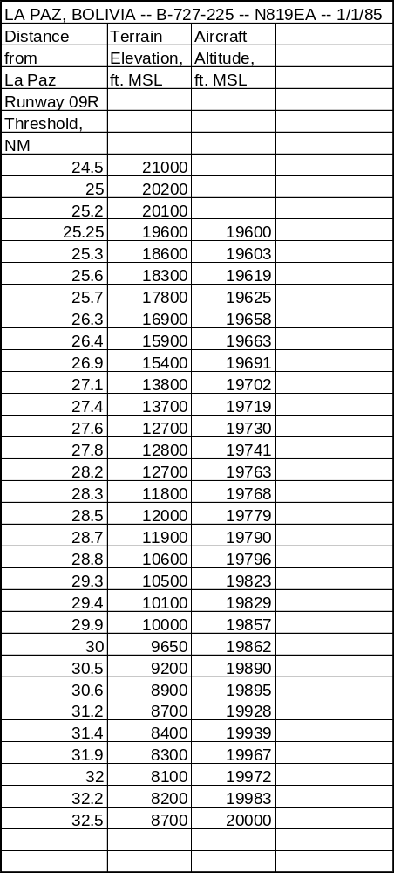

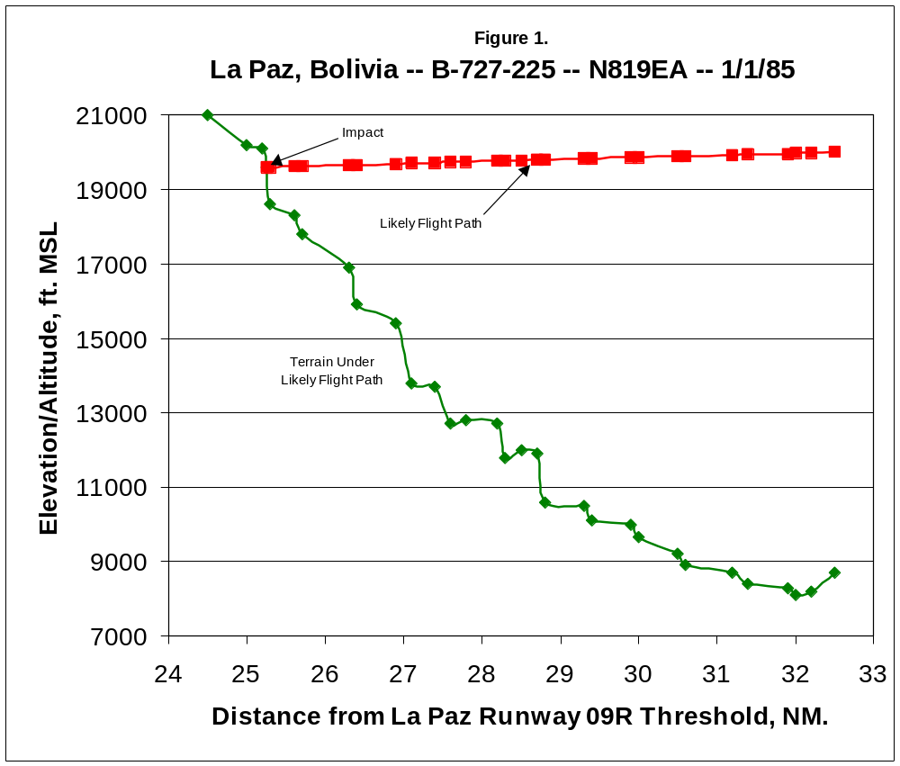
3.2 Flat Rock, NC – PA-31T – N600CM – 8/23/85

The Flat Rock accident involved a Piper Aircraft PA-31T turboprop on a personal FAR Part 91 flight from Louisville, KY to Greenville-Spartanburg, SC. The aircraft, owned by the pilot, impacted the 3460 ft. MSL level of Stone Mountain, a 3640-ft. peak along the Blue Ridge of North Carolina, approximately 26 NM north of the destination airport. Impact occurred when the aircraft was on a heading of 155º magnetic, in cruise configuration. The pilot and four passengers were killed. Weather in the vicinity was classified as bright night, visual meteorological conditions (VMC). The broken cloud ceiling at the time was about 100 ft. above the summits of the Blue Ridge peaks in the area.

A few minutes before the accident, the pilot of N600CM reported to ATC “35 (nautical miles) from the airport, VFR (visual flight rules) for landing.” At the Asheville, NC terminal radar approach control facility, controllers observed the flight in a steady descent from 9700’ to 3600’ in the vicinity of the accident site. The pilot, flying VFR, was just under the cloud ceiling, dangerously close to the uninhabited and unlit mountain peaks in the area. Lacking visual reference, the pilot did not see Stone Mountain until it was too late to react. (12)

N600CM was not equipped with FDR, CVR or GPWS. Table 3 presents altitude and elevation information for this accident. This information is presented graphically in Figure 2.

Table 3. Data for Flat Rock, NC CFIT Accident

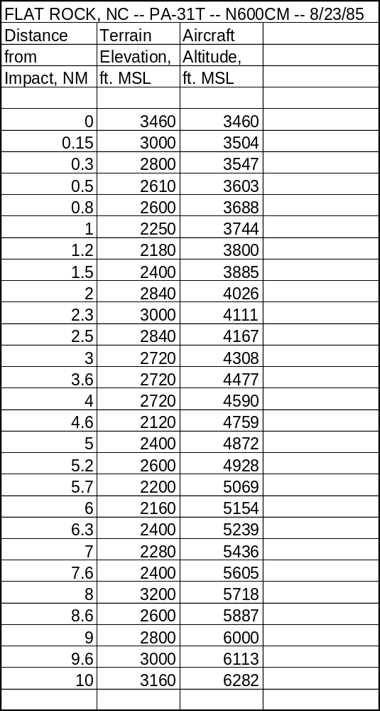
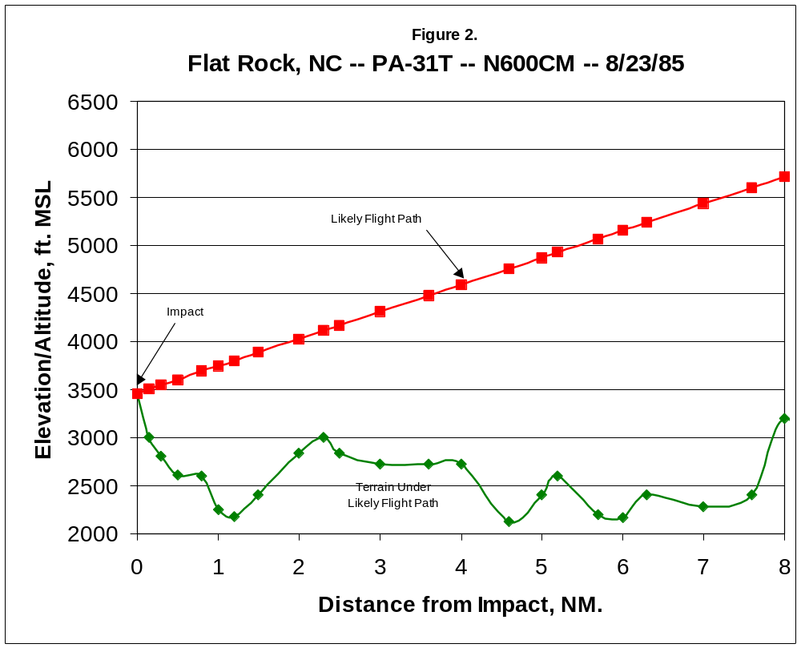
3.3 Windsor, MA – Be-100 – N65TD – 12/10/86

The Windsor accident involved a Beechcraft Be-100 turboprop corporate aircraft, owned by Teledyne Industries, on a business flight from Lorain, OH to Pittsfield, MA. The aircraft impacted a heavily wooded slope of Judges Hill, about 13 NM from the destination airport, at approximately the 2240’ level, 50’ below the summit. Gear and flaps were retracted at impact. All six persons aboard the flight were killed. Judges Hill is one of several prominent terrain features in the Berkshire Mountains near the approach path to Pittsfield. At the time of the accident, weather in the vicinity was classified as daylight, IMC.

Shortly before the accident, the pilot of N65TD reported “five tango delta, procedure turn inbound Pittsfield,” which indicated the aircraft was beginning its approach. The aircraft apparently began its descent prematurely, deviating well below the published LOC Runway 26 approach procedure. In conditions of very limited visibility, the aircraft descended into the terrain. (13)

N65TD not equipped with FDR, CVR or GPWS. Table 4 presents altitude and elevation information for this accident. This information is presented graphically in Figure 3.
Table 4. Data for Windsor, MA CFIT Accident

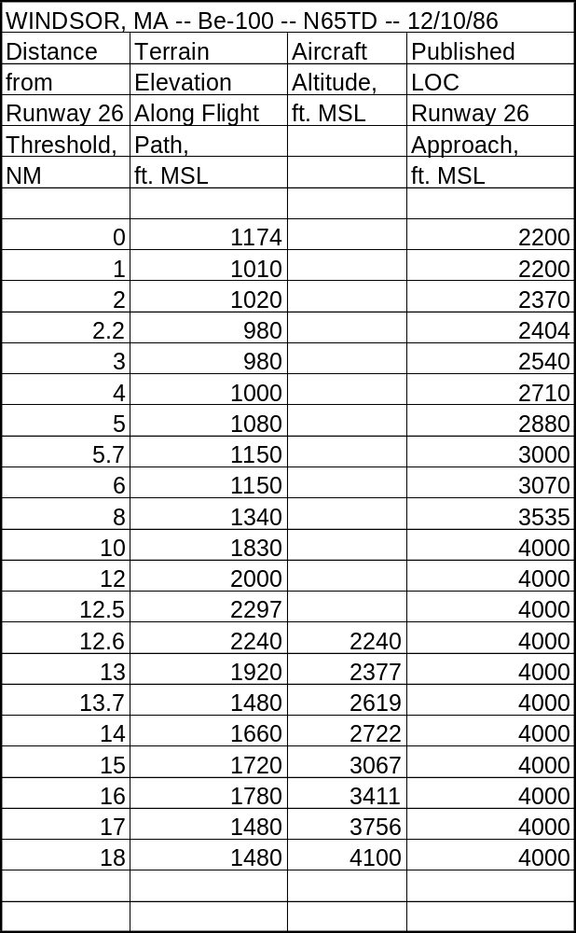
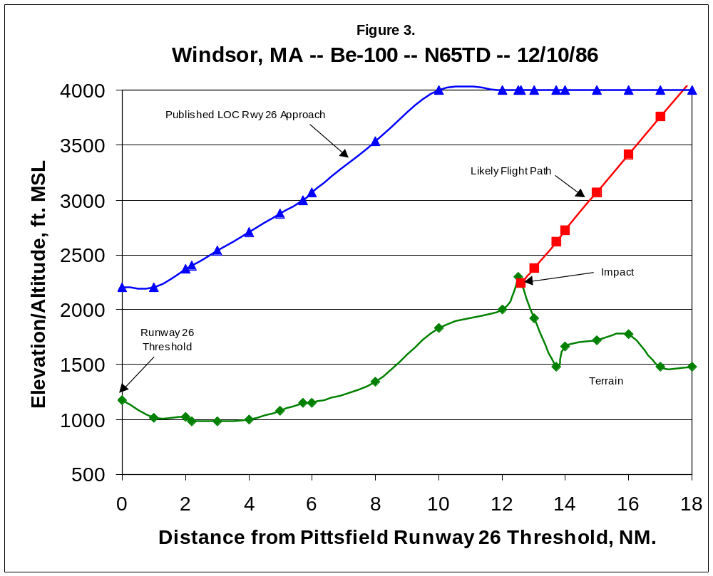(placeholder for Windsor chart)
3.4 Eagle, CO – LJ-24A – N31SK – 3/27/87

The Eagle accident involved a Gates Learjet 24A turbojet, owned by Connie Kalitta Services, Inc., which was on a FAR Part 91 positioning flight from Denver to Eagle to enplane a patient for a medical evacuation flight. The aircraft impacted an 8022’ mountain ridge at the 8000’ level, 22’ below the summit, approximately 4 NM northwest of Eagle airport on a heading of 195º magnetic. N31SK was in approach configuration at impact. All three persons aboard were killed. Weather in the accident vicinity was classified as dark night, VMC.

The pilot of N31SK reported passing the STUPE intersection, and was cleared by ATC for landing at Eagle. Shortly before the accident, the pilot reported “eight to ten miles out, and it’s clear to Eagle.” From the position and heading of the aircraft at impact, investigators assumed the pilot had elected to fly the circle-to-land LDA-A Runway 07 approach to Eagle. The pilot descended well below the altitudes specified for this approach, but may have done so because he could see the airport. Post-crash investigation showed the pilot would have had the airport in sight for all but the last one to three seconds of flight, when the uninhabited, unlit mountain ridge obstructed his view. Only a very small adjustment to the aircraft’s controls would have been required to gain the additional 22’ of altitude necessary to clear the ridge. However, lacking visual reference, the pilot was unable to see the terrain until it was too late. (14)

N31SK not equipped with FDR, CVR or GPWS. Table 5 presents altitude and elevation information for this accident. This information is presented graphically in Figure 4.
Table 5. Data for Eagle, CO CFIT Accident
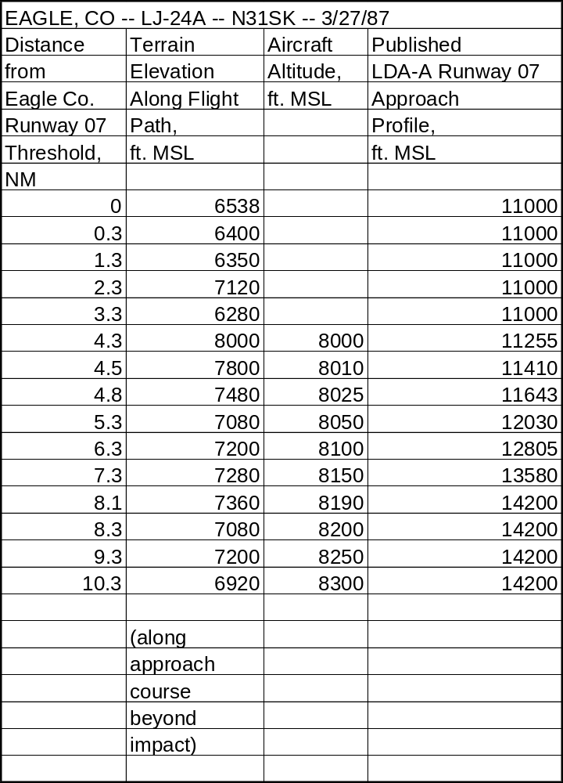
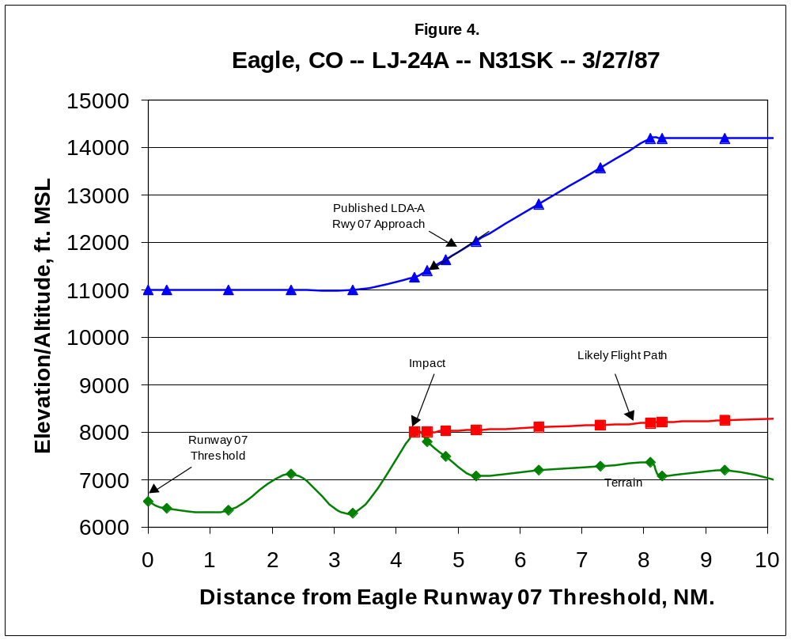
3.5 Tegucigalpa, Honduras – B-727-200 – N88705 – 10/21/89

The Tegucigalpa accident involved TAN-SAHSA flight 414, a Boeing 727-200 turbojet leased by TAN–SAHSA from Continental Airlines, on a regularly scheduled commercial passenger flight from Managua, Nicaragua, to Tegucigalpa. The aircraft impacted a mountain known as Cerro de Hula at the 4800’ MSL elevation, approximately 800’ below the summit, 4.8 NM from the Tegucigalpa Runway 01 threshold. At impact, the aircraft was in approach configuration. Of the 138 passengers and 12 crewmembers on board, 131 persons were killed, 17 sustained serious injuries, and 2 persons sustained minor injuries. Weather in the accident vicinity was classified as daylight, IMC. Locally heavy rain showers were reported at the accident site.

SAHSA-414 was cleared by Tegucigalpa ATC for the VOR/DME Runway 01 approach, which includes a series of three step-downs from the initial approach fix altitude of 7500’ MSL to avoid high terrain in the neighborhood of the airport. Rather than following the prescribed step-down procedure, however, the crew began a continuous descent from about 7600’ MSL at about 11 NM from the airport to the accident site. The aircraft’s descent profile was well below the published step-down course for the entire approach. (15)

N88705 was equipped with FDR, CVR and GPWS. However, because Honduran law did not require installation, the GPWS had been disconnected at the time of the accident. Table 6 presents altitude and elevation information for this accident. This information is presented graphically in
Figure 5.
Table 6. Data for Tegucigalpa, Honduras CFIT Accident
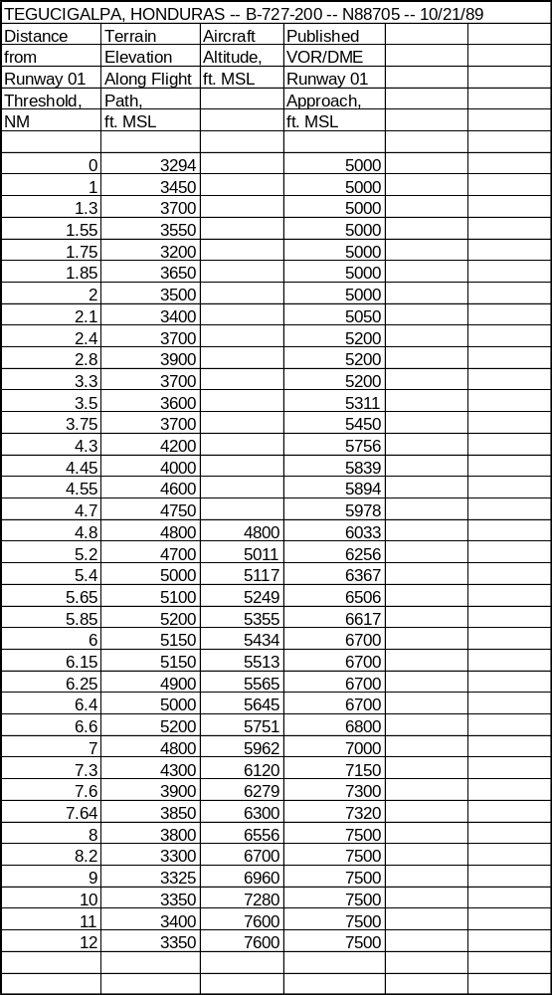

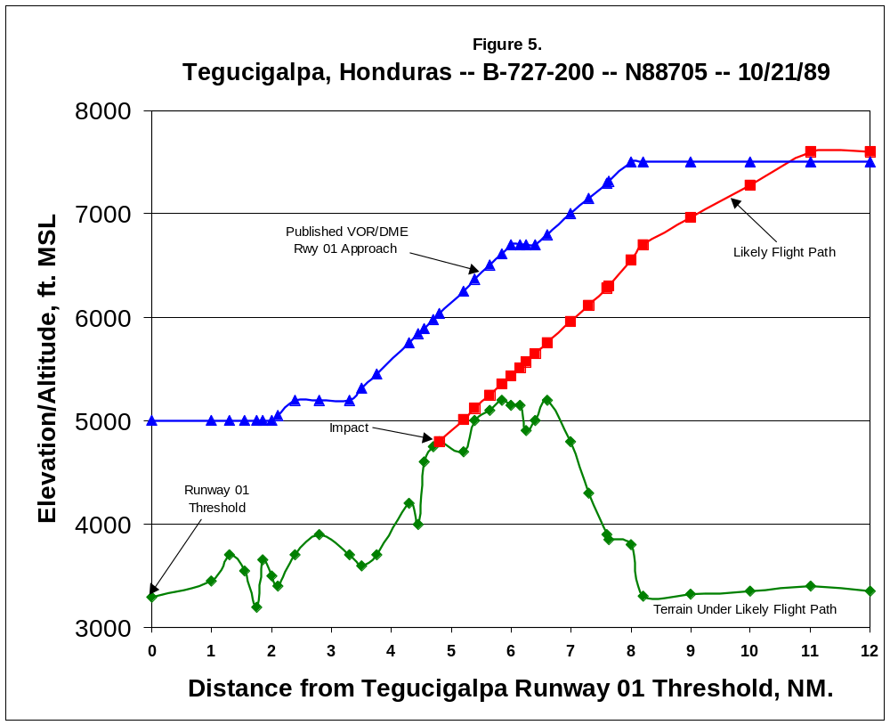
3.6 Halawa Point, HI – DHC-6-300 – N707PV – 10/28/89

The Halawa Point accident involved Aloha Island Air flight 1712, A DeHavilland DHC-6-300 Twin Otter turboprop, on a regularly scheduled FAR Part 135 commuter flight from Kahului, Maui, to Kanunakakai, Molokai. Impact occurred in the coastal mountains on the north side of the island of Molokai. The aircraft, in cruise configuration, impacted the 600’ MSL elevation of a ridge near Halawa Point whose summit measured 1050’ MSL. All 20 persons aboard were killed. Weather in the accident vicinity was classified as dark night, IMC. While weather along the projected flight path of N707PV was generally clear, a localized area of IMC existed at Halawa Point, created when moist, warm winds moving across the Pacific were abruptly lifted upwards into cooler air by the steep terrain of Molokai.

Radar plots of flight 1712 show that it climbed to an altitude of about 1000’ MSL following takeoff, then descended to 500’ MSL at a point about five miles from the Molokai coast. It is likely the aircraft encountered the localized weather at this point and descended below the cloud ceiling to maintain visual contact with the terrain as is required under visual flight rules. At a point about two miles southeast of Halawa Point, the aircraft turned on a heading of 260º magnetic. The crew made this turn intending to fly their regular route parallel to and just offshore from the north coast of Molokai. However, because of limited visibility, they made this turn prematurely, heading the aircraft directly towards very steep terrain on Halawa Point. Lacking visual references, they were unable to see the terrain ahead until it was too late. (16)

N707PV not equipped with FDR, CVR or GPWS. Table 7 presents altitude and elevation information for this accident. This information is presented graphically in Figure 6.
Table 7. Data for Halawa Point, HI CFIT Accident
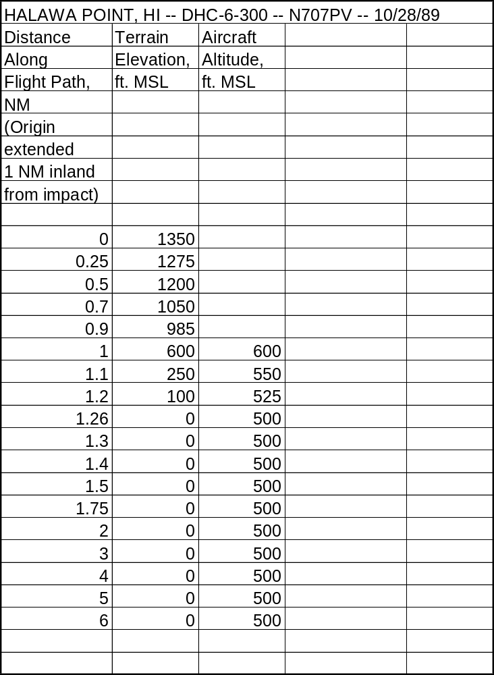

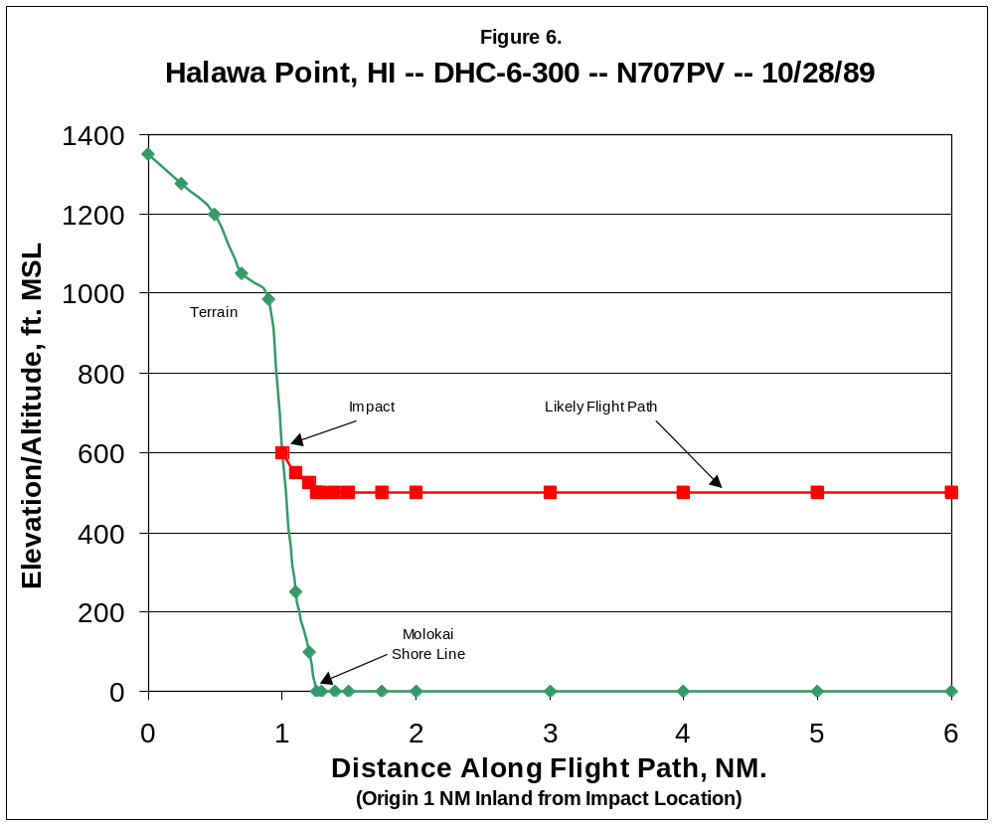 (placeholder for Molokai chart)
3.7 San Diego, CA – HS-125 – N831LC – 3/16/91

The San Diego accident involved a Hawker-Siddeley DH-125-1A turbojet in an on-demand FAR Part 91 charter flight from Brown Field, San Diego, CA to Amarillo, TX. The aircraft impacted Otay Mountain, a 3550’ MSL peak in the San Ysidro Mountains, approximately 8 NM from the takeoff point. Impact occurred approximately 250’ MSL below the summit on a bearing of 050º magnetic, while the aircraft was in cruise configuration. All ten persons aboard were killed. The accident gained national attention as all the passengers were members of country singing star Reba McIntire’s band. Weather in the accident vicinity was classified as dark night, VMC.

Because a late night departure was planned, the aircraft had been positioned at Brown Field on the outskirts of San Diego due to a noise curfew in effect at San Diego-Lindbergh field. While waiting for his passengers to arrive, the pilot, who was unfamiliar with local procedures and terrain, had three separate conversations with the local Flight Service Station (FSS). During these conversations, the FSS specialist suggested it would save time if the flight departed under visual flight rules and picked up its IFR clearance once airborne. The pilot indicated reluctance to climb through 3000’ MSL without an IFR clearance, as that would involve flight into the San Diego Terminal Control Area (TCA) whose “floor” was 3000’ MSL. The pilot then stated: “… so I would be better off if I headed right northeast and stayed down … below three thousand.” The FSS specialist replied “That’ll be fine.” This was a fatal mis-communication: the pilot had been referencing 3000’ MSL, while the FSS specialist understood the pilot’s altitude reference as 3000’ above ground level. (17)

Radar data indicate the flight took off normally and leveled off at approximately 3300’ MSL. The pilot had filed an IFR flight plan, but due to a delay in takeoff, this flight plan had expired. Without IFR clearance, the flight could not climb into the San Diego TCA without violating flight rules. Responding to the pilot’s request for IFR clearance, the San Diego TRACON controller indicated N831LC’s flight plan had “clocked out” but that he would “put it right back in.” Shortly afterward, the aircraft impacted Otay Mountain. Because terrain in this location is uninhabited and unlit, the crew of N831LC did not see the mountain until it was too late to avoid impact. (18)

N831LC not equipped with FDR, CVR or GPWS. Table 8 presents altitude and elevation information for this accident. This information is presented graphically in Figure 7.
Table 8. Data for San Diego, CA CFIT Accident
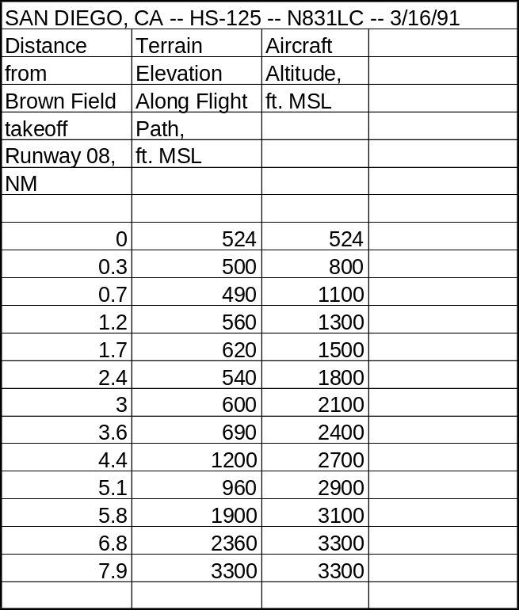

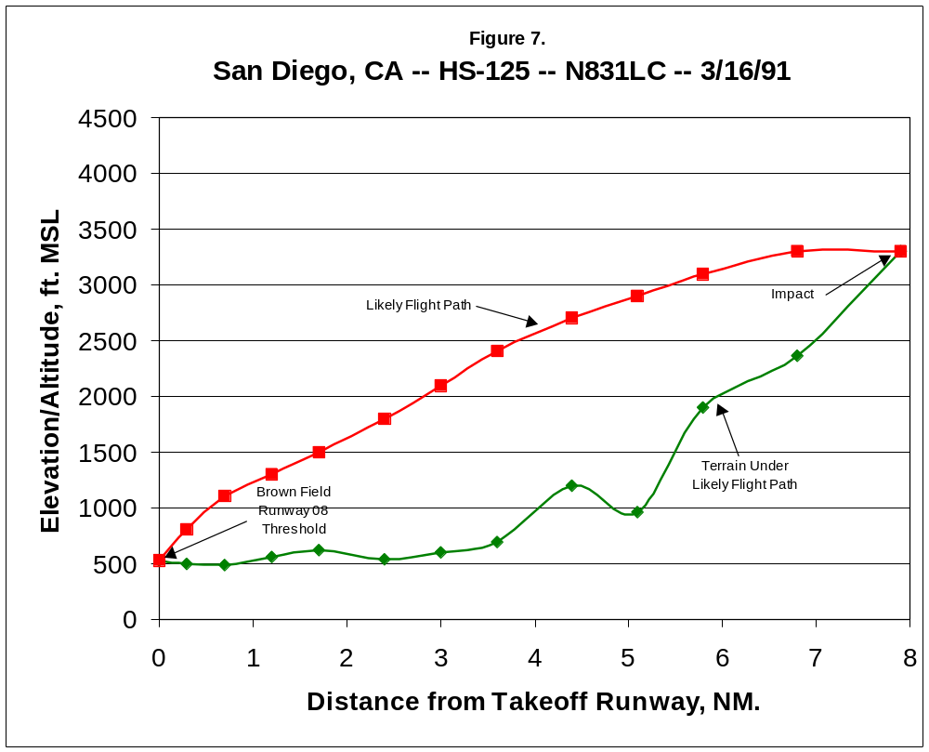 (placeholder for San Diego chart)
3.8 Rome, GA – Be-400 – N25BR – 12/11/91

The Rome accident involved a Beechcraft Be-400 turbojet owned by Bruno’s, Inc., a regional grocery store chain, on a business flight from Rome to Huntsville, AL. The aircraft impacted Lavender Mountain, the highest terrain within a 5 NM radius of the airport, shortly after takeoff. Impact occurred at the 1580’ MSL level, approximately 120’ below the summit, on a heading of 025º magnetic. The aircraft was in cruise configuration. All nine persons aboard were killed. Weather in the accident vicinity was classified as daylight, IMC. The cloud ceiling obscured the tops of the mountains in the area.

N25BR was carrying executives of Bruno’s on an annual pre-Christmas tour of the company’s various stores. Rather than face what might have been a lengthy delay for an IFR clearance, the flight crew elected to depart Rome under visual flight rules (VFR). CVR transcripts indicate the first officer was at the controls. Shortly after takeoff, the captain radioed the Atlanta, GA Air Route Traffic Control Center (ARTCC) and requested an IFR clearance, which would enable the aircraft to climb above the cloud ceiling. Atlanta ATC instructed the flight to remain VFR because of traffic currently approaching Rome. Shortly afterward, the captain remarked to the first officer: “We’re going to have to get away from that mountain down there pretty soon.” There followed a discussion of how this should be accomplished; the first officer suggested “a one-eighty (degree turn) to the left.” The captain replied “You’re getting close … (turn) to the right.” The first officer replies: “I can’t see over here. That’s why I wanted to go the other way,” and then asks “should I just punch up (i.e., climb through the cloud ceiling)?” Shortly after this conversation, the aircraft impacted Lavender Mountain. In conditions of limited visibility, the flight crew did not see the terrain until it was too late to react. (19)

N25BR was equipped with a CVR, but did not carry either FDR or GPWS. Table 9 presents altitude and elevation information for this accident. This information is presented graphically in Figure 8.
Table 9. Data for Rome, GA CFIT Accident
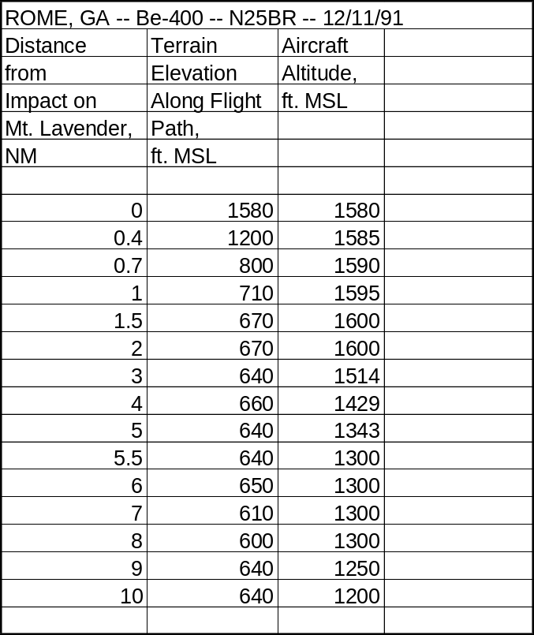

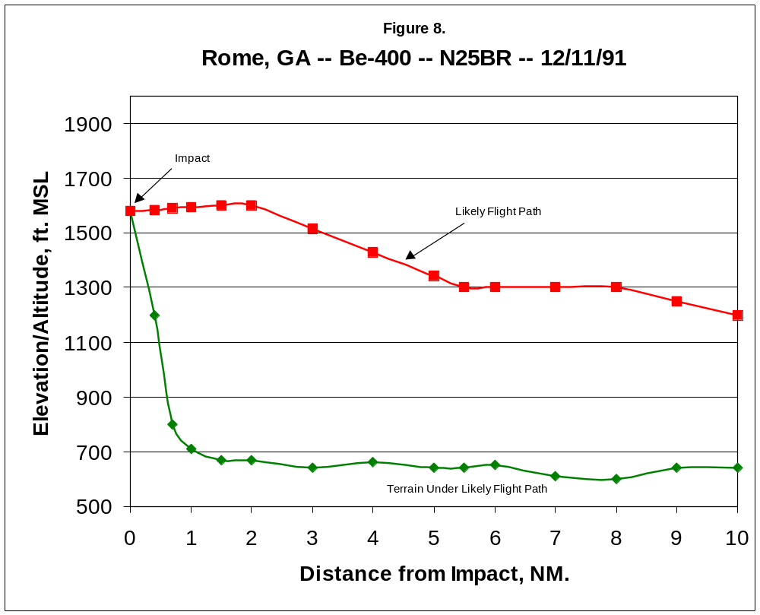(placeholder for Rome chart)
3.9 Gabriels, NY – Be-1900C – N55000 – 1/3/92

The Gabriels accident involved Commutair Flight 4821, a Beechcraft Be-1900C turboprop, on a regularly scheduled FAR Part 135 commuter flight between Plattsburgh, NY, and Saranac Lake, NY. The aircraft impacted Blue Hill, approximately 4.3 NM from the destination airport, at the 2280’ MSL elevation, about 110’ below the summit, on a heading of 230º magnetic, on course for runway 23 at Saranac Lake. Four persons were on board; two were killed and two suffered serious injuries. At impact, gear and flaps were retracted. Weather in the accident vicinity was classified as dark night, IMC.

Flight 4821 was cleared by the Boston ARTCC for an instrument landing system (ILS) approach to Saranac Lake Runway 23. Radar data plots show the aircraft remained on course through the ZECKA intersection (the initial approach fix). After passing this point, the flight turned to join the localizer signal, and began a rather rapid descent. Approximately 7.5 NM from the runway threshold, N55000 passed through the midpoint of the glide slope signal. Beyond that point, the aircraft descended well below the established approach profile to the impact point. Lacking visual reference, the pilot was unable to see Blue Hill until it was too late to avoid impact. Because the aircraft had no GPWS aboard, the pilot received no warning that his flight path had deviated well below the glide slope signal. (20, 21)

N55000 was equipped with a CVR, but did not carry either FDR or GPWS. Unfortunately, the CVR was destroyed in the crash, and did not yield any useful information. Table 10 presents altitude and elevation information for this accident. This information is presented graphically in Figure 9.
Table 10. Data for Gabriels, NY CFIT Accident
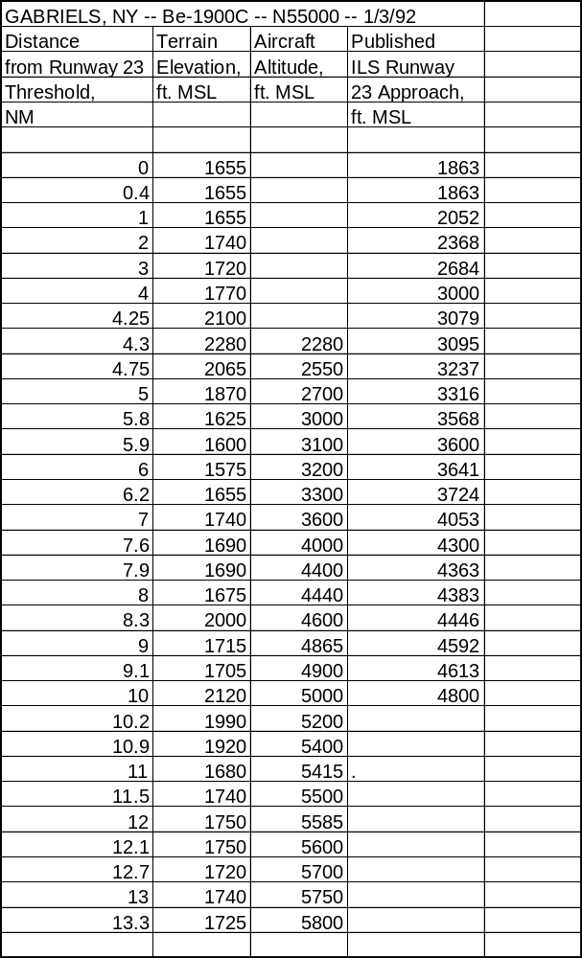

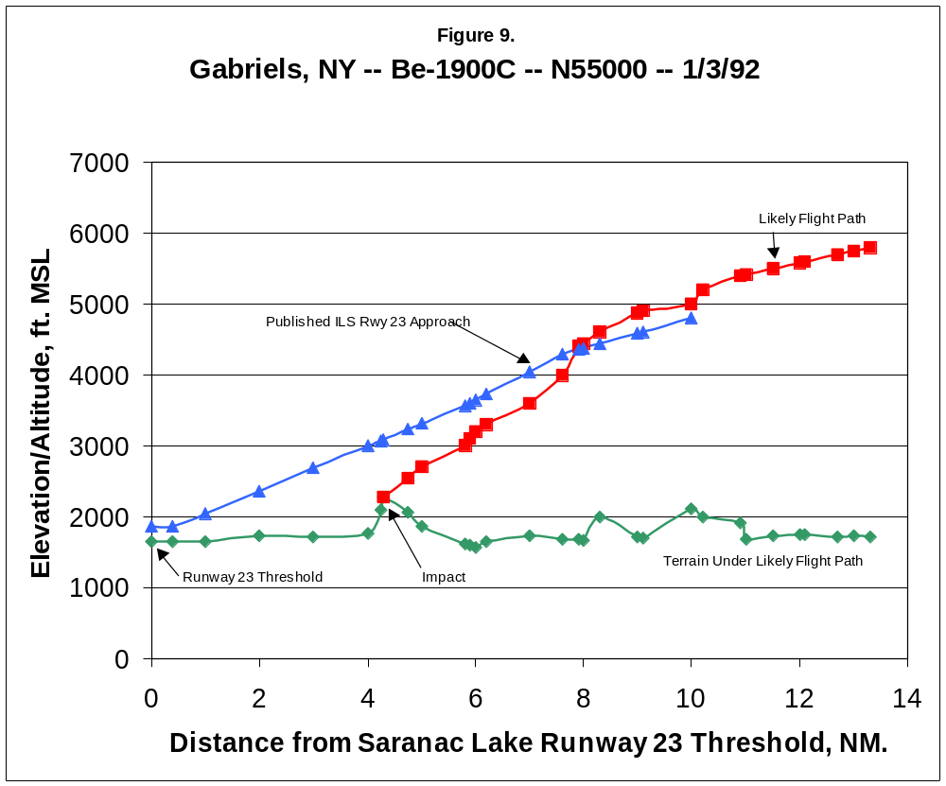
3.10 Alamogordo, NM – MU-2B-30 – N108SC – 6/24/92

The Alamogordo accident involved a privately owned Mitsubishi MU-2B-30 turboprop on a personal FAR Part 91 flight from Alamogordo to Burnet, TX. Shortly after takeoff, the aircraft impacted a ridge in the Sacramento Mountains to the east of Alamogordo at the 6100’ MSL level, approximately 1500’ below the summit, on a heading of 035º magnetic. The aircraft was in cruise configuration; all six persons aboard were killed. Weather in the accident vicinity was classified as dark night, VMC.

Following takeoff from Alamogordo, N108SC was advised by ATC: “eight sierra charlie, maintain VFR through one one thousand …”. The pilot responded, “Roger, we’re going to circle up over the airport a little bit, just to ensure terrain clearance …”. A short while later, the pilot asked ATC “what’s your minimum terrain clearance out in this neck of the woods?” That was the last transmission received from the aircraft. Circling to gain altitude after takeoff, N108SC had strayed too far to the east, into the Sacramento Mountains. In the dark night, there were no lights in the uninhabited area to provide visual reference. (22)

N108SC was not equipped with CVR, FDR or GPWS. Table 11 presents altitude and elevation information for this accident. This information is presented graphically in Figure 10.
Table 11. Data for Alamogordo, NM CFIT Accident
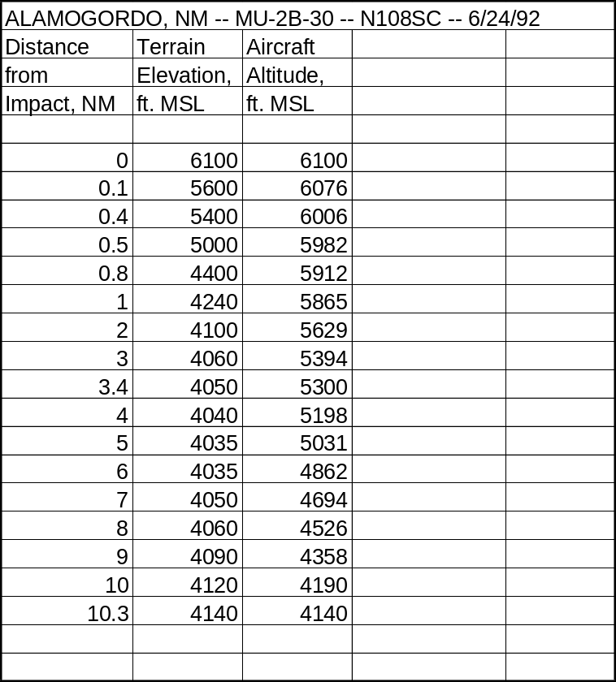

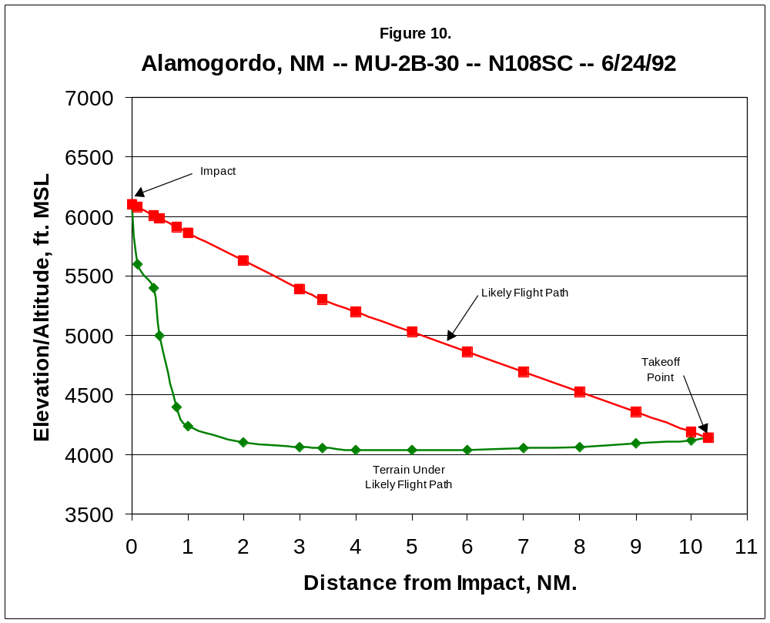
3.11 East Granby, CT – MD-83 – N566AA – 11/13/92

The East Granby accident involved American Airlines flight 1572, a McDonnell-Douglas MD-83 turbojet on a regularly-scheduled FAR Part 121 flight from Chicago, IL to Hartford-Bradley Field, Windsor Locks, CT. On a VOR approach to Runway 15 at Windsor Locks, the aircraft impacted trees on the summit of a ridgeline approximately 2.5 NM northwest of the runway threshold. Impact occurred on a heading of 149º magnetic, on course for Runway 15. Although one of its engines failed and the other engine and control surfaces were damaged, the crew managed to keep the aircraft airborne and made an emergency landing in the safety overrun area for Runway 33 (the opposite end of Runway 15), destroying an antenna array in the process. Because the crew was able to land the aircraft safely, only one passenger suffered minor injuries in the emergency evacuation process which commenced once flight 1572 had come to a stop. Weather in the accident vicinity was classified as dark night, IMC, and was a strong contributing factor. An extremely powerful cold front was passing through the area at the time, and atmospheric pressure was dropping rapidly, with high winds, windshear and heavy rain. Post-crash investigation showed the pilots had not received an updated weather briefing and had not set their altimeter to the correct barometric pressure reading at the time of the accident, which caused their altimeter to give falsely high readings. (23)

The CVR transcript indicates that after passing DILLN, the final approach fix, the first officer said to the captain, “You’re going below your… (minimum).” Radar and FDR data show the aircraft at this point had descended about 300’ below the published minimum descent altitude (MDA) for the approach. Shortly after this statement, the GPWS sounded a “Sink Rate!” alert. Four seconds later, the aircraft struck the trees, and the GPWS sounded its “Whoop! Whoop! Pull Up!” alarm. The crew initially applied full thrust, intending to fly a missed approach, but soon realized that the engines were not developing power. The aircraft began a slow descent, and the first officer reported the runway was in sight. The captain then called for full flaps to achieve a “balloon effect,” minimizing the aircraft’s descent rate. The resulting flight path allowed the flight to touch down just short of Runway 15. The NTSB report on this accident states “the excellent crew resource management and flight skills that the flight crew used … following (the) encounter with the trees, were directly responsible for limiting the number of injured passengers to one individual.” (24)

N566AA was equipped with CVR, FDR and GPWS. Table 12 presents altitude and elevation information for this accident. This information is presented graphically in Figure 11.
Table 12. Data for East Granby, CT CFIT Accident
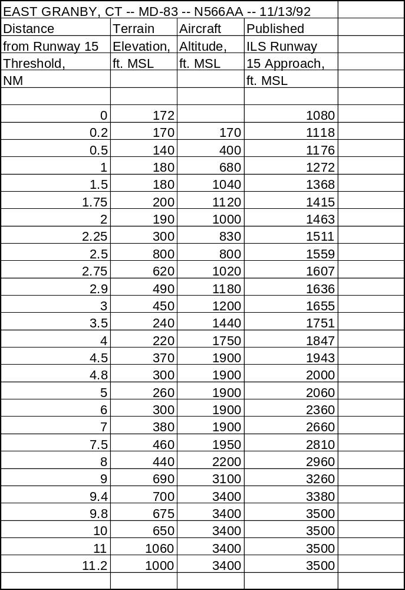
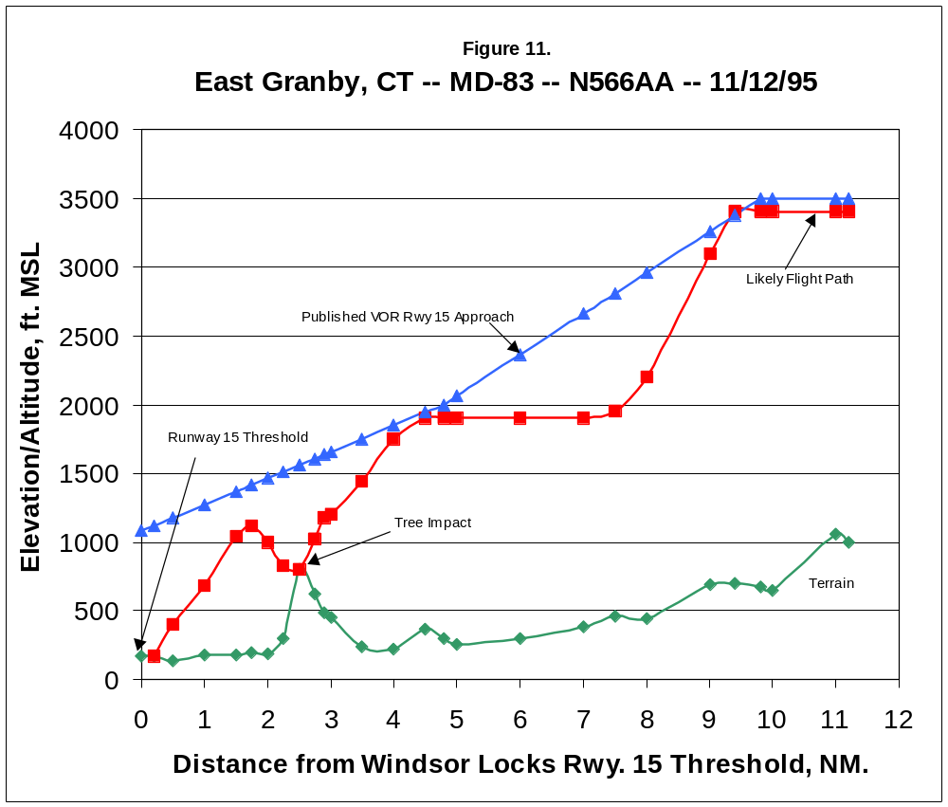
3.12 Buga, Colombia – B-757-200 –N651AA – 12/20/95

The Buga accident involved American Airlines flight 965, a Boeing B-757-200 turbofan on a regularly scheduled FAR Part 121 flight from Miami, FL to Cali, Colombia. The aircraft impacted a ridge on San Jose Mountain, which rises above the town of Buga to 12,900’ MSL at its highest point, at approximately the 8960’ elevation, on a heading of 221º magnetic, while the aircraft was in approach configuration. Impact was 30.4 NM from the Cali VOR facility. Of the 167 persons aboard, only four passengers survived with serious injuries. Weather in the accident vicinity was classified as dark night, VMC.

The Cali airport lies in the middle of a valley between two mountain ridges. The crew of flight 965 were expecting to fly an ILS approach in which they overflew the field, circled back and landed on the northbound runway (designated 01). However, because winds were calm, the Cali approach controller offered the crew the option of a “straight-in” approach to the opposite end of this runway (19): “would you like the one-nine straight in?” CVR transcripts show the first officer said to the captain: “yeah, we’ll have to scramble to get down (but) we can do it.” The captain then replied to ATC: “Yes sir, we’ll need a lower altitude right away, though.”

The VOR/DME approach to Cali Runway 19 is a non-precision approach starting at the Tulua VOR facility, 43 NM from the Cali VOR at an altitude of 14,900’ MSL. Beyond Tulua, aircraft follow a heading of 200º magnetic and descend to 5000’ MSL. Following the contours of the valley, they then turn to a heading of 190º magnetic 21 NM from the VOR, maintaining a 5000’ MSL altitude until reaching a navigational fix 16 NM from the VOR. At this point, they descend to the 3900’ MSL minimum descent altitude; the ROZO non-directional beacon (NDB) is the signal for aircraft to begin final approach.

Because there was no terminal radar at Cali, ATC had to rely on pilot reports for information on aircraft position, and requested that flight 965 “report (passing) Tulua (VOR).” The flight crew, after some initial confusion, realized that ROZO was the final approach fix, and asked ATC “can 965 go direct (to) ROZO and do the ROZO ONE arrival (procedure)?” ATC replied “Affirmative,” but then reiterated “Report Tulua and 21 miles (the point at which the approach course turns), 5000 feet.” (25)

To slow their airspeed and increase their descent rate, the captain extended the aircraft’s speed brakes at this point, and tuned the flight management system to ROZO by entering an “R” on its keyboard. Post-crash investigation shows the flight management computer responded with a list of the 12 nearest navigational facilities, ranked in order of distance from the aircraft, having call signs beginning with “R,” together with their latitude/longitude coordinates. Unknown to the captain, this list did not contain ROZO; it was not entered as such in the flight management system’s memory. Without bothering to verify its position, the captain selected the topmost facility on the list, assuming it was ROZO. Unfortunately, it was the ROMEO NDB located in Bogota, 130 NM away. (26)

Once this selection was made, the aircraft began a sharp, 90º turn to the east, heading towards ROMEO. It was just about this point that the aircraft passed over the Tulua VOR. Because Tulua was no longer an active waypoint for the flight, it was not displayed on the flight management system, and the crew was unaware it had been crossed. For reasons that are unclear, the crew did not notice the aircraft had veered sharply off course for about 45 seconds, and then took another 45 seconds to take appropriate corrective action. All the while, the aircraft was descending.

Cali ATC, realizing the flight should have passed Tulua, but had not reported doing so, then asked “distance now?” The captain responded “distance from Cali (VOR) is 38 (NM).” Cali ATC acknowledged, but did not question the report. Since Tulua is 43 NM from the VOR, it had clearly been passed. Post-crash investigation showed the controller in question had command of the English language sufficient to engage in routine ATC exchanges, but apparently not enough to raise detailed questions to the crew of flight 965 regarding position and heading as they strayed off course. (27)

Over the next minute, the CVR shows the crew realizing they are heading away from Cali. The captain says: “Where are we? Come right … go to Cali … we got (expletive) up here, didn’t we?” The first officer then disengages the flight management system and initiates a manual turn to the right of approximately 90 degrees, the end result of which places the aircraft back on the initial approach course. Unfortunately, the excursion off the approach course had taken the aircraft well beyond the confines of the valley containing the airport. Still descending, N651AA was now dangerously close to the peaks on the east side of the valley. Eventually, the aircraft’s GPWS begins to sound a “Terrain! Terrain!” alert, followed quickly by a “Whoop! Whoop! Pull Up!” warning. The crew’s reaction was immediate and decisive; the nose was pitched up and maximum throttle applied. But the speed brakes remained deployed, a factor which negatively affected the aircraft’s climb rate. Eleven seconds after the initial alert, the aircraft impacted San Jose Mountain. (28)

N651AA was equipped with CVR, FDR and GPWS. Table 13 presents altitude and elevation information for this accident. This information is presented graphically in Figure 12.
Table 13. Data for Buga, Colombia CFIT Accident
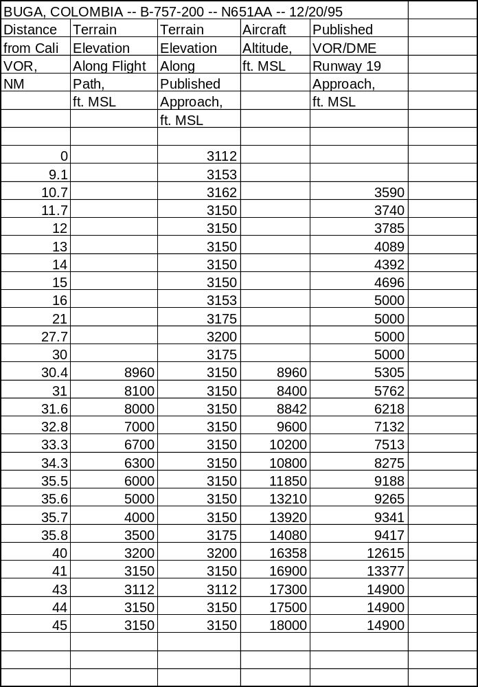

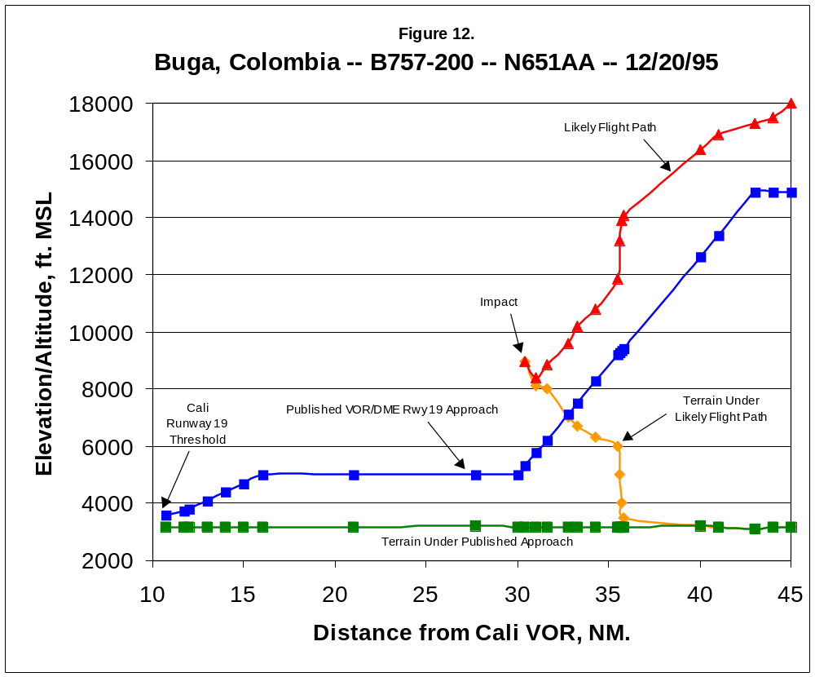(placeholder for Buga chart)
3.13 Nimitz Hill, Guam – B-747-300 – HL-7468 – 8/6/97

The Nimitz Hill accident involved Korean Airlines flight 801, a Boeing B-747-300 turbofan, on a regularly-scheduled FAR Part 129 flight from Seoul, South Korea to Agana, Guam. The aircraft, on an ILS approach to Runway 06L at Guam’s Won Pat Airport, impacted Nimitz Hill, a 700’ MSL peak, at the 662’ elevation, and 3.7 NM from the runway threshold. At impact, the aircraft was in landing configuration on a heading of 063º magnetic, on course for Runway 06L. Of the 254 persons aboard, 229 were killed, and 25 survived with serious injuries. Weather in the accident vicinity was classified as dark night, IMC.

At the time of the accident, the glide slope (GS) portion of the instrument landing system (ILS) at Won Pat Field was inoperative. Because of this, the “descent below glide slope” portion of the aircraft’s GPWS also did not function. As KA801 passed the FLAKE intersection west of Guam, it turned to join the localizer signal and begin the approach at approximately 2600’ MSL. ATC at the Guam combined center/approach control (CERAP) facility at this point instructed the aircraft “Korean Air 801, cleared for ILS Runway 6 approach, glide slope unusable.” CVR transcripts show the crew then expressed confusion over the glide slope signal and had a brief discussion, concluding with the statement: “Glide slope is incorrect.” (29)

FDR and Radar data show HL-7468 started to descend at a point approximately 9 NM from the Runway 06L threshold, although the published approach specifications state 2600’ MSL should be maintained until 7 NM from the runway. The aircraft descended through 2000’ MSL over a mile before reaching the outer marker, designated GUQQY, the point where descent below 2000’ is authorized by the published approach. (30)

As the crew started their landing checklist, the GPWS sounded “One thousand.” This was a “smart altitude callout” feature of newer-model GPWS equipment. The captain then asked again, “Isn’t the glide slope working?” At this point, the aircraft was a mile west of Nimitz VOR, but was passing through the altitude that the published approach specifies should be maintained until reaching this facility.

Despite being cautioned the glide slope was not working, the captain persisted in a continuous descent as though it were, disregarding the step-down approach required if it is inoperable.

The crew continued the checklist until the GPWS again sounded “Sink Rate!” The first officer then stated: “Sink Rate OK.” The flight engineer stated “Not in sight,” indicating the runway was still not visible. At this point, the captain said “Go around” (i.e., abandon the approach and climb out). At this point, the autopilot was disengaged and flaps were retracted, and the throttle was increased. But the large aircraft’s momentum still carried it downward to impact with Nimitz Hill. The GPWS smart altitude callouts can be heard on the CVR: “fifty – forty – thirty – twenty …”

Since the Nimitz VOR is located directly adjacent to the accident location, post-crash investigators speculate that perhaps the captain thought this facility was located at or near the airport, as is typically the case. In actual fact, it is located 3.3 NM from the Runway 06L threshold. (31)

HL-7468 was equipped with CVR, FDR and GPWS. Table 13 presents altitude and elevation information for this accident. This information is presented graphically in Figure 12.
Table 14. Data for Nimitz Hill, Guam CFIT Accident
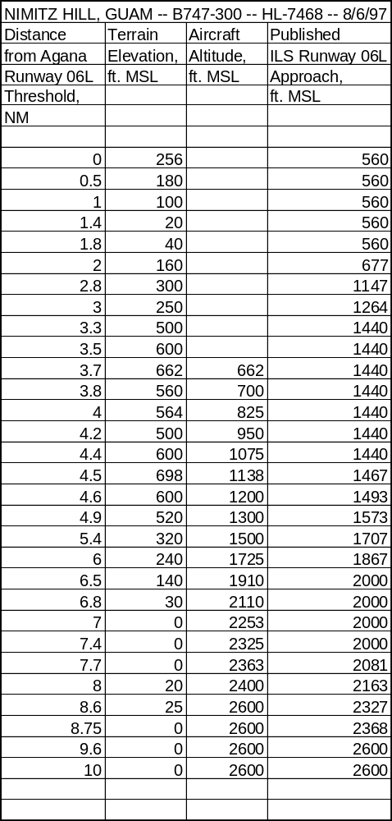
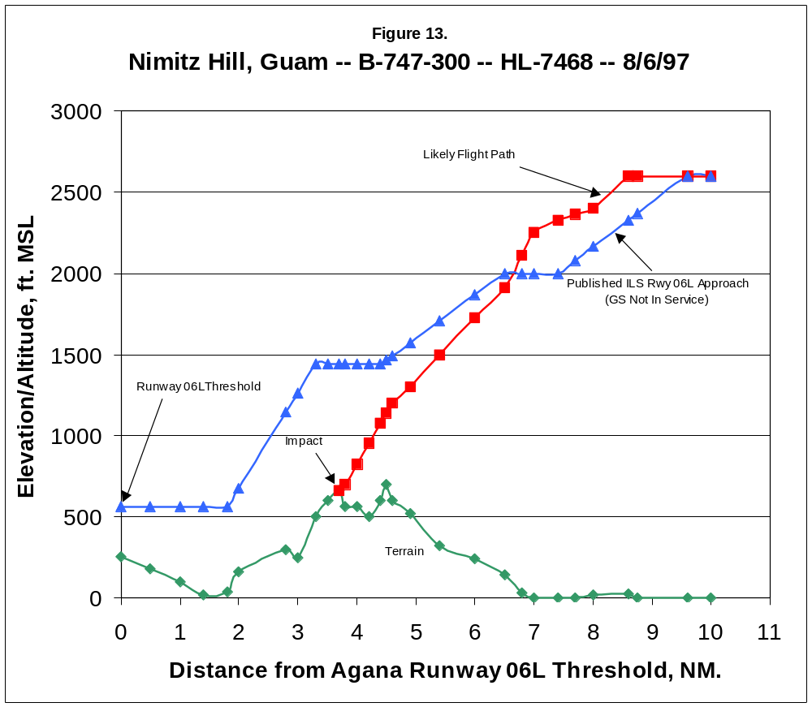(placeholder for Guam chart)
APPENDIX A
REFERENCES

1. Proposed Technical Standard Order TSO-C151, Terrain Awareness and
Warning Systems (Washington, DC: Federal Aviation Administration
(FAA) Aircraft Certification Service) October 22, 1998.

2. Spiller, David, Investigation of CFIT Accidents Involving Multi-Engine, Fixed-
Wing Aircraft Operating under Part 135 and the Potential Application of a
Ground Proximity Warning System (Cambridge, MA: Volpe National
Transportation Systems Center) March 1989, Vol. 1, p. 1.

3. Hopkins, Jay, “Avoiding CFIT,” Flying Magazine (Greenwich, CT: Hachette
Magazines, Inc.) April 1992, p. 44.

4. Bateman, Don, “Development of Ground Proximity Warning Systems,”
Appendix to Flight Into Terrain and the Ground Proximity Warning System
(Redmond, WA: Allied Signal Aerospace, Inc.) Engineering Report # 070-
4251, April 1996, p. 3.1

5. Ibid., p. 3.2.

6. Loomis, James and Richard Porter, “The Performance of Warning Systems in
Avoiding CFIT Accidents,” Proceedings of the Symposium on Aviation
Psychology (Columbus, OH: Battelle Columbus Laboratories) 1981.

7. Phillips, Robert, Investigation of Controlled Flight Into Terrain for Selected
Aircraft Accidents Flying Under FAR Part 121 and 135 Flight Rules and
the Potential for Their Prevention by Enhanced GPWS (Cambridge, MA: Volpe National Transportation Systems Center) Project Memorandum # DOT-TSC-FA6D1-96-03, pp.6-7.

8. Proposed TSO-C151, op. cit. , p. 1.

9. Phillips, op. cit., p. 17.

10. Rodriguez, R. G., “Information Involving Operation of EAL 980, La Paz,
Bolivia, January 1, 1985”, memorandum included in Aviation Accident
Report (AAR) # DCA85RA007 (Washington, DC: National Transportation
Safety Board (NTSB)) May 6, 1985, pp. 1-7.

11. “Team Fails to Find Recorders in Eastern Crash,” Aviation Week and Space
Technology Magazine, Oct. 28, 1985, p. 29.

REFERENCES, Cont’d.

12. AAR # ATL85FA256, Flat Rock, NC (Washington, DC: NTSB) Oct. 27,
1986.

13. AAR # ATL87MA041, Windsor, MA (Washington, DC: NTSB) Apr. 12,
1987.

14. AAR # FTW87NA086, Eagle, CO (Washington, DC: NTSB) Jul. 18, 1988.

15. Civil Aeronautics Board of Honduras, Final Report of the Accident Involving
… Boeing 727 Owned by Continental Airlines and Leased to Servicio
Aereo de Honduras, S.A. (SAHSA) … Which Occurred on … October 21,
1989 (Tegucigalpa, Honduras: CAB) Report # MJH/DTB/247023, Nov.
28, 1989.

16. AAR # DCA90MA005, Halawa Point, HI (Washington, DC: NTSB)

17. Flight Safety Foundation, “Crew’s Failure to Monitor Terrain Clearance After
Night Takeoff Results in Collision with Mountain,” Accident Prevention,
Vol. 52 # 9, Sept. 1995.

18. AAR # LAX91FA132, San Diego, CA (Washington, DC: NTSB) Dec. 26,
1991.

19. AAR # DCA92MA011, Rome, GA (Washington, DC: NTSB) Jul. 8, 1992.

20. AAR # DCA92MA016, Gabriels, NY (Washington, DC: NTSB) May 20,
1992.

21. Flight Safety Foundation, “Captain’s Failure to Establish Stabilized Approach
Results in CFIT Commuter Accident,” Accident Prevention, Vol. 52, #7, July 1995.

22. AAR # DEN92FA064, Alamogordo, NM (Washington, DC: NTSB) Jan. 8,
1993.

23. AAR # DCA96MA008, East Granby, CT (Washington, DC: NTSB)

24. Flight Safety Foundation, “During Nonprecision Approach at Night, MD-83
Descends below MDA and Contacts Trees, Resulting in Engine Flame-out
and Touchdown Short of Runway,” Accident Prevention, Vol. 54, #4, April
1997.

REFERENCES, Cont’d.

25. “CVR Reveals Last Minutes before Colombia Crash,” Aviation Week and
Space Technology Magazine, May 6, 1996.

26. “Recovered Flight Management Computer Memory Puts New Spin on Cali
Accident,” Aviation Week and Space Technology Magazine, Sept. 9,
1996.

27. Aeronautica Civil de la Republica de Colombia, Aircraft Accident Report:
Controlled Flight Into Terrain, American Airlines Flight 965 … December
20, 1995.

28. Flight Safety Foundation, “Preparing for Last-Minute Runway Change,
Boeing 757 Flight Crew Loses Situational Awareness, Resulting in
Collision with Terrain,” Accident Prevention Vol. 54 #7/8, Jul./Aug. 1997.

29. AAR # DCA97MA058, Nimitz Hill, Guam (Washington, DC: NTSB), Feb. 24,
1998, especially Airplane Perfornance Study, Docket # SA-517,
Exhibit #13A.

30. Feith, Gregory, “Opening Statement of Investigator in Charge
(Washington, DC: NTSB) Public Hearing on KAL Flight 801,
Mar. 24, 1998.

31. Roberts, Wally, “TERPS, CFIT and Me,” IFR Refresher, June 1998,
pp. 10-15.

