National Transportation Analysis Regions (NTARs)

The Bureau of Transportation Statistics

February 29, 1996

https://doi.org/10.21949/1520943

National Transportation Library preservation note: The information in this document was present on the Bureau of Transportation Statistics (BTS) website from February 29, 1996, through approximately, November 28, 2004.

The original URL was http://www.bts.gov/programs/cfs/ntar/ntar_defined.html. This URL is no longer functional.

Because some BTS statistical products, reports, and datasets use the National Transportation Analysis Regions (NTAR) codes, NTL is providing access to the contextual information and code tables that were once available on the BTS web.

Please note that while the information gathered below is not displayed in the same way as the original webpages, the intellectual content of those pages is captured and preserved for future use. Minor edits were introduced to correct errors, or improve navigation.

These preservation actions were taken on March 09, 2021. Information and tables, where needed, were harvested from the Internet Archive’s Wayback Machine, at https://web.archive.org/web/20041020234825/http://www.bts.gov/programs/cfs/ntar/ntar_defined.html.

NTL thanks the Internet Archive for helping us preserve this important content.

National Transportation Analysis Regions (NTARs)

The Bureau of Transportation Statistics

February 29, 1996

https://doi.org/10.21949/1520943

Introduction

National Transportation Analysis Regions (NTARs) have been defined by the U.S. Department of Transportation (DOT) to collect and publish information on the interregional movements of goods. This paper explains how NTARs were defined in preparation for the Commodity Flow Survey (CFS).

The Issue

The U.S. Department of Transportation (DOT) requires information on the interregional movements of goods and people to understand the demands being placed on the Nation's transportation system and the ability of the system to meet those demands. The required information raises two statistical problems:
- The geography of transportation demand and activity are molded by economic, social, and physical forces that generally ignore political boundaries. Mountain ranges and the hinterlands of major economic centers are just two of the many characteristics that affect patterns of transportation supply and demand and that have little correlation to State lines. As a consequence, much transportation data need to be organized by functional geography rather than by State or other large political units.
- Data on the characteristics of activity between regions are inherently more massive -- and thus more difficult to acquire and manage -- than data on the characteristics of regions. One record per region becomes one record for each pair of regions. For example, the individual populations of 50 States can be described by a column with 50 cells; the migrations of people from each State to each State needs a matrix with 2,500 cells.

To deal with these statistical problems, the transportation community needs an effective yet parsimonious set of regions with the following characteristics:
- Coverage. The regions should cover all portions of the 50 States and the District of Columbia.
- Number. There should be no more than 90 regions for some applications to keep origin-destination tables within 8,000 cells.
- Functional Geography. The regions should be based on centers of population or economic activity that account for most of the origins, destinations, or transfers of long distance passenger and commodity movements. Each region should encompass the hinterland of the region's terminals for long distance transportation. Where hinterlands of closely neighboring centers substantially overlap, the regions should be combined. (Note: long distance movements are generally defined by travel by individuals that is typically not made on a daily or weekly basis. The specific length varies from 50 to 100 miles depending population density and door-to-door speed of the transportation system.)
- Size. Each region should be small enough so that there are more long distance movements to and from other regions than within the region.
- Stability. The regions should encompass areas of foreseeable growth and change so that boundaries do not have to be redefined within the a few years.
- Comparability. The regions should be coterminous with -- or aggregates of -- regions used by other Federal agencies that produce statistics on transportation or related economic and social characteristics.

None of the geographic units traditionally used by Federal agencies meet all of the desired criteria:
- Census Regions and Divisions are far too big. Most multi-State regions used by Federal agencies encompass more intraregional than interregional long distance movements, and most include multiple, major centers of population and economic activity that are far apart.
- States generally do not reflect functional geography. Several of the Nation's biggest population centers (including New York and Chicago) are divided by State boundaries. Some of the biggest States also include multiple, major population centers that are far apart and economically independent (such as Los Angeles and San Francisco).
- BEA Economic Areas of the U.S. Bureau of Economic Analysis (BEA) cover the country and reflect functional geography, but are too numerous. There were 183 BEA areas when the CFS was conducted in 1993, and have since been significantly redefined. Some of the BEA areas are too small to encompass overlapping transportation hinterlands (such as Baltimore and Washington).
- Metropolitan Statistical Areas (MSAs) and Consolidated Metropolitan Statistical Areas (CMSAs) reflect functional geography, but do not cover the entire country and are too numerous.
- Census Production Areas used in previous Commodity Transportation Surveys do not cover the entire country.
- Labor Market Areas used by the U.S. Department of Agriculture are too numerous.
- Counties and other sub-State levels of government are too numerous.

BEA Economic Areas come the closest of these geographical units to meeting DOT's needs, as long as they are combined to be less numerous and to eliminate overlapping hinterlands. DOT has accomplished this by selecting BEA Economic Areas as “NTAR Cores” based on population and surrogate measures of economic activity; combining NTAR Cores based on distance; and dividing the remaining BEA Economic Areas among the NTAR Cores based on distance and special boundary conditions. This approach assumes that the major long distance transportation facilities of each BEA Economic Area are at or near the center of the area's largest major city, and that the hinterlands of each major long distance transportation facility is a function of distance.

The 7-Step Process for Defining NTARs

DOT has aggregated BEA Economic Areas into 89 NTARs to support the CFS and other programs for collecting and publishing transportation data by functional geography. (89 was selected to leave room for the possible addition of Puerto Rico in the future.) DOT used the 1987 definition of BEA Economic Areas that was in effect during the design and implementation of the 1993 CFS. DOT also used the most current estimates of population and employment data available during the CFS design process. These data were published by BEA in Survey of Current Business, November, 1990, pp. 39-43). Mileage data were calculated from an extraction of the Oak Ridge National Laboratory National Planning Highway Network using Caliper Corporation's TransCAD software package.

1. All BEA Economic Areas projected to reach 1 million population by the year 2000 were selected as the initial NTAR Cores. These 69 areas had at least 955,000 population in 1988, and were assumed to be the major generators of intercity passenger travel.

2. All BEA Economic Areas having as many or more jobs as the NTAR Core with the smallest 1988 population were included on the list of NTAR Cores. The NTAR Core with the smallest estimated 1988 population in Step 1 had 402 thousand jobs. This step added 11 more NTAR Cores. The resulting top 80 NTAR Cores accounted for approximately 80 percent of the U.S. population and employment in 1988, and were assumed to be the major generators of intercity freight movements outside of mining and agriculture.

3. An additional six ports that were not included in Step 2 were added as NTAR Cores. Wilmington (NC), Charleston (SC), Savanna (GA), and Mobile (AL) were added to distinguish them from competing ports in other States. Brownsville (TX) was added to distinguish it as a major port and Mexican gateway from other distant ports and border crossings in Texas. Duluth (MN) was added to distinguish its Great Lakes traffic from Mississippi River traffic in Minneapolis.

4. All NTAR Cores within 50 miles of each other were combined. Distance was based on the shortest major highway route between the centers of each area's major city. This assumes that areas within such close proximity share major interregional transportation terminals. The 50-mile criteria merged Providence into Boston and Washington into Baltimore, reducing the number of NTAR Cores to 84 and leaving room for 5 additions.

5. The most distant unselected BEA Economic Area from the NTAR Cores was designated an NTAR Core. Distance was based on the shortest major highway route between the centers of the major city in each area. (Water distance was used for the noncontiguous regions of Alaska and Hawaii.) This step was repeated five times to fill out the maximum number of NTARs. This step assumes that the most distant areas include vast domains of agriculture or natural resources that generate significant commodity flows, and that the most distant areas are so far removed that there are more long distance trips within the areas than to other NTARs. Alaska, Great Falls (MT), Minot (ND), Rapid City (SD), and Boise (ID) in turn became NTAR Cores under this step.

6. Each unselected BEA Economic Area was assigned to the nearest NTAR Core based on the distance of the shortest major highway route between the centers of the major city in each area.

7. Some of the BEA Economic Area assigned to NTARs in step 6 were reassigned to other NTARs based on particular circumstances.
- Reno (NV) was reassigned from Sacramento (CA), Yakima (WA) was reassigned from Seattle (WA) to Boise (ID), and Richland (WA) was reassigned from Portland (OR) to Boise (ID) to recognize the Sierra-Cascade boundary and to reduce the disparity of population and employment between the affected NTARs. The boundary overrides distance because the mountains cause enormous changes in the environment -- and thus the economy -- between the Pacific Rim and the Intermontane West. In the parlance of transportation surveys, the mountains provide an effective screen line.
- Minneapolis (MN) lost Sioux Falls (SD) and Aberdeen (SD) to Rapid City (SD), and Fargo (ND) to Minot (ND) to keep the grain producing regions of the northern Great Plains together and to provide a screen line between those regions and their major ports on the Mississippi and the Great Lakes. These reassignments also provide additional population and employment to regions that were defined by the distance criteria and short on both people and jobs.
- Lubbock (TX) was reassigned from Dallas (TX) to El Paso (TX) because Lubbock is more similar in environment and economy to rural westernmost Texas than to highly urban Dallas, and because the initial Dallas NTAR was unnaturally elongated.
- Corpus Christi was assigned to Brownsville rather than San Antonio because the distances differed by only 10 percent, because the economic functions and the environments of the two coastal areas had more in common with each another than with the Texas interior, and to reduce the disparity of population and employment between Brownsville and San Antonio.
- New Orleans (LA) picked up Shreveport (LA) from Dallas (TX), Lake Charles (LA) from Houston (TX), and Monroe (LA) from Jackson (MS) to keep the coastal and river ports of Louisiana together, and to provide a screen line between the ports and the shipping regions of northeast Texas, Arkansas, and Mississippi.

The final definition is shown in the maps below.

[Larger views of the maps are available on the last 2 pages of this preservation document.]

Map 1: NTARs and States

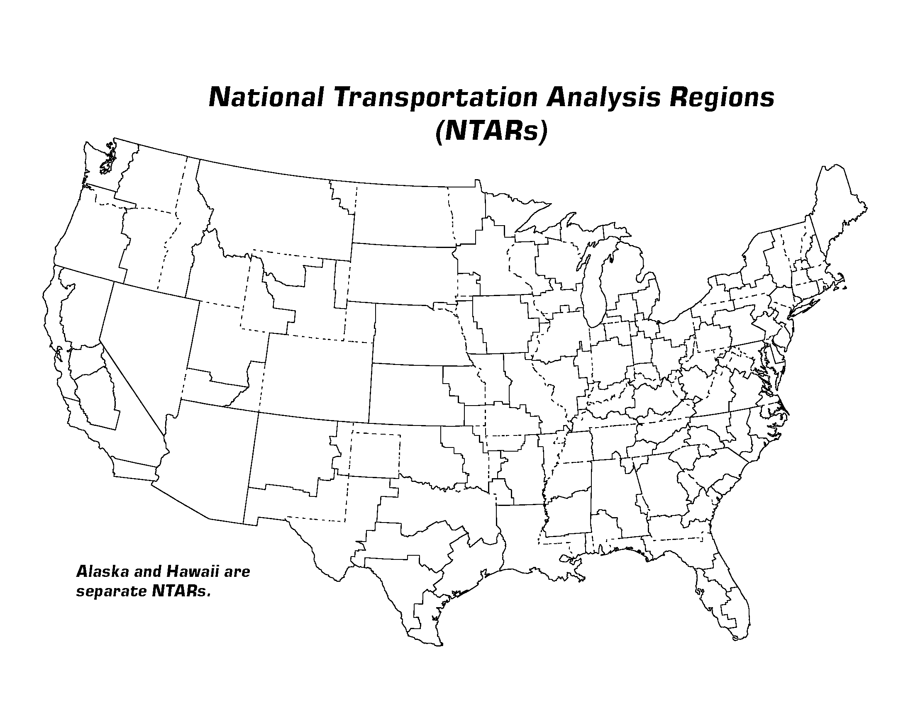

Map 2: NTARs and BEA Economic Areas

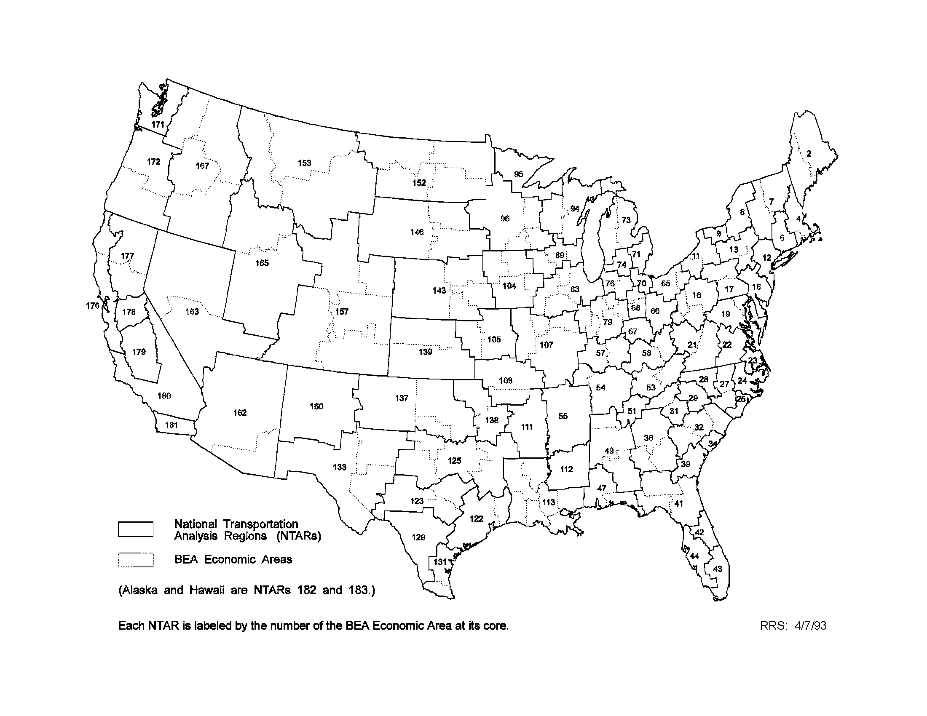

Applicability of NTARs to Passenger Transportation

NTARs were designed with the hope of supporting data collection and analysis for both passenger and freight transportation, but the design was driven by the requirements of the CFS. The suitability of NTARs for passenger flow surveys and analysis is open to question. Eleven of the NTARs are based on ports and distance, and may be too small in population and employment to be appropriate for measuring long distance passenger travel. Passenger-oriented NTARs can be created by aggregating NTARs that do not reach a threshold of population and employment, or by creating a new set of NTAR cores based solely on population and employment. The former approach reduces the number of NTARs through consolidation, and maintains comparability with the freight-oriented NTARs. The latter approach would keep the total number of NTARs at 89, but lose comparability between passenger and freight data.

Applicability of NTARs to Freight Transportation

NTARs appear to capture the functional geography of freight transportation, although more differentiation of ports would have been desirable. In the many cases, the competing ports are within the same BEA Economic Area and cannot be separated without cleaving the building blocks of the NTARs. A five-way split NTAR 113 along BEA Economic Area boundaries would have been desirable to distinguish the river and coastal ports of Louisiana, but could not be accommodated without increasing the total number of NTARs or dramatically altering the existing NTARs.

Based on initial experience with the 1993 CFS, NTARs create three potential problems:

1. In some instances, the geographic difference between the NTAR and State involves a small area and creates confidentiality problems (e.g. the small portion of Utah in the Nevada NTAR).

2. Census would like to use other statistics collected at the State level for expansion of CFS sample data and for quality assurance.

3. Some NTARs may not encompass enough economic activity to result in useful data.

The biggest problem is that BEA significantly realigned its Economic Areas in 1995. Existing NTARs are no longer compatible with the new Economic Areas. These new Economic Areas will probably not be changed before 2002, and may become the basis for a new definition of Metropolitan Statistical Areas (MSAs) by the Office of Management and Budget after the Year 2000 Census.

The Bureau of Transportation Statistics has considered three options for defining NTARs to support the planned 1997 CFS.
- Use 1993 NTARs. This preserves comparability between 1993 and 1997 CFS data, allows planning for 1997 to proceed, and defers change until 2002. Current problems with NTARs are maintained, and comparability with BEA Economic Areas in 1997 is lost. The chance to test transportation applications of MSAs based on BEA Economic Areas before MSAs are redefined in 2002 is also lost.
- Redefine NTARs Based on New BEA Economic Areas. This increases the possibility of comparability between 1997 and 2002 CFS data, maintains comparability with BEA Economic Areas in 1997, and provides a chance to test transportation applications of MSAs based on BEA Economic Areas before MSAs are redefined in 2002. Comparability between 1993 and 1997 are lost, and redefinition must be completed quickly without a chance to chance to resolve problems 1 and 3 encountered with 1993 geography. Comparability with states (problem 2) remains unsolved.
- Redefine NTARs So That State Boundaries are Not Crossed. This fixes the small overlap issue (problem 1) and comparability with States (problem 2), and provides an alternative to BEA Economic Areas as a basis for MSA redefinition. Comparability is lost between 1993 and 1997 CFS data (and with 2002 CFS data if the alternative basis for MSAs fails to work). Comparability is lost with BEA Economic Areas in 1997, and the scheme may work no better for transportation applications than the 1993 geography (problem 3).

The Bureau of Transportation Statistics proposes to maintain the 1993 NTAR definition in 1997 unless subsequent evidence overwhelmingly demonstrates that 1993 geography is fatally flawed. Comparability between 1993 and 1997 is very important, and a strong case has not been advanced for maintaining comparability with data that will be available only by BEA Economic Area in the future. Comparability with county data is maintained in any case

Conclusions

NTARs have been developed to provide a functional geography for data collection and analysis that solves two problems: some States are big and contain multiple centers of economic activity, and several centers of economic activity straddle State lines.

NTARs do not replace various units of Census geography for corridor-level and metropolitan-focused studies, but can be used to define the larger geographic context in which flows among central cities and suburbs are scrutinized. NTARs do not replace political jurisdictions when results by State are desired, but can be used to indicate whether functional geography affects policies that are aimed at political jurisdictions.

In the absence of arguments to the contrary, NTARs defined for the 1993 CFS will be used in 1997 even though the underlying BEA Economic Areas have been significantly redefined. Comments and suggestions are welcomed, and should be directed to:

Commodity Flow Survey

Office of Data Development and Standards

1200 New Jersey Ave. SE

Washington, DC 20590

United States

CFS website: https://www.bts.gov/cfs

Email: cfs@dot.gov

Phone: 800-853-1351

Alt Phone: 202-366-3282

Business Hours:

8:30am-5:00pm ET, M-F

[Please note: the contact information above has been updated to be accurate as of 2021-03-09.]

National Transportation Analysis Regions (NTARs): Numeric Code and Geographic Title
(NTAR) Code Geographic Region described by NTAR code
2 Portland-Bangor, ME
4 Boston, MA--Providence-Warwick, RI
6 Hartford-New Haven, CT--Springfield, MA
7 Albany, NY--Burlington, VT
8 Syracuse-Utica, NY
9 Rochester, NY
10 Buffalo, NY--Erie, PA
11 Binghamton-Elmira, NY--Scranton, PA
12 New York, NY
16 Pittsburgh, PA--Morgantown-Wheeling, WV
17 Harrisburg-York-Williamsport, PA
18 Philadelphia, PA
19 Baltimore, MD--Washington, DC
21 Roanoke-Lynchburg, VA--Charleston, WV
22 Richmond-Petersburg, VA
23 Norfolk-Virginia Beach-Newport News, VA
24 Rocky Mount-Wilson-Greenville, NC
25 Wilmington, NC
27 Raleigh-Durham-Fayetteville, NC
28 Greensboro-Winston-Salem-High Pt., NC -Winston-Salem-High Pt., NC
29 Charlotte, NC
31 Greenville-Spartanburg, SC--Asheville, NC
32 Columbia-Florence, SC--Augusta, GA
34 Charleston, SC
36 Atlanta-Columbus-Macon, GA
39 Savannah, GA
41 Jacksonville-Tallahassee, FL--Albany, GA
42 Orlando-Melbourne-Daytona Beach, FL
43 Miami-Fort Lauderdale, FL
44 Tampa-St. Petersburg, FL
47 Mobile, AL-Pensacola, FL
49 Birmingham-Montgomery-Huntsville, AL
51 Chattanooga, TN
53 Knoxville-Johnson City, TN-Bristol, TN-VA
54 Nashville, TN--Paducah, KY
55 Memphis, TN
57 Louisville, KY--Evansville, IN
58 Lexington, KY--Huntington, WV
65 Cleveland-Youngstown, OH
66 Columbus, OH
67 Cincinnati, OH
68 Dayton-Springfield-Lima, OH
70 Toledo, OH
71 Detroit, MI
73 Grand Rapids-Saginaw, MI
74 Lansing-Kalamazoo, MI
76 Fort Wayne-South Bend, IN
79 Indianapolis-Kokomo, IN--Champaign, IL
83 Chicago-Rockford-Peoria, IL--Davenport, IA
89 Milwaukee-Madison, WI--Dubuque, IA
94 Appleton-Green Bay-Wausau, WI
95 Duluth, MN
96 Minneapolis-St. Paul-Rochester, MN--La Crosse, WI
104 Des Moines-Cedar Rapids-Waterloo, IA
105 Kansas City, MO--Topeka, KS
107 St. Louis-Columbia, MO--Quincy-Springfield, IL
108 Springfield, MO--Fayetteville, AR
111 Little Rock-North Little Rock, AR
112 Jackson, MS
113 New Orleans-Baton Rouge-Shreveport, LA
122 Houston-Beaumont, TX
123 Austin-Waco-San Angelo, TX
125 Dallas-Fort Worth-Abilene, TX
129 San Antonio, TX
131 Brownsville-Corpus Christi, TX
133 El Paso-Lubbock-Odessa, TX
137 Oklahoma City-Lawton, OK--Amarillo, TX
138 Tulsa, OK--Fort Smith, AR
139 Wichita-Salina, KS
143 Omaha-Grand Island, NE--Sioux City, IA
146 Rapid City-Sioux Falls-Aberdeen, SD
152 Minot-Fargo-Grand Forks-Bismarck, ND
153 Great Falls-Missoula-Billings, MT
157 Denver-Grand Junction, CO--Cheyenne, WY--Scottsbluff, NE
160 Albuquerque, NM
162 Phoenix-Tucson, AZ
163 Las Vegas-Reno, NV
165 Salt Lake City, UT--Idaho Falls, ID
167 Boise City, ID--Spokane-Yakima, WA
171 Seattle, WA
172 Portland-Eugene, OR
176 San Francisco-Oakland-Eureka, CA
177 Sacramento-Redding, CA
178 Stockton-Modesto, CA
179 Fresno-Bakersfield, CA
180 Los Angeles, CA
181 San Diego, CA
182 Anchorage, AK
183 Honolulu, HI

