Electronic Freight Management (EFM) Governance

www.its.dot.gov/index.htm
Final Report — March 2012
FHWA-JPO-12-070

Produced by FHWA Office of Operations Support Contract
DTFH61-06-D-00004
Federal Highway Administration
Research and Innovative Technology Administration

Notice

This document is disseminated under the sponsorship of the Department of Transportation in the interest of information exchange. The United States Government assumes no liability for its contents or use thereof.

The U.S. Government is not endorsing any manufacturers, products, or services cited herein and any trade name that may appear in the work has been included only because it is essential to the contents of the work.

Photo credits: Cover art courtesy of FHWA. All other art within this document is original.

Technical Report Documentation Page
1. Report No.  FHWA-JPO-12-070 | 2. Government Accession No. |  | 3. Recipient’s Catalog No.
4. Title and Subtitle  Electronic Freight Management Governance |  |  | 5. Report Date  March 2012
 |  |  | 6. Performing Organization Code
7. Authors  Tim McGrath, (Document Engineering Services), Ron Schaefer (SAIC), Diane Newton (SAIC), Andy Schoka (Document Engineering Services) |  |  | 8. Performing Organization Report No.
9. Performing Organization Name and Address  Science Applications International Corporation (SAIC)  1710 SAIC Drive  McLean, VA 22102 |  |  | 10. Work Unit No. (TRAIS)
11. Contract or Grant No.

DTFH61-06-D-00005
12. Sponsoring Agency Name and Address  United States Department of Transportation  Federal Highway Administration  1200 New Jersey Ave., SE  Washington, DC 20590 |  |  | 13. Type of Report and Period Covered
 |  |  | 14. Sponsoring Agency Code
15. Supplementary Notes
Mr. Randy Butler, COTM
16. Abstract
The Electronic Freight Management (EFM) initiative is a USDOT-sponsored project that applies web technologies to improve data and message transmissions between supply chain partners. This report describes a new EFM Governance Model and the necessary steps to implement the model. EFM Governance is the system through which the national and international freight communities’ demand for and supply of electronic business services to support freight operations (EFM) is directed and controlled. Governance involves evaluating and directing the implementation and operations of EFM communities among collaborating organizations and monitoring its employment to achieve planned business objectives. It also includes the strategy and policies for using EFM among those collaborating communities. This document outlines and details these overarching strategies and policing for using EFM and assesses the options for structural models that are appropriate for EFM Governance.
17. Key Words  Electronic freight management, supply chain freight information, web technologies, data transmission, message transmission, supply chain partners, e-business concepts, process coordination, public-private collaboration, tracking freight, multimodal freight |  | 18. Distribution Statement  No restrictions.
19. Security Classify. (of this report)  Unclassified | 20. Security Classify. (of this page)  Unclassified |  | 21. No of Pages  32 | 22. Price  N/A
Form DOT F 1700.7 (8-72) Reproduction of completed page authorized.

Table of Contents
Electronic Freight Management (EFM) Governance 1
1 Introduction 6
1.1 Background to EFM 6
1.2 Vision 6
1.3 History 7
1.4 Recruitment and Engagement 7
1.5 EFM Business Benefits from Pilots 9
2 Strategy for Long Term Sustainability 11
2.1 Strategic Governance Requirements 11
2.2 Management 12
2.3 Ownership 12
2.4 Central Services/Registry 12
2.5 Intellectual Property Rights 13
2.6 Information Security 13
2.7 Value of Governance 13
3 Recommended EFM Governance Model 14
3.1 The EFM Consortium 15
3.2 The EFM Governing Body 16
3.2.1 Development 17
3.2.2 Support 17
3.2.3 Monitoring 17
3.3 Secretariat Services 18
3.4 EFM Community Providers 18
3.4.1 Community Provider Agreements 19
3.5 Open Forum 20
3.6 Governance of Standards 20
3.6.1 Message Standards 21
3.7 Maintenance and Support Policy 22
3.8 Maintenance Tools 22
3.9 Intellectual Property Policy 22
3.10 Financial Model 23
3.10.1 Operating Costs 23
4 Next Steps 24
5 Referenced Documents 26
6 Definition of Terms 27

Table of Figures
Figure 3-1. EFM Governance Model (based on ISO Framework) 15
Figure 3-2. The Framework for EFM Governance Standards 20

Table of Tables
Table 1-1. Business Benefits from using EFM 10
Table B-1. Governance Model Evaluation Matrix 30

Introduction
The Electronic Freight Management (EFM) initiative has proven itself effective in providing a mechanism for sharing supply chain freight information that is simpler, cheaper, and more efficient to implement than traditional Electronic Data Interchange (EDI) solutions.
The US Department of Transportation (USDOT) would like to see these benefits extended outside the Pilot community in a manner that is organizationally, commercially and technically sustainable into the future.
This report describes a new EFM Governance Model and the necessary steps to implement the model.
- What is the service provider/business model?
- Who has governance authority (who owns the brand)?
- What is the role of the user community?
- How do we ensure the EFM standards remain relevant?
- Who owns and operates any central services?
- What is included in any licensing agreements?

Background to EFM
The Electronic Freight Management (EFM) initiative is a USDOT-sponsored project that applies web technologies to improve data and message transmissions between supply chain partners. It promotes and evaluates innovative e-business concepts, enabling process coordination and information sharing for supply chain freight partners through public-private collaboration. The initiative focuses on developing an open, standards-based system for tracking freight as it moves across borders and transitions from mode to mode, without the expense of engaging proprietary shipping services.
An end-to-end system for tracking shipping information, EFM provides comparable efficiencies as proprietary, integrated systems for enhanced tracking and security connecting all supply chain partners in the information loop rather than parsing information out on an individual, piecemeal basis. The EFM solution provides near real-time information sharing — tracking the movement of goods from order placement to final delivery.

Vision
The goal of EFM is to provide a mechanism for sharing supply chain freight information that:
- Is Simpler, Cheaper, And More Efficient To Implement Than Traditional Electronic Data Interchange (EDI),
- Allows For All, But Especially Small To Medium Sized And Less Sophisticated, Supply Chain Partners To Access The Information,
- Makes It Easier To Customize The Flow Of Information Between And Among Partners,
- Ensures That Data Are Entered Once But Used Many Times, Thereby Eliminating Data Transcription Errors, And
- Helps Companies Replace Paper Trails With Electronic Information, Freeing Up Human Resources That Were Previously Devoted To Manual Data Entry And Associated Quality Control Overhead.

History
The US Department of Transportation (USDOT) launched the EFM initiative in 2003. In cooperation with the Limited Brands, Inc. and their supply chain partners, the EFM team developed, field-tested and evaluated a system that integrated logistics technologies with the Internet and Intelligent Transportation Systems (ITS) data. This was known as the Columbus Electronic Freight Management project or CEFM. CEFM provided visibility to orders being fulfilled by overseas apparel factories as they moved via international air cargo with intermediate truck movements, consolidation and de-consolidation facilities, Customs clearance and ultimate delivery to the Limited Brands‘ Distribution Centers. The deployment test implemented web services and other components to support an existing end-to-end international import truck-air-truck supply chain. The CEFM ran in parallel to The Limited‘s existing supply chain visibility applications and was successfully completed in 2007.

Recruitment and Engagement
Following the CEFM deployment test, the USDOT pursued EFM adoption through a series of smaller-scale case studies. USDOT’s goal in these case studies was to further implement EFM, but with scaled-back USDOT involvement that focuses primarily on implementing the core principles of the EFM architecture at new adoption locations.
- DEMDACO – DEMDACO is a Kansas City-based importer of gift and decorative items. Their supply chain is an ocean-rail oriented supply chain, with dray support at both origin and destination locations. The supply chain originates in China and ends in Kansas City, MO. Ocean carriers transport the containers into a U.S. West Coast port where they are transferred by rail for destination into Kansas City. DEMDACO did not have an integrated or automated system in place for tracking and managing their inbound shipments. Their major supply chain partners participating in the study included their freight forwarder, customs broker and the ocean and motor carriers. DEMDACO participated in a short-term case study of Electronic Freight Management (EFM) beginning in 2008, which resulted in a two-month deployment of EFM among DEMDACO and their partners in early 2009 (February to April). Their first pilot provided visibility for shipments as they left overseas factories, moved via ocean with intermediate intermodal movements, Customs clearance and ultimate delivery to their Distribution Center. Their EFM system also provided additional functionality to manage the free time and return of ocean containers.
A second pilot was conducted at DEMDACO with a goal of providing visibility of shipment status and estimated time of arrival (ETA) information to DEMDACO via the Kansas City Trade Data Exchange (TDE). The EFM package connected DEMDACO’s ocean Carriers (MSC and APL), dray carrier, International Express Trucking (IXT) and the TDE administrator (Kansas City SmartPort) and automated the exchange of purchase order, rail status, dray status, and ETA. The benefits included less time spent by DEMDACO to research and monitor shipments, improved timeliness in EDI information, and access to new information.
- Interdom Partners – Pride Trucking – The goal of this pilot was to completely automate all information exchanges between Interdom Partners and one of their primary dray carriers, Pride Trucking. The EFM package was implemented in both Interdom and Pride’s back office system and facilitated the exchange of order, pre-note, status, and invoice. The primary benefit of this case study was that these exchanges had previously been completely manual; automating them improved both the speed and accuracy with which they were completed. Also, because the EFM package was integrated into Interdom and Pride’s legacy systems, it continues to operate and provide lasting benefits to both companies.
- Interdom Partners – Agmark Logistics – Although Interdom and Agmark’s communications were facilitated by a value-added network, the goal in implementing the package was to directly connect Interdom with Agmark (a customer). Order and status were targeted with a web service to demonstrate a reduced dependency on third party data providers for EDI translation and rail status information and the costs associated with them.
- Worldwide Logistics – the goal of the Worldwide Case study was to implement the EFM package within the web site of a Worldwide customer (Griffin Pipe Products Co.) to facilitate automatic updating of shipment status. Doing so reduced the communications required between Griffin Pipe and Worldwide to research this information, resulting in more efficient labor utilization for Worldwide due to accuracy, completeness and timeliness of data and information. Also, because the EFM web service was integrated into both Worldwide’s and Griffin Pipe’s Web site, the benefits continue although the case study evaluation period has ended.
- Express Systems Intermodal (ESI) – The goal of the case study with ESI was to automate the invoicing process between ESI and one of their dray carriers, Hammer Express; it also provided an opportunity to develop and test the development of a smart phone application to provide ESI’s customers with mobile access to container status and availability information. The smart phone app provided a time savings for ESI’s customers since status and availability information were available ‘on-demand’ instead of navigating a web site or making a phone call. The automation of the invoice process eliminated the need to receive, print and re-key, providing large labor savings to ESI.
- Fellowes – Because of changing operational parameters and supply chain partners, the Fellowes case study resulted in the simulated implementation and benefits assessment of the EFM package. The simulation assumed a full implementation of the package, one where web services was used for consignment booking, dispatch, status, delivery and customs clearance processes. In terms of assessing the potential benefits of EFM, the package was compared to the other means of completing supply chain transactions in terms of implementation, operations and maintenance costs. Therefore, the benefits of EFM are articulated in terms of avoiding the expense of completing the transactions via the alternative means – manually or automated (electronic data exchange (EDI) through a value-added network (VAN)).
- Freightgate – The goal of the Freightgate case study was to improve productivity, data quality and lower transaction cost for all parties involved in the shipment booking process. The case study involved a complete supply chain, including a shipper, broker, information service provider (Freightgate) and dray carriers. Freightgate implemented EFM with its business partners during the case study. The EFM package automated booking process using Universal Business Language (UBL)-compliant booking messages.

EFM Business Benefits from Pilots
The following table shows the business benefits derived from the EFM pilots. In most cases the total process improvements were substantial and except for the simulation case studies and DEMDACO, all the remaining EFM deployments are still in use today continuing to provide value and savings.

Table 1-1. Business Benefits from using EFM
Case Study | Minimum Attractive Rate of Return | Useful Life | Net Present Value | Benefit Cost Ratio | Annual Total Process Improvement
SAIC
WorldWide Integrated Supply Chain Solutions | 10.00% | 5 Years | $58,648.33 | 7.33 | $17,916.00
Kansas City SmartPort - DEMDACO | 10.00% | 5 Years | $25,470.06 | 2.49 | $11,216.00
Interdom Partners-Agmark | 10.00% | 5 Years | ($1,151.63) | 0.94 | $4,800.00
Interdom Partners-Pride | 10.00% | 5 Years | $77,193.57 | 6.62 | $23,990.00
Express Systems Intermodal | 10.00% | 5 Years | ($579.56) | 0.96 | $3,830.00
Fellowes (Simulation) | 10.00% | 5 Years | $1,603,676.52 | 18.39 | $276,000.00
Battelle
Carter Transportation | 10.00% | 5 Years | $57,761 | 1.36 | $24,710
ACME (Simulation) | 10.00% | 5 Years | $8,814,749 | 127.15 | $2,619,293

Strategy for Long Term Sustainability
USDOT’s short-term goal is to stimulate further implementation of EFM, but with scaled-back USDOT involvement that focuses primarily on a contractor’s development of a registry and other implementation core elements that will provide feedback on the interest of industry in adopting EFM.
The ultimate goal for USDOT is to promote the commercial adoption and use of self-supporting EFM-related systems and standardized services through a USDOT-RITA sponsored open portal. Key to encouraging commercialization and wider adoption is providing security for the investments stakeholders make when implementing an EFM solution. Implementers recognize that standards will evolve and change but need stability and security for the investment they make. They will adjust their level of initial investment based on their confidence in a stable future.
The continued operational stability of EFM requires a defined governance model.
Governance of EFM is defined as the system through which the national and international freight communities’ demand for and supply of electronic business services to support freight operations (referred to as EFM) is directed and controlled.
Governance involves evaluating and directing the implementation and operations of EFM communities among collaborating organizations and monitoring its employment to achieve planned business objectives. It includes the strategy and policies for using EFM among those collaborating communities. For example, governance controls would ensure that changes to EFM Profiles are minimal, reached by consensus, and driven by strong business needs.

Strategic Governance Requirements
- A standardized governance model for all EFM implementations based on federated levels of responsibilities.
- A recommended implementation process within a community of users, identifying the relationships between all parties to the governance model and the cooperation needed between them to realize the full benefits of adoption. Full benefits will be realized when EFM best practices are adopted by all supply chain partners. It’s critical that partners serving multiple shippers, like forwarders and brokers and logistics firms adopt EFM and perpetuate it with partners in other supply chains to further spread the benefits.
- Each EFM community to adopt EFM Profiles (and related standards) that not only promote integration with other services but also capture "data coherence" and "semantic consistency" of the information between these services. An EFM profile should:
- Identify core set of information elements
- Identify “how” you communicate the information elements to your partners
- Include generic rules and procedures for refining a tool for use within your organization, and
- May include code lists, message schemas, etc.
- To keep the EFM standards in a form that will not be altered without the user community’s consent. This will also ensure the proper operation and utilization of the standard set of messages for all future adopters.
- A standards-based coherence model that can also be used to pre-qualify incoming participants and set required levels of engagement as dictated by the governance model.
- The EFM Governance Model can be promoted as an international trade facilitation framework standard (similar to initiatives such as “Single Window,” which is the implementation of a single window system that enables international (cross-border) traders to submit regulatory documents at a single location and/or single entity).

Management
This open community model covers the policies, systems and procedures laid down to guide the development and operations of EFM Communities.

Ownership
EFM shall, to the extent possible, be implemented using an open source solution and shall not rely on any third-party, proprietary solution that requires purchase of software licenses by the deploying party.

Central Services/Registry
For the EFM communities to interoperate, a single master registry identifying the various EFM Communities in operation is required.
This central service could also be expanded to include publication of specifications, code lists and other supporting materials.
The Registry is vital to the establishment of the EFM Governance Model. Members of the Consortium will post their available Web Services and necessary instructions on the Registry for viewing to all other participants of EFM. Participants will be able to view the services available and from which company, then proceed to download the necessary services to begin electronically communicating with the other participants/trading partners.

Intellectual Property Rights
The intellectual property of the EFM solution should be offered on a nonexclusive, worldwide, non-sub licensable, perpetual patent license on fair, reasonable, and non-discriminatory terms without payment of royalties or fees to make, have made, use, market, import, offer to sell, and sell, and to otherwise directly or indirectly distribute Licensed Products that implement the EFM specifications. These are the terms for open standards and would be most likely to encourage wider adoption.

Information Security
Only authorized parties involved in the consignment may access certain shipment records. The rules as to who may access the data and what data they may access, is determined by the shipment owner on a permission basis. The term, Friends of the Shipment (FOS) was coined in CEFM. Under this rule, a partner will not be privy to information that they do not have a need to know or that is business sensitive or might be used against a competitor.

Value of Governance
The value of implementing a governance model is twofold; keeping the standard aligned to prevent runaway customization from happening as it did with EDI, and to assist users to get full benefit out of EFM by promoting involvement among a larger group. Participation with users in one or two supply chain may reap benefits of 5-10% but a community of users could realize benefits of 20-25%.

Recommended EFM Governance Model
This model has been inspired by other initiatives, but reflects the uniqueness of the EFM approach to create an open community where interoperability is achieved through common specification and not point-to-point arrangements.
The guiding principle for the EFM Governance Model is that a variety of solutions to support supply chain communities exist, and will continue to exist, into the future. In addition, privately operated supply chain communities exist within and across borders. EFM does not replace these solutions; it complements them and aims to co-ordinate information exchange between different communities.
To satisfy these requirements several potential governance models were considered (see Appendix B). The recommended model is based on communities operating their own solutions and registering these with a common central service. As a result, the proposed governance model for the EFM approach is built around two levels of governance:
- Global Coordination - providing governance over all common components, standards and registries of accredited EFM solutions; managed by the EFM Consortium and shown in Figure 1.
- Community Coordination - providing governance over the implementation and use of EFM services within a common community. These communities may be based around a single supply chain (e.g. DEMDACO), a logistics community (e.g. Freightgate) or a service provider (e.g. SAIC), depicted as EFM Community Providers in Figure 1.
To execute this model and the two levels of governance mentioned above involves the actions and interactions of four entities:
- The EFM Consortium
- The EFM Governing Body
- EFM Community Providers
- EFM Participants, i.e. The User Community
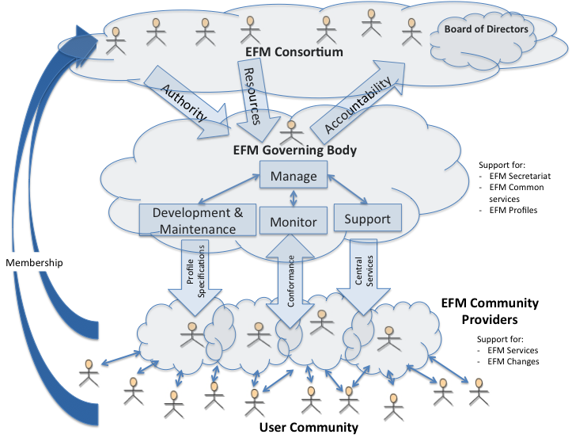
Figure 3-1. EFM Governance Model (based on ISO Framework)

Figure 1 depicts the relationships among the various parties operating with the governance model. Below is an explanation of each group and their role.

The EFM Consortium
The EFM Consortium is the non-profit legal entity that will own the EFM “Brand.” It has the authority to issue license agreements for EFM services that enable organizations to become EFM Community Providers. The composition of the EFM Consortium shall include transportation stakeholders and other interested parties willing to share in the expenses of the organization.
Constitutionally, the EFM Consortium should be an Open Community based on the following policies:
- Membership criteria: Membership criteria should be no more restrictive than necessary to ensure an efficient process.
- Costs of participation: To the extent possible while still spreading costs fairly and accomplishing objectives, dues required to participate in all meaningful activities should be made acceptable to all classes of stakeholders and users.
- Member acceptance: All applicants that meet the established criteria should be automatically admitted in any category to which they choose to apply.
- Governance: The Board or other governing body should not be controlled in the long term by the founders, although founding members will typically hold the initial seats. The board should also represent all classes of stakeholders, regardless of whether each class can afford a top-level membership.
- Technical Participation: All members of eligible classes should be entitled to participate equally in technical and other activities.
- Transparency: At a minimum, all standards should be posted for public comment prior to adoption. Some consortia make all of the minutes and other proceedings of their working groups public from the beginning of a technical process.
- Adoption: All standards should be available for implementation by non-members as well as members on a non-discriminatory basis.
To help get the EFM Consortium launched it is recommended invitations be issued to current EFM stakeholder organizations such as DEMDACO, Freightgate, Kansas City SmartPort, SAIC and Battelle. Other invitees could be the parties involved in e-Freight, a European Commission strategy for paper-free transportation management: World Customs Organization (WCO); IATA, International Air Transport Association (IATA); International Federation of Freight Forwarders Association (FIATA); Regional Freight Forwarders Association, and USDOT. Commercial service providers such as GTNexus and INTTRA may also be interested in joining the Consortium but possibly from a different perspective given these companies process electronic messages for their customers today for a fee.
The EFM Consortium establishes the EFM Governing Body as the accountable entity for ensuring that their interests, as well as those of the participating communities, obtain value from their investment in EFM while managing its risk. The agreed level of authority and boundaries on the scope of the EFM Governing Body would be documented in the form of a charter.

The EFM Governing Body
The EFM Governing Body, with its supporting resources (secretariat), is an elected body responsible for achieving the overall objectives of the EFM while taking into account, in its decisions, the legitimate expectations and interests of the Consortium. It acts to guide the adoption and use of EFM through policy making, strategy formulation, supervision of the EFM Community Providers, and accountability to the EFM Consortium. The Governing Body shall address policy making and strategy topics such as:
- Consortium commitment to the user community;
- Certification agreements for Community Providers, including terms and conditions of registration and accreditation;
- Future requirements or new functionality for EFM,
- EFM adoption,
- EFM development and maintenance, and
- EFM support.
Within the context of its operation, the EFM Governing Body functions include: development, support, and monitoring.

Development
This function includes the development and maintenance of the documents, specifications and implementation guides. Typical categories of changes could include:
- Modifications to existing specifications,
- The addition of new specifications,
- Modifications to existing code lists, and
- The addition of new code lists.
Development and maintenance tasks should be project driven. Specific tasks are nominated through the EFM Consortium with project teams appointed from its members.

Support
Support covers the secretariat functions, publication of documents, specifications and implementation guides for Community Providers. It also includes the provision of statements in respect to the strategies and policies affecting the Data Model, such as upgrades or new services. Services may include Web sites, registries and repositories.

Monitoring
Monitoring is the on-going reporting and assessment of the EFM service performance against expected outcomes as well as reporting of EFM Communities’ conformance with established criteria.
Regarding supervision of the EFM Community Providers, the EFM Governing Body shall address topics such as:
- The implementation package for Communities,
- Performance monitoring,
- Conformance compliance, and
- Ensuring that EFM Community Providers comply with the minimum requirements defined by the Community Provider Agreement.

Secretariat Services
The recommendation is for one member of the Consortium to volunteer to function as the "Secretariat," providing most (or all) administrative and other services, either without charge, or for payments derived from the fees of other members.

EFM Community Providers
EFM Community Providers should be responsible for ensuring that the EFM Consortium achieves required outcomes within the strategies and policies established by the EFM Governing Body.
Example of current EFM Community Providers are: Freightgate, Kansas City SmartPort, DEMDACO and SAIC.
Within the proposed governance model, each accredited EFM Community Provider must implement mechanisms for managing demand and supply of available EFM services supporting freight transportation management operations. This includes:
- Transforming their community’s information exchange requirements into the EFM context,
- Startup testing and validating of new participants entering the Community, and
- Monitoring ongoing operations to ensure performance, quality and security requirements are maintained.
In addition, each accredited EFM Community Provider must implement mechanisms for managing demand and supply of change initiatives to EFM services. Changes could include:
- Modifications to existing EFM services,
- The addition of new EFM services,
- Modifications to existing EFM profile schemas,
- The addition of new EFM profile schemas,
- Modifications to existing EFM Support data (e.g. business process rules, code lists), and
- The addition of new EFM Support data.
Finally, each accredited EFM Community Provider should monitor and assess the performance and conformance of the ongoing operations and report to the EFM Governing Body on an established schedule basis.
EFM Community Providers become accredited by entering into a Community Provider Agreement that commits them to certain levels of service. The EFM Community Provider Agreement is required in order to ensure consistency of the technical standards, specifications and procedures across the entire EFM solution.

Community Provider Agreements
The EFM solution requires that a number of parties work together in a trusted environment based on common specifications and standards. The development and maintenance, as well as the implementation and use, of these common specifications and standards need to be governed across the full infrastructure. In order to clearly regulate the roles and responsibilities of each party in the EFM solution, a set of agreements should be established.
An EFM Community Provider Agreement is entered into between individual EFM Community Providers and the EFM Governing Body for the purpose of defining the terms and conditions under which the Parties shall provide governance for the different levels of the EFM service.
The intent of this agreement, as with the overall governance model, is to ensure that the role and responsibilities of each party are clearly described and openly available thus making EFM an open and transparent community.
The Agreement should be based on:
- Global coordination over all common components of the EFM solution;
- Local coordination and supervision of the implementation and use of the EFM services operating within a community; and
- Open and transparent provision of services based on a common set of agreements as well as common definition of services and service levels.
The main aspects regulated in this Agreement should include:
- Giving the EFM Community Provider the authority to represent EFM within its domain of responsibility;
- That the EFM Community Provider is responsible for ensuring adequate performance by the EFM services established within its domain, including their compliance to the EFM specifications.
- That the EFM Community Provider is guaranteed access to the EFM specifications in a timely manner;
- That the EFM Community Provider is responsible for maintaining the data about its registered EFM users in a timely manner;
- That EFM users are guaranteed open access to the EFM services according to specification in a timely manner.
- That all other EFM Community Providers are guaranteed open access to the Community Providers EFM services in order to deliver business documents to the EFM users according to specifications;
- That the EFM Community Provider guarantees to deliver any business document received from another EFM Community Provider to the stated receiving EFM user in a timely manner;
- That the EFM Community Provider guarantees to deliver any business document received from an EFM user to the stated receiving EFM Community Provider according to EFM specifications in a timely manner.

Open Forum
To promote even wider collaboration, an Open Forum for non-Consortium members can be provided as a communication channel for wider industry review and comment on the activities of the EFM approach. It’s to the EFM Community Users’ advantage to promote wide use of EFM. It gives them a broader community to work with and also it offers them a wider choice of partners to choose among related to contractual agreements among the partners.

Governance of Standards
The proposed governance model for EFM standards is based on the EFM Governance Framework described by the following diagram (Figure 2). This framework depicts the process in which new standards are developed and accepted within the EFM Consortium.

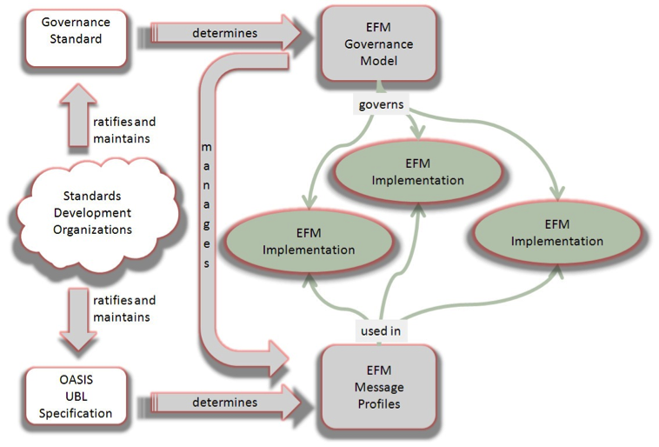
Figure 3-2. The Framework for EFM Governance Standards
The key points to this framework are:
- The EFM Governance Model is itself an implementation of this framework.
- The EFM messages themselves are conformant customizations of the Organization for the Advancement of Structured Information Standards (OASIS) UBL standard documents. These are known as EFM Message Profiles as shown in Figure 2.
- The EFM Governance Model defines and establishes the maintenance processes for the EFM Message Profiles.
- Every implementation of EFM will support the EFM Message Profiles to ensure data coherence and semantic consistency.

Message Standards
During the EFM case study pilots the EFM architecture followed Universal Business Language (UBL) as the basis for its XML messages. UBL is governed by OASIS. EFM employs these message types as services. The services employed by EFM include: receive order, consignment, booking service, confirm booking, load shipment, consignment partners, subscription, receive status, query status, divert shipment, request clearance, and receive clearance.
The subset of information elements for UBL documents used in EFM web services is known as a Message Profile.
While the EFM program has evolved with its particular strategy, it has parallels in associated domains that have formalized the definition of profiles. Based on work done by the European Committee for Standardization (CEN) Workshop on 'Business Interoperability Interfaces on public procurement in Europe' (BII), an EFM Profile may be defined as a specification of how one or more EFM Business Processes are executed by specifying the EFM business rules governing its business collaborations and the information content (Message Profile) of the electronic business transactions exchanged.
In order to support the exchange of EFM business documents in an open and interoperable manner, the Message Profiles within EFM should be described with an aim to function as part of a formal agreement. This would be done in order to lower one of the main barriers to the efficient and effective implementation of EFM that is the need to entering into bilateral agreements with each business partner. By publishing Profile descriptions organizations implementing EFM can claim conformance to the Profile. In doing so the organization is committing to all aspects of the Message Profile and thus limiting the need for further bilateral agreements.
In the context of the EFM, an EFM Message Profile would provide a description of the information content of the electronic business transactions exchanged by pointing to a given data model for each of the business transactions.
Not all pilot implementations have used the same information elements for the UBL documents used in their electronic transactions. Therefore a ‘core’ Profile of the common elements used in every pilot implementation has been prepared. Adherence to these Message Profiles should form part of the EFM Community Agreement.
Alternative to UBL
Although the EFM case studies followed the UBL standards future deployments of the EFM architecture may not necessitate the ongoing use of UBL. The EFM architecture can leverage any type of payload, whether it is an XML document or even EDI, as long as both parties agree to its use. Restricting future use of EFM by requiring the use of UBL may hinder the commercialization and industry use of EFM.

Maintenance and Support Policy
The key component of EFM governance is establishing a registry to host all the participant services and necessary instructions on how to connect with other EFM participants. A service provider to the EFM Consortium would be a logical option to set up the registry.

Maintenance Tools
When developing specifications for EFM, the tools used should not restrict its design or lock-in community providers to also use that tool. This means artifacts produced must be portable across different tools and technologies.
With respect to EFM maintenance, there are specific requirements for any tools used for its maintenance:
- Allow the production of compatible and conformant UBL customizations
- Approved organizations can produce conformant standard UBL adaptations.
- Access to Community Providers to produce national customizations of EFM standards [which are either compatible or conformant].
- Allows developers to generate output in interoperable formats for standard adaptations and national customizations
- Allow other non-member organizations to produce their own customizations.
- Maintain code lists and code list extensions.
- Allows user access to different layers for viewing

Intellectual Property Policy
Any Intellectual Property Rights held related to EFM could be licensed to the Consortium under a reasonably and non-discriminatory license (RAND). The annual fee would be established by negotiations between the Consortium and the IPR holder.
The Consortium members should be allowed to distribute sub-licenses to their community participants at no charge. In effect the license fee per member is covered by part of the cost of membership to the Consortium.
The next major release of EFM would be owned by the EFM Consortium and could be offered to the members under a royalty free license.

Financial Model
For EFM to flourish in the industry the overall process to join and use any of the services available must be easy and relatively inexpensive to use. There will need to be an initial investment from USDOT or a commercial company that is willing to implement a UDDI/Registry and/or repository. The EFM Registry is analogous to the Yellow Pages for those participating in the EFM program. If you want to advertise your available Web Services then your company would need to post your Web Service instructions on the Registry for a fee. To access the Registry or to be a part of the EFM program would also require a fee albeit much smaller. Below is a suggested price list for the different levels of participation.
Participation Type | Annual Fees
Registry Posting of Services Available | $2,500
Participant only | $500
Other interested parties, contributors | $250

Operating Costs
Operating the governance model will incur a variety of expenses, some of which can be provided by Consortium members or others for a fee. Typical cost areas are:
- Web site development and hosting
- Conference call hosting
- Member communications
- Tradeshows
- Publishing press releases
- Marketing collateral
- White papers
- Marketing studies
- Speaking engagements
- Article placements and interviews

Next Steps
Key to getting EFM into operation is a foundation of EFM users that not only see its importance in meeting their immediate business needs but also have a vision as to its importance in the long term business environment. Some of those users can be prompted to further action through a request for discussion of this report, either by USDOT or through promotion by the current users themselves. The items discussed and promoted in this report may provide the impetus to move into the next step to get EFM into greater use. Additionally, a global audience of interested standards development experts in ISO TC204 Intelligent Transport Systems are engaged in establishing a Technical Specification (TS) for electronic freight governance as part of the worldwide ITS standards products. A TS gets recognition in ISO as a reference document that has global support, and may lead to the next step of becoming an international standard for electronic freight governance. With this as a lead-in for next steps the following outline identifies the steps that need to be taken in order to get EFM available for full discussion and provide a method for governance of its adoption.
- Socialize the governance model concept:
  - Within USDOT
  - With candidate stakeholders
    - Discuss Governance principles with current EFM users
    - The USDOT and European Commission are currently working to establish a joint pilot for transport between Europe and the USA to verify that the common approach to interoperability really works. This could bring EFM and its European counterpart together as an integrated tool or suite of tools.
    - This project can include a test-bed for piloting the governance model.
  - With trade facilitation bodies
- An ISO Technical Specification (TS) is being developed to further socialize the governance concept for EFM and e-Freight that can be used in a test-bed. The TS is expected to be adopted before the end of 2012.
- Obtain Guidance from EFM users/stakeholders on following items:
- Formation of Consortium
  - Develop initial constitution
  - Invite current EFM participants
  - Register Consortium
  - Appoint Secretariat
    - Expected to be a volunteer position
  - Elect Governing Board
  - Establish liaisons with associated initiatives
- Transference
  - Intellectual Property Rights
  - Brand
- Hold inaugural Plenary meeting-Begin the Process!
  - Outreach to new participants

Referenced Documents
This section contains a listing of documents referenced during the development of this document.
- Reference: ISO/IEC PDTR1 38502 – Governance of IT – Framework and Model
- Reference: An Academic Research Paper exploring the value of creating a Business Model for EFM; University of Maryland
- Reference: Varadan, R., Channabasavaiah, K., Simpson, S., Holley, K., & Allam, A. (2008). Increasing business flexibility and SOA adoption through effective SOA governance. IBM Systems Journal, 47(3), 473-488.

Definition of Terms
Electronic Freight Management (EFM) – A USDOT research and development program that promotes and evaluates innovative e-business concepts, enabling process coordination and information sharing for supply chain freight partners through public-private collaboration.
Web Service – A computer application that follows the Basic Profile specified by the WS-I group, serving data typically formatted as a Simple Object
EFM Governance – the system through which the national and international freight communities’ demand for and supply of electronic business services to support freight operations (branded as EFM) is directed and controlled.
Consignor – the sender of a consignment to be delivered whether by land, sea or air.
Consignee – the receiver of the consignment.

Appendix A - Acronym List
CEFM Columbus Electronic Freight Management
EC European Commission
EDI Electronic Data Interchange
EFM Electronic Freight Management
ESI Express Systems International
ETA Estimated Time of Arrival
FHWA Federal Highway Administration
FIATA International Federation of Freight Forwarders Association
FOS Friend of Shipment
IATA International Air Transport Association
IXT International Express Trucking
RAND Reasonably and Non-Discriminatory
SC Supply Chain
SCV Supply Chain Visibility
SOA Service-Oriented Architecture
TDE Trade Data Exchange
UDDI Universal Description, Discovery and Integration
UBL Universal Business Language
USDOT United States Department of Transportation
VAN Value Added Network
WCO World Customs Organization
XML Extensible Markup Language

Appendix B - Alternative Governance Models
- Centralized
A single organization manages all EFM implementations and provides a single common registry.
- Distributed
Independent organizations manage independent EFM implementations and supply service details
- Federated
Various organizations manage independent EFM implementations and supply service details to a single common registry.
- Public
A government agency manages the common EFM services. (USDOT, EC)
- Private
A commercial organization that manages the common EFM services. (GTNexus, INTTRA, IATA, GS1)
- Collaboration
A community not-for-profit entity manages the common EFM services.

Table B-1. Governance Model Evaluation Matrix
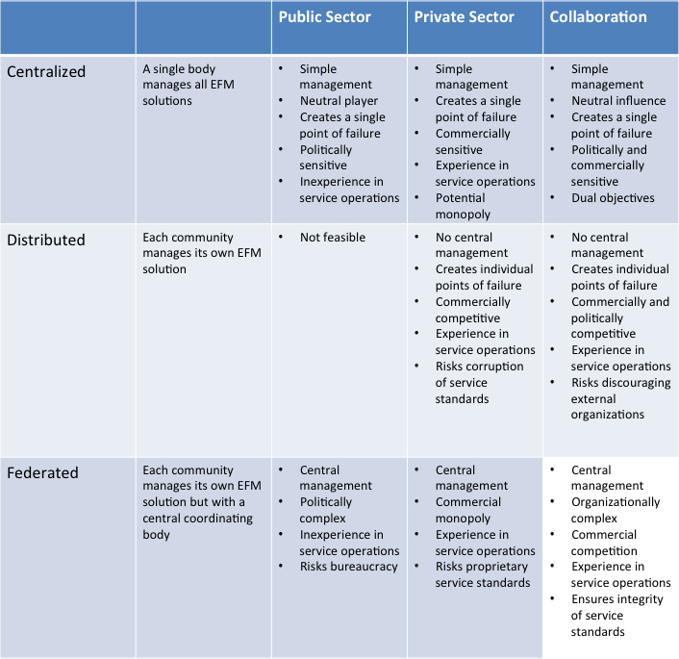

U.S. Department of Transportation
ITS Joint Program Office-HOIT
1200 New Jersey Avenue, SE
Washington, DC 20590
Toll-Free “Help Line” 866-367-7487
www.its.dot.gov
FHWA-JPO-12-070

ISO/IEC PDTR1 38502 – Governance of IT – Framework and Model
An EFM service is a Web service created specifically to address business processes related to electronic freight management. Examples include: receive order, confirm booking, and obtain status.
CWA BII00 – Profile Architecture, Ver 1.4, dated 2009-06-26

