Rural Transportation Emergency Preparedness Plans

Heather Nachtmann, Ph.D.
Edward A. Pohl, Ph.D.

MBTC 2091
July 2009

DISCLAIMER
The contents of this report reflect the views of the authors, who are responsible for the facts and the accuracy of the information presented herein. This document is disseminated under the sponsorship of the Department of Transportation, University Transportation Centers Program, in the interest of information exchange. The U.S. Government assumes no liability for the contents or use thereof.

Table of Contents
1 Introduction 4
2 Background 5
2.1 Rural Transportation 5
2.1.1 Rural Transportation Systems 5
2.1.2 Rural Vulnerability 7
2.2 Emergency Planning 10
2.2.1 Emergency Planning: General 10
2.2.2 Emergency Planning: Transportation 13
2.2.3 Emergency Planning: Rural Areas 16
2.3 Guide for All Hazard Emergency Operation Planning 17
3 Emergency Operations Plans Comparison 21
4 Transportation Readiness Assessment and Valuation for Emergency Logistics 23
4.1 Development of TRAVEL Tool 24
4.2 Description of TRAVEL Tool 27
4.3 Demonstration of TRAVEL Tool 32
4.4 Results of TRAVEL Tool 37
5 Summary 38
References 39
Appendix 42

List of Exhibits
Exhibit 1. Social Vulnerability Factors (Cutter et al., 2003) 7
Exhibit 2. Rural-Urban Continuum Codes (USDA ERS, 2003) 8
Exhibit 3. Rural-Urban Classifications 9
Exhibit 4. Hypothesis Testing Results 9
Exhibit 5: Emergency Operations Plan Components (DHS, 1996) 20
Exhibit 6: Elements of the Basic Plan (DHS, 1996) 20
Exhibit 7: Description of the Functional Annexes (DHS, 1996) 21
Exhibit 8: Annexes of Select County EOPs 22
Exhibit 9: TRAVEL Development Process 24
Exhibit 10: TRAVEL Assessment Hierarchy 28
Exhibit 11: Evacuation Hierarchy 29
Exhibit 12: Mass Care Hierarchy 29
Exhibit 13: Health and Medical Hierarchy 30
Exhibit 14: Resource Management Hierarchy 30
Exhibit 15: Evacuation Route Analysis Measure (M-E-1) 32
Exhibit 16: Opening Page for the TRAVEL Tool 33
Exhibit 17: Data Entry Sheet 35
Exhibit 18: Results Bar Graph 38
Exhibit 19: Evacuation Route Analysis Measure (M-E-1) 42
Exhibit 20: Evacuation Mobility Assets Measure (M-E-2) 42
Exhibit 21: Evacuation Transportation Personnel Measure (M-E-3) 43
Exhibit 22: Mass Care Facility Readiness Measure (M-MC-1) 43
Exhibit 23: Mass Care Sustainability Measure (M-MC-2) 44
Exhibit 24: Health and Disease Control Measure (M-HM-1) 44
Exhibit 25: Medical Services Support Measure (M-HM-2) 45
Exhibit 26: Resource Supply Chain Measure (M-RM-1) 45

Abstract
Improving the emergency preparedness of rural transportation systems is the overall goal of this research. Unique characteristics exist in rural transportation systems including widely dispersed and diverse populations and geographic areas. Exploring rural transportation emergency preparedness is important because these networks are essential for transporting freight and linking rural residents with distant services. This research investigates the disaster relief and recovery needs of rural communities and provides an assessment tool for evaluating transportation-related emergency preparedness for these communities. The Federal Emergency Management Agency’s Guide for All Hazard Emergency Operation Planning is a vital source used by state and local officials to develop emergency operations plans. This guide is used as the basis for developing the Transportation Readiness Assessment and Valuation for Emergency Logistics (TRAVEL) tool. TRAVEL is a value-based assessment tool for evaluating transportation readiness in emergency operations planning. A demonstration of TRAVEL based on three rural county-level emergency operations plans is provided to demonstrate the use of TRAVEL in a real world scenario.

1 Introduction
Multiple agencies including the U.S. Department of Homeland Security (DHS) and U.S. Department of Transportation (DOT) have conducted comprehensive vulnerability assessments of transportation networks in high-density urban areas. These risk-based assessments support robust security and emergency preparedness plans for these high-density urban systems. A previous study sponsored by the Mack-Blackwell Rural Transportation Center (Nachtmann, et. al., 2007) investigates how these urban-based vulnerability assessments can be adapted and applied to rural transportation systems where the resources are limited, and the population and industry are widely disbursed. We have extended this prior research to explore how rural communities should prepare for the transportation support they will need in emergency situations. The Transportation Readiness Assessment and Valuation for Emergency Logistics (TRAVEL) tool is designed to assist emergency planners in assessing the quality of their emergency operations plans (EOPs) with respect to transportation readiness. The TRAVEL tool is based on a Value Focused Thinking framework (Keeney, 1992) within an all-hazards approach to emergency operations planning.
Many EOPs are based on the assumption that all standard means of transportation will be available and feasible when an emergency occurs. However, in many cases, the disaster that initiates the EOP may disable emergency vehicles or destroy the roads and bridges that are vital to emergency response. As transportation security professionals prepare contingency plans for emergency response, it is important to recognize the important role that transportation plays in their emergency operations. A literature review of general and rural emergency operations planning is provided. The usage of and dependence on transportation during emergency response of catastrophic events is assessed and reported. In addition, the development process of the TRAVEL Tool is described, and a demonstration of the TRAVEL Tool on three rural county-level EOPs is provided to exemplify the use of TRAVEL.

2 Background

2.1 Rural Transportation

2.1.1 Rural Transportation Systems
For Census 2000, the Census Bureau (2009) classifies urbanized areas (UA) and urban clusters (UC) as “core census block groups or blocks that have a population density of at least 1,000 people per square mile and surrounding census blocks that have an overall density of at least 500 people per square mile” respectively. Rural is defined as all areas outside of UAs and UCs. Key differences exist between urban and rural transportation systems including access to the conventional transportation modes of air, rail, road, and water as well as the characteristics of demographics, geography, public transportation systems, and emergency response systems. Rural areas generally have significantly fewer resources, such as personnel and funding, to devote to transportation planning. The authors provide a more detailed comparison of rural and urban transportation systems in Nachtmann, et. al. (2007).
Rural transportation systems exhibit common characteristics throughout the U.S. Generally, these characteristics are a result of low population densities and large distances between population centers. In the 2000 census, 21% of U.S. residents and 73% of counties nationwide are classified as rural (University of Arkansas Division of Agriculture, 2007). Rural poverty rates are 2.8% higher when compared to those in urban areas (Brown, 2008). Rural areas also have higher proportions of disabled and elderly persons (Burkhardt, et al., 1998). Thirty-two percent of rural residents are considered transit dependent (Rucker, 1994). The geography of rural areas also factors into the workings of rural transportation systems. A large proportion of the nation’s land mass (83%) is considered to be rural (Burkhardt, et al., 1998). Rough terrain, such as steep grades and mountain passes, require a much different transportation system than those in urban areas. Rural areas also experience more dramatic weather events which, in turn, significantly affect road conditions (Dye Management Group, Inc., 2001).
Rural communities are served by multiple modes of transportation. Rural airport service is quite different from urban airport service as there are far fewer rural airports per land area than in urban areas (Stamm, 2002). Greater distances are traveled by users to access these rural airports. In order to be considered a rural airport, airports must handle fewer than 100,000 departures per year and be located more than 75 miles from airports handling more than 100,000 departures annually (Bureau of Transportation Statistics, 2009). Rural roads boast vast coverage in the U.S. There are 3.1 million miles of rural roads nationwide. These roads comprise 80% of national road miles and 40% of vehicle miles traveled (Dye Management Group, Inc., 2001). Rural roads tend to be narrow with 90% being two-lane or less (Hill, 1999). While the dominant mode of public transportation for rural residents is the bus (U.S. Department of Agriculture Economic Research Service (USDA ERS), 2005), nearly 80% of rural counties have no public bus service (Rural Welfare Policy Panel, 1999). When bus service is available, routes are generally longer with fewer arrivals per location. Rural roads carry high volumes of freight. The vast majority of manufactured goods that are transported across state lines travel by road. Additionally, 28% of the nation’s intercity freight travels by road (Dye Management Group, Inc., 2001). Rail transportation has become almost completely dedicated to the movement of freight. Railroads move more than 40% of the nation’s freight (Association of American Railroads, 2008). Rural residents have limited access to rail transit with almost six in ten residents living outside the service of passenger rail transportation (USDA ERS, 2005). Also, fewer than 200 nonmetro areas nationwide are served by rail (USDA ERS, 2005). Rural water transportation is not easily distinguished from urban water transportation. Available in forty one states, the nation’s waterway system consists of 26,000 miles of navigable inland waterways, 275 locks, and over 9,100 commercial facilities (Dye Management Group, Inc., 2001; USDA ERS, 2005). Water transportation moves approximately 14% of the nation’s intercity freight (Dye Management Group, Inc., 2001).

2.1.2 Rural Vulnerability
The Social Vulnerability Index (SoVI) (Cutter, et al., 2003) is a relative measure of the overall social vulnerability to environmental hazards of a given county within the U.S. The index was constructed using socioeconomic and demographic data collected from the 2000 Census. Cutter, at al. (2003) used this data to identify social vulnerability factors and associated metrics that influence social vulnerability. These factors are summarized in Exhibit 1. The actual index is found by summing each factor to obtain a composite value ranging from -10 to +50. The less vulnerable a county, the more negative the index becomes, and likewise the more vulnerable, the more positive. A complete listing of all counties and their respective SoVIs is available at the University of South Carolina’s Hazards and Vulnerability Research Institute website (http://webra.cas.sc.edu/hvri/products/sovi.aspx).
Exhibit 1. Social Vulnerability Factors (Cutter et al., 2003)
Factor | Description
Personal wealth | Wealth enables counties to absorb and recover from losses
Age | Children and elderly are most affected by disaster
Density of the Built Environment | Significant structural losses might be expected from a hazard event
Single-sector Economic Dependence | Singular reliance on one economic sector creates economic vulnerability
Housing Stock and Tenancy | Quality and ownership of housing impacts displacement from damage
Race and Ethnicity | Racial and ethnic disparities affect access to resources and cultural difference
Occupation | Counties heavily dependent on lower wages service occupation might face slower recovery
Infrastructure | Infrastructure affects ability to divert resources in time of need
In this research, the SoVI is used to determine if rural counties in Arkansas are more socially vulnerable than urban counties in the state. To begin, all counties in Arkansas are classified as rural or urban based on their Rural-Urban Continuum Code (as given in Exhibit 2) which divides counties into nine categories based on population density and urbanization (USDA ERS, 2003). These categories allow for distinctions between rural and urban counties to be drawn. The codes are classified in a ranking system from one to nine, with one being the most metro and nine being completely rural. Five data sets are created using various groupings of the continuum codes of the counties in Arkansas as shown in Exhibit 3. Four separate tests of hypothesis using two sample t-tests are performed to compare the urban data set to each of the other four rural classification data sets at a confidence level of α = 0.15. Each test investigates the significant difference between the average SoVI of counties classified as urban and those classified as rural ().
Exhibit 2. Rural-Urban Continuum Codes (USDA ERS, 2003)
Code | Description
Metro counties:
1 | Counties in metro areas of 1 million population or more
2 | Counties in metro areas of 250,000 to 1 million population
3 | Counties in metro areas of fewer than 250,000 population
Nonmetro countries:
4 | Urban population of 20,000 or more, adjacent to a metro area
5 | Urban population of 20,000 or more, not adjacent to a metro area
6 | Urban population of 2,500 to 19,999, adjacent to a metro area
7 | Urban population of 2,500 to 19,999, not adjacent to a metro area
8 | Completely rural or less than 2,500 urban population, adjacent to a metro area
9 | Completely rural or less than 2,500 urban population, non adjacent to a metro area

Exhibit 4 presents the results of five hypothesis tests. Using a confidence level of α = 0.15, the mean of the Urban data set is found to be significantly lower than the means of the Rural, Rural - Non-Adjacent to Metro, and Completely Rural data sets. This indicates that rural counties in Arkansas are more socially vulnerable than urban counties. A significant difference was not found between the means of the Urban data set and Rural-Adjacent to Metro data set indicating that proximity to an urban county reduces the social vulnerability of a rural community. Understanding social vulnerability differences between rural and urban communities can assist in emergency preparedness planning by providing valuable information regarding the communities’ social vulnerability indicators such as social dependence and infrastructure holdings.
Exhibit 3. Rural-Urban Classifications
Rural-Urban Classifications | Description | Continuum Codes
Urban | Central counties containing one or more urbanized areas, or counties lying on the outskirts of a metropolitan area whose residents are economically coupled with those central counties within the metropolitan area (an urbanized area consists of a central city and surrounding territory having a population exceeding 50,000 people, or a population density greater than 1000 people per square mile) | 1, 2, 3
Rural | All counties not meeting the above urban classification description | 4, 5, 6, 7, 8, 9
Rural - Adjacent to Metro | Non-metropolitan counties that are physically adjacent to one or more metropolitan areas | 4, 6, 8
Rural - Non-Adjacent to Metro | Non-metropolitan counties that are not physically adjacent to one or more metropolitan areas | 5, 7, 9
Completely Rural | Counties containing a population of fewer than 2,500 people | 8, 9

Exhibit 4. Hypothesis Testing Results
Data Set | Urban Mean | Rural Mean | Urban Sample Size | Rural Sample Size | P-value | Significant?  α = 0.15
Urban vs. Rural | 0.1061 | 1.4998 | 20 | 55 | 0.0540 | Yes
Urban vs. Rural – Adjacent to Metro | 0.1061 | 1.2578 | 20 | 26 | 0.1700 | No
Urban vs. Rural - Non-Adjacent to Metro | 0.1061 | 1.7167 | 20 | 29 | 0.0410 | Yes
Urban vs. Completely Rural | 0.1061 | 1.5746 | 20 | 13 | 0.1040 | Yes

2.2 Emergency Planning

2.2.1 Emergency Planning: General
The U.S. places a strong emphasis on emergency preparedness. Preparedness “addresses the full range of capabilities to prevent, protect against, and respond to acts of terror or other disasters” (U.S. Government Accountability Office (GAO), 2006a). The Robert T. Stafford Disaster Relief and Emergency Assistance Act, signed into law November 23, 1988, states that federal, state, and local governments share a joint responsibility for emergency preparedness. The Act further states that the federal government should provide “necessary direction, coordination, and guidance” to ensure that an all-hazards emergency preparedness system is in place (DHS, 2007). In response, the Federal Emergency Management Agency (FEMA) developed a comprehensive, risk-based, all-hazard approach to emergency planning entitled the Guide for All-Hazard Emergency Operations Planning (All-Hazards Guide) (DHS, 1996). Its purpose is to provide aid to state and local governments in developing a custom all-hazard EOP for their respective areas of jurisdiction. The advantage of an all-hazards approach to emergency preparedness is that this approach ensures “that the nation is better prepared for terrorist events while simultaneously better preparing itself to deal with natural disasters” (GAO, 2005). The All-Hazards Guide details the components necessary for a good EOP and identifies key personnel and resources that may be needed. The recommendations provided by the guide are centered around the basic goal of emergency preparedness, which “is that first responders should be able to respond swiftly with well-planned, well-coordinated, and effective actions that save lives and property, mitigate the effects of the disaster, and set the stage for a quick, effective recovery” (GAO, 2006c).
The July 19, 1989 crash of United Airlines Flight 232 provides an excellent example of how an effective and practiced emergency response plan can save lives. The established Sioux City emergency plan was rehearsed annually with various disaster scenarios, enabling rescuers to “discern the weaknesses in their coordination efforts” and establishing trust among the different branches (Larson et al., 2006). During the actual emergency, rescuers “were so familiar with the plan that they never needed to refer to it.” In January 2009, emergency workers were able to pre-position their boats and ambulances downstream according to current data provided by underwater sensors belonging to the New York Harbor Observing and Prediction System and analysis provided by ocean engineers at the Center for Maritime Systems at Stevens Institute of Technology. As a result of these previously established relationships, all 155 passengers were rescued safely (Verrico, 2009).
Since the terrorist attacks of September 11, 2001 and the devastating Hurricane Katrina of 2005, emergency planning and response have become even higher priorities for the federal government. Catastrophic Disasters (GAO, 2006a) discusses the federal government’s response to Hurricane Katrina and identifies areas of improvement in the nation’s “readiness to respond to a catastrophic disaster.” Emphasizing the importance of emergency planning, the document states that “catastrophic disasters involve extraordinary levels of mass casualties, damage, or disruption that will immediately overwhelm state and local responders, circumstances that make sound planning…all the more crucial.” To improve the nation’s preparedness for and response to disasters, plans should “detail what needs to be done, by whom, how, and how well” (GAO, 2006). This point is reiterated in another GAO report which states that one desirable characteristic of a strategic plan is identification of “organizational roles, responsibilities, and coordination” (GAO, 2006b).
Given the characteristics of an acceptable EOP, one group performed a public health study of emergency preparedness among five nations in Oceania. These researchers collected emergency preparedness data, including data from emergency function categories such as communications, transportation, healthcare facility evacuation, and search and rescue (Keim and Rhyne, 2001). Each nation’s EOP was checked for the presence of essential emergency functions and essential planning elements, as identified by FEMA’s All-Hazards Guide (DHS, 1996). These essential elements include a basic plan, functional annexes, hazard-specific annexes, standard operating procedures, plan concepts, and training and exercises. Although the research was only focused on the public health and medical sectors of the five nations, emergency preparedness in general was found to be quite low. The authors mention, however, that planning is not the only factor that affects preparedness; “cultural, economic, social, educational, experiential, legislative, and architectural/structural influences” may also impact preparedness (Keim and Rhyne, 2001). This statement further supports the link between emergency preparedness and social vulnerability.
A similar preparedness study was performed in the U.S.. Mann, et al. (2004) aim to “characterize state-level readiness…and correlate readiness with existing programs providing an organized response to medical emergencies” (Mann, et al., 2004). The assessment involved a survey that evaluated the five components of disaster readiness including disaster planning, coordination, training, resource capacity, and preparedness for biological/chemical terrorism. The results of the study suggest that while “disaster plans are prevalent among states, key programs and policies were noticeably absent.” Many states had failed to perform any kind of emergency drills or tests to evaluate their EOP. Only nineteen states had “plans that addressed issues related to the contamination of livestock, crops, or animal feed,” concerns that could face rural communities across the nation. Given the complexity of any effective EOP and the wide range of unique communities that are present in any state, it is easy to see why deficiencies exist within the state’s plan. While it may be necessary for each community to adapt plans to its own circumstances; if information sharing occurs across communities, “time could be saved and needless duplication of effort avoided” (GAO, 2005).
Effective emergency planning is not an easy task. There are many challenges involved in planning for the preparedness, response, and recovery process. Because absolute security is unattainable, “defining an acceptable, achievable (within budget constraints) level of risk” is a necessary but difficult task (GAO, 2006c). To help assess the risks faced by communities across the country, “FEMA developed HAZUS, a nationally standardized, GIS-based, risk assessment and loss estimation tool to be used in planning and preparing for, responding to, and recovering from hazard events” (Srinivasan, 2003). According to Srinivasan (2003), the tool considers all impacts that a disaster might have on a community, including physical damage, economic loss, and social impacts. Cutter, et al. (2003) focus specifically on the social impacts of disasters, arguing that some communities are more socially vulnerable than others. Social vulnerability is represented as the social, economic, demographic, and housing characteristics that influence a community’s “ability to respond to, cope with, recover from, and adapt to hazards” (Cutter, et al., 2003). Each factor affects the vulnerability of each community differently. Because every community is unique, differences in these factors result in a different social vulnerability index (SoVI) for each community, which further complicates the emergency planning process.
Additional challenges arise when adapting an all-hazards approach to emergency planning. These include proper identification of potential emergencies and the requirements for appropriate response, assessing current capabilities against those requirements, and developing effective and coordinated plans among first responders (GAO, 2005). In its response to the GAO report Catastrophic Disasters (2006a), DHS comments on the difficulties faced in emergency planning. “Since resources are finite…tough choices must be made about how to allocate the human and financial resources available to attain the optimal state of preparedness.” As indicated by the varying SoVIs of U.S. communities, the diversity of areas across the U.S. complicates large-scale emergency planning. “Because different states and areas face different risks, not every state or area should be expected to have the same capability to prepare for a catastrophic disaster” (GAO, 2006a). This issue becomes apparent when comparing the EOP of an urban area with that of a rural area.

2.2.2 Emergency Planning: Transportation
Transportation plays a key role in emergency planning. The movement of supplies and people is a vital component of any emergency response effort, as seen in FEMA’s All-Hazards Guide (DHS, 1996). A key component of an EOP’s Basic Plan is Administration and Logistics, a section that provides policies for managing the flow of resources such as materials and people. The All-Hazards Guide also lists Evacuation as one of the functional annexes that must exist in an effective EOP (DHS, 1996). Effectively moving large groups of people during an emergency situation involves careful transportation planning. Search and Rescue is another transportation-related section part of an EOP. The All-Hazards Guide states that search and rescue teams are responsible for assisting trapped or injured persons, providing first aid, and “assisting in transporting the seriously injured to medical facilities.” Emphasizing the significance of transportation is identified as an important focus of the country’s critical infrastructure protection effort (GAO, 2005).
Ambulance availability, ambulance coordination, and patient transportation are other examples of the importance of transportation to emergency operations, and each element should be considered when creating an EOP. Proper planning in this area can save lives. This is discussed by Larson, et al. (2006) who analyze responses to several major emergencies in recent history. In the aftermath of the 1989 crash of United Airlines Flight 232 at the Sioux City airport in Iowa, excellent planning by police and emergency medical personnel expedited the transfer of victims injured during the crash. Mutual aid agreements between Sioux City and its neighboring communities allowed all available emergency vehicles in the surrounding area to be ready and waiting at the airport to transport injured passengers (Larson, et al., 2006). In addition, police set up road blocks on the highway between the airport and the hospital, allowing the ambulances to travel much faster. “The first victims arrived at the hospital less than 16 minutes after the plane crashed while the last victim arrived within 40 minutes of the crash” (Larson, et al., 2006). Proper transportation planning allowed authorities to respond quickly and efficiently, thus mitigating the effects of this deadly disaster.
While the importance of transportation is apparent in much of the emergency planning literature, very little documentation exists on emergency planning with an explicit focus on transportation. This may be due to the complexity of emergency preparedness of related transportation systems and the high variability of the systems themselves.
There are many transportation related challenges involved in emergency planning and security. Allowing a legitimate and timely flow of people and goods through the nation’s transportation systems while maintaining an adequate level of security is not a simple task (GAO, 2005). This challenge is common among multiple modes of transportation including aviation, rail, and mass transit. While airports are located in controlled and isolated environments, the very nature of rail and mass transit systems requires that the systems are open (i.e. have multiple access points and even no barriers in some cases) in order to quickly move large groups of people (GAO, 2005). This makes rail and mass transit systems vulnerable to attack, further complicating emergency preparedness efforts. The freight rail system in the U.S. is extremely large, with over 100,000 miles of rail moving millions of tons of freight across the U.S. daily (GAO, 2005). The freight itself may also complicate security issues. “In 2001, over 83 million tons of hazardous materials were shipped by rail in the U.S. across the rail network, which extends through every major city as well as thousands of small communities” (GAO, 2005). Clearly, rail systems are a challenging consideration in emergency planning for both urban and rural communities.
The nation’s intricate highway system provides additional challenges to emergency preparedness. According to the Federal Highway Administration (2009), the National Highway System “is approximately 160,000 miles of roadway important to the nation's economy, defense, and mobility.” Like freight rail systems, the National Highway System is open, making it both easily accessible and vulnerable to attack. Its massive size alone means that, at any given time, at least one part of the system is likely to be facing the threat of disaster in the form of major traffic accidents, floods, or tornadoes. If one section of a major thoroughfare is disabled, rerouting traffic is not always practical or feasible. If disaster strikes a highway near an urban area, resources are likely to be close and readily available. In a rural setting, adequate resources are likely to be far away and potentially unavailable. These types of transportation-focused scenarios must be considered when creating an EOP that is tailored to a specific area.
The complexity and vast size of the nation’s transportation systems indeed complicate emergency planning and security concerns. However, transportation is a vital part of the emergency planning process and cannot be ignored. During an emergency, problems with transportation assets and infrastructure can have a trickle effect by complicating other emergency response efforts that can only function when transportation assets and infrastructure are available and functioning properly. As the foundation for many other emergency operations functions, transportation systems must be considered carefully and not be taken for granted.

2.2.3 Emergency Planning: Rural Areas
There are limited sources focused on emergency planning for rural areas. This may be due to the relatively low population levels of rural areas as compared to urban areas. The existing emergency planning literature focuses primarily on high population areas where disasters are likely to immediately affect large amounts of people. However, nonmetropolitan areas in the U.S. account for 2,052 counties, contain 75% of the Nation's land, and include 17% of the U.S. population (USDA ERS, 2003). Because these areas represent such a large geographical portion of the nation and are home to nearly 50 million U.S. citizens, emergency planning has an obvious and important role in rural communities. In addition, rural areas must be able to adequately handle a “migration of large populations displaced from urban areas” after a disaster (Furbee, et al., 2006). While emergency planning is important in both urban and rural settings, the planning process is different for these areas.
A portion of the literature focuses on the disaster preparedness of rural emergency medical services. A survey of rural emergency medical services (EMS) organizations across the country reveals that many of them would be quickly overloaded by any large scale disaster (Furbee, et al., 2006). Most organizations surveyed placed a low priority on interacting with other disaster response organizations instead placing priority on “basic staff training and retention.” With their limited resources, most rural EMS organizations prefer to focus on maintaining day-to-day operations rather than sink funds into planning for an event that may never occur. According to Furbee, et al. (2006), “there is no single standard that requires EMS organizations to have a disaster plan,” but even if a plan exists, there is no guarantee that it is adequate or even acceptable. The reality is that most rural EMS organizations are not prepared for large scale disasters. Suggestions have been made on how to improve readiness, but funding and other resources do not exist to implement the necessary changes.
Rural EMS organizations are further challenged by “increased reliance on volunteers, fewer healthcare professionals,…less surge capacity, and greater distance from other needed resources” (Furbee, et al., 2006). Given these handicaps and limited resources, the paper suggests that rural EMS agencies should take an all-hazards approach to emergency planning, improve communications among emergency service agencies, and increase involvement in regional planning in order to understand their roles during a large scale emergency. The GAO (2005) originally identified an all-hazards approach to emergency planning and called for “state and local governments to sign mutual aid agreements to facilitate cooperation with their neighbors in time of emergency.” The importance of these agreements was emphasized because, although incident response “would occur at a local level, it could spread across local, state, and even national boundaries.”
Challenges exist in rural emergency planning because rural areas differ greatly from urban areas where the majority of resources exist. For rural areas, population densities are lower, mass transit is virtually non-existent, and resources are often more scarce. Even among rural communities, major differences exist. Some rural areas lie in a flood plain, while others lie on a fault line, and some lie near both. Some rural areas are manufacturing communities, while others are agriculture-based. Agriculture products such as crops, livestock, and food products could be at risk for bioterrorism attacks and should also be considered during emergency planning (GAO, 2005). The report also identifies the accidental or deliberate spread of animal disease as a potentially devastating threat to the agricultural economy, an issue that is likely unique to rural environments. The dissimilarities between rural and urban environments suggest that emergency plans for rural areas necessarily differ from emergency plans for urban areas.

2.3 Guide for All Hazard Emergency Operation Planning
As stated in Section 2, the DHS FEMA (1996) developed a comprehensive, risk-based, all-hazard approach to emergency planning. The All-Hazards Guide is designed to help state and local governments develop a custom all-hazard EOP. The guide describes an EOP as a document that assigns responsibilities to organizations and individuals during an emergency that exceeds the capabilities or normal responsibility of any single agency (such as the local police department). Each assigned responsibility includes performing certain actions at projected times and places. According to the All-Hazards Guide, an EOP describes how people and property will be protected during an emergency, and it identifies resources (people, equipment, facilities, supplies, etc.) that are available for response and recovery operations. In addition to emergency response, training and exercises depend on an EOP. Training helps emergency response personnel to become familiar with their responsibilities and to acquire the skills necessary to perform assigned tasks. Exercising provides a means to validate plans, checklists, and response procedures and to evaluate the skills of response personnel.
When disaster strikes, citizens expect the government to respond immediately. The elected officials at both state and local levels are legally responsible for ensuring that necessary and appropriate actions are taken to protect people and property from the consequences of emergencies and disasters. A local EOP focuses on measures that are essential for protecting the public, including warning, emergency public information, evacuation, and shelter. A state EOP is the framework within which local EOPs are created and through which the federal government becomes involved. The EOP ensures that all levels of responders are able to mobilize as a unified emergency organization to protect the public.
There are five key phases in the development of an EOP: Team Formation, Research, Development, Validation, and Maintenance. A brief description of each phase is discussed next.
Phase One: Team Formation The development of a knowledgeable, diverse and motivated team is essential to the development of a good EOP. The team can be made up of a wide range of emergency response agencies. A subset of the potential team members listed in the All-Hazards Guide includes:
- Law enforcement, fire/rescue, and emergency medical services
- Hazard mitigation planner/coordinator
- Public works agencies and utility companies
- Social service agencies and volunteer organizations
- Area hospitals, emergency medical service agencies, coroner, and other appropriate members of the medical community
- Educational administrators
- Public Information Officer
- Local media
- Industrial and military installations in the area
- State aviation authority
- Port authorities and U.S. Coast Guard
- Organizations in the animal care and control community.
Phase Two: Research The Research phase consists of reviewing the jurisdiction's planning framework, analyzing the hazards faced by the jurisdiction, determining the resource base, and noting characteristics of the jurisdiction that could affect emergency operations.
Phase Three: Development The Development phase includes creating a rough draft of the basic plan, scheduling planning meetings, establishing committees for completing areas of the plan, producing a final draft, obtaining concurrence from agencies regarding specific responsibilities within the EOP, and disseminating of the plan.
Phase Four: Validation The Validation phase should allow relevant agencies to review the plan and offer suggestions for improvement, perhaps through a “table top” exercise. The EOP should be checked for its conformity to regulatory requirements, existing standards, and its practicality.
Phase Five: Maintenance The EOP should be systematically reviewed and revised by the planning team on an annual basis. Because conditions, environments, and regulations can change frequently, the EOP must be adaptable in order to remain useful and current.
According to the All-Hazards Guide, an EOP should consist of a Basic Plan, Functional Annexes, Hazard-Specific Appendices, and Standard Operating Procedures (SOPs) and Checklists as described in Exhibit 5. As described in Exhibit 5, the Basic Plan provides an overview of each jurisdiction and their role in the EOP. Exhibit 6 further describes each element contained in the Basic Plan.

Exhibit 5: Emergency Operations Plan Components (DHS, 1996)
Plan Component | Component Description
Basic Plan | - Provides overview of the jurisdiction's emergency response organization and policies  - Describes legal authority for emergency operations  - Summarizes situations addressed by the EOP  - Explains the general concept of operations  - Assigns responsibilities for emergency planning and operations
Functional  Annexes | - Focuses on one of the critical emergency functions that the jurisdiction will perform in response to an emergency  - Primary audience consists of those who perform the tasks
Hazard-Specific Appendices | - Provides additional detailed information applicable to a particular hazard
SOPs and Checklists | - Provides detailed instructions that an organization or an individual needs to fulfill responsibilities and perform tasks assigned in the EOP

Exhibit 6: Elements of the Basic Plan (DHS, 1996)
Basic Plan Element | Element Description
Purpose | Contains general statement of what the EOP is meant to do
Situation & Assumptions | Outlines what hazards the EOP addresses, what characteristics of the jurisdiction may affect response activities, and assumptions made while preparing the EOP
Concept of Operations | Explains the jurisdiction's overall approach to an emergency situation including division of jurisdictional responsibilities; activation of the EOP; general sequence of actions before, during, and after the emergency situation; and who requests aid and under what conditions
Organization & Assignment of Responsibilities | Establishes the emergency organization that will be relied upon to respond to an emergency situation
Administration & Logistics | Covers general support requirements and the availability of services and support for all types of emergencies
Plan Development & Maintenance | Describes the overall approach to planning including the assignment of planning responsibilities
Authorities & References | Indicate the legal basis for emergency operations and activities

The Functional Annexes focus on one of the critical emergency functions that a jurisdiction will perform in response to an emergency. A description of each Functional Annex is provided in Exhibit 7Exhibit 7. In addition to its purpose, each annex should contain the same elements as the Basic Plan (see Exhibit 6).
Exhibit 7: Description of the Functional Annexes (DHS, 1996)
Annex | Function
Direction & Control | Provides overview information on the means the jurisdiction will use to direct and control those activities of government that are essential to saving lives, protecting property, and restoring government services during and following emergency situations
Communications | Provides information on establishing, using, maintaining, augmenting, and providing backup for all types of communications devices needed during emergency response operations
Warning | Describes the warning systems in place in the jurisdiction and the responsibilities and procedures for using them
Emergency Public Information | Describes the means, organization, and process by which a jurisdiction will provide timely, accurate, and useful information and instructions to area residents throughout an emergency
Evacuation | Describes the provisions that have been made to ensure the safe and orderly evacuation of people threatened by the hazards the jurisdiction faces
Mass Care | Describes the provisions that have been made to ensure disaster victims receive the appropriate services when at a mass care facility
Health & Medical Services | Describes policies and procedures for mobilizing and managing health and medical services under emergency or disaster conditions
Resource Management | Describes the means, organization, and process by which a jurisdiction will find, obtain, allocate, and distribute resources to satisfy needs that are generated by an emergency

In addition to the Basic Plan and Functional Annexes, an EOP may include Hazard-Specific Appendices to address special and unique response procedures, notifications, protective actions, emergency public information, and other needs generated by a particular hazard. A Hazard-Specific Appendix should contain the same elements as the Functional Annexes and be developed for any of the following relevant hazards: Earthquake, Flooding & Dam Failure, Hazardous Materials, Hurricane, Lethal Unitary Chemical Agents & Munitions, Radiological Hazards, Terrorism, and Tornado.

3 Emergency Operations Plans Comparison

In an effort to better understand existing levels of emergency preparedness in rural communities, the EOPs of five rural counties were reviewed and compared. In general, the plans are very similar with many sections being nearly identical. The basic structure of each EOP appears to be derived from the FEMA’s All-Hazard Guide (DHS, 1996) as described in Section 2.3. However, each plan is tailored to the specific characteristics and needs of its respective county. The bulk of each county’s EOP consists of the Functional Annexes. The titles of Annexes A through K are nearly identical for each of the five EOPs as shown in Exhibit 8. There are slight differences in the lettering, titles, and contents of the additional annexes. The titles and content of these annexes are similar to the functional annexes put forth by the All-Hazard Guide (DHS, 1996) as defined in Exhibit 7.
Exhibit 8: Annexes of Select County EOPs
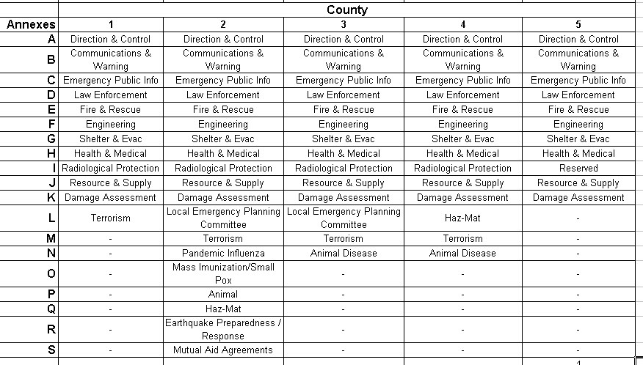

A detailed comparison was performed on one annex common to all five county EOPs, Shelter & Evacuation. All five EOPs initially identify probable threats as tornadoes, floods, and hazardous material spills. Three of the counties also identify earthquakes as probable threats and additionally take radioactive fallout into consideration. While each county’s EOP lists the assumptions that are made, the number and type of assumptions vary from each plan. Some of the common assumptions related to transportation are listed below:
- While some disaster events are slow moving thus providing ample reaction time, the worst case assumption is that there will be little or no warning of the need to evacuate.
- Assistance from outside the county through mutual aid agreements and state and federal level emergency management agencies will be available if needed.
- Protective actions in the event of severe weather will be short term, spontaneous, and consist of a small sector of the county. Therefore, minimal governmental action will be required.
- Under localized emergency conditions, a high percentage of evacuees will seek shelter with friends or relatives rather than go to established shelters. However, planning is for one hundred percent of evacuees.
Each EOP’s Shelter & Evacuation Annex includes a Concept of Operations section that covers natural disasters and man-made peace time disasters and emergencies. Three of the EOPs also cover war emergencies and enemy attack. All five EOPs also assign responsibilities and administrative duties with three of the EOPs adjusted for earthquake scenarios. In addition to the documented procedures, each annex includes a variety of attachments including listings of available resources, necessary supplies and equipment, and maps. Overall, the Shelter & Evacuation Annexes of all five EOPs are very similar, although each annex is customized to its respective county.

4 Transportation Readiness Assessment and Valuation for Emergency Logistics
We developed Transportation Readiness Assessment and Valuation for Emergency Logistics (TRAVEL) to assist state and county level emergency planners in assessing the quality of their emergency preparedness plans with respect to transportation support. The TRAVEL tool was developed using a Value Focused Thinking (VFT) framework (Keeney, 1992). We utilize the basic tenants of the approach to help assess the adequacy of EOPs with respect to transportation needs. The goal is to identify existing shortcomings in EOPs with respect to transportation so that the EOPs can be improved in order to make recovery from a potential catastrophic event easier on the community. Keeney (1992) defines values as those things that we care about and as principles that we use to evaluate the actual or potential consequences of action or inaction. These values can be used in assessing the fitness of any solution to a problem. The values themselves include elements such as characteristics of consequences that matter, guidelines for action, priorities, trade-offs, and ethics, and attitudes towards risk. The basic premise of VFT is that focusing early and deeply on values when facing difficult situations will lead to more desirable consequences (Keeney, 1992). We demonstrate the applicability of TRAVEL on the EOPs of three rural counties.

4.1 Development of TRAVEL Tool
In this effort we used a modified VFT process to develop the TRAVEL tool. The inherent advantage of using VFT is the development of values which can be used to assess the adequacy of the solutions. We employed an eight step process to develop TRAVEL as shown in Exhibit 9.
Exhibit 9: TRAVEL Development Process
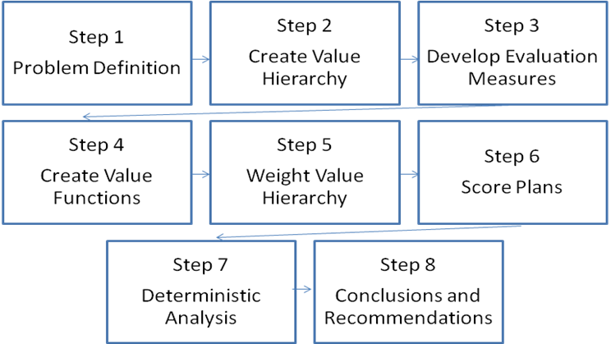

Step 1 – Problem Definition: This step involves defining the problem we are trying to analyze. It is actually the most important step because each subsequent step is built off of the defined problem. In our case, the problem or concern of interest is whether a county’s EOP has adequately addressed all of the transportation needs for relevant catastrophic events for its region.
Step 2- Create Value Hierarchy: Keeney (1992) tells us that a value hierarchy should be a complete mutually exclusive and collectively exhaustive set of evaluation concerns for the problem of interest. Also, a critical attribute of the hierarchy is that it is easily understood by the users of the model. The goal is to capture the essential attributes using as small a hierarchy as possible. In this effort we used a top down approach to develop our hierarchy. With this approach, we identified the fundamental attributes and then subdivided them until we got to a point where we could adequately measure or assess the performance against that attribute. We developed our top level attributes by examining the key areas of an EOP in which transportation would play a critical role. We used the FEMA All-Hazards Guide to support our thinking in this process.
Step 3 – Develop Evaluation Measures: Step 2 yields a qualitative framework for the problem of interest. The next step is to specify evaluation measures to measure the level of attainment with respect to the lowest level values in the hierarchy. The use of evaluation measures permits an unambiguous rating of values within the hierarchy. Evaluation scales can be natural or constructed measures and may be either direct or proxy with regard to the attribute it is measuring. A natural scale is one that is generally understood, for example “number of fatalities.” A constructed scale is used when natural scales are not appropriate or do not exist to measure the attribute of interest. In our analysis, we used constructed scales for all of our measures. We constructed these scales based on developing a list of essential items for each attribute. These attributes were then scored on a scale from one to five depending on whether the plan had all of the essential elements for that attribute (five) or none of the essential elements for that attribute (one). While natural scales are generally preferred to constructed scales, we felt that this was the best mechanism for assessing the fitness of a plan with regards to a specific attribute. The main difficulty with our constructed scale is that the possibility exists that the scale may be interpreted differently by distinct evaluators depending on their perception of the terms used in the constructed scale. For this reason, great care was taken in establishing the list of essential components for each attribute as well as developing the description of each scoring mechanism.
Step 4 – Create Value Functions: The value function translates the measure for a particular attribute into a number between zero and one hundred for the range of scores applicable to that attribute. The least preferred score will have a value of zero and the most preferred score has a value of one hundred. This implies that a plan that has the least preferred scores for all of the attributes will have a total value score of zero while a plan that has the most preferred score for all of the attributes will have a total value score of one hundred. We classify a plan that has a total value score of one hundred as the “ideal” plan and use it as a measure of comparison for all plans analyzed. The values score are normalized to a scale from 0 to 1.
Step 5 – Weight Value Hierarchy: Selecting the weights for each level of the hierarchy requires input from the stakeholders and associated subject matter experts. The process of assigning weights is usually accomplished by determining the weights for the lowest tier for each branch of the hierarchy and progressing upward until the top level hierarchy is assessed. There are a variety of approaches for determining the weights within a hierarchy including swing weighting, direct weighting, and relative weighting. In our effort, we used relative weighting. This process requires defining the importance of each attribute by ranking them in terms of importance and then assigning 100 pts to the most important attribute and then apportioning an appropriate amount of points from 0 to 100 to the lower ranked items. These local weights are then used to construct global weights by taking the product of the local weights at each level of the hierarchy as you move down each branch. The sum of all the global weights along the bottom level of the hierarchy should sum to one.
Step 6 – Score Plans: Typically the process of scoring the plans would be performed by the EOP team. The process requires reviewing the EOP and assessing it against each of the measures contained in the value hierarchy. The scoring itself concludes when the team reaches a consensus on how the plan scores for each measure. Achieving consensus adds credibility and defensibility to the values assigned for the plan. It is also important due to the fact that constructed scales are utilized for the evaluation measures.
Step 7 – Perform Deterministic Analysis: This process entails combining the score for the multiple evaluation measures into a single measure of the overall quality of the transportation elements of the EOP for the county. This process value is described mathematically as (Kirkwood, 1997):
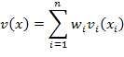
where
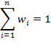
Step 8 –Conclusions and Recommendations: Based upon the analysis and examining the score for each plan, the team quickly identifies whether or not the plan is acceptable. In addition, each plan is compared to the ideal plan and areas for improvement can be quickly identified. Based on this analysis, the EOP team can revise the plan towards improvement with regards to transportation capabilities.

4.2 Description of TRAVEL Tool
The TRAVEL tool is a spreadsheet based assessment tool built in Excel 2007. The tool was constructed using the process described in Steps 1 though 8 of Section 4.1. In this section, we present the basic structure of the hierarchy. We begin with the top level of the assessment hierarchy. The fundamental objective is to assess the adequacy of the transportation elements of an EOP. The four supporting objectives for TRAVEL are how well it addresses the transportation needs associated with Evacuation, Mass Care, Health and Medical, and Resource Management. The Assessment Hierarchy and the associated local weights are given in Exhibit 10.

Exhibit 10: TRAVEL Assessment Hierarchy
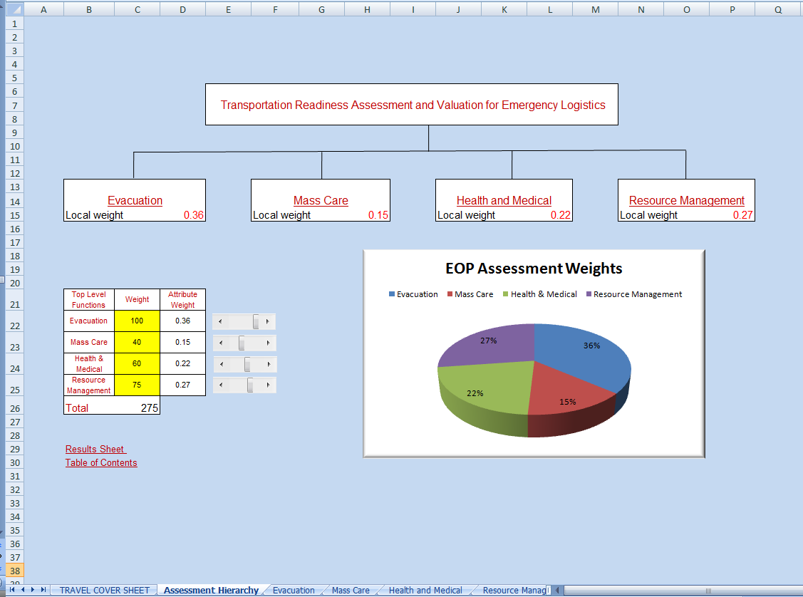
Each of these four supporting objectives is further broken down into its own hierarchy. We begin with the Evacuation objective. The Evacuation objective has three supporting attributes: Evacuation Route Analysis, Evacuation Mobility Assets, and Evacuation Transportation Personnel. The Evacuation objective hierarchy and its local and global weights as defined by the research team are given in Exhibit 11. The Mass Care hierarchy is designed to assess the ability of the EOP to meet the transportation needs associated with the Mass Care Facility Readiness as well as for Mass Care Sustainability. The Mass Care hierarchy and its local and global weights are provided in Exhibit 12. Next, a hierarchy is constructed to assess the transportation support within the EOP for Health and Medical services. The two supporting attributes in this hierarchy involve transportation support for Health and Disease Control and for Medical Services. The Health and Medical hierarchy and the associated local and global weights are given in Exhibit 13. Given in Exhibit 14, the fourth supporting hierarchy is the Resource Management hierarchy which is used to assess the level of resource support for transportation in the EOP.
Exhibit 11: Evacuation Hierarchy
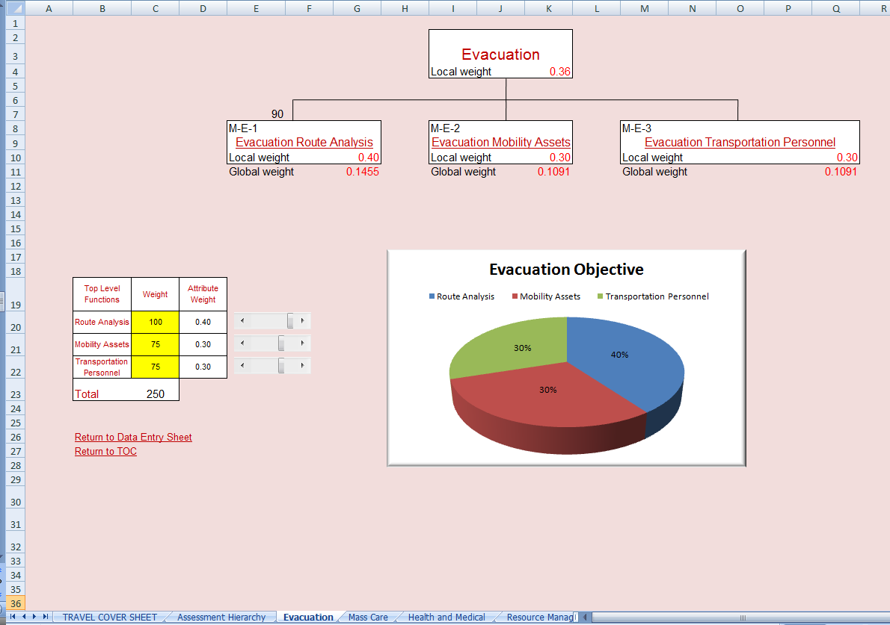
Exhibit 12: Mass Care Hierarchy
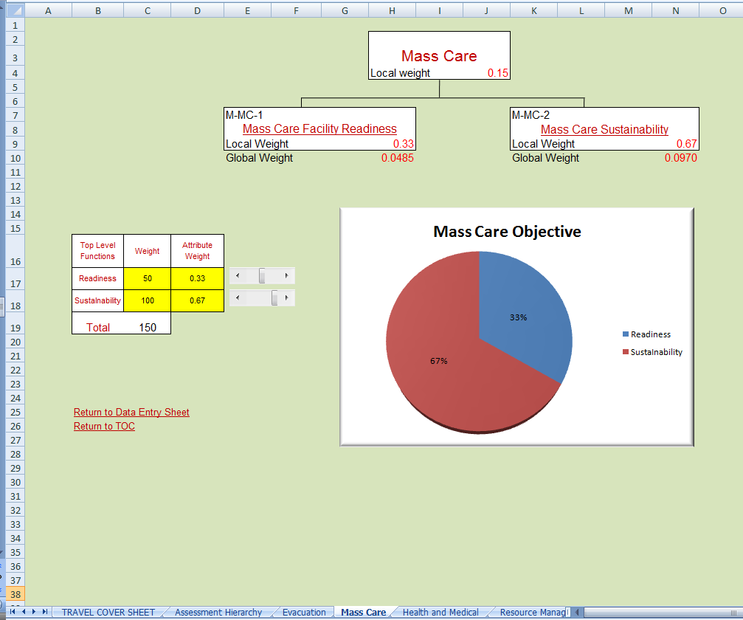
Exhibit 13: Health and Medical Hierarchy
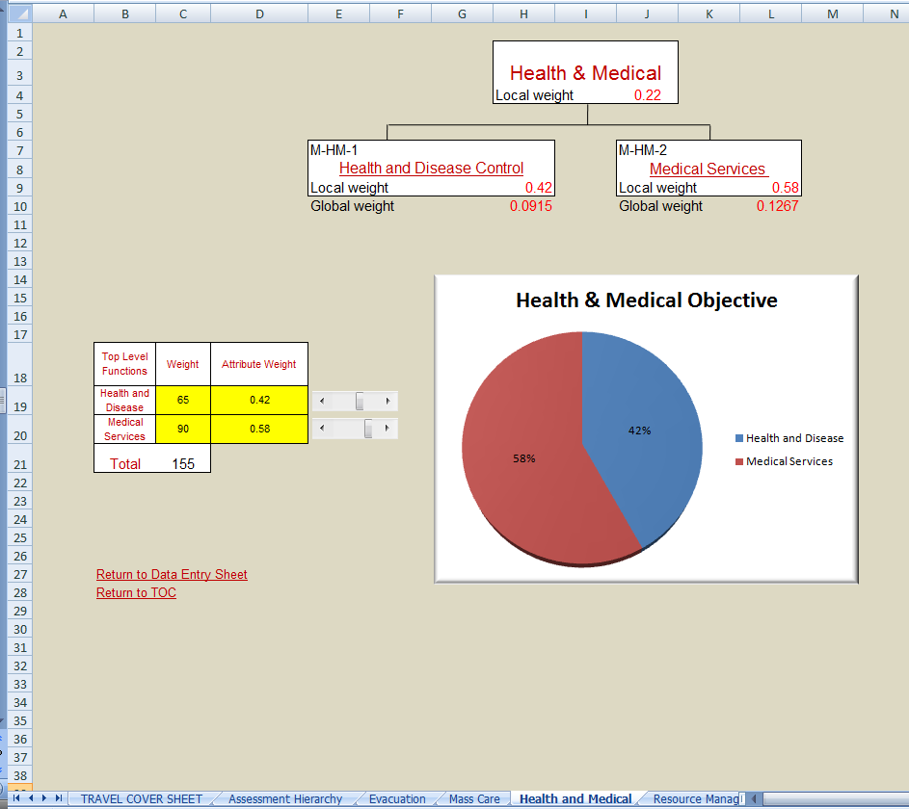
Exhibit 14: Resource Management Hierarchy

Each attribute has measures that assess the adequacy of the EOP with regard to that measure. Across the four attributes, the TRAVEL tool consists of a total of eight measures. Each measure is a constructed scale. Exhibit 15 provides an example of the measure for Evacuation Route Analysis attribute (M-E-1). Similarly constructed measures are created for the other seven attributes and provided in the Appendix. Notice that the constructed scale for the measure is a value from one to five, with five being the best and one being the worst. In this example, if the EOP fails to contain all of the essential components, it cannot get a score of five. While if it contains most and mentions all essential components, it would be eligible for a score of four. If the plan contained few or no essential components with regard to evacuation routes, then the plan would receive a score of one. Exhibit 15 also provides a picture of the value function. This mapping from the evaluation score to the value score is accomplished through consensus of the members of the EOP team. Each value function is unique to each measure and should be fixed before plans are evaluated. For M-E-1 (as shown in Exhibit 15), a score of one has zero value for this measure while a score of five has a value of 100 and a score of four has a value of 68. These value scores are normalized to a scale from zero to one and used in the calculation of the total value score by multiplying them by their appropriate global weight for each measure.
The main benefit of a spreadsheet based tool is that it is very easy to adapt to the tool to the group using it. The TRAVEL tool is designed so that subject matter experts can easily adjust their weighting preferences for the attributes as well as their value functions for each of the measures. Section 4.3 provides a demonstration of how the TRAVEL tool is used and the value of the information it can provide to emergency planners.

Exhibit 15: Evacuation Route Analysis Measure (M-E-1)
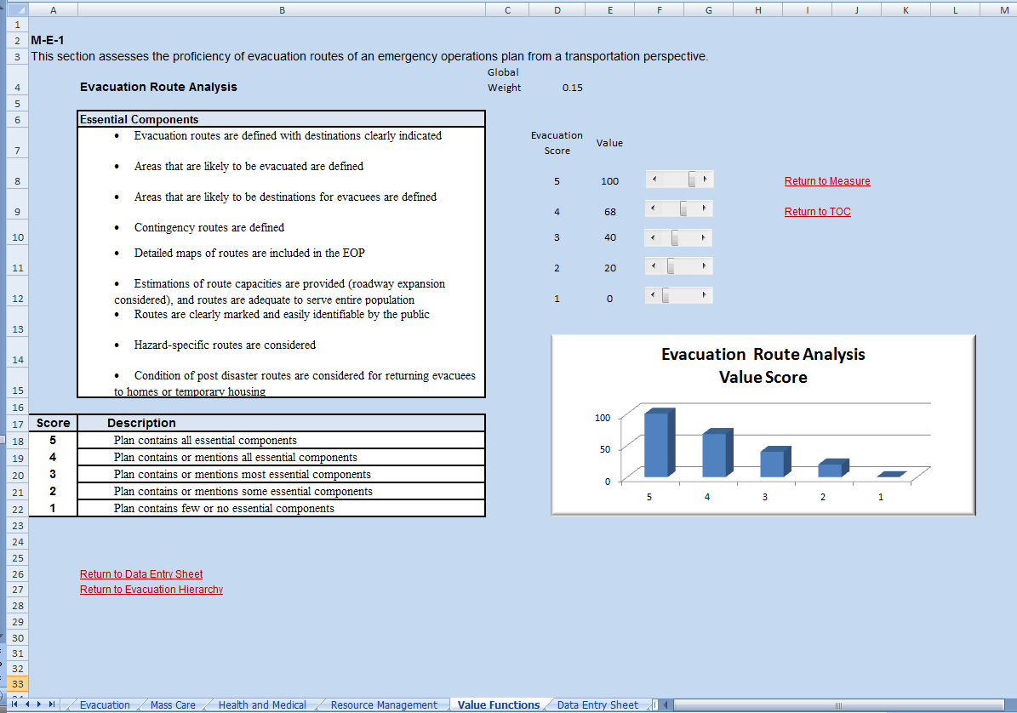

4.3 Demonstration of TRAVEL Tool
The TRAVEL tool was used to assess three rural county EOPs provided to the research team. The research team served as the subject matter experts throughout the process for this demonstration. Before viewing any of the emergency preparedness plans, the research team established consensus on weights and value functions for the model. All members are familiar with the EOP literature as well as the FEMA All-Hazard Guide. We begin the demonstration process by starting on first worksheet of the TRAVEL Tool. When the TRAVEL Excel file is opened, it should open to the cover page. If it does not, click on the TRAVEL COVER SHEET tab at the bottom of the Excel spreadsheet. The cover page is shown in Exhibit 16.

Exhibit 16: Opening Page for the TRAVEL Tool
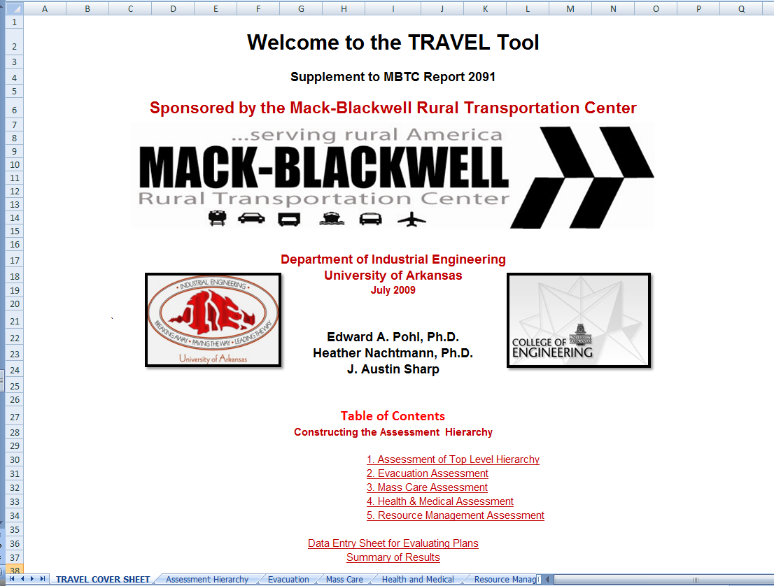
To begin the EOP assessment process, click on Assessment of the Top Level Hierarchy (or select the Assessment Hierarchy tab). This will bring up Exhibit 10. At this point, we set the appropriate levels for the weights of each of the four supporting attributes. The first step in the process is to identify the relative importance of each of the supporting objectives to the overall goal of assessing transportation readiness of EOPs. In this case, the research team determined that the Evacuation supporting attribute was most important, with Resource Management second, Health and Medical third and Mass Care fourth. The most important attribute received a score of 100 and the other attributes were scored accordingly using the slider bars to the right of the weights table. The scores were then normalized, and the attribute weights were calculated. In this example, the pie chart in Exhibit 10 shows us the derived weights for each of the supporting objectives. The global weights for the four objectives are: Evacuation, 36%; Mass Care, 15%; Health and Medical, 22%; and Resource Management, 27%.
We continue the process by setting the weights for each of the lower level hierarchies. We do this by clicking on the supporting attribute we wish to view first. Click on Evacuation in the hierarchy in Exhibit 10 (or select the Evacuation tab). This brings us to Exhibit 11. Once again we determined the importance of each of the supporting attributes. In this instance, the research team determined that Evacuation Route Analysis was the most important attribute, and it received a score of 100 by moving the appropriate slider bar in the weight table. Evacuation Mobility Assets and Evacuation Transportation personnel were determined to be of equal importance and were each given a score of 75. Once again the scores were normalized and the local weights for the attribute calculated. The pie chart in Exhibit 11 shows us the local weights for each supporting attribute: Evacuation Route Analysis, 40%; Evacuation Mobility Assets, 30%; and Evacuation Transportation Personnel, 30%. Examining the hierarchy in Exhibit 11, we can see that the global weight for each of the supporting attributes is annotated on the bottom of the hierarchy. This weight is the product of the local weight for the upper objective (Evacuation, 36%) and the local weight of the supporting objective (Evacuation Route Analysis, 40%) yielding a global weight for Evacuation Route Analysis of 0.15. The global weight is then used as the multiplier for the value score when it is obtained. This process is continued for each of the other three elements of the hierarchy as shown in Exhibits 12-14.
Once we reached consensus on the local weight for each level of the hierarchy, we constructed the value functions for each of the measures in the hierarchy. This model has a total of eight measures. We now describe the process of establishing the value functions for one of the measures. A similar process was used on each of the other seven measures as shown in the Appendix. In Exhibit 11, clicking on Evacuation Route Analysis (or selecting the Value Functions tab) brings you to Exhibit 15. In Exhibit 15, we see the measure for Evacuation Route Analysis and its associated constructed scale. At this point, the EOP team (in this demonstration, the research team) assigns a value to each of the constructed scale scores using the slider bars next to each score for the measure. For example, a score of five, indicating that the plan contains all essential components with regards to Evacuation Route Analysis as described in the box, was given a value score of 100. A score of one implies that the plan contains few, if any, essential components for Evacuation Route Analysis. This measure score was given a value of zero by the research team. The histogram in Exhibit 15 displays the value scores for each of the constructed scale elements for this measure. This same process was used to develop the value functions for the other seven measures as provided in the Appendix. Once all of the value scores were developed by the team, the model is complete and ready to be used to assess EOPs.
In order to validate functionality of the TRAVEL tool, the team evaluated three rural county EOPs. Each plan was thoroughly reviewed by at least two members of the research team, and consensus was achieved when scoring each plan against each measure. In order to score a plan, an analyst clicks on the Data Entry Sheet (or selects the Data Entry Sheet tab). that is listed on the opening page of the TRAVEL tool (Exhibit 16). Clicking on the Data Entry Sheet brings up the table shown in Exhibit 17.
Exhibit 17: Data Entry Sheet
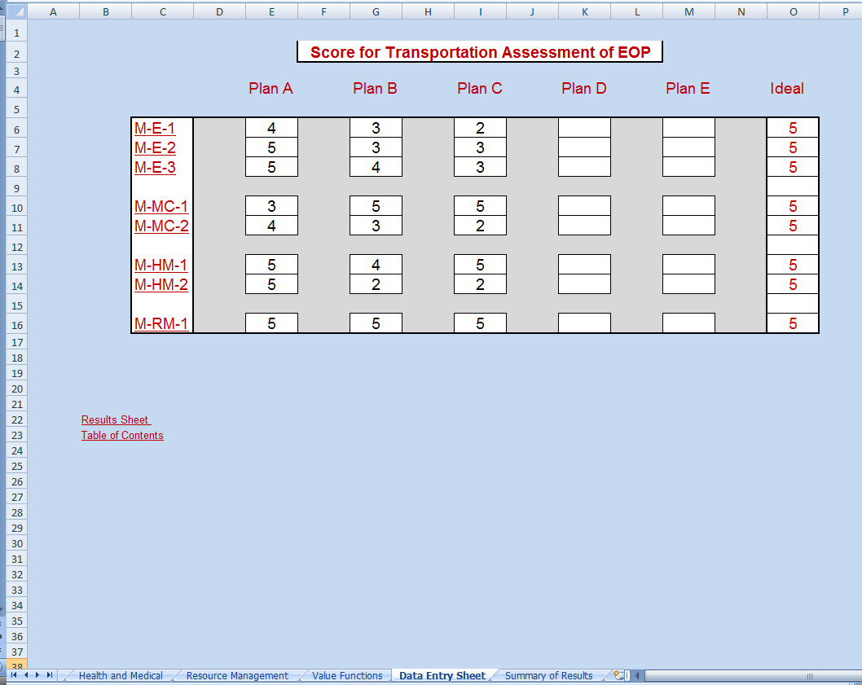

This sheet is used to enter the scoring data of each measure for a given EOP. The current sheet is designed to evaluate five EOPs at a time. The ability to evaluate multiple plans simultaneously could be useful to assessing the adequacy of the plans for a specific region. In this demonstration, we evaluate three rural county-level EOPs. If the analysts click on a measure number, it takes them to the description of the measure and gives them the ability to determine what the appropriate score is for the respective plan. If we select M-E-1, it will take us to Exhibit 11 where the analyst assesses how well the plan under consideration addresses Evacuation Route Analysis. In this example, the research team concluded that Plan A contained or mentioned all of the essential components for Evacuation Route Analysis and therefore gave it a score of four for measure M-E-1. The score is entered in the Data Entry Sheet by clicking on the Return to Data Entry Sheet label at the bottom of the M-E-1 page. A similar process is used to evaluate the other seven measures. The three rural county EOPs were evaluated, and the scores for each were entered into the Data Entry Sheet. Next, we provide descriptions of the three counties whose plans were assessed as part of this demonstration.
County A Summary: County A is a rural county located in the central U.S. with a population less than 20,000 and a Rural Continuum Code equal to 6. The county is one of the most vulnerable in the state in which it resides with a SoVI greater than 3.0. It is located near a major fault line, and as a result, any location within the county could be subject to significant damage in the event of an earthquake. Two railways and three major highways bisect the county bringing increased risk of hazardous material spills. A single oil product pipeline and numerous gas pipelines also traverse the county. In addition, a large proportion of the county is vulnerable to flooding including the county seat.
County B Summary: County B is a centrally located rural county within the continental U.S.. It has a population of just over 15,000 and a Rural Continuum Code of 8. It is one of the top ten most vulnerable counties within its state with a SoVI greater than 4.0. The county is at risk of earthquakes due to its proximity to a major fault line. Four major highways cross the county exposing it to the potential for hazardous material spills. A major gas supply pipeline also crosses the county.
County C Summary: County C is also located in the central part of the U.S.. The county has a population less than 10,000 and is one of the least vulnerable in its state with a SoVI value of less than -3.0. The county is considered to be rural based on its Rural Continuum Code rating of 8. Three major roadways and one railway cross the county bringing with them the potential for hazardous material spills.

4.4 Results of TRAVEL Tool
Once the Data Entry Sheet has been completed for all measures, we evaluate the results by clicking on the Results Sheet link at the bottom of the Data Entry Sheet. This brings up a bar graph that summarizes the contribution of each measure to the total value score (see Exhibit 18). The computation of Plan A’s total value score is provided as an example:
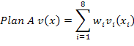
Suppose that the experts have defined a total value score of 65 (indicated by the red line) as the minimum acceptable score for an EOP, one could quickly assess whether or not an evaluated EOP meets the minimum standards as well as where it seems to fall short. The chart also contains a bar graph of the ideal score. This allows one to quickly identify which measure(s) the plan is lacking in terms of performance. For example, we see that, while plan C meets the minimum standard, it is lacking with regard to three measures; Evacuation Route Analysis (M-E-1), Mass Care Sustainability (M-MC-2), and Medical Services Support (M-HM-2). In order to improve the overall value of the plan, emergency planners should focus on adding more of the essential components associated with each of these three measures. This Results Sheet gives the team a quick summary of the status of each plan as well as the relative strengths and weaknesses of each. This approach also gives the Plan C team the opportunity to see which areas of their EOP have sufficiently considered transportation support and in which areas transportation support is weak. This enables the EOP team to benchmark against other plans and to see how these plans address the essential elements of the areas in which their own plan is weak. Again, the goal is to provide guidance on how to improve the transportation aspects of their EOP, not to grade the plans on an absolute scale of pass or fail.
Exhibit 18: Results Bar Graph
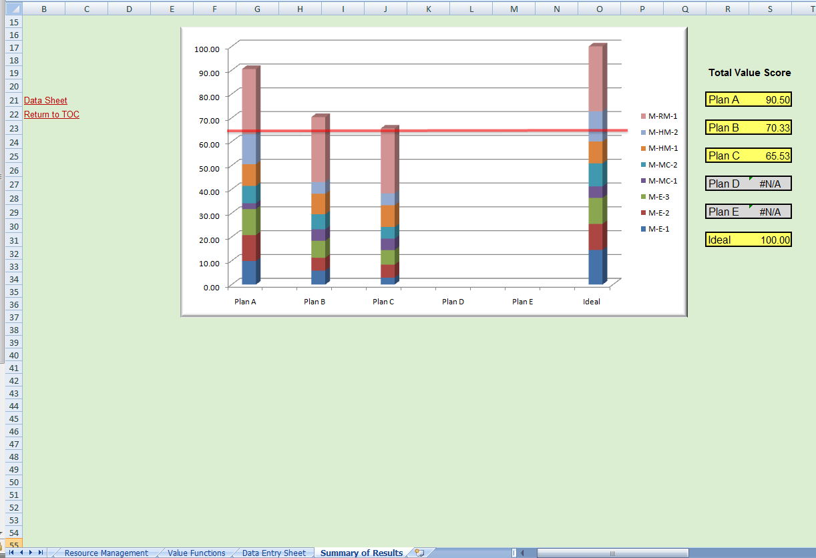

5 Summary

Emergency operations planners at all levels understand that transportation plays an important role in successful execution of their disaster rescue and recovery efforts. A review of EOPs clearly indicates that transportation resources are integrated into today’s EOPs. However, it appears that a common assumption is that all standard means of transportation will be available and feasible when an emergency occurs. Clearly, in a catastrophic disaster, this may not be the case. This study is an initial effort to explore how well state and local planners are considering transportation when developing their EOPs. In addition to increasing awareness of the essential role that transportation plays in emergency operations, we develop the Transportation Readiness Assessment and Valuation for Emergency Logistics (TRAVEL) tool which enables emergency operations planners to assess the quality of their EOPs with respect to transportation readiness and to identity any areas for improvement. The TRAVEL tool was developed using a Value Focused Thinking framework (Keeney, 1992) within the commonly accepted all-hazards approach to emergency operations planning. In our future work, we will continue to develop practical methods and tools to enable improved emergency preparedness of rural transportation systems.

References

Association of American Railroads, “Overview of America’s Freight Railroads,” May 2008.
Brown, Dennis M., “Public Transportation on the Move in Rural America,” U.S. Department of Agriculture, Economic Research Service, July 2008.
Bureau of Transportation Statistics, Department of Transportation, http://www.bts.gov/programs/airline_information/rural_airports/, accessed July 2009.

Burkhardt, Jon E., James L. Hendrix, and Adam T. McGavock, “Assessment of the Economic Impacts of Rural Public Transportation,” Transit Cooperative Research Program - Report 34, Transportation Research Board, National Academy press, Washington, D.C., 1998.

Cutter, Susan L., Bryan J. Boruff, and W. Lynn Shirley, “Social Vulnerability to Environmental Hazards,” Social Science Quarterly, Vol. 84, No. 2, June 2003.
Dye Management Group, Inc., “Planning for Transportation in Rural Areas,” Federal Highway Administration, July 2001.

Furbee, Paul, Jeffery Coben and Sharon Smyth, “Realities of rural emergency medical services disaster preparedness,” Prehospital & Disaster Medicine, Vol. 21, No. 2, March-April 2006.
Hill, Christopher J., “Intelligent Transportation in Rural and Small Urban Areas,” ITS America, 1999.
Keeney, Ralph L., “Value Focused Thinking: A Path to Creative Decision Making,” Harvard University Press, 1992.
Keim, Mark E. and Gary J. Rhyne, “The CDC Pacific Emergency Health Initiative: A Pilot Study of Emergency Preparedness in Oceania,” Emergency Medicine, Vol. 13, No. 2, June 2001.
Kirkwood, Craig W., Strategic Decision Making, Wadsworth Publishing Company: Belmont, CA, 1997
Larson, Richard C., Michael D. Metzger, and Michael F. Cahn, “Responding to Emergencies: Lessons Learned and the Need for Analysis,” Interfaces, Vol. 36, No. 6, 2006.
Mann, N. Clay, Ellen MacKenzie, and Cheryl Anderson, “Public Health Preparedness for Mass-Casualty Events: A 2002 State-by-State Assessment,” Prehospital and Disaster Medicine, July-September 2004.

Nachtmann, Heather, Edward A. Pohl, and C. Richard Cassady, “Homeland Security for Rural Transportation Networks,” Mack Blackwell Rural Transportation Center Final Report, 2007.

Rucker, George, “Status Report on Public Transportation in Rural America,” Federal Transit Administration, U.S. Department of Transportation, 1994.
Rural Welfare Policy Panel, “Rural America and Welfare Reform: An Overview Assessment,” Policy Research Institute, February 1999.

Srinivasan, Deepa, “Battling Hazards with a Brand New Tool,” Planning, Vol. 69, No. 2, February 2003.

Stamm, B. Hudnall, “Terrorism Risks in Rural and Frontier America,” IEEE Engineering and Medicine and Biology, Vol. 21, No. 5, 2002.

University of Arkansas Division of Agriculture, “Rural Profile of Arkansas,” 2007.
U.S. Census Bureau, “U.S. Census 2000 Urban and Rural Classification,” http://www.census.gov/geo/www/ua/ua_2k.html, accessed July 2009.
U. S. Department of Agriculture Economic Research Service, “Measuring Rurality: Rural-Urban Continuum Codes, 2003,” accessed April 2009 from http://www.ers.usda.gov/briefing/rurality/ruralurbcon/.

U. S. Department of Agriculture Economic Research Service, “Rural Transportation at a Glance,” Agriculture Information Bulletin Number 795, January 2005.
U.S. Department of Homeland Security Federal Emergency Management Agency, “Guide for All-Hazard Emergency Operations Planning,” SLG 101, September 1996.
U.S. Department of Homeland Security Federal Emergency Management Agency, “Robert T. Stafford Disaster Relief and Emergency Assistance Act,” FEMA 592, June 2007.
Department of Transportation Federal Highway Administration, “The National Highway System,” http://www.fhwa.dot.gov/hep10/nhs/, accessed July 2009.
U.S. Government Accountability Office, “Catastrophic Disasters,” GAO-06-618, September 2006a.
U.S. Government Accountability Office, “Homeland Security: Assessment of the National Capital Region Strategic Plan,” GAO-06-1096T, September 2006b.
U.S. Government Accountability Office, “Emergency Preparedness and Response,” GAO-06-467T, February 2006c.
U.S. Government Accountability Office, “Homeland Security,” GAO-05-33, January 2005.
Verrico, John, “Science Aided Hudson River Rescue,” U.S. Department of Homeland Security – Science and Technology, Public release date: February 19, 2009.

Appendix
Exhibit 19: Evacuation Route Analysis Measure (M-E-1)
Exhibit 20: Evacuation Mobility Assets Measure (M-E-2)
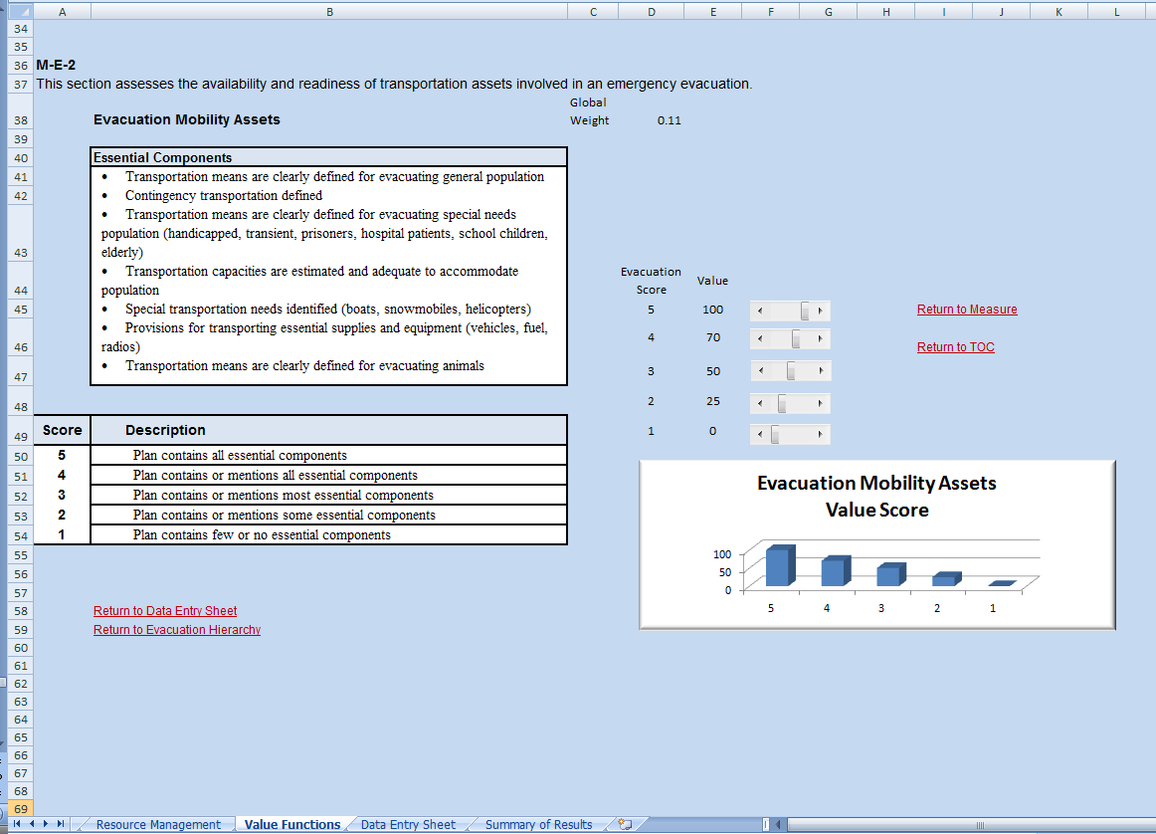

Exhibit 21: Evacuation Transportation Personnel Measure (M-E-3)
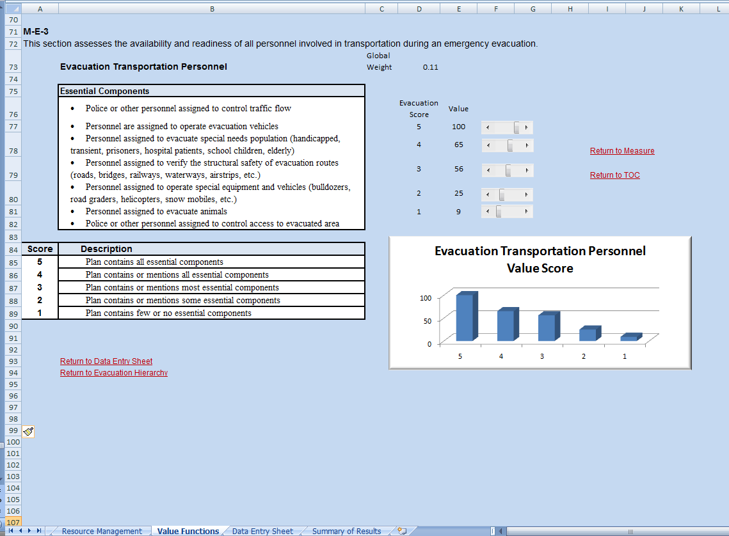
Exhibit 22: Mass Care Facility Readiness Measure (M-MC-1)
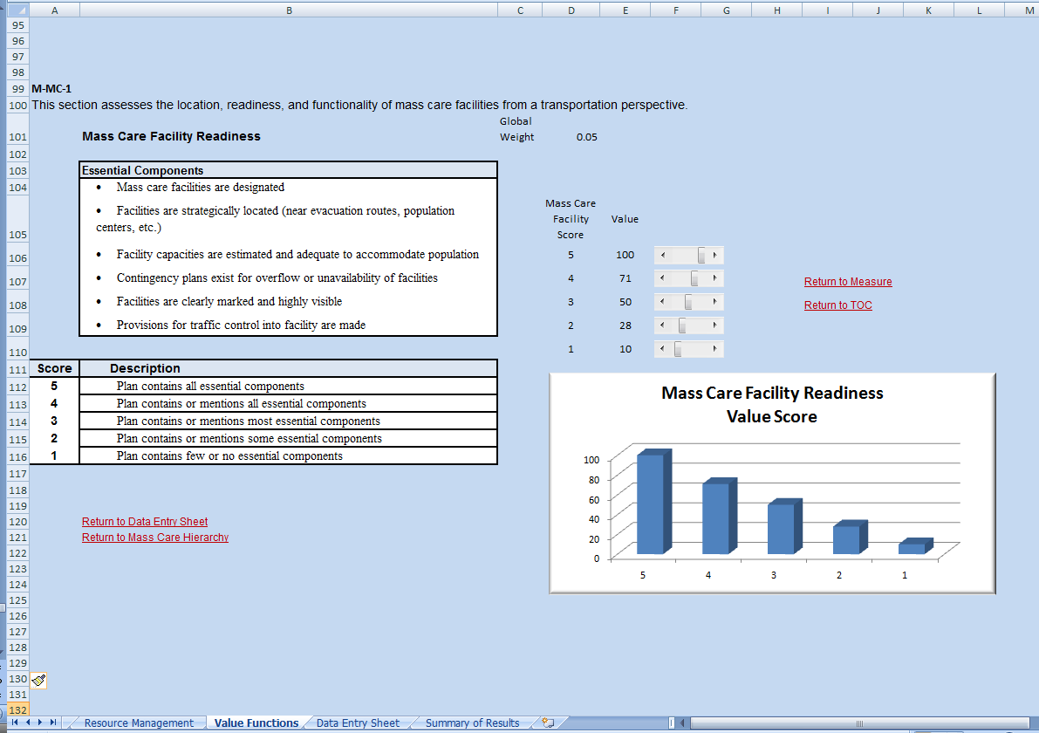
Exhibit 23: Mass Care Sustainability Measure (M-MC-2)
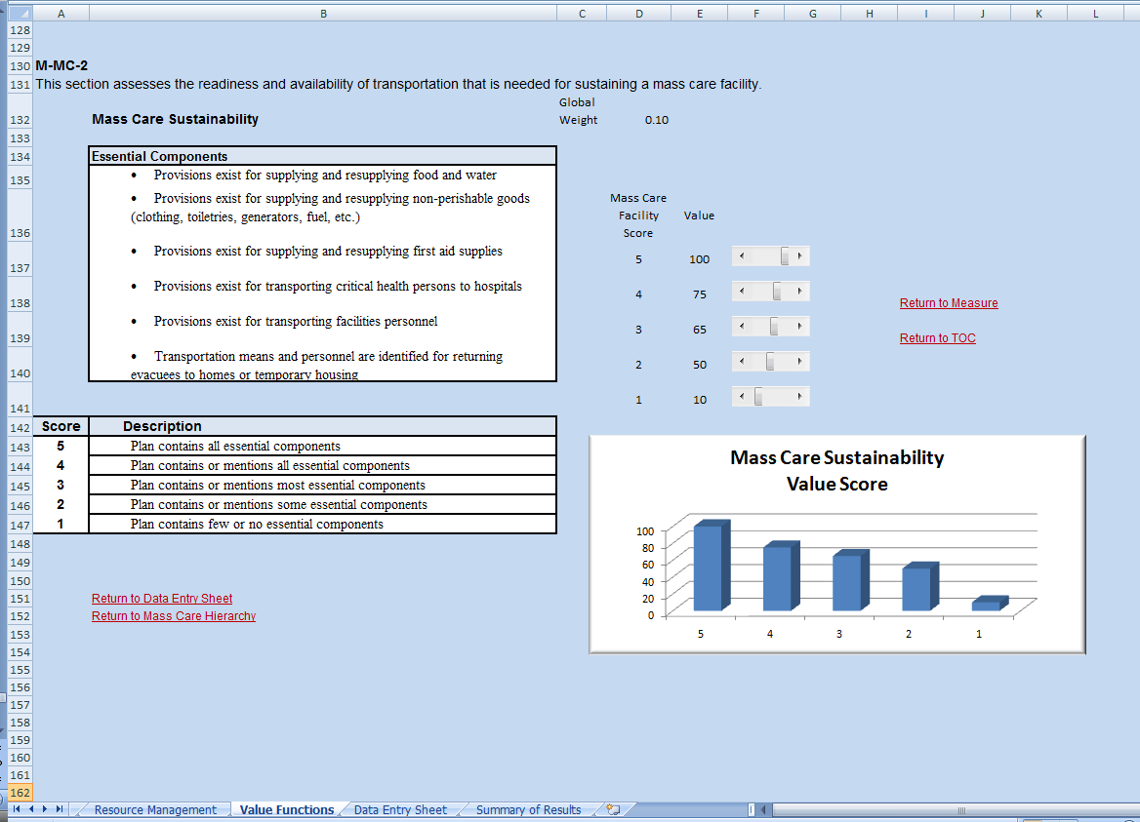
Exhibit 24: Health and Disease Control Measure (M-HM-1)
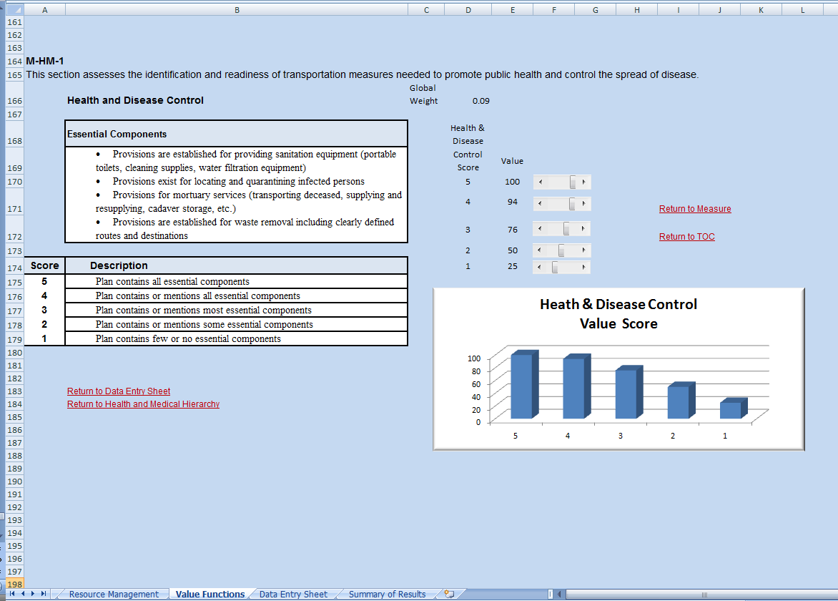
Exhibit 25: Medical Services Support Measure (M-HM-2)
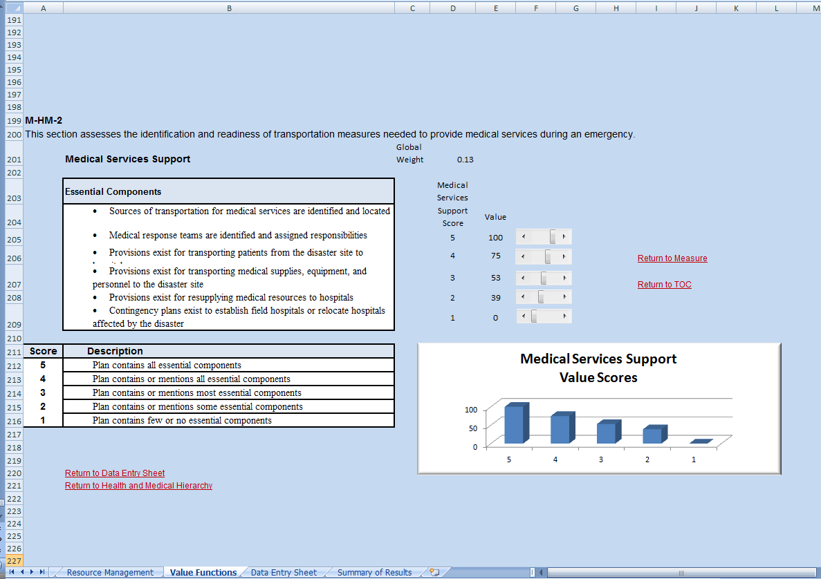
Exhibit 26: Resource Supply Chain Measure (M-RM-1)


