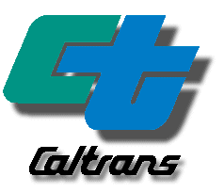

California Department of Transportation

Division of Mass Transportation

Survey for
Rural Transit Assistance Program

(February 2006)

Survey for
Rural Transit Assistance Program

GOVERNOR ARNOLD SCHWARZENEGGER

STATE OF CALIFORNIA

SUNNE WRIGHT MCPEAK, SECRETARY
BUSINESS, TRANSPORTATION AND HOUSING AGENCY

WILL KEMPTON, DIRECTOR

DEPARTMENT OF TRANSPORTATION

DIVISION OF MASS TRANSPORTATION
OFFICE OF TRAVEL FORECASTING AND ANALYSIS
STATEWIDE TRAVEL ANALYSIS BRANCH

FEBRUARY 2006

Survey for
Rural Transit Assistance Program

February 2006

Prepared for

State of California
Department of Transportation
Division of Mass Transportation
Rural and Small Transit Operators Procurement and
Monitoring Branch

Prepared by

Azita Fatemi, P.E.,
Research Program Specialist II
Leo Gallagher, Research Program Specialist I
Ayalew Adamu, PhD, Research Manager II, Chief
Division of Transportation System Information
Office of Travel Forecasting and Analysis
Modeling and Travel Analysis Branch
Division of Transportation System Information

Lupe R. Rios, Associate Transportation Planner
Dan Mundy, Senior Transportation Planner, Chief
Rural and Small Transit Operators Procurement and
Monitoring Branch

Acknowledgements

The following staff of the Office of Traffic Forecasting and
Analysis is acknowledged for his review effort:

Gregory Miyata, Research Program Specialist II

TABLE OF CONTENTS Page
Executive Summary 1
RTAP Survey Findings 1
Survey Conclusion 2

LIST OF CHARTS Page
Chart 1 - Overall, what is your perception of CalACT's implementation of RTAP for rural transit operators? 3
Chart 2 - How effective have the CalACT conferences been to your organization? 3
Chart 3 - Please identify which best describes your transit service area 4
Chart 4 - In your position, do you have the authority to decide who attends training programs? 4
Chart 5 - How many employees do you supervise in your organization? 5
Chart 6 - How many days per person do you allow for management and staff to attend transportation related training, workshops and conferences each calendar year? 5
Chart 7 - How much does your agency budget in regards to your management and staff training, workshops and conferences (include travel expenses and registration fees)? 6
Chart 8 - How did you learn about RTAP activities? (Choose one or more answers) 6
Chart 9 – If you receive RTAP Bulletin, do the Bulletins provide sufficient information to decide if you or staff should attend? 7
Chart 10 - RTAP provides up to $1,500 to rural agencies for registration, travel and lodging expenses incurred while traveling to and from workshops, and training. Does CalACT respond in a timely manner to your requests for information or approvals? 7
Chart 11 - After you submit your post expense form, receipts and write-up to CalACT, does your organization receive the scholarship reimbursement within 90 days? 8
Chart 12 - RTAP maintains a Catalog of Resources that is available in hard copy and on the Internet. Do you access any of the materials in the RTAP Catalog of Resources? 8
Chart 13 - RTAP funds are used to assist in planning the content of CalACT conferences. Have you attended any of the following CalACT conferences? (Choose one or more answers) 9
Chart 14 - Was the content of the conferences beneficial to your organization’s needs? 9

LIST OF CHARTS Page
Table 1 - RTAP Survey Summary 10
Table 2 – Please suggest any additional topics you would like to see incorporated into the RTAP workshops 13
Table 3 - Please provide any additional comments regarding RTAP 15
Table 3 – (Continued) 16
Table 3 – (Continued) 17

Executive Summary

For

Rural Transit Assistance Program (RTAP) Survey

Currently, the California Association for Coordinated Transportation Inc. (CalACT) is under contract to the Department of Transportation, Division of Mass Transportation (DMT) to implement all aspects of Rural Transit Assistance Program. (RTAP). RTAP was created by Congress in 1986, under Section 18(h) of the Surface Transportation Act administered by the Federal Transit Administration (FTA). The program provides training, technical assistance and other resources to rural and urban transit operators throughout the State of California. CalACT is a statewide, non-profit organization that has represented the interests of small, rural, and specialized transportation providers since 1984, and has been instrumental in conducting RTAP training programs under several contracts with the Department since 1990.

The DMT conducted an Internet survey among rural transportation agencies to obtain information regarding the implementation of the RTAP. This survey was conducted between January 12, 2006 and February 10, 2006, and was intended to assist the Department in determining Transit Agency’s satisfaction with RTAP trainings and how RTAP can be improved.

This report presents the overall effectiveness of the RTAP. Graphical presentation of the survey results describe the number of employees in the transit operator’s organization, their service areas, training programs, training budgets and other related information regarding RTAP activities and CalACT’s implementation of the program. Table 1 summarizes responses to the survey questions, and percent distributions of the total surveyor’s. For your reference, unedited survey participant’s suggestions and comments are shown in Tables 2 and 3.

RTAP Survey Findings

The results of the RTAP Survey revealed that the level of overall satisfaction with the RTAP program is very high. Chart 1 represents the respondents' perception of CalACT's implementation of the RTAP for rural transit operators. A total of 57 percent of the respondents answered that they were "Very satisfied" with the program, while 42 percent responded that they were "Satisfied", and only 1 percent responded that they were "Dissatisfied". Chart 2 describes the respondent's response to the CalACT effectiveness for their organization; while 56 percent reported "Very satisfied", 41 percent reported "Satisfied", and only 3 percent responded that they were "Dissatisfied".

As illustrated in Chart 3, 48 percent of the survey respondents indicated that they served transit service areas with a population less than 50,000, 31 percent respondents provided transit service serving small urban populations of less than 200,000, and 21 percent identified that they were operating transit service in urban areas serving populations greater than 200,000.
Chart 4 indicates that the majority of the respondents were in the position of authority to decide who attends training programs while 36 percent were not in a position of authority. The RTAP survey revealed that 36 percent of the respondents supervised 1 to 10 employees, 9 percent supervised 11 to 20 employees, 15 percent supervised 21 to 50 employees and only 7 percent had more than 50 employees to supervise. Of the total respondents shown in Chart 5, 33 percent did not supervise any staff.

Chart 6 reports that the survey showed 19 percent of RTAP providers allocated 10 days or more per person for management and staff to attend transportation related training, workshops and conferences during each calendar year, 17 percent allocated 6 to 10 days, 27 percent allocated 3 to 5 days, 19 percent 1 to 2 days while 27 percent responded that this question is not applicable to their organization.

The survey question of how much RTAP agencies budget for training, Chart 7 shows that 12 percent indicated they had an annual employee training budget of over $10,000, 18 percent allocated $5,000 to $9,999 to training, 30 percent budgeted $1,000 to $4,999, and 23 percent budgeted less than $1,000 for their training program.

Chart 9 indicates that 82 percent of the survey respondents reported that RTAP bulletins they received provided sufficient information for the agency to decide if management or staff should attend the RTAP training, while 11 percent did not receive the RTAP training bulletin, and only 7 percent were not aware of the RTAP training program.

Regarding the $1,500 scholarship fund that is available through RTAP for travel and lodging expenses incurred while traveling to and from workshops and training, Chart 10 indicated that 45 percent indicated that CalACT responded to them in a timely manner, while 19 percent were not aware of the fund and 34 percent had not requested scholarship funds.

Chart 12 indicates that 43 percent of RTAP survey respondents were aware of the RTAP Catalog of Resources on the Internet and had accessed it, while 23 percent were not aware of the catalog, and another 23 percent were aware of the catalog, but had not accessed it.

Survey Conclusion

Out of a total of 520 transit agencies that were invited to participate in the survey, 128 or 26 percent, consisting of transit managers, transit staff, and other transit related occupations completed the survey. Overall, the 2006 RTAP survey indicated that the RTAP administered by CalACT has been very effective and successful. A significant 99 percent of the survey respondents were either "Very Satisfied", or "Satisfied" with the RTAP program. In addition, 97 percent of the rural transit providers reported that their organization was "Very Satisfied" or "Satisfied" with the effectiveness of the CalACT program. The opinions of 83 percent of survey participants indicated that the RTAP conferences provided content beneficial to their organization's needs, while 17 percent answered "Other". Conversely, none of the agencies reported that the conferences were not beneficial.

Chart 1 - Overall, what is your perception of CalACT's implementation of RTAP for rural transit operators?
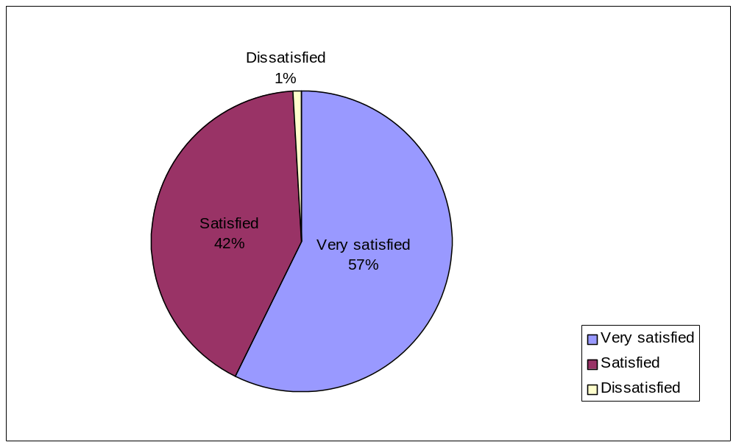

Chart 2 - How effective have the CalACT conferences been to your organization?
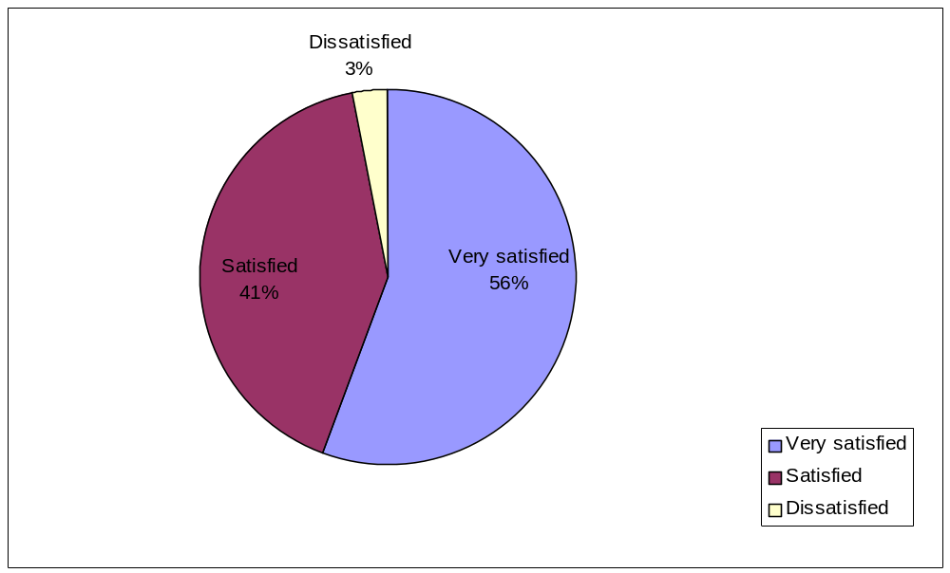

Chart 3 - Please identify which best describes your transit service area
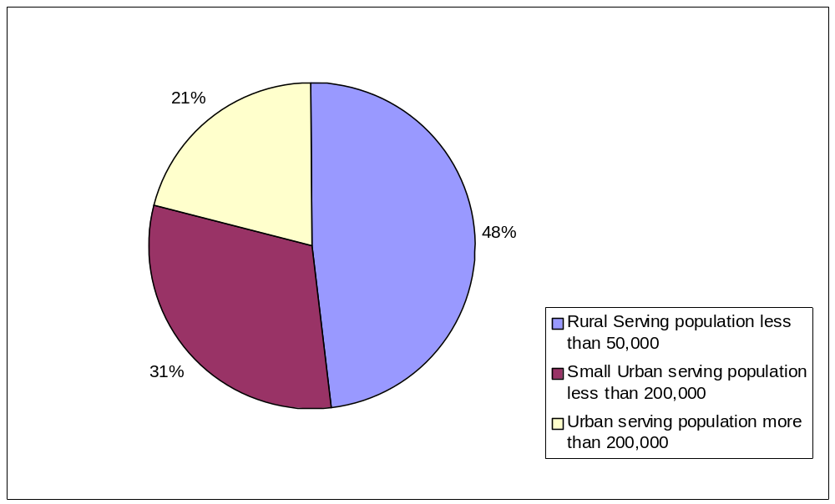

Chart 4 - In your position, do you have the authority to decide who attends training programs?

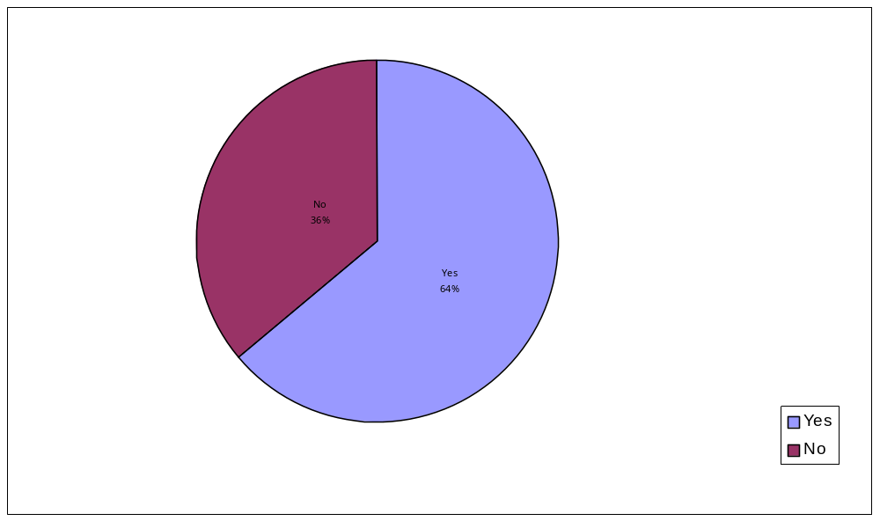

Chart 5 - How many employees do you supervise in your organization?
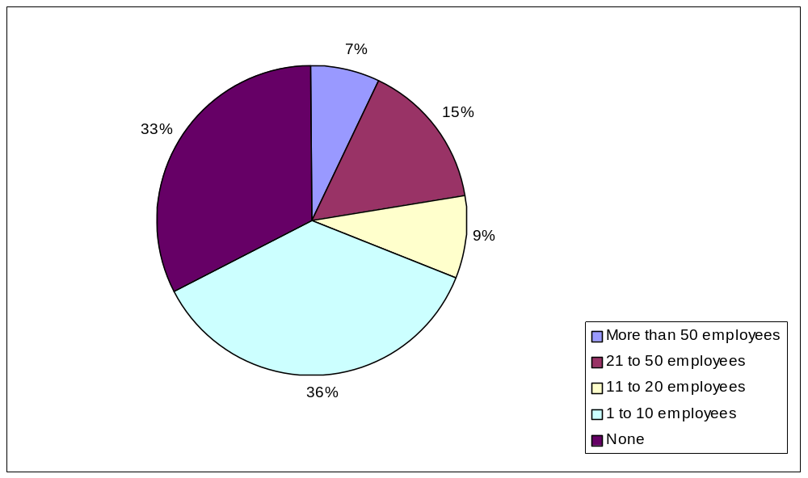

Chart 6 - How many days per person do you allow for management and staff to attend transportation related training, workshops and conferences each calendar year?
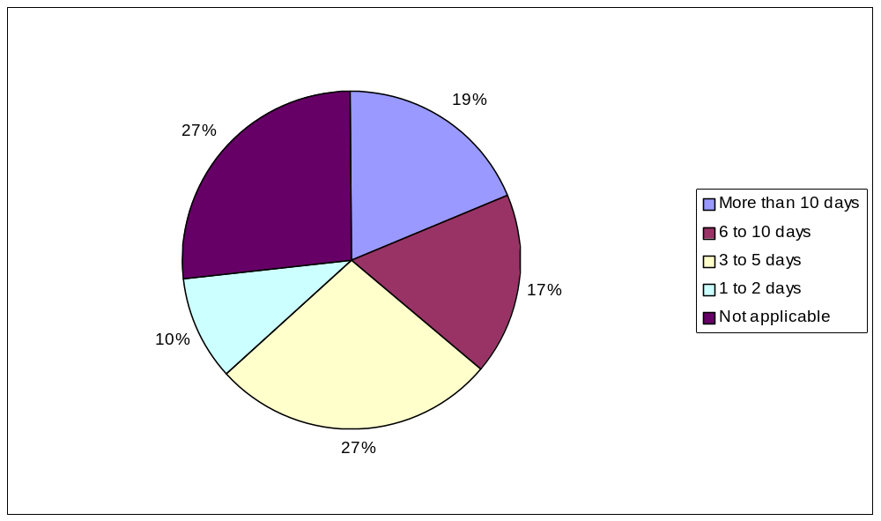

Chart 7 - How much does your agency budget in regards to your management and staff training, workshops and conferences (include travel expenses and registration fees)?
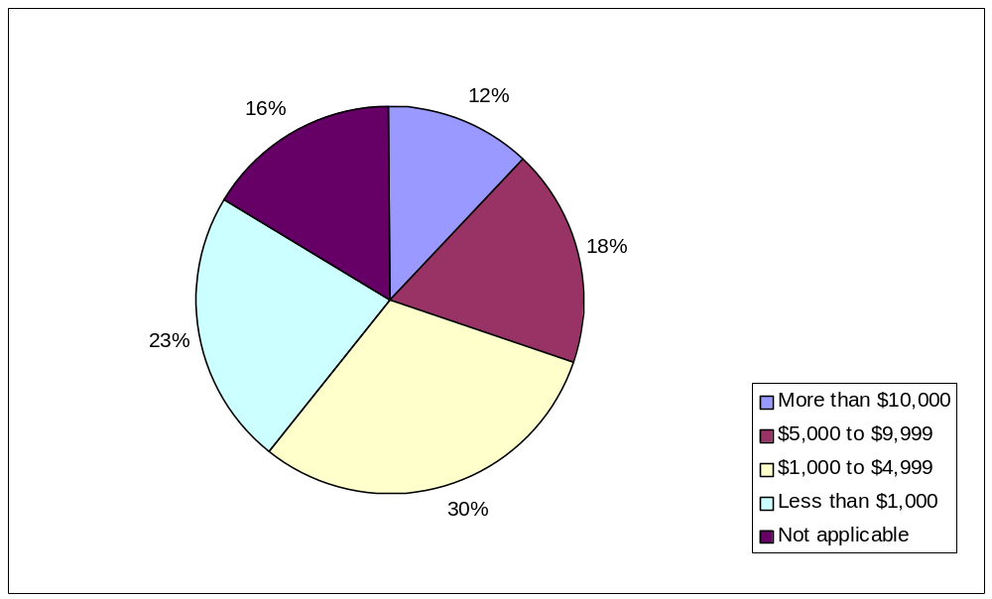

Chart 8 - How did you learn about RTAP activities? (Choose one or more answers)
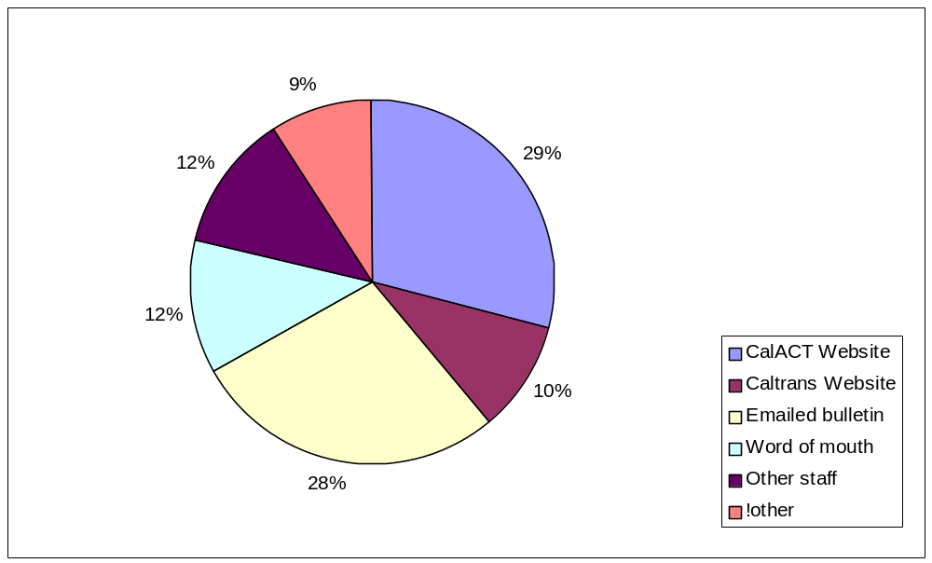

Chart 9 – If you receive RTAP Bulletin, do the Bulletins provide sufficient information to decide if you or staff should attend?
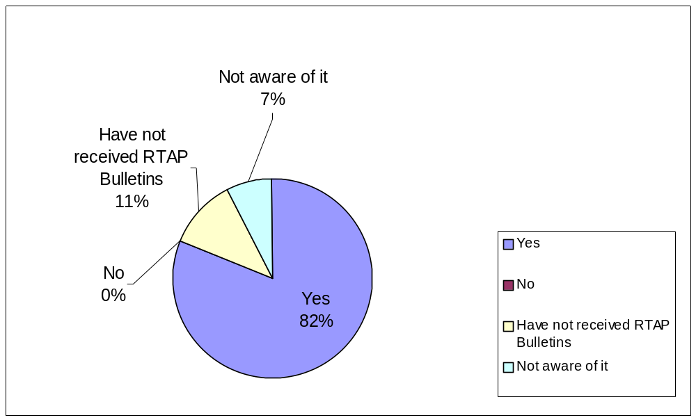

Chart 10 - RTAP provides up to $1,500 to rural agencies for registration, travel and lodging expenses incurred while traveling to and from workshops, and training. Does CalACT respond in a timely manner to your requests for information or approvals?
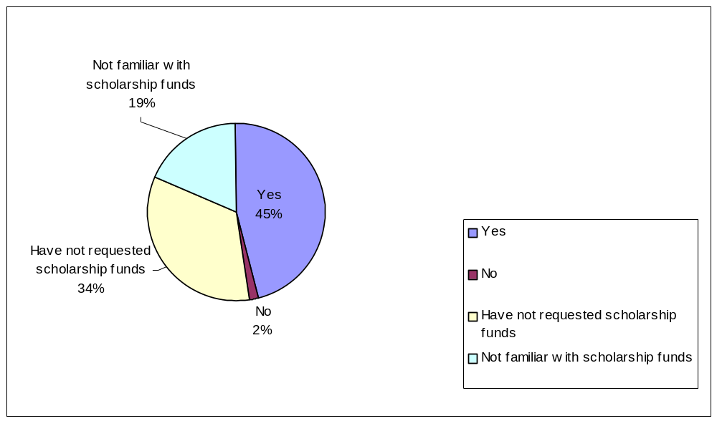

Chart 11 - After you submit your post expense form, receipts and write-up to CalACT, does your organization receive the scholarship reimbursement within 90 days?
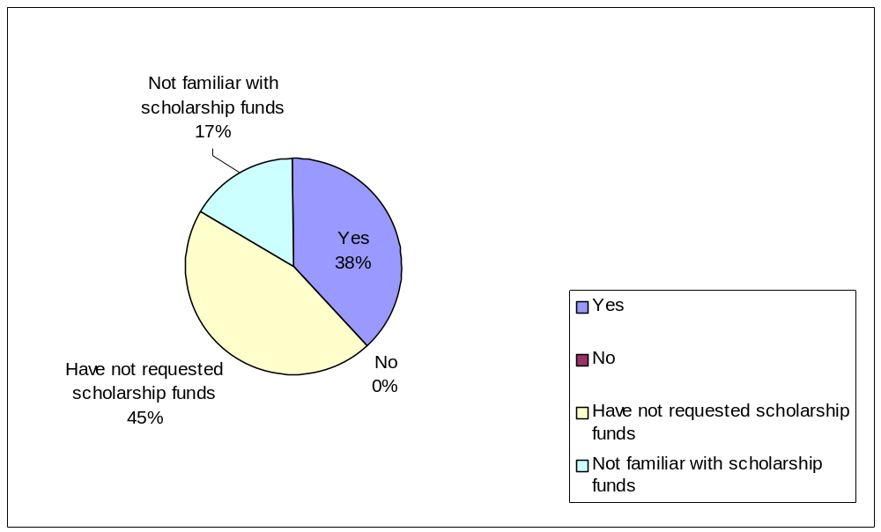

Chart 12 - RTAP maintains a Catalog of Resources that is available in hard copy and on the Internet. Do you access any of the materials in the RTAP Catalog of Resources?
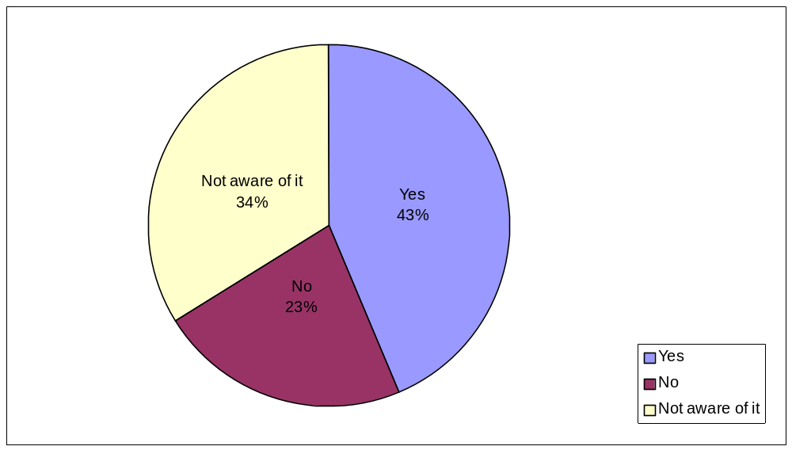

Chart 13 - RTAP funds are used to assist in planning the content of CalACT conferences. Have you attended any of the following CalACT conferences? (Choose one or more answers)
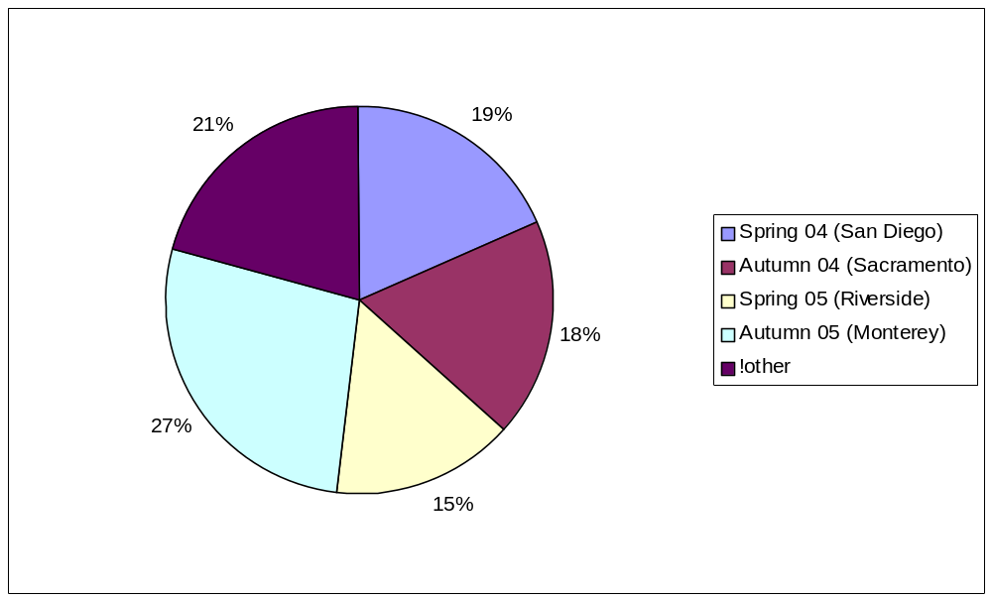

Chart 14 - Was the content of the conferences beneficial to your organization’s needs?
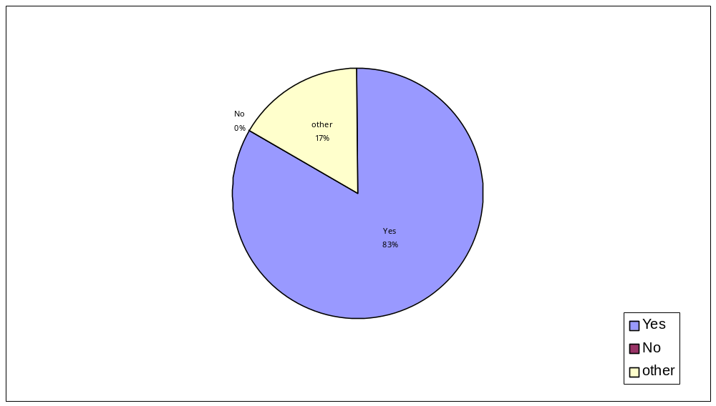

Table 1 - RTAP Survey Summary
SURVEY SUMMARY | Total | Percent
1. How effective have the CalACT conferences been to your organization?
Very satisfied | 55 | 56%
Satisfied | 41 | 41%
Dissatisfied | 3 | 3%
Total | 99 | 100%
2. Overall, what is your perception of CalACT's implementation of RTAP for rural transit operators?
Very satisfied | 59 | 57%
Satisfied | 43 | 42%
Dissatisfied | 1 | 1%
Total | 103 | 100%
3. Please identify which best describes your transit service area. (Choose one or more answers)
Rural Serving population less than 50,000 | 66 | 48%
Small Urban serving population less than 200,000 | 42 | 31%
Urban serving population more than 200,000 | 29 | 21%
Total | 137 | 100%
4. In your position, do you have the authority to decide who attends training programs?
Yes | 80 | 64%
No | 45 | 36%
Total | 125 | 100%
5. How many employees do you supervise in your organization?
More than 50 employees | 9 | 7%
21 to 50 employees | 19 | 15%
11 to 20 employees | 11 | 9%
1 to 10 employees | 45 | 36%
None | 41 | 33%
Total | 125 | 100%
6. How many days per person do you allow for management and staff to attend transportation related training, workshops and conferences each calendar year?
More than 10 days | 23 | 19%
SURVEY SUMMARY | Total | Percent
6 to 10 days | 21 | 17%
3 to 5 days | 33 | 27%
1 to 2 days | 12 | 10%
Not applicable | 33 | 27%
Total | 122 | 100%
7. How much does your agency budget in regards to your management and staff training, workshops and conferences (include travel expenses and registration fees)?
More than $10,000 | 15 | 12%
$5,000 to $9,999 | 22 | 18%
$1,000 to $4,999 | 37 | 30%
Less than $1,000 | 28 | 23%
Not applicable | 20 | 16%
Total | 122 | 100%
8. How did you learn about RTAP activities? (Choose one or more answers)
CalACT Website | 63 | 29%
Caltrans Website | 21 | 10%
Emailed bulletin | 60 | 28%
Word of mouth | 26 | 12%
Other staff | 26 | 12%
Other | 20 | 9%
Total | 216 | 100%
9. If you receive RTAP Bulletins, do the bulletins provide sufficient information to decide if you or staff should attend?
Yes | 99 | 82%
No | 0 | 0%
Have not received RTAP Bulletins | 14 | 11%
Not aware of it | 9 | 7%
Total | 122 | 100%
10. RTAP provides up to $1,500 to rural agencies for registration, travel and lodging expenses incurred while traveling to and from workshops, conferences and training. Does CalACT respond in a timely manner to your requests for information or approvals for scholarship assistance under the RTAP program?
Yes | 57 | 45%
No | 2 | 2%
SURVEY SUMMARY | Total | Percent
Have not requested scholarship funds | 42 | 34%
Not familiar with scholarship funds | 23 | 19%
Total | 124 | 100%
11. After you submit your post expense form, receipts and write-up to CalACT, does your organization receive the scholarship reimbursement within 90 days?
Yes | 46 | 38%
No | 0 | 0%
Have not requested scholarship funds | 55 | 45%
Not familiar with scholarship funds | 20 | 17%
Total | 121 | 100%
12. RTAP maintains a Catalog of Resources that is available in hard copy and on the internet. Do you access any of the materials in the RTAP Catalog of Resources?
Yes | 54 | 43%
No | 28 | 23%
Not aware of it | 42 | 34%
Total | 124 | 100%
13. RTAP funds are used to assist in planning the content of CalACT conferences. Have you attended any of the following CalACT conferences? (Choose one or more answers)
Spring 04 (San Diego) | 32 | 19%
Autumn 04 (Sacramento) | 31 | 18%
Spring 05 (Riverside) | 26 | 15%
Autumn 05 (Monterey) | 47 | 27%
Other | 36 | 21%
Total | 172 | 100%
14. Was the content of the conferences beneficial to your organization’s needs? | Total | Percent
Yes | 90 | 83%
No | 0 | 0%
Other | 18 | 17%
Total | 108 | 100%

Table 2 – Please suggest any additional topics you would like to see incorporated into the RTAP workshops

"Asking for money" you can do it "media interaction" how to prepare for it and use it to enhance your organization
A DOT workshop that would cover every aspect of DOT requirements. I would also like to see the Transit and Paratransit Management Certificate Program offered in Sacramento all at once with no breaks in training.
Baby Seat / Child tie downs in 5310 Paratransit vehicles
Breaking Down the Regulatory Barriers to Trip Sharing and coordination of services
Bues to view at both conferences.
Bus Procurement process (funding, specs, inspection, etc.) Fare Box Recovery Ratio reporting ("optimizing" operating -vs.- capital expenses) for agencies with trouble meeting the ratio
Can you get a lift maintenance class in the LA area? How about a Supervisor's Drug & Alc class?
Certified Community Transit and Supervisor Course
Changes in legislation under SAFETEALU
Context Sensitive Solutions in Transit Planning Using/navigating the Caltrans website effectively Caltrans organization and how it relates to local transit/transportation (mini CT planning academy) GIS in transit
Contracting for service in maintenance. Budget preparation
Customer service module for front-line staff (e.g. dispatchers and reservationists)
Have not attended yet.
How to find reliable and affordable vehicle maintenance
I think cal act does a good job overall. I should use the services more. It seems when I do have a problem with a vehicle I usually get a good response from the cal trans. crew. (Dan, Robert, Chris H.)
I would like to see the "managing Contracts" workshop provided in Northern California again.
Impact of new SAFETEA-LU programs and provisions (such as New Freedom and Coordinated Human Services Transportation Plan) to planning agencies and transit operators.
Intercity bus issues, planning, and marketing. Auditing operating statistics...current practices and recommendations.
ITS innovations and integration to increase services to the general public while containing "ADA only" expenses. New freedom act training. FTA grant management. DBE goal setting and reporting training. Drug and Alcohol compliance training.
Keep the ADA reviews. Training the trainer opportunities. Emergency evacuation topics. Disaster preparedness topics. Thanks!
Table 2 – (Continued)
LET THE AGENCIES KNOW IN ADVANCE ABOUT THE WORKSHOP WITH THE INFORMATION REGARDING THE SCHOLARSHIP.
More ADA Operational Subjects
More Human Resource specific workshops that are roundtables with breakout groups.
More maintenance training for new Shop Supervisors and additional training for new Operations Dispatchers and Supervisors.
More sensitivity training.
More Small operations issues. We don't all operate with hundreds of buses.
Most effective ways to manage contractor (bus company) to comply with regulations
None
None come to mind.
None.
Perhaps more information regarding implementation of the security plans and provisions that are soon to be part of the FTA triennial audits.
Programs offered are fine - would like to see more dates to choose from especially in the Bay Area or central valley.
Review of transit ridership/fare/mileage relationships to meet farebox. Review of farebox calculations. Review of programs to increase farebox revenues in a rural environment.
RTAP provides versatile workshop agendas for the small to urban operations. I would have no suggestions. Doing a great job.
Service design, expansion and reduction, small operator marketing, technology options for vehicles, fuels, scheduling, monitoring and security, and ADA compliance
This is the first time I have been aware of the workshops.
This is the very first I have heard of this organization.
Transportation Development Act update
Understanding the new SAFTEA-LU legislation as it relates to rural transit, what regulations have changed, what's changed in FTA Section 5311-CMAQ processing at Caltrans Headquarters. DBE process refinement. Continue Native American Indian coordination towards improved tribal transportation. Shared expertise training with other peers. Technology Training. Software Training. Sessions on how to mobilize support for a local sales tax continuation for transportation funding. How "not" to Lobby.
Bottom of Form

Table 3 - Please provide any additional comments regarding RTAP
Although the limit has been increased for scholarships I don't believe the limit was set high enough to enable rural operators to participate in very many workshops and/or conferences. It would also be helpful if funds were available to help offset the costs of the Transit and Paratransit Management Certificate Program.
As a new Transit Manager here at the County I have found the RTAP a valuable tool and informative base. I would not have been able to attend the fall 2005 conference without the RTAP scholarship. As a result I have made relationships with peers and neighbors that have proven to be beneficial. I rely on this program and appreciate the support that I receive when I have questions.
CalACT has been very aggressive in promoting the RTAP
CalACT has done an outstanding job administering the California RTAP Program for Caltrans. The goals and objectives have been realized. The Conferences and Workshops have been well attended, and scheduled through the State to have opportunities to attend session within two hours of very rural agency. The networking experiences have been exceptional. Caltrans staff participation and presentations have been the best in recent years. Everyone has been working very well together. Definite progress has been realized to ensure transit access to an ever-greater segment of California's rural population. The small urban and social service operators have also benefited. I'm just glad Congress and the President agreed to continue funding the RTAP Program for us rural operators another six years!!!
CalACT is a wonderful organization and an asset to the transit industry. I have always felt that the RTAP program is effectively administered.
Great training avenue. Keep up the good job.
I appreciate your services.
I have leaned and enjoyed the workshops. I send 2 to the conferences as we are a small transportation program providing dial -a-ride transportation for seniors and the mobility impaired.
I would appreciate more information, to see if these workshops would be of benefit to my staff and service area.
I would like to learn more. I am interested in the scholarship funds, as little or no funding is available for travel and lodging outside of Sacramento County by the County to attend workshops.
If it were not for the RTAP scholarship program I could not attend the CalACT conferences nor could I send staff to overnight workshops. This program is VITAL to our agency. THANK YOU!!!!!!!!!!!!!!
It is a good program for small to medium operators.
More notice of workshops. First one I have seen and have had several state vans for past three years.
None
Not familiar with RTAP we service our community mainly the City of San Francisco.
Table 3 – (Continued)
Not typically a RTAP scholarship user as I work for Caltrans. I receive considerable very favorable comments from agencies regarding the RTAP scholarship program and courses that have been conducted.
Pete, Meg and Ursell among others at CalACT do a fantastic job. I can always count on them for a prompt response and they are always eager to assist us.
Please send information to me in the future to: Ukiah Senior Center Att: Marilyn DeFrange/Transportation Mngr. 499 Leslie Street Ukiah, CA 95482
RTAP funds are available for TSI Transit Bus Operator Trainer Classes. When a small rural transit operator, such as SMOOTH, is not able to schedule a trainer into one of the few classes available in California, they are in some cases forced to send trainer candidates out of state. The $1500 RTAP budget is very welcome but obviously would not cover the cost of out of area or out of state training sessions such as described. Last year SMOOTH sent a trainer to Denver for the TSI course (no closer classes were available for the next 3-4 months). SOLUTION? Is there alternative funding for distance events when needed? Thank you for the opportunity to provide input.
RTAP has been a great resource for our friends in the rural communities and is still very relevant.
RTAP has been very beneficial to this agency. The cadre of teachers has been outstanding. This program is a real find and super resource for rural and small urban agencies.
RTAP is a resource that is essential, in my opinion. The persons who are involved (even though he's moved on, I must praise Pete Spaulding as one example of many fine, competent and enthusiastic individuals) run a first-rate organization, in my opinion. I just hope that our budget allows us to renew our membership in CalAct as the years continue to unfold.
RTAP is good!
RTAP provides essential training and CalACT staff always does a great job helping with our scholarships. THANKS!
RTAP provides informative workshops that are used for the implementation and development of safe and successful transit operations in rural and urban areas. RTAP also provides an opportunity to network with colleagues that are willing to share experiences for development of best practice ideas for implementation in small or urban operations. RTAP is a "G" thing a GOOD thing!
RTAP scholarships and fee-free workshops enabled me to attend conferences and seminars in the past.
Thanks for sending this survey. I applied for the Scholarship funds today, but there was a discrepancy in the room prices for the actual cost vs. what was listed in the scholarship instructions on the spring conference registration form.
The RTAP program, and particularly the scholarships, have been essential to keeping our agency informed about policy and technical issues involving rural transit.
Table 3 – (Continued)
This program has been very beneficial in allowing myself and staff to attend a variety of workshops that have helped us in our jobs.
Too bad that some of the Caltrans people are not included
Two conferences a year is too much. It seems the board members benefit from the conferences more than the rural agencies. Some of the workshops are redundant and attendance is sporadic. With the exception of 5310 and 5311 grant information.
Very positive experience overall and love the yahoo roundtable do not discontinue the roundtable!!!
Very satisfied and would hate to think about any changes being made. Cal Act is doing super.
Very satisfied with all training and conferences that K/T NeT has been involved with.
Very useful. I especially like the materials made available in library kept by CalACT. Conferences are also very informative, especially for rural transit providers.
Video taping of the conferences to share with staff who are not able to attend.
We are located in Elk Grove CA. The city has grown immensely but the southern neighboring area, which is quite close to us, is still quite rural. Are we still being considered a rural transportation area in spite of the fact the population is over 100,000?
Without RTAP many of us small operators would not be able to attend important workshops and conferences.
Would like to see more workshops in the Los Angeles area. But then again it wouldn't be very Rural!

