Final Report
Testing & Evaluation of Close-Range SAR for Monitoring & Automatically
Detecting Pavement Conditions

Overview
This report summarizes activities in support of the DOT contract on Testing & Evaluating Close-Range SAR for Monitoring & Automatically Detecting Pavement Conditions & Improve Visual Inspection Procedures. The work of this project was performed by Dr. Don Atwood and Dr. Keith Cunningham of the University of Alaska Fairbanks with support of ImSAR, makers of the world’s smallest SAR, located in Springville, Utah.
As described in the Team Project Activities document, the preliminary goals of the project were to:
- Conduct a kick-off team meeting at ImSAR facilities in Springville, Utah. Review SAR sensor operation with ASF scientists, Yotta pavement engineer, and ImSAR engineers (hereinafter called the “team”). Review science methodology, labor expectations, equipment, facilities, and pavement test areas. Yotta pavement engineer identifies and documents test pavement and pavement conditions to be imaged near ImSAR facilities. ImSAR engineers work with ASF scientists to develop a mount for the ImSAR sensors on an ImSAR vehicle. Two days of image testing with X-band sensor and two days of image testing with Ku-band sensor. Collect documentation, experiment notes, and test results for future reporting.

- Document sensor test methodologies and experimental results of pavement imaging with the two SAR sensors. Optimal use of the SAR sensors learned from this test for pavement imaging is documented based on the results of the tests conducted. Imaging data is forwarded onto supporting Yotta pavement engineers for their analysis of the imagery for pavement surface and crack detection. Additional experimental analysis is defined and documented by team, as necessary.

- Summarize results of kick-off meeting, first round of SAR sensor experimentation, and resulting pavement imaging results to DOT in the first quarterly report within three (3) months of the effective date of the Agreement.

- Be available for a possible presentation to DOT in Washington DC as part of a project summary and information sharing event

In the first round of experiments, important discoveries were made with respect to the viability of using radar for detection of cracks in road pavement. However, the experimentation offered equivocal outcomes that called into question the path of our originally-planned research:
- Utilizing radar in a real aperture mode, an X-band radar was mounted on the back of a truck to investigate whether it could see cracks as the truck passed overhead. We found that the outcome was significantly dependent upon the composition of the pavement. For asphalt, the results were disappointing. The signal from cracks and features are drowned out by noise. The robust detection of cracks without innumerable false positives is seen as unlikely using current technology. For concrete roadways, the approach looked promising. However, the detection seemed limited to cracks that were perpendicular to the radar line of sight (a limited subset of actual cracks). Using matched filter processing techniques, this approach could be optimized. However its utility is limited to perpendicular cracks in concrete roadways.
- Utilizing radar in a Synthetic Aperture mode (SAR), a Ku-band radar was mounted on a plane and flown over features of interest. It should be noted that due to peculiarities of SAR, these results should be identical to those acquired from a vehicle. In this mode of operation, high resolution images were produced. As in the real aperture experiments described above, the radar proved extremely capable of seeing cracks in concrete, provided they are perpendicular to the radar look direction.

In light of the limitations of radar technology for detecting cracks in all but ideal imaging conditions, ImSAR, our contract partner, decided it was not in their business interest to continue participation in the project as a cost-matching partner. As a response, Don Atwood and Keith Cunningham of UAF spoke with Mr. Ceasar Singh of the DOT about the best way to proceed; as it was clear that a significant deviation from the original project plans was called for. After consideration, it was decided to close out the current contract; leading to this final report, a letter of closure, and settlement of fiscal accounts.
In the remainder of this report, we provide a detailed description of the experiments performed with ImSAR in Springville, Utah and describe our actions to report the findings at the Transportation Research Board 91st Annual Meeting in Washington, D.C.

Description of Radar Experiments and Findings
The experimental work was performed during the week of 31 October in Springville, Utah. All experiments were conducted by Don Atwood and Keith Cunningham of the University of Alaska Fairbanks, and Adam Robertson and Peter Weir of ImSAR. Yotta engineers were unavailable for the first meeting, but provided documentation that showed the nature of the cracks they were attempting to identify.
The ImSAR company is the maker of the world’s smallest Synthetic Aperture Radar (SAR) systems. Two of their products, an X-band SAR and a Ku-band SAR were believed to be particularly well suited for the detection of imperfections in road pavement. Experiments consisted of controlled experiments on the ImSAR premises as well as detection of identified cracks in roads and sidewalks in the environs of the ImSAR facility. These latter investigations were conducted with the ImSAR sensors mounted on a vehicle and flown in a Cessna 172N aircraft.
In the sub-sections that follow, the report will 1) provide background on why SAR might be an effective method for detecting cracks, 2) outline the experiments conducted in Springville, UT, 3) summarize the results, and 4) provide conclusions and make recommendations to the DOT regarding the future of this endeavor.
- Background: SAR Basics
Unlike passive optical sensors that rely on the reflectance of sunlight to detect features, Radar (RAdio Detection And Ranging) is an active sensor. Radar transmits microwaves, then forms an image based on the reflected signal from a target. “Ranging” is the key term in the acronym in that radar images portray the strength of signal versus the distance (or range) from sensor to target. The resolution of an image in the range direction is dependent upon the accuracy of the clock that measures the time between transmitting and receiving the radar signal, with this time being proportional to the distance from radar to target.
Radar systems illuminate an area of sky or ground, the size of which is dependent on the shape of their antennas. The Diffraction Equation of optics dictates that small antennas illuminate larger area, while large antennas illuminate smaller areas. The kind of radar systems that are seen at airports and aboard large ships are known as Real Aperture Antennas. They use antennas that are much larger than the transmitted microwaves to create a narrow, pencil-like beam that yields high spatial resolution in the azimuth direction. The radar ranging tells the distance to a target, while the direction of that pencil-like beam determines the target’s direction.
An alternative, and more clever adaption of radar is to use a synthetic aperture. Such systems rely upon sensor motion (mounted on a satellite, plane, or vehicle) to create an effective, large antenna. By the previously mentioned Diffraction Equation, this extremely large synthetic aperture gives SAR systems extremely high resolution. Interestingly for SAR (as compared to real aperture radar), the smaller the antenna, the higher the spatial resolution. (See figure 1 for a schematic comparison between real aperture and synthetic aperture radars.) In the case of the small SAR systems made by ImSAR, the resolution of the X-band system can be as high as 30cm, while that of the Ku-band system can equal 10cm.
Whether real aperture or synthetic aperture, what a radar “sees” depends upon the way that the transmitted microwaves interact with the target. In the case of imaging roads, microwaves that impinge upon a smooth road surface at a grazing angle, tend to undergo specular reflection. The microwaves bounce off into space with little or no energy being reflected back to the sensor. This means that a perfectly smooth road should look very dark to a radar system. Road cracks on the other hand provide surfaces against which microwaves can backscatter, sending signal back to the detector and yielding a bright return in the radar image. This effect becomes more pronounced when the scattering object is the same dimension as the microwaves being transmitted. Thus X-band with a wavelength of 2.9 cm and Ku-band with a wavelength of 1.8 cm are well-suited to image the small anomalous features that characterize road damage.
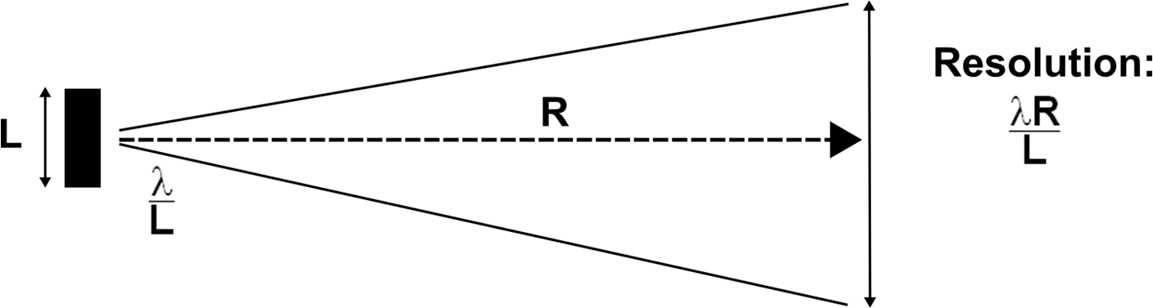
Figure 1. Whereas any optical system is governed by diffraction theory, the resolution can be improved through the use of a large antenna. The top schematic shows a real aperture radar, while the bottom schematic shows a SAR, in which a large effective antenna, L_{eff}, is achieved and the resultant resolution equals the actual physical size of the antenna, L.
As the goal of this project is to mount a miniature SAR to a vehicle, both real aperture and synthetic aperture radar configurations are feasible.
- In the real aperture mode, the radar is mounted on the vehicle in either a forward-looking or rear-looking manner. Due to small antenna size, this mode illuminates the span of one lane at a distance of about 30’. Since the corresponding resolution is the same as the area of illumination, one cannot determine whether a target object is on the left or right side of the lane. Rather one can only determine its range, and thus its position along the lane as the vehicle drives. Although this mode does not pinpoint the exact location of each crack, it should provide more than adequate determination of crack locations for pavement engineers to inspect.
- If instead of the above, one uses the ImSAR radar in the synthetic aperture mode, the SAR must be mounted so as to be side-looking. In this case, a high resolution image of the road can be acquired, instead of just an along-track record of anomalies. By this description, SAR mode operation sounds like the obvious choice for crack detection. However, it requires much more sophisticated processing, and makes the automated identification of cracks from an image more challenging.

Consideration of these two options, suggested that both options should be investigated. One or the other might prove to be better for the goal of detecting cracks from a moving vehicle. For investigating the real aperture mode, the X-band radar was mounted on a vehicle looking backwards. For the synthetic aperture mode, the Ku-band SAR was mounted on a plane and flown over a region of roads that had been characterized for cracks. The choice of a plane as a platform, instead of a vehicle, may seem inappropriate. However, an interesting aspect of SAR is that the resolution is independent of the range. Whether thousands of feet from a plane, or ten feet from a vehicle, the imaging resolution of the SAR should be roughly equivalent. Since the system parameters of the Ku-band SAR had already been optimized for an airborne platform, the decision was made to conduct the SAR experiments from a plane. The details of the experiments conducted in the real aperture and synthetic aperture modes are outlined in the sections that follow.
Real Aperture Experiments
The real aperture road experiments were conducted with a vehicle-mounted X-band radar operating in a real aperture mode. Since the microwaves illuminate the ground at a grazing incidence, most the energy is expected to propagate away into space. Any backscatter from a target (crack) will return to the radar. Radar, by its very nature measures distances to targets, thus in this mode, the radar yields a representation of targets as a function of distance from the truck’s tailgate. If the truck is moving, targets “sweep” through the illuminated footprint. The trick to this mode of operation is coming up with a way to extract the signal from the clutter of this time-evolving signal. One simple-minded approach would to apply a range gate, by which one only looks at the return from a narrow set of range values. For example, one could look for targets as they sweep through a window of ranges between 15 and 16 feet. The only trouble with this approach is that random noise that can mask the signal. Thus, more sophisticated signal processing approaches should be considered.
Preliminary Experiments Since the use of radar for crack detection had not been previously demonstrated, a set of controlled experiments was conducted using idealized cracks illuminated by the X-band radar mounted on a ladder. Specifically, a set of 4’x 8’ insulation pads (used for home construction) were used to represent the roadway. These insulating pads are of 2” thickness and covered with a thin metallic veneer. Metallic tape was used to metalize the uncoated edges of the panels.
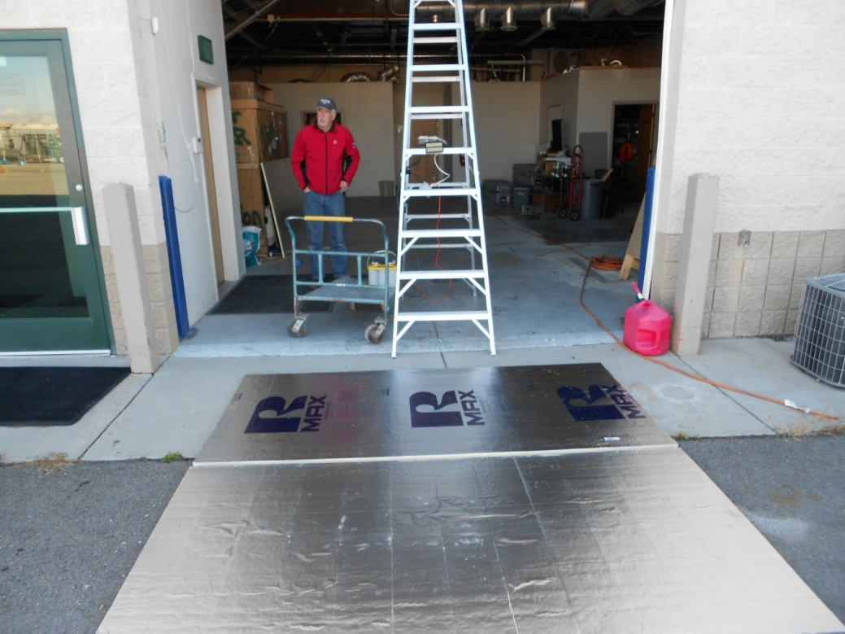
Figure 2. Configuration of preliminary experiments in which metallized foam sheets were illuminted by ladder-mounted X-band radar.
In these experiments, three panels were situated together on the ground, with variable spacing between the panels:
- No gaps
- 1” gap between 1st and 2nd panels
- Addition of 1” gap between 2nd and 3rd panels
- Increasing to 2” gap between 2nd and 3rd panels
- Increasing to 6” gap between 2nd and 3rd panels
Monitoring the individual radar chirps with an oscilloscope in real-time, we were able to observe noisy, but discernible signals from the gaps of 1” and greater. However, the native noise of radar makes the use of a single radar chirp ineffectual for crack detection. Some sort of time averaging is required to extract the signal from the background clutter.
The solution used to address this problem is called a water fall plot, in which the strength of radar returns are plotted in range and time. To minimize processing time, only every 10th radar chirp is displayed in the image. For unmoving targets, as in this preliminary experiment, the cracks yield straight lines at a fixed range. For targets moving away from the sensor (e.g. if the sensor was moving), individual targets are expected to form lines that steadily increase in range with time. An example of this is shown below, for the preliminary experiment in which the second gap is being increased (by hand) from 2” to 6”. The strength of the return (at about 15 on the range scale) is seen to steadily increase as the gap size grows.
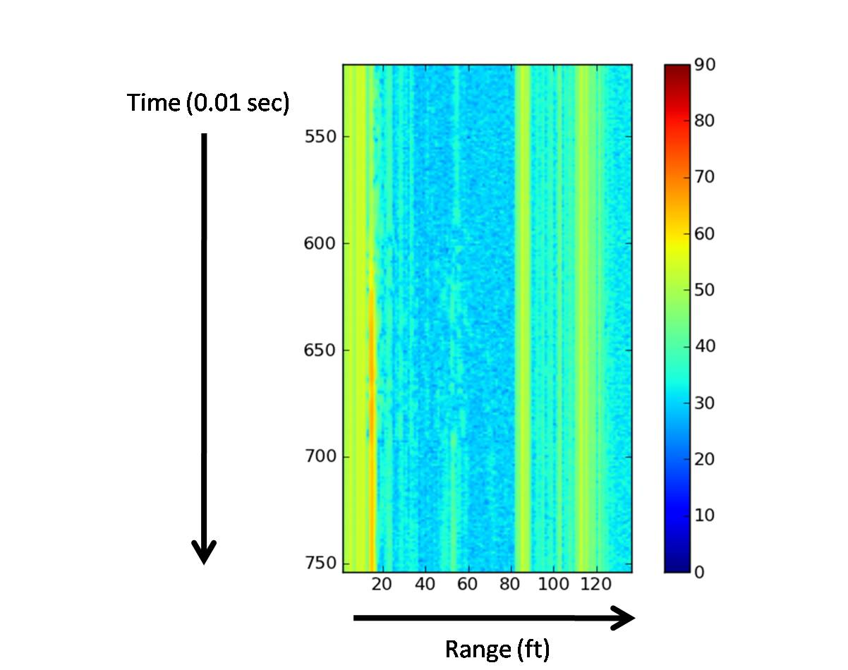
Figure 3. Waterfall plot for preliminary experiment in which gap between 2nd and 3rd panel is increased from 2” to 6”. The strengthening return is seen in the vertical line that progresses from green to orange at the 15’ range.

Road Tests Upon completion of the controlled experiments with panels, a number of road tests were conducted over a variety of surface conditions. The X-band radar was mounted at a height of 5’ on the tailgate of a truck, looking back down at the pavement at an angle of approximately 45 degrees. With this geometry, the illuminated footprint on the ground is approximately 0.3 x Range. In other words, at a distance of 10’ from the radar, the width of the illumination is about 3’, and broadens with increasing distance from the back of the truck. In optimized operation, the radar antenna would be tailored to provide illumination of the entire width of a road lane at a reasonable range. The set-up of the radar is shown in Figure 4.
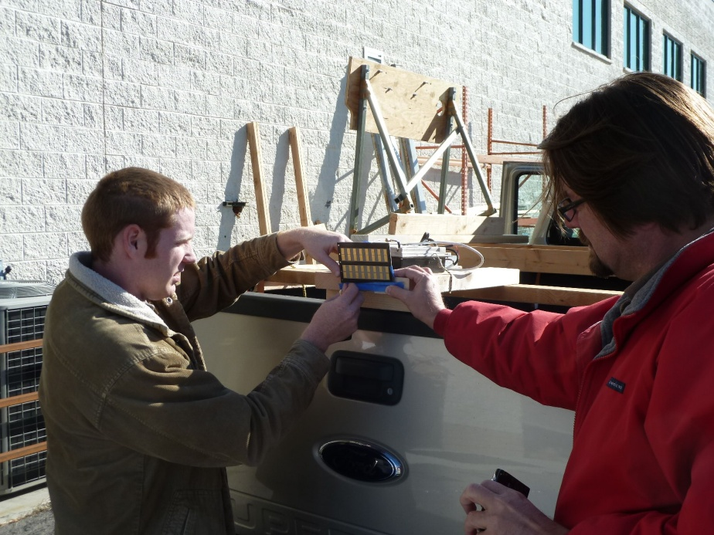
Figure 4. X-band radar mounted on tailgate of truck. Antenna is looking down at approximately 45 degrees.
The impact of motion on the waterfall plots can be seen in Figure 5, where two corner reflectors were positioned at the edge of the asphalt road as the truck drove by. Reflectors are first seen at a range of approximately 25ft and increase in range as the vehicle drives past.
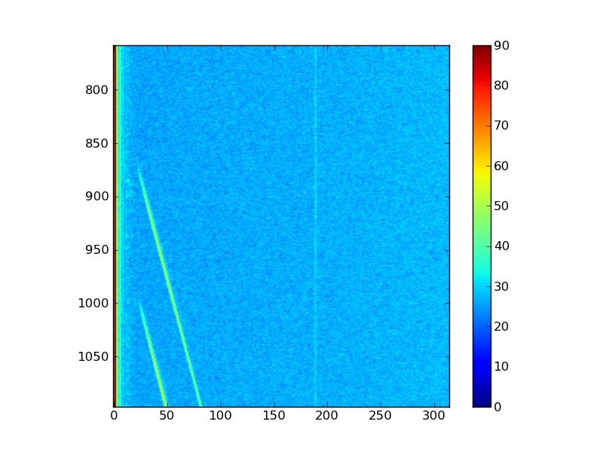
Figure 5. Two strong returns are seen as truck drives by two corner reflectors postioned along side of ashalt road. Random scatter from road features are seen at smaller ranges.
To investigate a consistent pattern of cracks in concrete, the sidewalk near ImSAR (Figure 6.) was imaged. The resulting waterfall plot is shown in Figure 7.

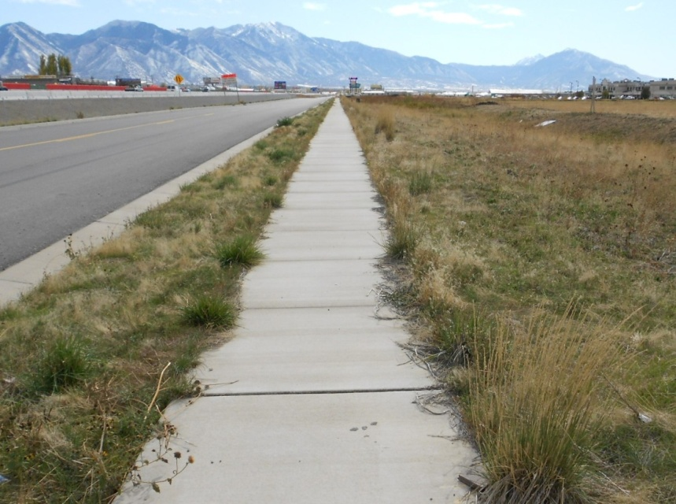
Figure 6. Sidewalk imaged by real aperture radar.

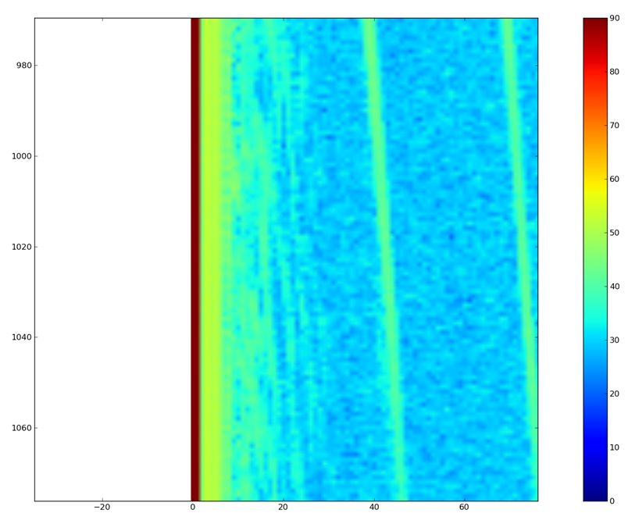
Figure 7. Concrete sidewalk cracks clearly seen in above waterfall plot as a succession of lines at the lower range scale (less than 30).
The results for cracks in concrete were very encouraging; yielding clear returns from the cracks and negligible return from the smooth surfaces. Unfortunately, the results were not so unequivocal for features in asphalt roads. Numerous experimental scenarios were explored at an airport, a parking lot, and on country roads. But the results can be best characterized by comparing two scenes: one for a pristine road with no discernible cracks and one for a road with a maze of “spider” cracks. This comparison is shown in Figure 8.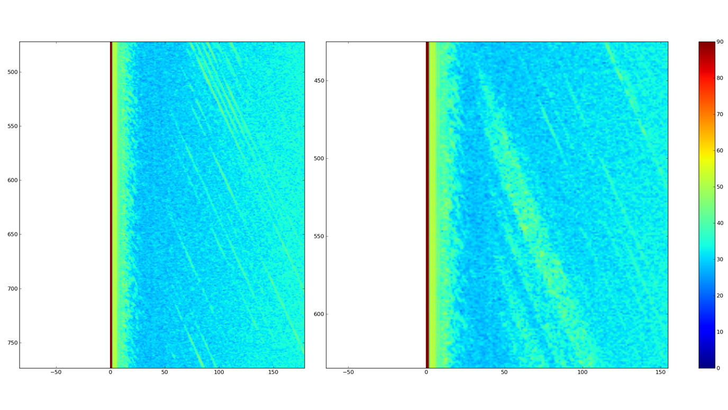
Figure 8. Waterfall images for asphalt pavement in case of pristine condtion (left) and a maze of “spider” cracks (right). All road features are seen at ranges of less than 50. Fenceposts are seen at larger ranges in left image, and a passing car is seen at larger ranges in right image.
Unlike the previous example in which concrete cracks were readily seen in Figure 7, there is no striking difference between the “good” and “bad” asphalt in Figure 8. The backscatter of microwaves from any surface depends on the roughness of the surface. A rule of thumb for roughness is that a surface is rough if the surface fluctuates by more than ¼ wavelength. For X-band radar, this is a mere 8 mm. Thus, asphalt surfaces look rough and produce random noise (or clutter) that masks the returns from the actual cracks. This poor signal-to-clutter issue is further exacerbated by the low signal from the cracks. Since asphalt cracks tend be very rough (on a 8mm scale), the signal gets reflected in all directions; further limiting the strength of the microwaves reflected back to the detector. Based upon this outcome, X-band characterization of surface features in roads made of asphalt appears unlikely due to the comparable magnitudes of signal and clutter.

Synthetic Aperture Experiments
As noted above, the synthetic aperture mode of radar offers improved resolution over the real aperture mode. SAR offers the possibility of seeing cracks as an actual image, rather than as waterfall plot with GPS coordinates. In this application, the Ku-band radar was deemed to be the better choice since it offers 3x better resolution. As noted above, we chose to operate the Ku-band SAR from an aircraft since the radar was already configured for airborne altitudes and the results would be equally applicable to vehicle-mounted applications.
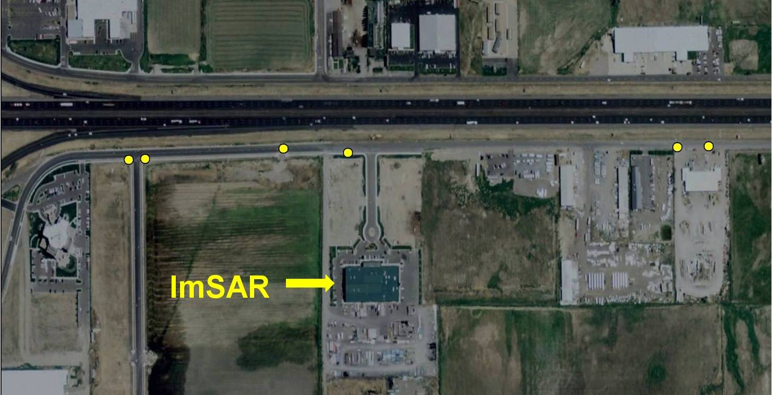
Figure 9. Google Earth image of the region around the ImSAR building, showing six identified concentrations of cracks in the aspahalt service road.

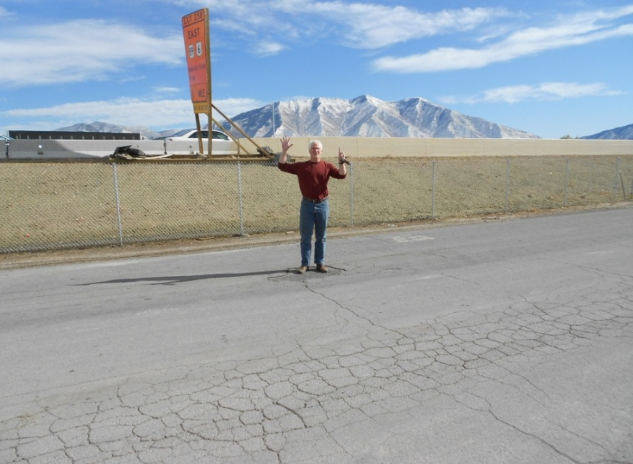
Figure 10. Photo showing cracks at one of the six locations in Figure 9.
To prepare for the flight tests, the service road in front of ImSAR was scanned for features of interest. As seen in Figures 9 and 10, a number of features were identified and geolocated with GPS. Of the six features identified in the service road, none were discernible in the Ku-band image. Moreover, all asphalt roadways are dark and appear to be dominated by noise. As observed with the X-band real aperture radar, Ku-band SAR seems incapable of discerning surface features in asphalt roadways.
Better results were found for features in the concrete. As in the case of the X-band radar, the Ku-band SAR could easily see sidewalk cracks in concrete. Figure 11 shows an optical image (from Google Earth) and the associated SAR image for the service road and sidewalk in front of ImSAR. Note that the SAR image was flown in a left/right direction. It should be noted that cracks that run parallel to the flight line are easily observed, while those sidewalk cracks running perpendicular to the flight direction are invisible.
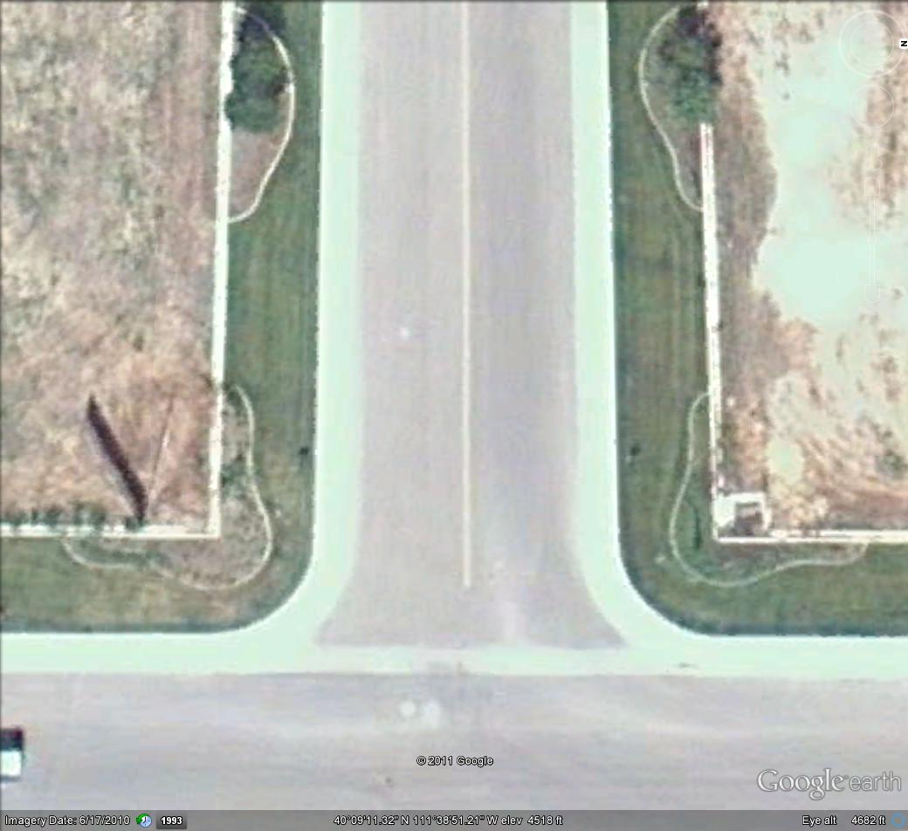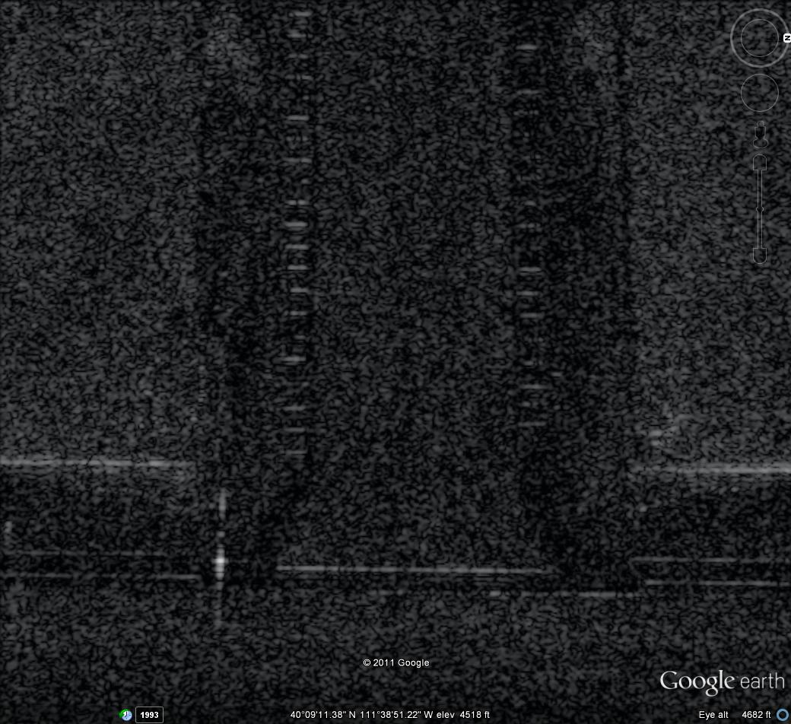
Figure 11. Google Earth image (left) and Ku-band SAR image (right) of roads and sidewalks in front of ImSAR. Cracks runing left/right (the same direction as the flight direction) are readily seen.
The preference for seeing cracks parallel to the flight direction is not surprising. Those cracks present a reflective surface facing the plane and yield a strong return relative to the flat surface of the sidewalk. On the other hand, cracks perpendicular to the flight direction merely present a trough to the microwaves; offering no siginificant surface with which to reflect microwaves.
While this statement at first appears to offer hope for the efficient use of SAR to detect cracks in concrete roadways, problems remain. Except for road centerlines, transverse cracks tend to dominate the cracks seen in highways. The reason for this, of course, is the heightened thermal expansion in the linear direction. With time, expansion and contraction produces tansverse cracks. Any efficient use of SAR will demand that the sensor paltform, either vehicle or plane, traverse along the direction of the the road. However from this vantage point, only linear cracks can be observed, not transverse cracks. An alternative technology will be needed to observe the predominate trasverse cracks.
Conclusions and Recommendations from Springville Experiments
Conclusions regarding the use of radar for crack detection are best addressed individually for the case of real and synthetic aperture configurations.
For real aperture radar, cracks were evident in the signal. However, the difficulty of this approach is the low signal-to-clutter ratio, that means the signature of cracks gets masked by noise. Unlike SAR, real aperture radar does not provide an actual image. Instead it yields the integrated return from all targets at a specific range. If we illuminate a roadway with microwaves, there are many possible contributions to the returned signal. Gravel, dirt, rough surfaces, as well as cracks all contribute to the radar return. Thus the signal that we seek (the return from pavement cracks) is masked by the additional clutter from all other sources. For large cracks that run transverse across the road, this may not matter. The signal-to-clutter ratio may be sufficient for us to identify the crack. However, for smaller cracks, or cracks running longitudinally down the road (which do not present a facet for strong radar return), the clutter will probably dominate the signal.
As noted before, we can strive to improve detection through sophisticated signal processing in the time domain, whereby we take advantage of the fact that the crack can be seen for some finite duration. However, our real-world examples do not suggest optimism. The human mind is a remarkable tool for identifying features. Under most circumstance, sophisticated algorithms strive to reproducibly detect what an operator can see naturally. Based on this criterion, the real aperture radar will not be a reliable tool for detecting crack. Although a number of known cracks did lead to clearly identifiable responses, pristine asphalt roads showed numerous responses that would be erroneously identified for road repair. Any robust technique must be able to unambiguously identify cracks; missing few, and not creating false positives. By this standard, the real aperture approach will not be adequate.
The use of synthetic aperture radar for crack detection yields a more positive outcome; however one with important qualifications. InSAR’s Ku-band radar offers remarkable performance for an airborne SAR system. But resolution alone does not determine the applicability of SAR for crack detection. More important is the way that microwaves interact with targets. The SAR imagery shown above indicates that Ku-band microwaves are very good at “seeing” features in concrete, provided they run parallel with the direction of sensor motion. Images of concrete sidewalks and highways yield high contrast delineation of cracks. For asphalt, though, the delineation of surface features is lacking. The reflective properties of blacktop (due to surface roughness) yielded exceedingly low returns and offered negligible surface detail. For the majority of roadways in America that are blacktop, SAR will not be a robust technique for crack detection.
In light of the original goal of investigating the applicability of radar (either real aperture or synthetic aperture) for crack detection in the nation’s roadway system, our initial findings are mixed. No clear path forward seems evident for the application of radar to blacktop roads. And while it can be argued that a vehicle mounted SAR could still meet the requirements for concrete roadways, issues arise with the detectability of cracks based on orientation. The use of SAR will do an enviable job of detecting cracks that run parallel to the line of motion. However, transverse cracks will be better detected using an alternative technology such as Lidar.
Based upon these conclusions (early in the project’s schedule), the DOT may determine that radar has no stand-alone, near-term role in road inspections. However, the utility of airborne SAR for the inspection of concrete roads may be profitably investigated. If there is a need to ascertain the condition of concrete roads, airborne inspection with Ku-band SAR may offer an expeditious and cost effective way to inspect for damage. Cracks, gravel on the road, avalanche debris, and snow and ice coverage, may all prove to be discernible using this technology. Whether the benefits to be accrued from such technology justify the continued investigation into airborne SAR is a question for the DOT to ponder.

Reporting Research Results to DOT
During the Second Quarter of the project, UAF summarized preliminary research results in the form of a DOT RITA quarterly report as well as a presentation delivered to the Transportation Research Board 91st Annual Meeting in Washington, D.C. The talk entitled, Close-Range Synthetic Aperture Radar for Pavement Inspection, was presented in the Sensing Technologies for Transportation Applications session.

